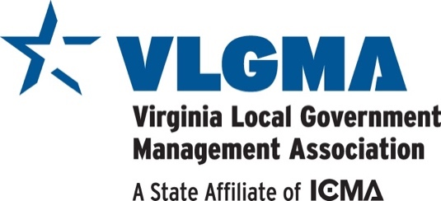

Conference Sponsorship Opportunities

Purpose
The Virginia Local Government Management Association greatly appreciates the support and participation of our
vendors at our meetings and activities. Proceeds from our sponsors are used to strengthen our programs and
networking opportunities by introducing our members to innovative programs and services. The following
represents deliverables to the vendor that will increase exposure to our membership while also recognizing the
professional ethics by which our members adhere.

Platinum Sponsor (>=$15,000) – Limit of Two
- Four complimentary registrations at both the winter and summer conferences (Total of 8 per year) with access to all seminar sessions, receptions, breaks, lunches, and dinners
- First choice of table space in a high traffic volume area during both winter and summer conferences, if desired and available
- PowerPoint Slide dedicated solely to your company logo rotated on projection screens during breaks, luncheon
and dinner (15 second rotation)
- Sponsor page logo placement on electronic conference bulletin with hyperlink to company website
- Recognition as a “Platinum Sponsor” on VLGMA sponsor website – logo with hyperlink
- VLGMA member to thank and recognize sponsor from the stage podium
- Opportunity to have an article published in E‐Newsletter
- Recognition on name tag as a “Platinum Sponsor”

Gold Sponsor (>=$5,000) – Limit of Four
- Four complimentary registrations at the winter or summer conference (Total of 4 per year) with access to all seminar sessions, receptions, breaks, lunches, and dinners
- Table space in a high traffic volume area during both winter and summer conferences, if desired and available
- Slide dedicated solely to your company logo rotated on screens during breaks, lunch, and dinner (10 second rotation)
- Sponsor page logo placement on electronic conference bulletin with hyperlink to company website
- Recognition as a “Gold Sponsor” on VLGMA sponsor website – logo with hyperlink
- VLGMA member to thank and recognize sponsor from the stage podium
- Opportunity to have article published in E‐Newsletter
- Recognition on name tag as a “Gold Sponsor”

Silver Sponsor (>=$2,500) – Limit of Ten
- Three complimentary registrations at the winter or summer conference (Total of 3 per year) with access to all seminar sessions, receptions, breaks, lunches, and dinners
- Table space during both winter and summer conferences, if desired and available
- Shared Slide (two companies per slide) rotated on screens during breaks, luncheon, and dinner (5 second rotation)
- Sponsor page logo placement on electronic conference bulletin with hyperlink to company website
- Recognition as a “Silver Sponsor” on VLGMA sponsor website – logo with hyperlink
- Opportunity to have article published in E‐Newsletter
- Recognition on name tag as a “Silver Sponsor”

Bronze Sponsor (>=$1,500) – Limit of Sixteen
- Two complimentary registration at the winter or summer conference (Total of 2 per year) with access to all seminar sessions, receptions, breaks, lunches, and dinners
- Shared Slide (four companies per slide) rotated on screens during meals (5 second rotation)
- Sponsor page logo placement on electronic conference bulletin with hyperlink to company website
- Recognition as a Bronze Sponsor on VLGMA sponsor website – logo with hyperlink
- Recognition on name tag as a “Bronze Sponsor”

Friend (>=$1,000) ‐ No Limit
- One complimentary registration at the winter or summer conference (Total of 1 per year) with access to all seminar sessions, receptions, breaks, lunches, and dinners
- Recognition on name tag as a “Sponsor”

FAQ

- How long does a sponsorship last?

Sponsorships are for one calendar year (October 1-September 30)

- What is the process and deadline to sign up to be a sponsor?

Sponsorships are accepted at any time. However, VLGMA will begin its annual recruitment period July 1 for
the following calendar year. Sponsors with finite limit are accepted on a first paid‐first served basis effective
every July 1. In order to get all deliverables as stated above, sponsors need to commit by December 15.

- If I become a Sponsor, will I have any claim to it the next year?

Each Sponsor level with finite limit will be given July 1-October 1 to renew sponsorship level before it is
opened up to other sponsors. VLGMA reserves the right to adjust the limitations and amounts of these
sponsorships on an annual basis.

