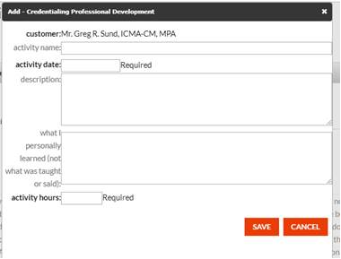
Jane Doe

Activity Name: Wholistic Credentialing Report

Activity Date 7/1/19

Description:
I attended the XX Annual conference in Anytown, US, June 18-20, 2019.
I attended the XX Conference Anytown US, May 3-4, 2019.
I attended the XX Annual Conference in Small Town, US, February 6-8, 2019.
I participated in numerous ICMA/State Association webinars, 2018/2019.
I read the book Atomic Habits by James Clear.
I read the book 4th Dimension Leadership by Ron Holifield.

What I personally Learned:
2018 and 2019 was a major transitional year for me. I had planned on focusing on Strategic Leadership, Human Resources Management and Workforce Engagement, and Technological Literacy. To an extent I did, but the situation in My Town shifted my focus and attention. The end of my last report had the following in it “I’ve got a great support team and as I write this report, I am gainfully and happily employed as the City Manager for the City of My Town. I am blessed and will not take this new opportunity lightly.” To that end, I have been extremely fluid in my focus and trainings over the last year.

In the columniation of my training over the last year, I can say I am a better manager and person from them. There was no one session or book that I read that drastically changed how I manage or approach our profession, rather Atomic Habits reminded me of what I do daily but reinforced my approach to life and my focus on intentional and successful habits. 4th Dimension, reminded me of my leadership habits and what I value in who I am in this life – a farther, a husband and a manager – in how I desire to live my life. A reminder and a refresher of proven leadership competencies. At the Municipal conference, I attended operational sessions that focused my attention on how to implement the concepts and policy recommendations I’d been making to my council. The XX Conference got me jazzed about technology and really thinking about artificial intelligence and autonomous transportation – how both will affect our culture, nation and local communities.

The State Management conference brought me back to the value of relationships and collaboration. The City Management Association conference is made up of primarily managers and deputy managers. The value of knowledge and experience of my fellow managers – in a venue that I can talk with them and engage in a safe place to share my questions, my fears, and my ideas is priceless. The time I spent asking questions about challenges I am facing – professionally and personally, resulted in great ideas…but more importantly, created (or reinforced) relationships that I can rely on (or lean on) in the future as I move into the future and am challenged in my management and leadership skills.

Conclusion: In my personal life, as I said in my last report, the last few years have been hard on my career and my family. Being asked to be the My Town City Manager was an honor, but it has had its own challenges and stigmas. I struggled for some time to regain my focus as a City Manager. I didn’t feel adequate as a husband to my very successful wife. I felt inadequate in my skills as a manager, a leader, and ultimately as a person (man). Over the last year, attending conferences, reading books, participating in webinars, and engaging with my colleagues from around the state and nation has ignited my passion, renewed my confidence, and put me in a place of loving the local government management profession.

I have taken the last year to be the best manager of my career. My trainings and continuous focus on improvement have helped me successful in my profession as a City Manager and as a husband and a father. I am blessed to be in this profession and I value the credentialed manager program and am proud to be a member of this esteemed group.

Sincerely,

