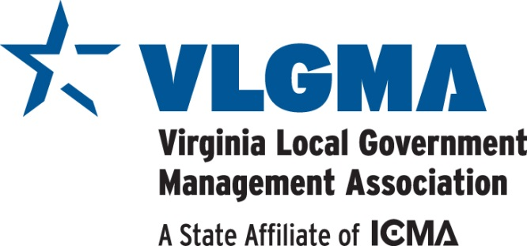

TO: Friends and Sponsors of VLGMA October 2019

FROM: Molly Harlow, Conference Coordinator
Weldon Cooper Center for Public Service, University of Virginia

RE: VLGMA 2020 Sponsorship Opportunities

The Virginia Local Government Management Association greatly appreciates your support and participation in our association meetings and activities. Your involvement strengthens our programs and networking opportunities and introduces our members to innovative products and services. We invite and welcome your participation once again for the 2019 Winter and Summer Conferences. VLGMA is a 501(c)(6) trade association of Virginia's local government professionals - city, county, and town managers as well as deputy, assistant managers and other local government employees.

This year, we are continuing with more well-defined sponsorship opportunities that will cover the entire year and both conferences. Opportunities to expose your organization’s services to our membership will be available at a variety of levels of support. Please see the attached Conference Sponsorship Opportunities form for more details. Take note that some levels provide exclusivity and will be offered on a first-come, first-choice basis.

CONFERENCE DETAILS

Winter Conference
February 12-14
Charlottesville Omni Hotel

Summer Conference
June 10-12
Virginia Beach Hilton Oceanfront

Complete seminar materials, including the agenda and hotel registration information, can be obtained as they become available by going to http://icma.org/en/va/home. We will provide all sponsors with information on making room reservations at the special conference rate as soon as it is available.

If interested, please return the enclosed conference registration form. We also need the enclosed Sponsor Ethics form signed and returned with your sponsorship contribution. As conference coordinator, I will be happy to work with you on an individual basis to accommodate your specific needs.

Contributions can be made via credit card (invoice will be emailed to you once Sponsorship Agreement is received) or by check made payable to "The University of Virginia" and sent directly to:

Ms. Molly Harlow, Conference Coordinator
Weldon Cooper Center for Public Service, University of Virginia

P.O. Box 400206
Charlottesville, VA 22904-4206

Please call me if you have any questions or if you need assistance with arrangements. My phone number is 434/987-0331; email is mjh3a@virginia.edu.

Thank you for considering this important contribution to the professional development of Virginia’s local government managers. I look forward to hearing from you.

