This is to certify that
«First_Name» «Last_Name»
Has satisfactorily completed an ICMA University

Telling People What They May Not Want to Hear
November 15, 2018

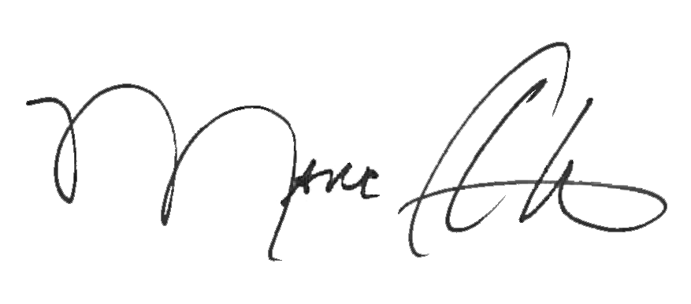

_______________________________ __________________________________________
Marc A. Ott Felicia C. Logan
ICMA Executive Director ICMA Leadership Development

