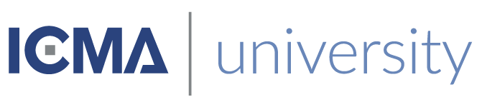

This is to certify that
«First_Name» «Last_Name»
Has satisfactorily completed an ICMA University

StandOut 2.0 - Building A Culture of Strength

Within the Organization
October 7, 2019

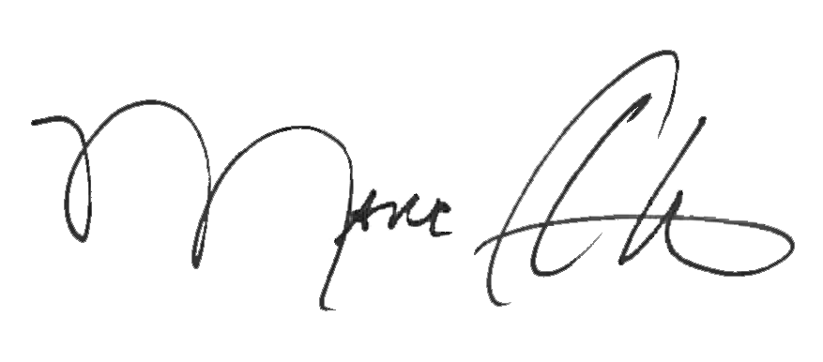

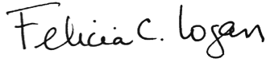

_______________________________ __________________________________________
Marc A. Ott Felicia C. Logan
ICMA Executive Director ICMA Leadership Development

