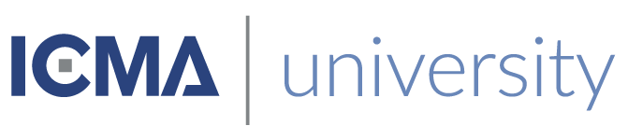

This is to certify that
«First_Name» «Last_Name»
Has satisfactorily completed an ICMA University

Shaping the Culture of Your Organization
December 7, 2017

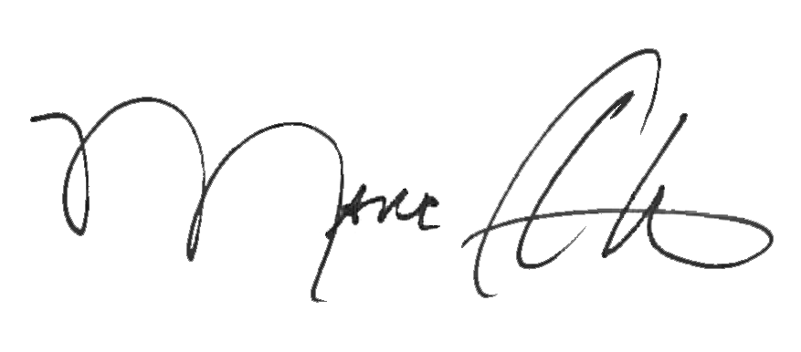

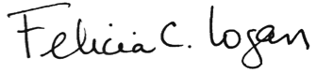

_______________________________ _______________________________
Marc A. Ott Felicia C. Logan
ICMA Executive Director ICMA Leadership Development

