**Selecting and Viewing Webinars with a Subscription**

1. Log on to <http://learning.icma.org> and go to your Dashboard. (Bookmark this site for easy access.)  
   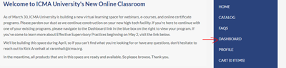
2. Look for your subscription under the Packages heading.   
   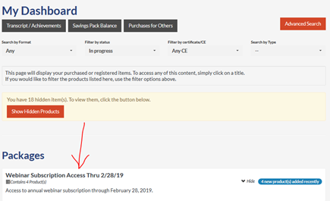
3. Click the Content tab  
   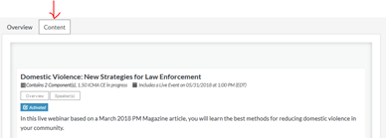

1. Activate the sessions you want to see.

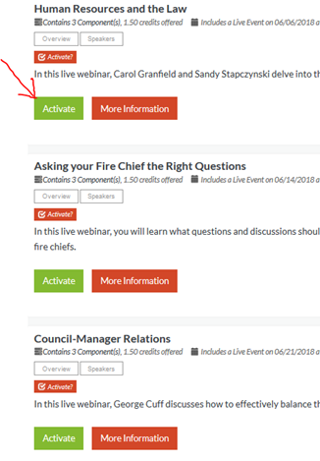

1. On the date of the event return to your Dashboard and click on your subscription.

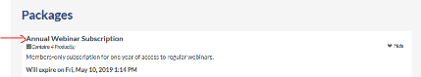

1. Then click the Content tab.

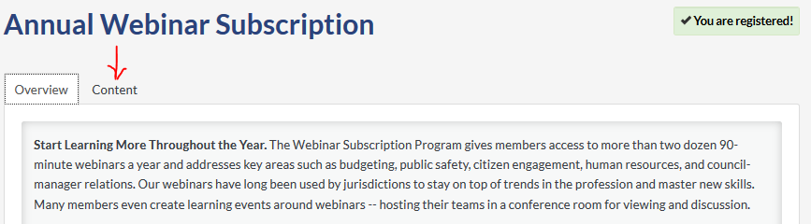

1. Activate webinars you want to attend or watch on demand.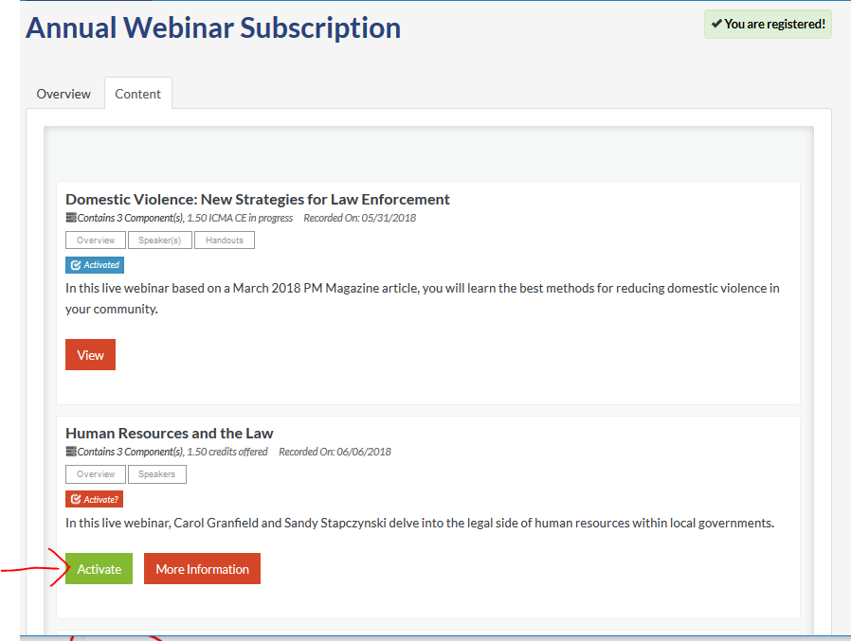
2. Click View.

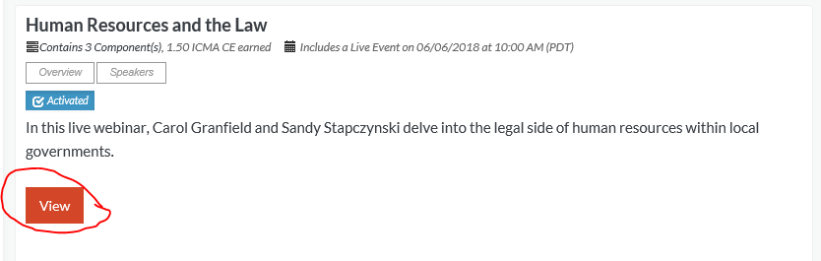

1. Click Add to Calendar and then come back on the date and attend. On demand events become available on the next business day following a live event.  
     
   