This is to certify that
«First_Name» «Last_Name»
Has satisfactorily completed an ICMA University

Repacking Your Bags: A Year of Living Purposefully
February 8, 2019

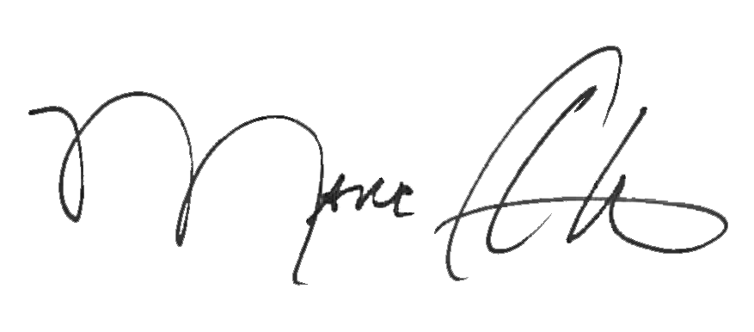

_______________________________ __________________________________________
Marc A. Ott Felicia C. Logan
ICMA Executive Director ICMA Leadership Development

