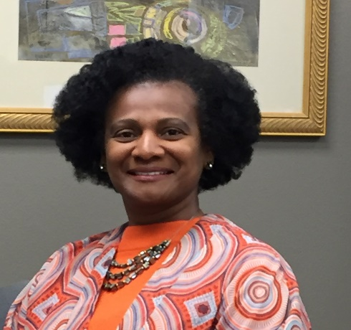
PRISCILLA WILSON
BIO

Priscilla Wilson currently serves as the Chief People Officer for ICMA, a role she has held since January 2020. Priscilla has enjoyed a 25-year career solidly grounded in full spectrum strategic human capital management, development, and engagement and preserves a reputation as one who consistently fosters and nurtures rapport and collaboration among diverse stakeholders.
Prior to joining ICMA in early 2020, Priscilla’s most recent role was as a Senior Vice President with the highly respected executive search and leadership development firm, The Mercer Group. Before serving as a consultant with The Mercer Group, Priscilla served the City of Garland, Texas for over a decade and a half as the Senior Managing Director/Chief Human Resources Officer.
Priscilla holds a master’s degree in Public Administration from the University of North Carolina at Chapel Hill and a bachelor’s degree in Political Science from North Carolina State University. She holds IPMA-SCP, SPHR-CP and SHRM-SCP certifications.

