This is to certify that
«First_Name» «Last_Name»
Has satisfactorily completed an ICMA University

Leadership and Management in a (Permanent) Crisis
January 29, 2018

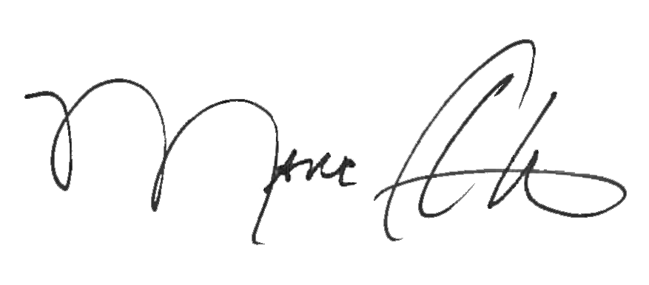

_______________________________ _______________________________
Marc A. Ott Felicia C. Logan
ICMA Executive Director ICMA Leadership Development

