INTRODUCTION
Fully implemented by January 31, 2016, the City of Leduc Corporate Training Program has positively impacted our strategic direction and transformed our environment into that of a learning culture.
The City of Leduc is committed to supporting a culture of continuous learning and development and growing and developing our organizational and leadership capacity. We believe that learning and development:
- is a shared responsibility between employees and supervisors and success is realized through effective performance and learning discussions.
- is an investment and employees require the time, space, and resources to develop, learn and grow.
- plays a fundamental role in building department and organizational capacity to deliver on business objectives and provide effective and efficient programs, services and policies to citizens both now and into the future.

PROBLEM ASSESSMENT
Training is a key component to maintaining our investment in human capital; ongoing development provides the ability to offer sought after services to our residents, and develop the skills necessary to develop new and innovative service levels. In addition, we are a dynamic, growing organization that recognizes the ability to attract and retain the best talent. Our investment in training reinforces this.
Our Corporate Training Program places the ownership on the employee to:
•Discuss learning and development goals with their supervisor
•Develop and implement a learning plan annually as part of Performance Management and understand how the learning objectives support both business priorities and professional aspirations; both linked to competencies.
•Share expertise by proactively participating in various knowledge transfer activities with peers.

PROGRAM IMPLEMENTATION & COSTS
The 2016 Professional Development Corporate Training Program offered 22 professional development courses and 58 Occupational Health and Safety courses, with a designated budget of $159, 435. In response to the economic realities and to reduce the impact on municipal tax dollars, the City of Leduc reduced the Corporate Training budget by 10% for 2017.
TANGIBLE RESULTS / MEASURABLE OUTCOMES
Excerpt from our annual Corporate Training Survey: “Significant improvement over the last few years. Please continue to provide programs that can allow departments to be current in municipal best practices. Thanks for helping me "coach" up my team. It is greatly appreciated.” – Manager, Community Development and Culture.
Uptake for the courses and programs offered through the Corporate Training Program is significant with a total of 550 City employees and 43 attendees from other municipalities which generated approximately $7000 in revenue. In addition, the 2016 OHS Corporate Training Program certified over 300 employees and ensured compliance with the Alberta Occupational Health and Safety Act, Regulation and Code, and changing legislative requirements.
In our recent Citizen Satisfaction Survey, results indicate that residents are extremely satisfied with the services that City staff provide. Training courses such as Influence with Ease, Verbal Judo, Respectful Workplace, Boost Energy, and Dealing with Difficult People have contributed to these noteworthy results:
Influence with Ease... The Art of Public Service “It was fantastic! Rephrasing our words and recognizing the 7 expectations from customers will help us to assist customers and better understand their needs.”
Verbal Judo: "It will be particularly valuable to me when dealing with customers ... I will be able to use a script I have prepared for a better explanation ... "
Boost Energy: "I believe that efficient tools were provided to help employees get through their workday to prevent burn-out and from being overwhelmed.”
Dealing with Difficult People: "The instructor was fantastic and the values I took away from the course will definitely assist me in both my personal and professional encounters with difficult people.”
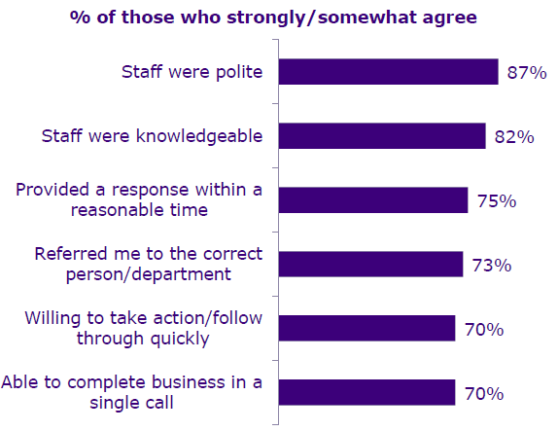
Source: 2017 Citizen Satisfaction Survey | Satisfaction with City Staff

LESSONS LEARNED
Annually, in September we conduct a Corporate Training Survey to assess needs and improve our program. In planning for 2017, we asked the question to directors and managers: “Who would you like to see more training for (leadership, management, supervisors, front line staff)?” Leadership was a front-runner at 72%. The others ranked at 67%, 56%, 50% respectively. It was noted that there appeared to be a ‘gap’ in courses geared towards supervisors, so we planned accordingly and, where possible, utilized in-house resources specific to various levels. Subject matter experts at all levels were responsible to select a course, research and develop course content, and then present the topic as an in-house Corporate Training offering.

RAISING AWARENESS
Managers play an essential role in the Corporate Training program. It is the responsibility of the managers to develop Learning Plans with each of their employees during the annual performance review period to determine which of the courses offered the following year would best aid in their professional development. Some of these learning objectives are clearly identified in their job descriptions, while others may be set to support an employee in a specific performance goal or project, and some are set with the intent of developing employees for future organizational requirements. This learning plan is comprised of S.M.A.R.T. Goals and designed to keep employees on track throughout the year, and aid in succession planning.
Managers are also tasked with approving / coordinating time off for employees to attend corporate training and upon return, discussing the lessons learned with their employees. It is essential that the employees take courses that bring personal and professional value to themselves, and to their departments. Supervisory support is an important dimension of the social aspect of learning. Training transfer is facilitated when trainees perceive that their supervisors are supportive in this way. Some examples of ways that our managers and supervisors promote this transfer are:
- Participating themselves in training events (we invite our supervisors to attend our New Employee Orientation Session alongside their new hire. They can attend the full day, or a portion thereof). Uptake for this has been great and it truly shows that support and commitment.
- Providing input to training via the annual Corporate Training Survey
- Discussing new learning and how to apply it
- Providing coaching, encouragement, and feedback
Overall, the City of Leduc Corporate Training Program; increases the grasp of and commitment to our strategic goals; and produces innovative ideas, solutions and strategies to meet the needs of the business.

