How to Get a Volume Discount and Register Your Team for Local Government 101 in 10 Easy Steps
(NOTE: We are using test accounts at the NONMEMBER rate for illustration purposes only.)
- Choose the product and click REGISTER.
- Click COMPLETE REGISTRATION NOW.
- If you are NOT taking the course you should first change the registrant name to add your first person.
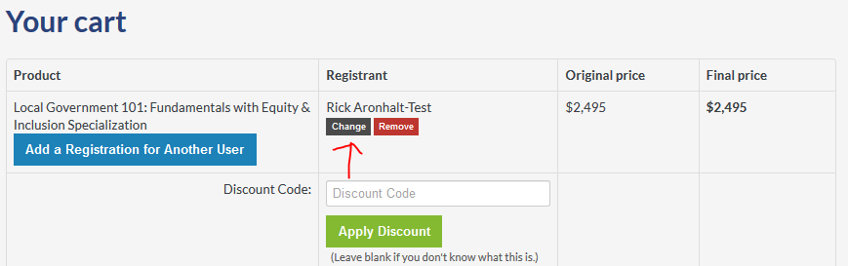
- Enter e-mail. NOTE: The person you are registering must have already logged into http://classroom.icma.org at least once in the past to be recognized in the system.
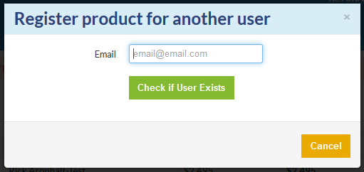
- Click CHANGE USER
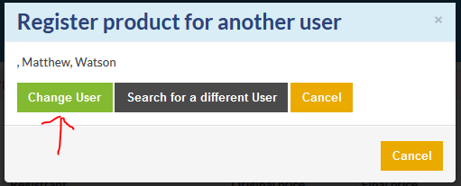

- Add registration for another user.
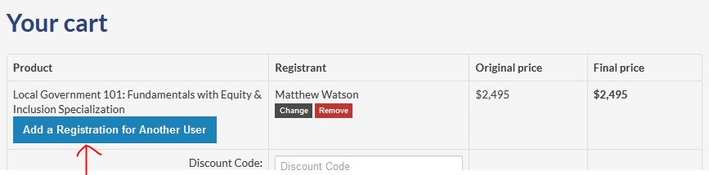
- Enter another user.
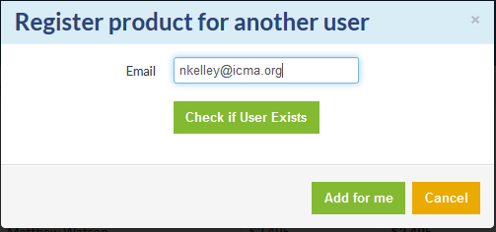
- Volume discounts will automatically apply.
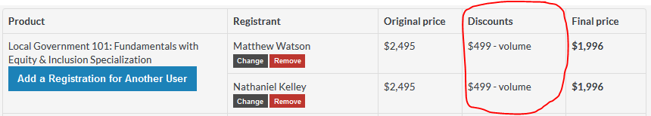
- Continue to click ADD A REGISTRATION FOR ANOTHER USER until you are finished. If you are eligible for a higher volume discount, it will automatically apply when you reach that volume.
- Complete payment and the sessions will appear in everyone’s DASHBOARD.
Two important notes:
- The volume discount applies to both learning tracks (Equity & Inclusion or Disaster Preparedness), so you may add a second learning track and assign team members to any combination of tracks adding up to your 2, 5, or 10 volume discount thresholds.
- If a member registers a team, EVERYONE gets the member rate along with the volume discount.

