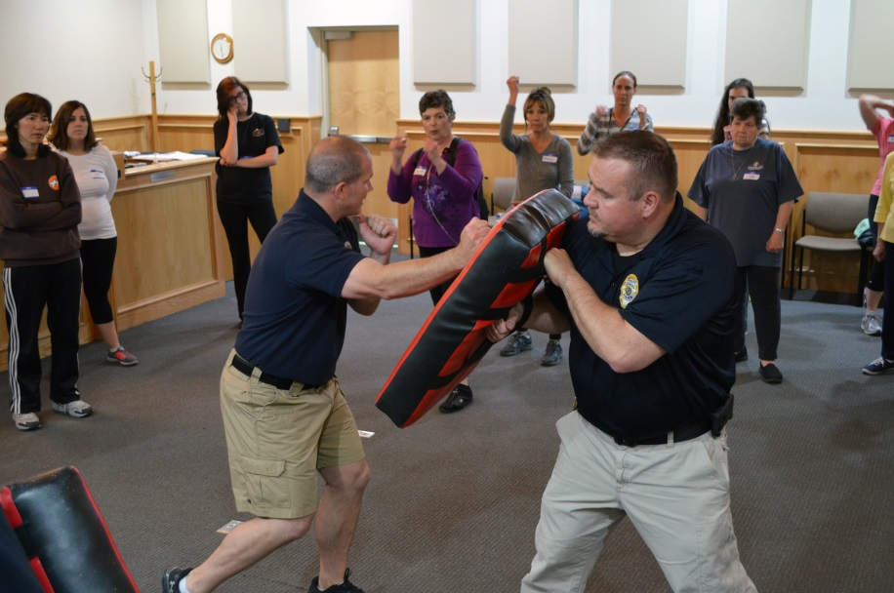
Frederick Police Department Self-Defense Classes Narrative Document
Problem Assessment
In a heightened climate of disdain for law enforcement, the Town of Frederick wanted to proactively find a way to give the public a chance to interact with our officers in a meaningful way. Every 98 seconds, an American is sexually assaulted, and 91% of the victims of rape and sexual assault are female. And while our community is relatively safe due to size, our residents do travel for work and entertainment purposes, and domestic violence and sexual assault can happen anywhere. A solution to combat both of these problems presented itself in the form of self-defense classes offered to female residents by the Frederick Police Department, free of charge.
Program Implementation and Costs
Conversations began with the Chief of Police Gary Barbour and Commander Todd Norris who immediately referred the idea to Sergeant Dave Egan (pictured right) and Officer Aaron Herbert (pictured left). Both of these Frederick police officers have extensive backgrounds in martial arts, arrest control instruction and self-defense instruction. Sgt. Egan and Officer Herbert decided that the format of a four-hour class with some classroom-style instruction followed by physical tactic-teaching would be most effective for a beginner level knowledge base. The decision to offer the classes for free was an intentional way to ensure that women at all socioeconomic levels had the same opportunity to participate in the class. Females living in households in the lowest income bracket experience rape or sexual assault victimization at almost double the rate of higher income brackets, so this would allow us to ensure access to the highest risk demographic.
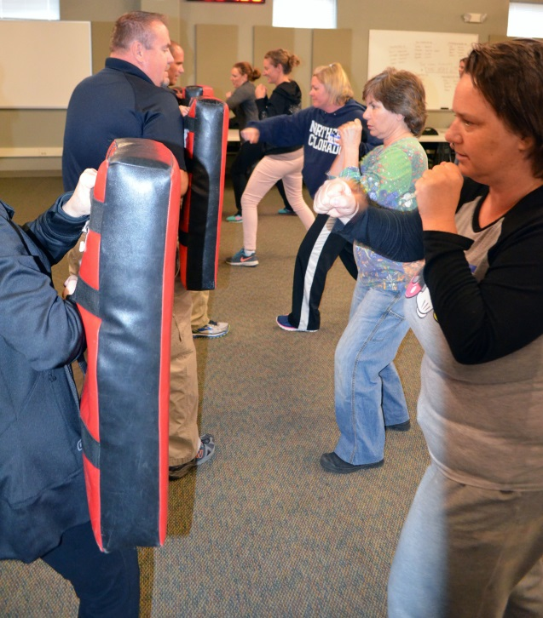
We timed the beginning of these classes with Sexual Assault Awareness Month in April of 2016. The first round offered two classes to 20 women each. An article in the March monthly newsletter, mailed with the utility bills to each household and business in Frederick, publicized the opportunity and within nine days, both classes were full with significant waiting lists.
We hosted the first class on April 9, 2016 in the court room at our police station. This allowed us to save funds by eliminating the need to rent a space. Each participant was required to sign a waiver holding the Town and its employees harmless in the event of an injury during the class. Sergeant Dave Egan and Officer Aaron Herbert began the class with a PowerPoint presentation about preventing situations where self-defense physical tactics are needed by using tools such as the Cooper Color Codes of Awareness and the Observe, Orient, Decide, Act (OODA) Loop. The Cooper Color Codes of Awareness are a scale of basic mental states that allow you to shift your level of awareness or readiness to the current requirements of your situation. The OODA Loop is a decision cycle that supports quick, effective and proactive decision-making. The classroom instruction was followed by a round of stretching before physical tactics such as fighting stance, breaking a wrist grab, breaking a hair hold, how to punch properly, elbow strikes, palm strikes, knee strikes, front kicks were demonstrated and then practiced on pads. At the end of the class, each participant received a certificate of completion as well as a free t-shirt that says ‘Property of No One: Frederick Police Department Self-Defense’ on the front and ‘Taught By’ with an outline of the police patch on the sleeve. These t-shirts are then worn with pride by the participants throughout the community after the class, serving as walking billboards for the police department and its community outreach efforts.
Cost for the program is minimal, consisting of the officers’ time to teach the class and additional staff time of the Community Relations Manager to create a registration form, publicize the program, manage registration and communication with attendees, design and print certificates, collate t-shirt sizes, design and order the t-shirts. All told, expenses total $625 per class.
Tangible Results or Measurable Outcomes of the Program
The enthusiasm for the initial classes has led us to expand this initiative by offering additional level one classes as well as creating a level two class for participants who want to continue learning to defend themselves. In less than a year, we have instructed over 100 women in Frederick in self-defense, which amounts to just under 3% of our total population of females 15 and up. The most tangible result comes from the attendees in their own words:
“The self-defense class was life changing. Since the class, I have put down my phone and become more aware when I’m out in public. My goal is to avoid iffy situations so I don’t need to punch someone in the throat,” said Frederick resident Jennifer Abrams.
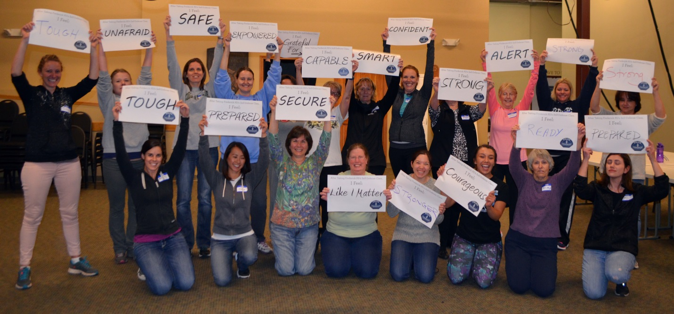
“Thank you. Thank you. Thank you. We really enjoyed the class. It was so informative. The officers were fantastic and so very patient. We will wear our t-shirts with pride,” said Frederick resident Pratima Pathak.
Lessons Learned During Implementation, and Analysis of the Program
We have changed the location of the classes from the municipal court room to the Frederick-Firestone Fire Protection District’s Business and Education Center, which allows us to have more room to practice the physical tactics more effectively. While Officer Herbert has taken the lead on instructing these classes, multiple officers have gotten the chance to be involved by holding pads and assisting in instruction during the physical tactics portion of the classes. We’ve added communication about the classes through our other communication channels, and still have a waitlist for future classes. While we would love to offer these classes more frequently, we are limited by staffing capacity at the police department. This program takes the officers off of patrol and away from their regularly assigned duties or requires overtime. However, it is a worthwhile program that we have seen great success with and will continue to offer as budget and scheduling allows.
How the Program Raises Awareness of the Contributions of Local Government Managers
When local government management is at its best, proactivity and utilization of talent at hand are both steadfast practices. This program combines not only those two philosophies, but is a budget-conscious way to connect residents to their government. We saw a situation and an ever-changing environment that was affecting many communities throughout the nation, and decided we wanted to work on improving relations between our law enforcement and the community in the hopes of preventing a similar situation here. A town’s reputation is a reflection of the manager, and to continuously strive to improve that reputation benefits the profession as a whole.

