This is to certify that
«First_Name» «Last_Name»
Has satisfactorily completed an ICMA University

Gauging Public Opinion the Right Way
February 6, 2020

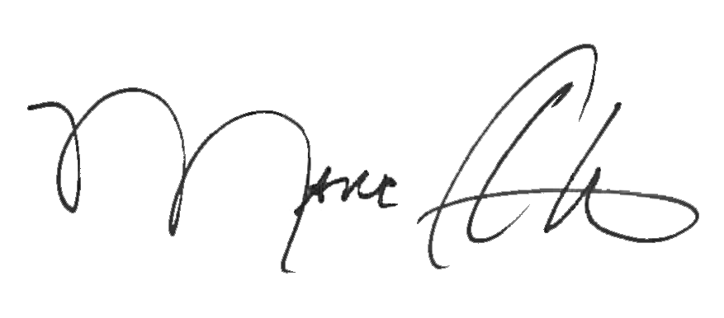

_______________________________ _______________________________
Marc A. Ott Felicia C. Logan
ICMA Executive Director ICMA Leadership Development

