This is to certify that
«First_Name» «Last_Name»
Has satisfactorily completed an ICMA University
Fatal Flaws of a Council-Manager Relationship
February 12, 2020

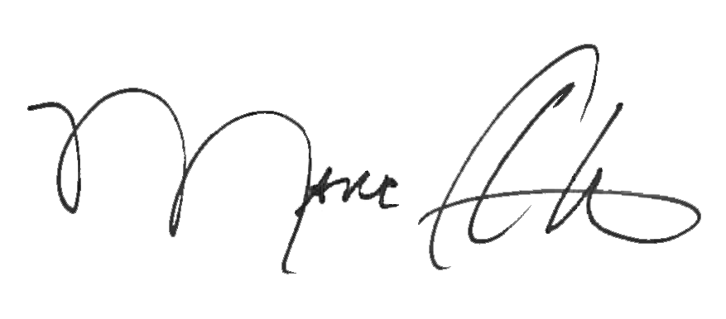

_______________________________ _______________________________
Marc A. Ott Felicia C. Logan
ICMA Executive Director ICMA Leadership Development

