Data Mapping and Performance Management

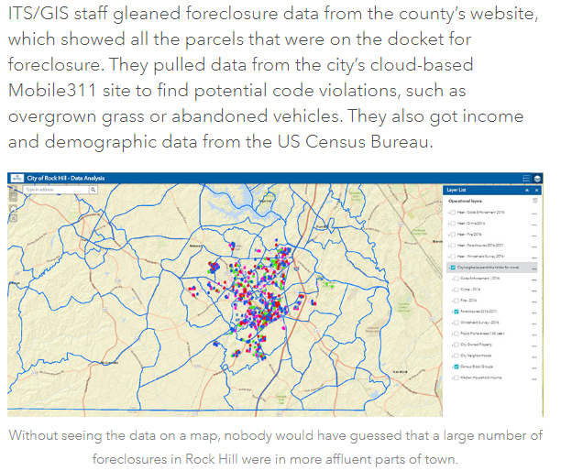

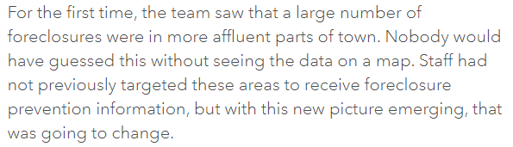

City of Rock Hill, South Carolina
https://www.esri.com/about/newsroom/arcnews/putting-public-safety-issues-on-the-map/

