This is to certify that
«First_Name» «Last_Name»
Has satisfactorily completed an ICMA University

ICMA Gettysburg Leadership Institute
May 15 -17, 2019

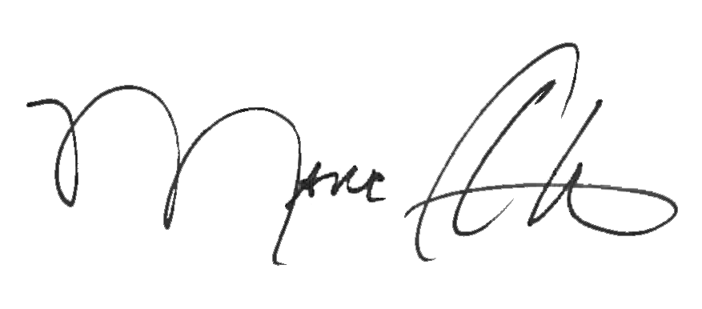

_______________________________ _______________________________
Marc A. Ott Felicia C. Logan
ICMA Executive Director ICMA Leadership Development

