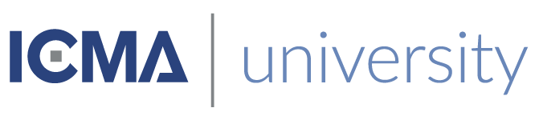

This is to certify that
«First_Name» «Last_Name»
Has satisfactorily completed an ICMA University

Making Democracy Work Institute I
February 26 – 27, 2019

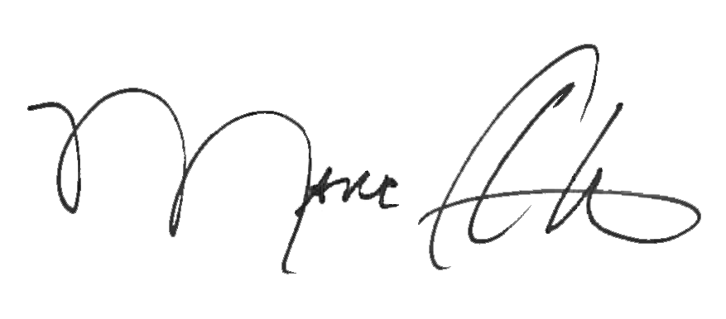

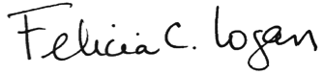

_______________________________ __________________________________________
Marc A. Ott Felicia C. Logan
ICMA Executive Director ICMA Leadership Development

