This is to certify that
«First_Name» «Last_Name»
Has satisfactorily completed an ICMA University

Case Study: Essential Management Skills
May 3, 2018

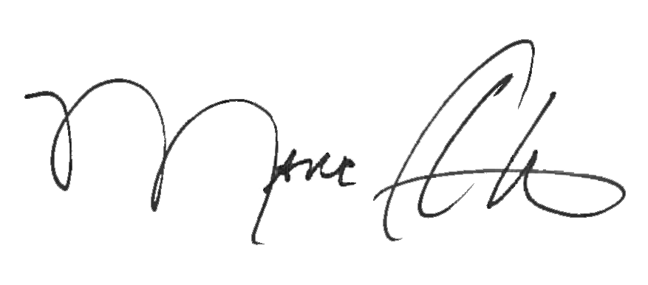

_______________________________ __________________________________________
Marc A. Ott Felicia C. Logan
ICMA Executive Director ICMA Leadership Development

