## Drupal is a content management system. Its purpose is to help users compose and present website content such as pages, photos, and other content types. Rather than forcing users to modify code, Drupal manages the details of how information is arranged and presented, letting users focus on the content to be displayed.

## Most of the content on a Drupal-based site is stored in a database. The content provider/creator submits text and images by filling in forms via a web browser. When visitors view a page, Drupal gets the relevant bits of content from the database and composes the components of the page in a template. This makes it easy for the person providing the content to quickly add or change content without needing knowledge of HTML or other web technologies.

# Common Drupal Terms

**Basic pages** are used for static content that can (but is not required to) be linked into the main navigation bar.

## **Content type** is content defined by a unique model established by ICMA. Examples of content types are articles, blog posts, and questions.

## **Fields** are elements like author name, article title, date, and so on, attached to a node. They provide flexibility to display different pieces of content in different places in different ways without duplicating content entry.

**Listing pages** are areas of the website that organize specific nodes and allow users to use a listing’s search and filters to more easily explore content. An example is ICMA’s news listing page.

**Masquerade** refers to the ability to post content in someone else’s name.

**Moderation** is the management of content in all areas of the website, in different stages of workflow.

**Node** is a piece of content, such as an article, blog post, basic page, etc.

**Node ID (NID)** is the unique identification number for each node.

**Workbench** is the term Drupal uses to describe the “waiting room” for content that is ready for final review and posting.

## Be sure to check out the Drupal Glossary on the Taoti blog, at <http://taoti.com/drupal-glossary>, for additional terminology.

# Workflow

The workbench module, explained in the following section, establishes an informal workflow for the moderation, or management, of content in the Drupal CMS.

*Note: Drupal does not have a notification system for content moderation. In other words, unlike some content management systems, Drupal does not notify you each time content is added or changed and you will need to monitor your workbench regularly.*

**Administrative Levels**



You can view all ICMA staff administrative (admin) roles here.

Admins are assigned different levels of rights in the CMS. Note that Drupal does not allow admin rights to be assigned to/for specific areas of the site. For example, suppose Clark Kent is an Admin Level 1 who is on the Research and Policy team. He can create and edit content regardless of where it will reside on the website—be it, for instance, in the Member Center area of the website—but he cannot publish it.

Only ICMA staff at Admin Levels 2 and 3 can publish, and they can publish to any section of the site. However, to clarify accountability, each website section or subsection is the responsibility of a single section manager (or in two instances, a team of two):

* Primary sections
  + Member Center – Lynne
  + About ICMA – Ellen
  + Career Development – Sam
  + Publications & Research – Sam
  + Partner with ICMA – Barbara
  + Home page, news, and events – Kathy
  + Topics – Douglas
* Subsections
  + PM Magazine – Beth
  + Annual Conference – Lynne/Julie
  + CityLinks—Rachel
  + Job Center – Rob/Lynne
* Affiliate websites—Rita

When an Admin Level 1 user has finished creating his or her content (article, blog post, or other), he or she has two options: (1) save it in the moderation state called *Draft* or (2) send it for approval by updating the moderation state to *Needs Review*. The content will then appear in the workbench, and it will be available to anyone at Admin Levels 2 and 3. The section manager (see list above) in the corresponding area of the site can then review and publish the content. In that person’s absence, any section manager could review and publish content in the workbench if circumstances necessitated.

If a section manager wants to make additions or changes to content in another section, he or she must email the other section manager outside of the Drupal CMS. The email message must include a link to the web page where the addition or change appears. The section manager can then publish it.

**Copy Editing**

All high-visibility, high-priority content, even if it was created by someone with publishing permission, will be reviewed by an editor (Kathy, Barbara, Ann, or Beth Payne). The definition of high-priority content may evolve, but this is the initial list:

* Landing pages
* Spotlights
* Relatively permanent website pages (e.g., “About the Strategic Partners Program”)
* Articles
* Blog posts
* Anything else that will appear on the ICMA home page or in *Leadership Matters.*

At the end of this document you’ll find a section entitled “Quality Assurance for the New Website—Brand Communication and Editorial Guidelines.”

# Introduction to Workbench

## ICMA’s Drupal uses the workbench module to create, edit, and publish all content on ICMA.org. Workbench provides overall improvements for managing content that Drupal does not provide on its own. Workbench gives us three important enhancements:

## a unified and simplified user interface for users who ONLY have to work with content. This decreases training and support time.

## the ability to control who has access to edit content based on an organization's structure rather than on the website structure.

## a customizable editorial workflow that integrates with the access control feature described above or works independently.

**Moderation State**

The workbench module enables content to be in three unique moderation states:

* **Draft**
  + The content is still being edited by the content creator.
* **Needs review**
  + Content creator has identified content that needs to be published.
* **Published**
  + Content is live for all website users to view.

**Content Type**

Content type is defined as**:**

* Answers
  + A node that creates an answer to a question.
* Article
  + A node that creates an article.
  + Appears on the following listing pages:
    - News listing page
    - Topic listing pages.
* Basic page
  + A node that creates a static page.
  + Appears on the following listing pages:
    - Topic listing pages.
* Blog post
  + A node that creates a blog post.
  + Appears on the following listing pages:
    - ICMA blog listing page
    - Topic listing pages.
* Document
  + A node that creates a detail page for a document.
  + Appears on the following listing pages:
    - Topic listing pages
    - Documents listing page.
* Event
  + A node that creates a detail page for an event.
  + Appears on the following listing pages:
    - Events listing page
    - Topic listing pages.
* Job post
  + Please do not use this content type.
    - Drupal is not currently using this content type. This will be developed at a later date.
  + Appears on the following listing pages:
    - Job listing page
    - Topic listing pages.
* Multimedia
  + A node that creates a page to display a player for video or audio content.
  + Appears on the following listing pages:
    - News listing page
    - Multimedia listing page
    - Topic listing pages.
* Program/project
  + A node that creates a page to display project content from global programs.
  + Appears on the following listing pages:
    - Project listing page
    - Topic listing pages.
* Publication
  + A node that creates a detail page for a publication.
  + Appears on the following listing pages:
    - Publication
    - Topic listing pages.
* Question
  + A node that creates a question posed to website users.
  + Appears on the following listing pages:
    - Topic listing pages
    - Questions listing page.

**Accessing the ‘My Workbench’ Module**

A logged-in admin user will see a black bar at the top of the CMS screen. Select *My Workbench* to enter the module.

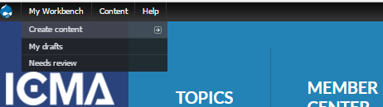

# My Workbench

The next screen is the content dashboard where users can view all (not just your own) CMS content activity.

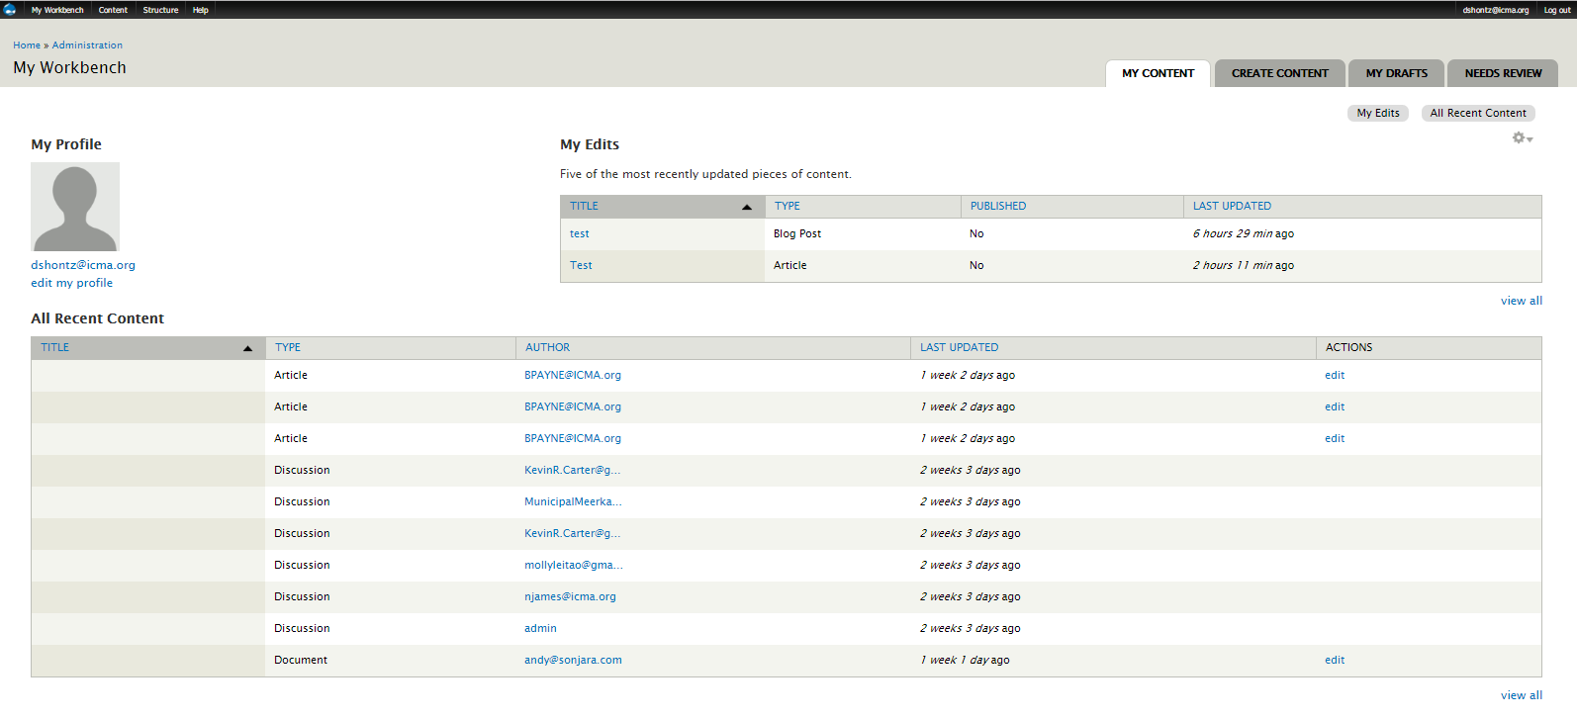

**Elements of the Dashboard**

Here’s a rundown of the information you’ll find on the dashboard:

* My Profile
  + Profile Image
  + Display Name
  + Edit My Profile
    - Edit your CMS Account

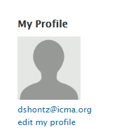

* My Edits

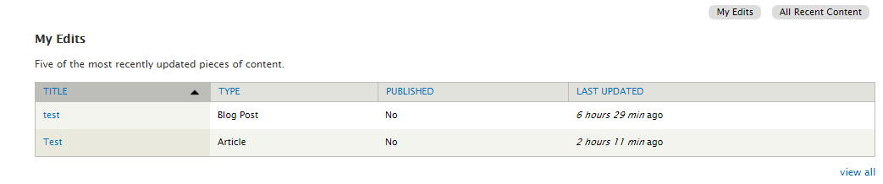

*This table lists users’ five most recently updated pieces of content, with this information:*

* + Title
    - Hyperlinked to content
  + Type
    - Content Type
  + Published
    - Indicates whether the content is visible to all website users
  + Last Updated
* All Recent Content

*This table allows the user to see all workbench activity on the entire site*

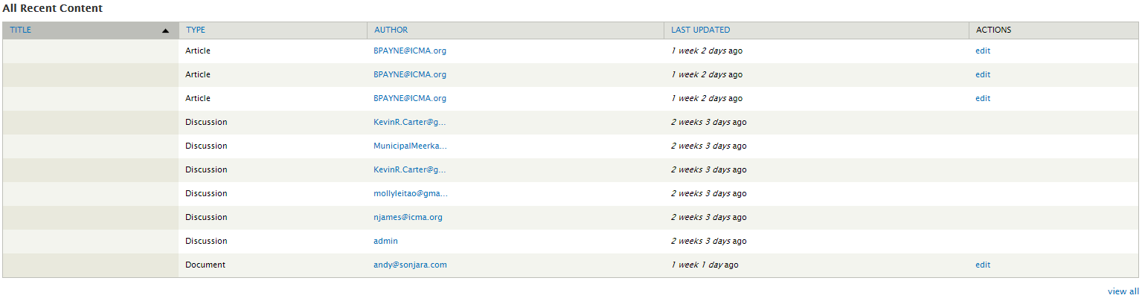

* + Title
    - Hyperlinked to content
  + Type
    - Content type
  + Author
  + Last Updated
  + Actions
    - “Edit” hyperlinks to the content form.

# Create Content

To create new content, users go to the ‘CREATE CONTENT’ tab in the workbench dashboard.



Or, logged-in users can also create content from the black bar at the top of the Drupal screen.

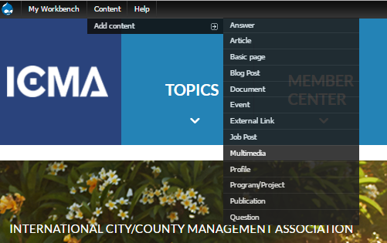

This guide describes all of the elements and steps of drafting an article. They are similar for all other content types.

**Drafting an Article**

Users can enter the article form by selecting article in the CREATE CONTENT tab.

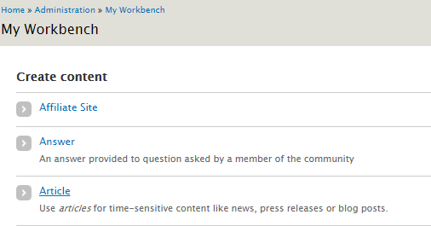

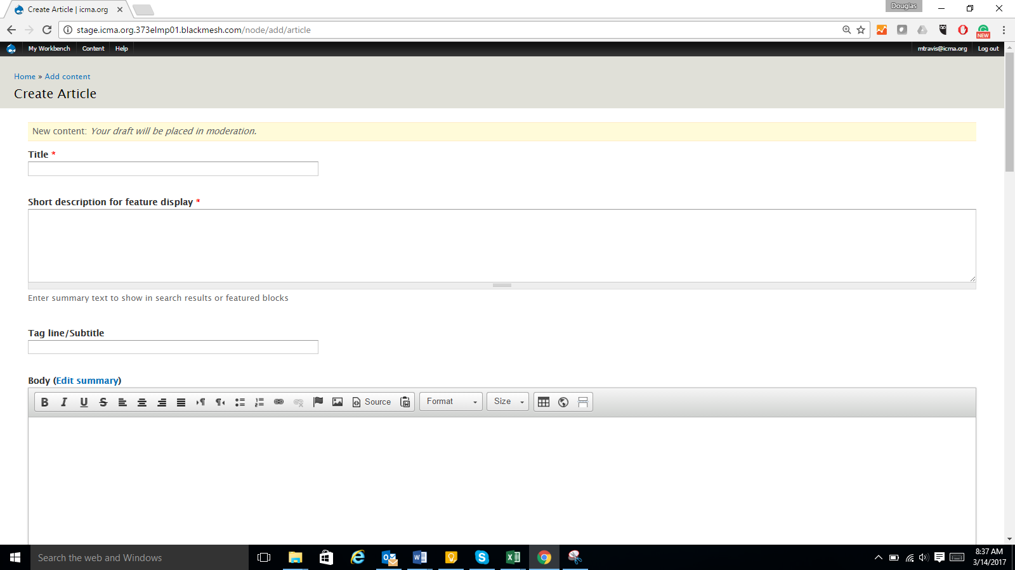

* Title

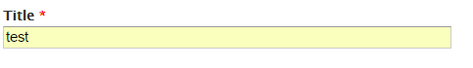

* Short description to display

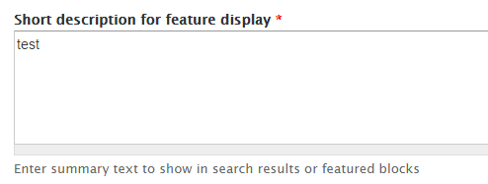

* + Displays below subtitle
  + Featured in content card in listings



* Tag line/subtitle



* + Displays at the top of article body
* Body

*The Body field is also referred to as the* ***‘What You See Is What You Get’ (WYSIWYG)*** *editor. The acronym is pronounced “wiz-ee-wig.” When entering body content, users may type and format text directly into the WYSIWYG editor with the available tools such as bold, italic, and link, or users may copy and paste from another application such as Notepad****. Be sure******to remove all extraneous HTML markup that Microsoft Word and other programs might insert into the text****, otherwise the predefined styles for the site will not display.*



* + Use “Format” to display the first paragraph on a page in a larger font. In URL fields, **use relative links when linking to pages/content within the site** (ex: /node-title rather than http://icma.org/node-title).
  + Always ensure the WYSIWYG text format is **Filtered HTML**. This accomplished by selecting Filtered HTML in the drop down at the bottom of the page.

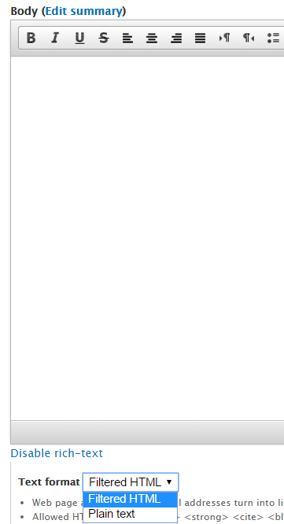

* + Use Format to select another heading style (h2, h3, etc.). The heading structure on a page should read like an outline and not skip levels. This is important for search engine optimization and for site accessibility (screen readers, etc.).
  + **Hyperlinking text:**

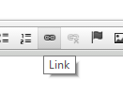

* + - Highlight the text you want to hyperlink and click “Link” in the ***WYSIWYG*.**
    - When linking to external sites, use an absolute URL with http:// before the web address.
    - When linking to internal content or content within the ICMA website use the format /node/(NID).
      * Example: if users were hyperlinking to *Advancing GIS in the Workplace* document at <http://stage.icma.org.373elmp01.blackmesh.com/documents/advancing-gis-workplace_63154.html>. All you would use is: /node/63154.

*Tip: Users can search all the content and locate their NIDs in the “**Content Library”**. Information on accessing the library on listed on page XX.

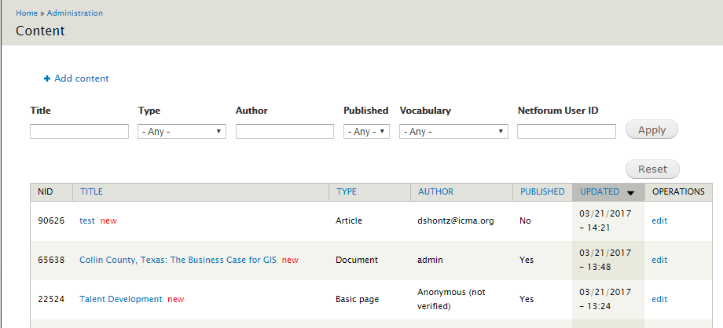

**Tip: When linking to a landing, topic, listing, or subsite page please use the Internal Links library at the end of this guide. (Example: linking to the Member Center is /landing_page/landing_page/2)

* + Adding images using the WYSIWYG Media Browser
    - The Media Browser is an image library of all images used on ICMA.org.
    - Access the Media Browser by selecting  in the WYSIWYG.

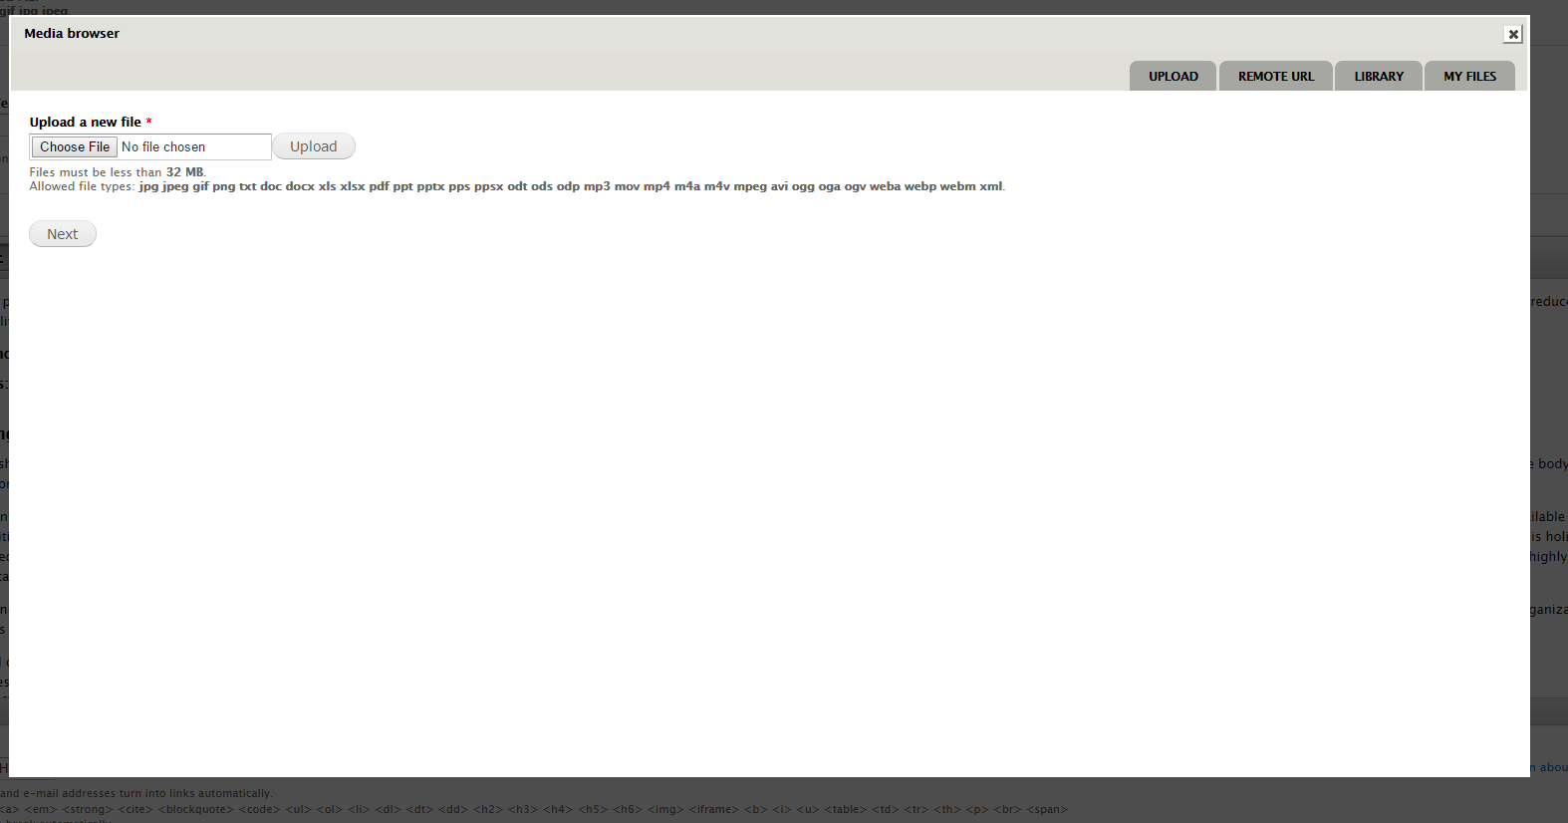

* + - To use an image already in the Media browser, select the “Library” tab.
    - To use an image you’ve previously uploaded to the Media browser, select the “MY FILES” tab.
    - To Upload a new file, select the Upload tab. You’ll need to provide: Name, Copyright, Alt Text, and Title Text.

*Tip: Make sure you name the image so you and other users can more easily find it in the future.

* Date

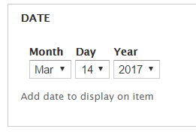

* + Date displays in the body of article.
* Author



* + Author displays on the article.
* Article type
  + Select an appropriate sub-type (from the menu) for use in listing page filters.
* Lead image
  + Featured on the right in the article body
  + Used to promote spots on landing pages
  + Minimum size of 900px width / 600px height.
* Lead image caption
  + Displays under lead image.
* Banner image
  + Featured to the right of the title
  + Minimum size of 1100px wide x 700px tall
  + Used to populate the spotlight.
* Related topics
  + For content to be featured on the topic pages, users will need to select a topic in the related-topics drop down.
  + Select “Add another topic” to tag content to multiple topics.
* Premium
  + Indicates content is accessible to ICMA members only.
* Article location
  + This element is only used to organize content in the international section of the website.
* Attached files
  + These are files placed at the bottom of your article for readers to download.
* Site placement
  + Here is where you indicate where content should appear on a subsite.
* Organization name
* Keywords
  + Using keywords is critical for search engine optimization. There will be a keywords database in the CMS.
* Revision Information

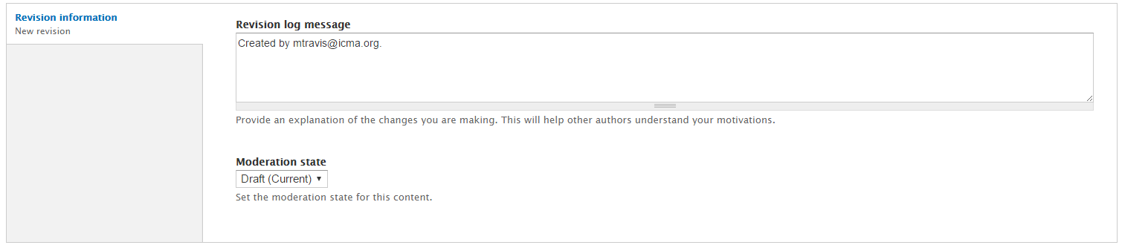

* + Moderation Notes [ICMA needs to determine whether to use this feature]
    - Users can add notes/questions during the moderation process; notes can be a reminder to yourself or something for the reviewers to see.
  + Moderation state
    - Select the moderation state for the content from the drop down.

*Note: Level 1 Admin users will only be able to put content in two moderation states: Draft Mode or Needs Review.*

# Viewing Your Drafted Article

After users select “save,” they will be sent to view the drafted content. CMS users will now be able to access three different views of content. 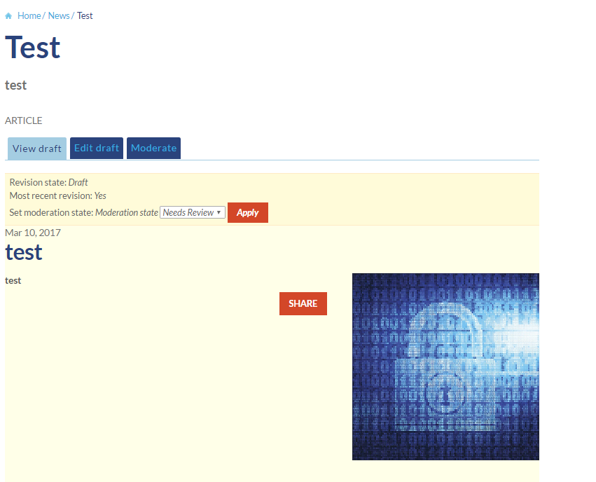

* View Draft
  + The view draft version is how the content will appear to website users.
    - CMS users can view the state of the content, see if the most recent revisions are showing, and update the moderation state.
* Edit Draft
  + Users will be taken back to the content entry form to edit.
* Moderation
  + This is an annotated timeline of the edit history of the content.

# MY Drafts

By going back to “My Workbench,” users can access the **MY DRAFTS** area of the module by clicking the “MY DRAFTS” tab.

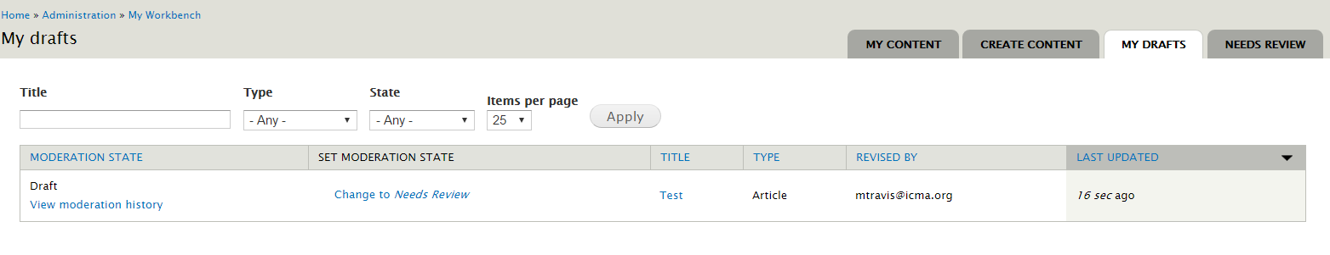

This table shows all the current pieces of content the user has in the “draft” moderation state. Users are able to search this table by title and content type.

**Table Features**

* Moderation state
  + In this column, the user is able to see the moderation view of the content.
* Set moderation state
* Title
* Type
* Revised by
  + Last user to edit content
* Last updated

# Needs Review

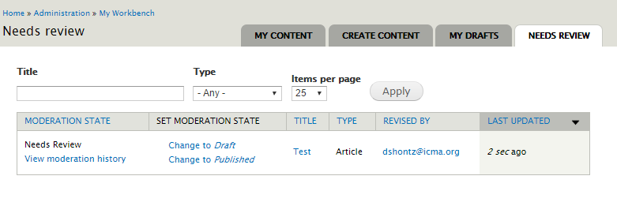

*Note:* ***DO NOT*** *put content in the Needs Review state if you do not want it published!*

**Publishing Content**

Admin Levels 2 and 3 have the authority to publish content. There are three places Admin Levels 2 and 3 can publish content:

* NEEDS REVIEW tab



* Edit Draft (Article form) Publishing Options

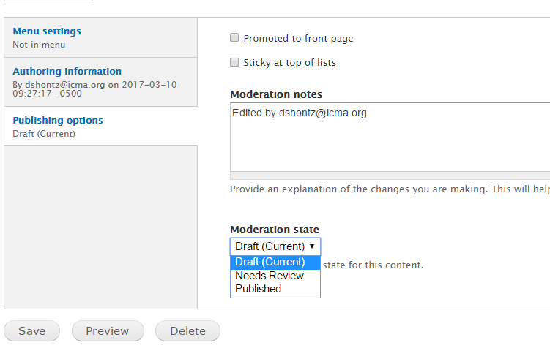

* Draft View

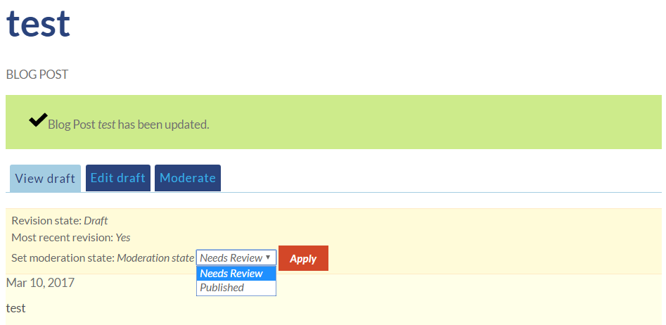

**Unpublishing Content**

All admins have the authority to unpublish content. The same three locations where the moderation state of content can be changed to publish users can change to draft. This will unpublish the content.

# Content Library

Another feature of the CMS is the searchable **Content Library**. Users have the ability search and view all content in this central location.

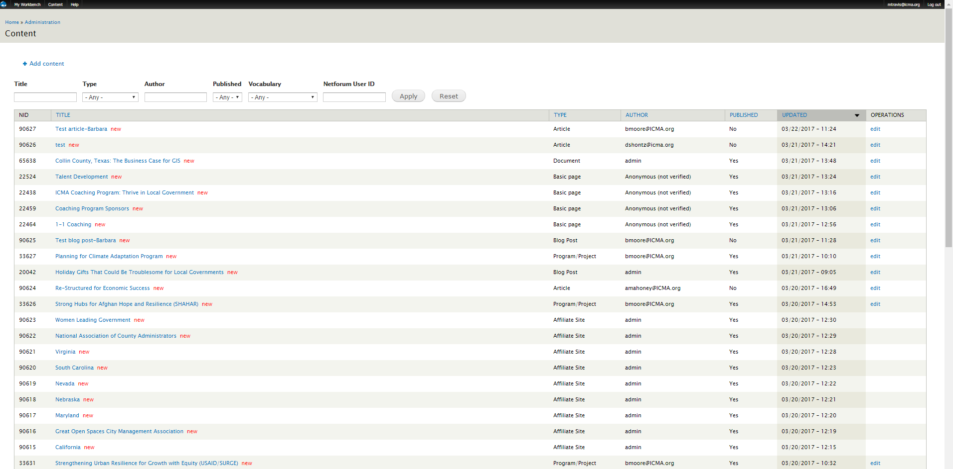

**Accessing the Content Library**

Users can access the library by clicking on “Content” in the top left corner of the screen.



**Searching the Content Library**

The library has multiple was to search and filter all the content. When using, these features click  to search and to start the search over.

* Title
  + Enter part or the complete title of the content
* Type
  + Select the content type in the dropdown
* Author
  + Enter the email address of the original author of the content
* Published
  + Filter by the if the content is in or not in the “Published” moderation state

**Elements of the Content Library**

* NID
  + Node ID
* TITLE
  + Hyperlinked title of the content
    - Leads to font-facing view of content
* TYPE
  + Content type
* AUTHOR
  + The original author of the content
* UPDATED
  + Last date and time the content was edited
* OPERATIONS
  + If the user has rights to edit the content, the hyperlinked “edit” will appear in this column.
    - Edit leads to content form

# Quality Assurance for the New Website—Brand Communication and Editorial Guidelines

**Brand Communication Guidelines**

Familiarize yourself with the [ICMA Brand Communication Guidelines](https://icma.sharepoint.com/Documents/ICMA%20Brand%20-%20Communication%20Guidelines%202016.pdf), which provide guidance on writing style and language to help ensure that ICMA projects a consistent image in all its outreach channels.

**Editorial Guidelines**

***Capitalization***

In a heading or title, capitalize nouns, verbs, pronouns, adjectives, intransitive verbs (e.g., *am, are, is*), and prepositions of four or more letters (i.e., among, before, into, through).

Capitalize the first letter of each item in a bulleted or numbered list.

Capitalize Arlington County but do not capitalize *county* when used alone.

Do not capitalize degrees, i.e., *master of public administration*.

Do not capitalize a descriptive job title (city manager, executive director, etc.) unless it precedes the name and is the person’s official title:

* + ICMA Executive Director Marc Ott is the keynote speaker.
  + Marc Ott, executive director of ICMA, is the keynote speaker.

***Punctuation***

Use commas to separate all the items in a series: red, white, and blue.

Use a comma after a city, state combination: Rockville, Maryland, is a great place to live.

Use a comma after day and year: July 4, 2017, is the deadline. Do not use a comma with month and year: July 2017 is the deadline.

***People***

Once you’ve used a person’s full name, use the person’s last name in subsequent reference to the person: Sally Jones is a keynote speaker. Jones will speak about the future of local government.

People are “who” (not “that”); organizations are “it” (not “they”).

***Places***

Do not abbreviate state names: Scottsdale, Arizona.

Use Scottsdale, Arizona, not city of Scottsdale, Arizona. Later in the text, if you refer to it as the *city*, do not capitalize *city* (or *town, village, state*).

***Sentence Structure***

Use short words and short sentences to improve comprehension and because they are faster to read.

Use the active voice (a sentence in which the subject does something).

Internal Links

|  |  |
| --- | --- |
| **Topics** | **Link** |
| Leadership and Ethics | taxonomy/term/12 |
| Leadership | taxonomy/term/116 |
| Equity & Inclusion | taxonomy/term/117 |
| Code of Ethics | taxonomy/term/118 |
| Ethics | taxonomy/term/119 |
| Elected Officials | taxonomy/term/120 |
| Form of Government | taxonomy/term/121 |
| Innovation | taxonomy/term/122 |
| Career Resources | taxonomy/term/13 |
| Next Generation of Managers | taxonomy/term/123 |
| CAO Resources | taxonomy/term/115 |
| Veterans | taxonomy/term/125 |
| Managing Local Government | taxonomy/term/14 |
| Strategic Planning | taxonomy/term/126 |
| Infrastructure Planning | taxonomy/term/127 |
| Human Resources | taxonomy/term/128 |
| Management | taxonomy/term/130 |
| Public Policy | taxonomy/term/131 |
| Performance Management | taxonomy/term/132 |
| Process Improvement | taxonomy/term/133 |
| High Performance Organizations | taxonomy/term/134 |
| Risk Management | taxonomy/term/186 |
| Contracts | taxonomy/term/136 |
| Legal Issues | taxonomy/term/137 |
| Town and Gown | taxonomy/term/138 |
| Partnerships | taxonomy/term/139 |
| Community Branding | taxonomy/term/140 |
| Organizational Development | taxonomy/term/10319 |
| Public & Community Safety | taxonomy/term/15 |
| Emergencies & Disasters | taxonomy/term/141 |
| Fire/EMS | taxonomy/term/142 |
| Gun Violence | taxonomy/term/143 |
| Police | taxonomy/term/144 |
| Public Safety | taxonomy/term/145 |
| Sustainable Communities | taxonomy/term/16 |
| Aging | taxonomy/term/146 |
| Brownfields | taxonomy/term/147 |
| Climate Change | taxonomy/term/148 |
| Energy Efficiency | taxonomy/term/149 |
| Food Security | taxonomy/term/150 |
| Resilience | taxonomy/term/151 |
| Solar Energy | taxonomy/term/152 |
| Sustainability | taxonomy/term/153 |
| Environment | taxonomy/term/154 |
| Healthy Living | taxonomy/term/155 |
| Public Health | taxonomy/term/156 |
| International | taxonomy/term/17 |
| International Development | taxonomy/term/157 |
| Service Delivery | taxonomy/term/18 |
| Libraries | taxonomy/term/158 |
| Telecommunications | taxonomy/term/159 |
| Transportation | taxonomy/term/160 |
| Utilities | taxonomy/term/161 |
| Sanitation | taxonomy/term/162 |
| Water & Wastewater | taxonomy/term/163 |
| Shared Service Delivery | taxonomy/term/164 |
| Parks and Recreation | taxonomy/term/165 |
| Public Schools | taxonomy/term/10318 |
| Public Works | taxonomy/term/166 |
| Code Enforcement | taxonomy/term/167 |
| Technology | taxonomy/term/19 |
| Technology & Data | taxonomy/term/168 |
| GIS Services | taxonomy/term/169 |
| Cybersecurity | taxonomy/term/170 |
| Community Engagement | taxonomy/term/20 |
| Citizen/Resident Surveys | taxonomy/term/171 |
| 311/CRM Systems | taxonomy/term/172 |
| Community Involvement | taxonomy/term/173 |
| Volunteers | taxonomy/term/174 |
| Civic Education | taxonomy/term/175 |
| Social Media | taxonomy/term/176 |
| Economic & Community Development | taxonomy/term/21 |
| Economic Development | taxonomy/term/177 |
| Children and Youth | taxonomy/term/178 |
| Community Diversity | taxonomy/term/179 |
| Housing & Community Development | taxonomy/term/180 |
| Community Planning | taxonomy/term/181 |
| Arts & Culture | taxonomy/term/182 |
| Financial Management | taxonomy/term/22 |
| Finance and Budgeting | taxonomy/term/183 |
| GASB | taxonomy/term/184 |
| Privatization | taxonomy/term/185 |

|  |  |
| --- | --- |
| **Landing Pages** | **Link** |
| Member Center | landing_page/landing_page/2 |
| About ICMA | landing_page/landing_page/3 |
| Publications & Research | landing_page/landing_page/5 |
| Partner with ICMA | landing_page/landing_page/6 |
| Career Development | landing_page/landing_page/12 |
| ICMA Annual Conference | landing_page/landing_page/15 |
| PM Magazine | landing_page/landing_page/16 |
| Global Programs | landing_page/landing_page/17 |
| ICMA University | landing_page/landing_page/19 |

|  |  |
| --- | --- |
| **Listing Pages** | **Link** |
| Job Center | job-posts |
| News | news |
| Events | events |
| Projects | projects |
| Multimedia | multimedias |
| Documents | documents |
| Survey Reports | search?type%5b%5d=document&search=ICMA+Survey+Research |
| ICMA Blog | blog-posts |
| Publications | publications |

|  |  |
| --- | --- |
| **Subsites** | **Link** |
| National Association of County Administrators | node/90622 |
| Women Leading Government | node/90623 |
| Great Open Spaces City Management Association | node/90616 |
| Maryland City/County Management Association | node/90617 |
| Nebraska City/County Management Association | node/90618 |
| Local Government Managers Association of Nevada | node/90619 |
| South Carolina City and County Management Association | node/90620 |
| Virginia Local Government Management Association | node/90621 |
| Cal-ICMA | node/90615 |