ICMA Certificates in Performance Management:
Examples of Process Improvement
Jurisdictions may take varying approaches to improving their internal processes, from focusing on the methods of collecting and analyzing performance data to conducting efficiency studies, dedicating additional resources, or enhancing the profile of performance as part of the organizational culture. Here are a few examples:

Raleigh, NC: This year, the City implemented a measure validation process for measures included in the strategic plan. The focus was on documenting measure definition, intent, and collection methodology. Each of the 70+ measures had a customized form that was completed by appropriate staff.
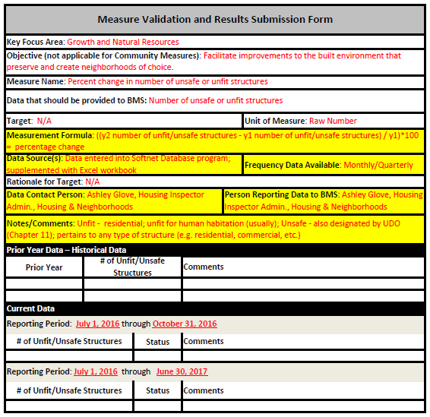

Bettendorf, IA: We continue to improve the data collection and analysis process to make performance measurement a repeatable, valuable management tool:
- Emphasizing the importance of data driven decision making to staff and City Council
- Including a Performance Management training session at biannual employee training
- Compiling and publishing a report of benchmarks and corresponding citizen survey results

Johnson City, TN: In the past year, we have started pushing performance management in the form of departmental dashboards, which were reviewed with the Primary Coordinator/Budget Office Staff and subsequently shared at open public meetings with the Board of Commissioners (which are televised). Previously in the budget office, one employee was the PC and served to assist in performance discussions. The 2016 budget included an additional person in the budget office (Management Analyst) to assist with the Performance Management program. The Budget Manager was reclassified and is now titled "Director of Budget and Performance Management" at the City Manager's request to meet the direction/instruction of the Board of Commissioners to be able to provide to our management and citizenry that the City of Johnson City is measuring performance and as a result is taking steps to improve efficiency and address gaps in performance to better serve our citizens.

San Mateo County, CA: The County has established six performance improvement teams and a Lean process improvement cohort of ten employees who intensively trained in six sigma practices. The County’s Health System has a Leap Institute, which manages performance through continuous process improvement initiatives.
Improving Access to Care (Lean process video): https://www.youtube.com/watch?v=EiGtawvKwDE

Bellevue, WA: For the first time, budget development focused on performance metrics related to each proposal, and the impact on the outcomes they are intended to achieve. We provided proposal writers and results teams with specialized training on metrics, goals and target-setting. In conjunction with our What Works Cities engagement, we made public commitments to using data to inform decision-making, launched an open data portal, and engaged the leadership team in clarifying targets for citywide priorities, routinizing analysis and discussion of performance data, and involving council in evidence-based strategic planning.

