2016 ICMA Strategic Leadership and Governance Award Application

THINKspot: A Collaborative Workspace and Maker Space

Problem Assessment
Justin DeStories, the Director of Engineering for a local aviation company located in Mesa, Arizona, heard from his uncle about an upcoming event held at the local library up the road from his work. It was called 3D Thursday, and being curious about 3D printing he decided to attend the presentation.
Already well-versed in 3D design, Mr. DeStories talked with the librarian who gave the presentation to see how he could utilize the 3D printer they had at the library for prototyping designed parts. He scheduled a training session with the librarian so he could learn how to use the printer himself, and then brought his 3D-designed aviation part files to the library to print out a 3D model for his prototype to validate the design before expensive aluminum parts were machined.
Fully implemented in October 2013, THINKspot is a collaborative workspace and maker space within the Red Mountain Branch of the Mesa Public Library. A collaborative workspace is a place where people can gather to work together in groups. A maker space is a place where people can come to tinker and make new things. We provide the community hands-on opportunities to innovate in a flexible, multipurpose space that encourages collaboration, conversation, creativity and curiosity.
These unique spaces are a growing trend in libraries but are often not the result of a city initiative. Usually they are simply created by the public library themselves. THINKspot was a city effort, with several departments involved.
Ultimately, THINKspot is a project that represents a new use of technology. We teach the public about 3D printing and design, how to start a business, and provide workshops on various skills they can use for their career or a hobby. With access to new technology, citizens are able to try it out and learn about it in a non-intimidating setting, with the library continuing to provide the excellent customer service they are known for.
The engineer described above is a true story. He was able to 3D print his prototypes in the library, test them on the helicopters at his local business, and then send his design elsewhere for it to be made in metal. Redefining the use of a local library!
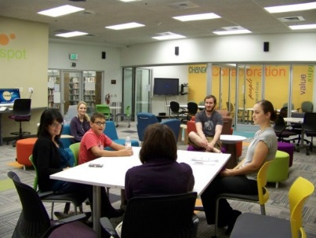
THINKspot engages the Mesa citizens not only as a space to collaborate with groups, but through workshops and trainings on advanced technology. Examples of community benefits are: small businesses are created, teens work on school projects, and college students collaborate on a Kickstarter campaign that will roll into a small business once they graduate. Elementary age kids learn how circuits are created, and build a robot. Families learn together how to solder electronics, which can lead them to create LED blinking Halloween costumes. All of these are new ways the library provides opportunities for our community to learn and create.
There are other spaces that can be collaborative, yet they are not provided by the government. Free access to technology enables a community to grow a more tech-savvy and computer literate community. As libraries search for a new identity in a technology driven world, they are searching for alternate ways to attract new users to their buildings.
Program Implementation and Costs
THINKspot began as an iMesa idea. iMesa was a resident-driven improvement effort to develop transformative community projects that will "Build a Better Mesa." On the iMesa website residents submitted, voted, and commented on ideas that transform the community. Initially THINKspot was called iMesa LINCS, which stood for Learn, Innovate, Network, Connect, and Succeed. Receiving high votes, it was decided to move forward with the development of this space.
The project was planned and implemented by library and city staff with input and advice from maker space, hacker space labs, and other collaborative workspaces in the area and throughout the country. We also received input from the local education community. Additionally, the staff did extensive research on similar spaces, toured local spaces and contacted national facilities for advice and feedback. Plans for the space were developed by a local architectural firm, furniture was selected, equipment and technology purchased, and a librarian was recruited to be the coordinator for the room.
Besides those mentioned above, we have had numerous supporters who have become partners as we grow THINKspot. We have formed multi-disciplinary relationships with Arizona State University (ASU), through their Entrepreneurial & Innovation Group, which has the Entrepreneurship Outreach Network, as well as ASU’s College of Technology & Innovation.
The total cost of the construction and renovation project was just over $260,000.00. THINKspot currently has advanced technology such as a 3D printer, SMART board, zSpace virtual computer, Cisco video conferencing system with camera, and two iMac computers with Adobe Creative Suite software (Photoshop, Dreamweaver, etc.) as well as other Apple photo, video, and music editing software. The total cost for the technology was approximately $50,000.
One cost-cutting effort was the location of the space. Rather than build a new, separate workspace and maker space on its own, we decided to use an existing space within the Red Mountain Library, which cut costs significantly. Two rooms were re-purposed within the existing building.
THINKspot allows for people to learn about, experiment with, and use the technology resources to do things that would be costly for them to purchase for individual use (studio fees, teleconferencing, 3D printing, 3D design). THINKspot is a place where citizens can learn new skills and jump-start their business, which helps grow the economic development of the city.
Tangible Results
City of Mesa residents and the surrounding community benefit from using THINKspot in several ways. Within THINKspot, is a room we call The Studio. The room has sound-proof walls and includes a green screen, HD video/photo camera on a tripod, and various types of microphone equipment. This feature of THINKspot is quite popular with local entrepreneurs and new start-up businesses. We have had several citizens film short videos to market their businesses (pictured top left), by placing the videos on their own websites. The Studio has also been a favorite of teens, who have used it for making music; singing, recording musical instruments (guitar, violin), and then used our iMac computers to edit their music and videos.
To date, THINKspot has had over 32,000 visitors. Some examples of events held are:
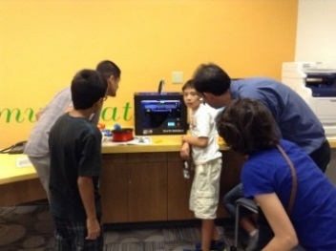
- 3D Spot and 3-D trainings- demonstrations of the 3D printer and the virtual holographic computer, zSpace. Citizens of all ages can learn about 3D printing, and discuss the impacts of this new innovative technology. 3-D Spot allows users to share designs and 3-D models that they have printed with one another.
- Code Club- an after-school club that teaches 8-12 year olds how to code. This has been extremely popular and is a dynamic and energetic gathering each week.
- ASU StartUp School Business Course- a partnership with Arizona State University’s Entrepreneurship Outreach Network, ASU provides the online courses and we facilitate in-person meet-ups, encouraging new entrepreneurs to discuss their learning.
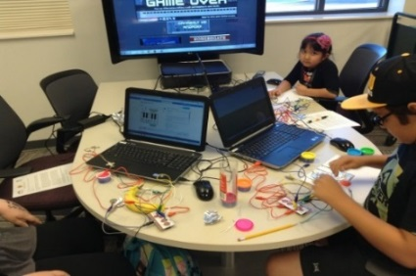
- Maker Monday- the third Monday of each month, all ages can come make things! We have used MaKey MaKey kits (pictured right), teaching circuitry concepts.
One well received program was the Idea to Product workshop that brought in four guest speakers (local entrepreneurs, and Arizona State University professors) to speak to a group of thirty citizens who were interested in how they could take their idea for a product or business and leave with an action plan.
Lessons Learned
One lesson learned was to involve various city departments. The station director of the city’s local television station was extremely valuable in sharing insight as well as providing assistance in the installation of The Studio and specific pieces of technology in the space.
Another valuable lesson learned was to gain support. Seek out the partnerships, while still creating the space. Gather feedback for what they would like to see and what they would like to use the space for. Also, a bonus of supporters is that they spread the word about the project, which is priceless.
THINKspot is a space for the public to create innovation through community collaboration; where they can come together in a comfortable, well-known environment. A space such as THINKspot transforms how libraries are perceived: still a place to gather together and form new ideas, but in an innovative way.

