Program Excellence Award: Community Health and Safety | Marcus Kellum, Code Enforcement Administrator mkellum@dekalbcountyga.gov Office: 404.687.3711 Cell: 404.860.7773
DeKalb county code enforcement division | ICMA 2016 Local Government Excellence Awards

DeKalb County, Georgia
DeKalb County Georgia is the most culturally diverse county in Georgia with over 64 spoken languages, and a population of over 750,000 residents with an average household income of $70,087. DeKalb County is gifted with unique and numerous assets, including proximity and accessibility to major highways, the presence of the National Centers for Disease Control, nationally recognized institutions of higher education, including Emory University, Agnes Scott College, and Mercer University, as well as continuous green space areas, such as Arabia Mountain and Stone Mountain.
Problem Assessment
There are approximately 400 known multifamily apartment complexes within Unincorporated DeKalb County, and it is estimated that there are approximately 200 unregistered apartment complexes. Many of these multi-family developments can be considered “aging housing stock”, so the decline in the integrity of some rental units has caused a negative impact on both the residents within the complexes, and residents in the surrounding neighborhoods. The challenge was to ensure that there were acceptable living conditions within these units that met minimum codes standards.
Similar conditions existed in the many of the hotels and motels throughout the County. There are 58 registered hotels and motel complexes within unincorporated DeKalb County, and some are in state of disrepair and lack compliance with codes. Many of these properties have become a convenient haven for criminal activities. This situation has impaired the growth and development of certain areas of the County and lessened the overall quality of life for residents in the neighboring areas.
Problem Assessment (continued)
Although advertised and legally established as hotels, some of these establishments operate informally as extended stay motels. There was a need to monitor and to make sure these properties were safe because of the amount of children that live in extended stay motels and utilize the public school system. According to the McKinney-Vento Act, children in homeless situations have the right to go to school, no matter where they live or how long they have lived there. These types of multi-family communities, hotels and motels house a transient and dense population that is often undeserved.
Program Implementation
In order to address these issues, the County developed a comprehensive strategic approach that included intervention and enforcement, because many of these properties showed high levels of crime and/or code violations. Key issues included repeated instances of reported crimes, code complaints and violations, as well as the presence of health code infractions. This approach included the onsite inspection for code violations with the goal of restoring the quality of life for the residents. As a result of a comprehensive analysis, the following two point strategy was implemented:
Policy Changes
- Changes to strengthen existing Nuisance Law and Property Maintenance Code

- Reinforcing existing Codes to increase the penalties for building and other code violations

- Modifying the current hotels/motels and multi-family business license process to keep establishments in compliance (revoking, suspending or denying licenses) and developing legislation that enables shut down of establishments that repeatedly fail to correct violations
Direct Action
- Tracking and reporting data on hotels/motels and multi-family complexes to determine improvement or decline and impact on the surrounding communities

- Institutionalizing annual inspections to ensure compliance with codes

- Working with hotels/motels and multi-family owners and management to adopt new practices that will help reduce crime and prevent health and safety hazards
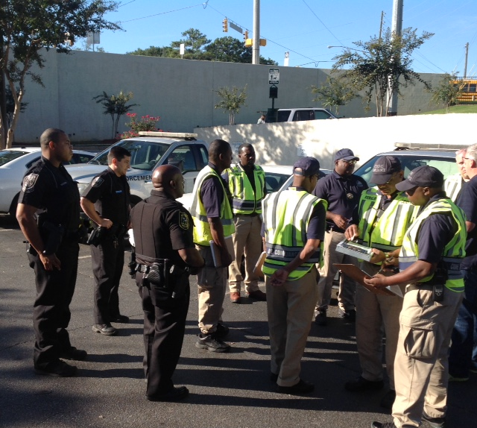
DeKalb County always prioritizes the health, safety and well‐being of its citizens, so when County officials determined that when multifamily rental dwellings, hotels and motels are allowed to deteriorate, crime rates increase, property values decrease, and tenant’s health and well‐being may be compromised. With the focus on improving and ensuring public health and safety, the County implemented an Interior Code Compliance Ordinance. This ordinance required property owners to hire private inspectors to inspect each unit and to submit a written report for review by code staff. After review and approval, the owners of multifamily rental property obtain Code Compliance Certificates prior to receiving their business license. The Multi-Family Enforcement Team (MET) is responsible for the enforcement of the Interior Code Compliance Ordinance and all code enforcement related issues at apartment complexes within unincorporated DeKalb County.
As it relates to hotels and motels, an intervention team, led by the Code Enforcement Division, consists of officers from Police, Fire, Health, Solicitor’s Office and Community Development, was established to address crime and enforce compliance with County Codes at hotels and motels.
The multi-departmental approach leveraged existing resources and collaboration opportunities to address and eliminate the negative impacts of these establishments and return them to their primary use as a family oriented multi-family/hotel/motel.
Tangible Results
To measure the outcome, a scoring methodology was utilized to monitor the most egregious establishments for intervention, as well as bring them to full compliance. To determine the hotels and motels causing the problems for surrounding neighborhoods, an index was created that utilized crime data from 2012-2014 and code enforcement and health data from 2010-2014 to create a composite score:
Crime Score + Code Enforcement Score+ Health Violation Score = Composite Intervention Score
This streamlined consolidation of the multi-departmental efforts redefined service delivery, and made each function stronger and more effective. Separate departments acting as stakeholders and partners in serving the best interest of the citizens, formed a single functional unit which served as point of service delivery. Tracking and reporting data to determine improvement or decline, and impact on the surrounding communities were essential, as well as institutionalizing annual inspections to ensure compliance with codes. While some properties failed to comply within the time allowed, enforcement efforts help to motivate compliance.

Lessons Learned
The Code Compliance Division is identifying true strengths and opportunities for improvement, and ultimately identifying potential priorities. Through a collaborative effort in partnership with various agencies; these teams are tasked with ensuring landlords provide suitable, safe and sanitary conditions to families living in multi-family communities and owners of hotels and motels comply with codes throughout the County. The teams not only meet immediate public concerns, but created a rational system of service delivery that resulted in greater effectiveness and improved code compliance and regulatory performance that can be emulated in any community.

