Reinventing the Budget Proce$$
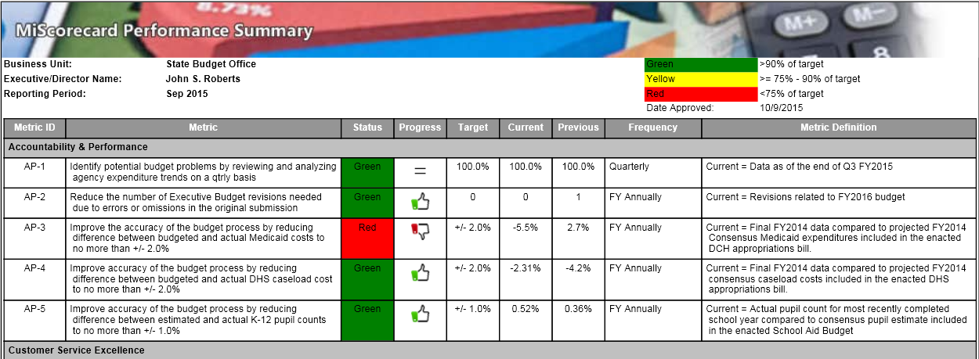
Part V – Standard Reports
An excerpt for Michigan’s Monthly Performance Summary which uses six categories for the measures:
- Accountability and performance,
- Customer service excellence,
- Expertise and commitment,
- Innovation and leadership,
- Operational efficiency, and
- Shared services.
Source: http://www.michigan.gov/openmichigan/0,4648,7-266-58521_60201_60957---,00.html.

A. Suggested Standard Budget Reports
(Click Here for Contact Information)
(Click Here for Organizational Chart)
(Click on Name for Webpage and Links to All Subordinate Agency Dashboards)
(Click Here for Chief Executive’s Full Budget Request)
(Click Here for Related Testimony & Other Documentation)

Budgeted Expenditures, Revenues & Workforce (Four Year Perspective)
Item | FY 2012 - 2013 Budget |  | FY 2012 – 2013 Actual |  | FY 2013 – 2014 Budget |  | FY 2013 – 2014 Actual |  | FY 2014 – 2015 Budget |  | FY 2014 – 2015 Actual |  | FY 2015 – 2016 Budget |  | FY 2015 – 2016 YTD |  | % Change in Budget FY 2012- 2015
Operating Expenditures
Salary - Regular
Salary - Overtime
Salary - Bonus
Salary – Holiday Pay
Salary - Longevity
Salary – Paid Out Sick/Vacation Leave
Salary – Other
Educational Benefits
Health Insurance
Miscellaneous
Retirement
Social Security/Medicare
Workers’ Comp
Total
Maintenance & Repairs - Building
Maintenance & Repairs – Office Equipment
Professional Services - Engineering
Professional Services - Financial
Professional Services – Legal
Professional Services - Management
Professional Services - Technology
Rent - Building
Rent - Equipment
Rent – Office Technology
Rent – Vehicles
Training - General
Training – Job Specific
Travel – Instate
Travel – Out of State
Utilities - Power
Utilities – Refuse Collection
Utilities - Wastewater
Utilities – Water
Vehicle - Fuel
Vehicle - Maintenance
Vehicle - Purchase
Total
Capital Expenditures
Capital Construction – Accessibility
Capital Construction – Drainage/Flood Control
Capital Construction – Energy Efficiency
Capital Construction – New
Capital Construction – Renovation (Other)
Capital Construction – Road Resurfacing
Capital Construction – Road (New)
Capital Construction – Roof Replacement
Capital Construction - Sidewalks
Capital Construction – Traffic Calming
Debt Servicing
Total
Revenues
Total Revenues
Reserves
Total Reserves
Characteristics of Expenditures
Onetime Expenditures
Ongoing Expenditures
Tax Expenditures
Unfunded Pension Liability
Characteristics of Revenue Sources
Federal Govt.
State Govt.
Local Govt.
Onetime
Ongoing
Donations – Cash
Donations – In Kind
Fees
Fines/Penalties
Grants- Non- Government
Characteristics of Workforce
# of Full-time
# of Part-time
# of Temporary
Full-time Equivalent
# of Mangers to Subordinates
Intern Hours
Volunteer Hours

Budgeted Expenditures, Revenues & Workforce
Budgeted Versus Actual Variance by Percentage(Four Year Perspective)
Item | FY 2012-2013 Budget  – Actual Variance | FY 2013 – 2014 Budget – Actual Variance | FY 2014 – 2015 Budget – Actual Variance | FY 2015 – 2016 Budget – Actual Variance | FY 2015 – 2016 YTD (Estimated) | Total Dollar Variance – FY 2012 – 2015 | Percentage Variance – FY 2012 – 2015
Expenditures
Revenues
Reserves
Onetime Expenditures
Ongoing Expenditures
Tax Expenditures
Unfunded Pension Liability
Full-time Equivalent Employees
Volunteer Hours

Aircraft, Vehicle & Watercraft Inventory
(Click on Item for Detail)
Equipment | Model Year | Acquisition Date | Acquisition Cost | Useful Life | Replacement Date | Status (Active, Reserve, Spare) | Notes
Airplane
Ambulance
Boat
Bulldozer
Bus
Car
Fire Engine
Fire Tender
Front End Loader
Helicopter
Mower
Police Car - General
Police Car – Patrol
Road Grader
Snow Plow
Street Sweeper
Trailer - Horse
Trailer – Mobile Office
Trailer – Other
Truck
Truck - Dump
Truck - Refuse Collection
Truck - Tow
Vans

Equipment Inventory (Non-Technology)
(Click on Item for Detail)
Equipment | Location | Acquisition Date | Acquisition Cost | Useful Life | Replacement Date | Energy Efficiency | Notes
Fire Hydrant
Generator
Light Poles/Light
Meter – Electric
Meter – Parking
Meter - Water
Playground
Storage Tank
Traffic Signal
Traffic Sign – Electronic
Traffic Sign – Metal
Total

Facility Inventory (Leased)
(Click on Item for Detail)
Building/Facility | Location | Agency | Net Usable Square Footage | Lease Term | Annual Lease Payment | Energy Efficiency | Notes
Total

Facility Inventory (Owned)
(Click on Item for Detail)
Building/Facility | Location | Agency | Net Usable Square Footage | Net Usable Square Footage Occupied | Acquisition Date | Acquisition Cost | Last Renovation Date | Energy Efficiency | Notes
Airport Control Tower
Airport Hanger
Airport Terminal
Animal Shelter
Aquarium
Barn/Stable
City Hall/Capitol
Community/Senior
Center
Convention Center
Correctional Facility
Court Building
Equestrian Arena
Fire Station
Fitness Center
Garage
Hospital
Library – Branch
Library – Main
Medical Clinic
Museum - Art
Museum - Historical
Museum – Nature Center
Museum - Science
Office Building
Performing Arts Center
Police Station
Power Plant
Pump Station
Recycling Center
School
Shop - Maintenance
Stadium
Training Facility - Fire
Training Facility – Law Enforcement
Transit Terminal
Visitor’s Center
Warehouse – Climate Controlled
Warehouse – Regular
Water Treatment Plant

Infrastructure Inventory (Owned)
(Click on Item for Detail)
Non-Building Item | Location | Agency | Acreage/  Square Miles | Acquisition Date | Acquisition Cost | Last Renovation Date | Condition | Notes
Athletic Field
Band Shelter/Gazebo
Basketball Court – Outdoor
Beach
Bridge
Cemetery
Conservation Easement
Dam/Flood Control
Dock/Marina/Pier
Fairgrounds
Garden - Scenic
Garden – Urban
Golf Course
Gun Range
Lake
Monument
Park - Campground
Park – Dog Park
Park - General
Park - Playground
Park - Skate
Roads/Streets
Sewers - Sanitary
Sewer - Storm
Swimming Pool
Tennis Court
Transit Stop
Utility Easement
Volleyball Court
Water Main
Wilderness Preserve
Zoo

Technology Inventory (Hardware)
(Click on Item for Detail)
Equipment | Location | Acquisition Date | Acquisition Cost | Useful Life | Replacement Date | Notes
Audio Visual - Projector
Audio Visual - Screen
Audio Visual – Video Camera
Camera
Computer – Desktop/Monitor
Computer - Laptop
Computer - Server
Computer - Tablet
Copier
Facsimile Machine
Postage Meter
Printer
Radios – Two Way
Security System
Telephone - Desk
Telephone - Mobile
Television
Voting Machine

Technology Inventory (Software)
(Click on Item for Detail)
Equipment | Seat Licenses | Acquisition Date | Acquisition Cost | Annual Lease Cost | Replacement Date | Notes
Accounting/Financial
Geographic Information System
Office Suite
Procurement
Publishing

Workforce Profile
(Click on Item for Detail)
Position | Age | Gender | Race | Education | Veteran | Longevity in Position | Longevity with Agency | Longevity with Jurisdiction | Eligible to Retire

Workforce Safety
(Click on Item for Detail)
Position | Age | Longevity in Position | Incident Type | Lost Days | Job Transfer | Job Restriction | Notes (e.g., strategy to mitigate recurrence)

Workforce Turnover
(Click on Item for Detail)
Position | Voluntary Separation |  |  |  | Involuntary Separation |  |  | Totals
 | Promotion | Resignation | Retirement | Transfer to Another Agency | RIF, Reorganization or Temporary Position | Terminated for Cause < 6 Months | Terminated for Cause > 6 Months | Voluntary | Involuntary

Workload (Four Year Perspective)
Item | FY 2012 - 2013 Projected | FY 2012 – 2013 Actual | FY 2013 – 2014 Projected | FY 2013 – 2014 Actual | FY 2014 – 2015 Projected | FY 2014 – 2015 Actual | FY 2015 – 2016 Projected | FY 2015 – 2016 YTD | % Change FY 2012- 2015
Adjudications
Client Contacts
Educational Outreach
Enforcement Actions
Freedom of Information Act Requests
Inspections
Investigations
Licenses/Permits Issued
Mutual Aid
Publications Issued
Regulations Issued/Revised
Full-time Equivalent Employees
Volunteer Hours

B. Suggested Agency Budget Request Template
(Individual Agency)
(Click Here for Contact Information)
(Click Here for Organizational Chart)
(Click Here for Summary of Major Changes and Efficiencies, Enhancements & Initiatives)
(Click Here for Related Testimony & Other Documentation)

Request versus Actual Expenditures, Revenues & Workforce (Historical Perspective)
 | FY 2013 - 2014 |  |  |  |  | FY 2014 - 2015 |  |  |  |  | FY 14–FY 15 Request vs. Actual
Item | Agency Request | CEO’s Request | Final Budget | Suppl. | Actual Spending | Agency Request | CEO’s Request | Final Budget | Supp. | Actual Spending
Expenditures
Revenues
Reserves
Onetime Expenditures
Ongoing Expenditures
Full-time Equivalent Employees
Volunteer Hours

Budgeted Expenditures, Revenues & Workforce (Four Year Perspective)
Item | FY 2012 - 2013 Budget | FY 2012 – 2013 Actual | FY 2013 – 2014 Budget | FY 2013 – 2014 Actual | FY 2014 – 2015 Budget | FY 2014 – 2015 Actual | FY 2015 – 2016 Budget | FY 2015 – 2016 YTD | % Change in Budget FY 2012- 2015
Expenditures
Revenues
Reserves
Characteristics of Expenditures (Including Losses from Fraud, Legal Settlements or Theft)
Onetime Expenditures
Ongoing Expenditures
Employee Fraud
Employee Theft
Hacking
Legal Settlements
Public Fraud
Public Theft
Characteristics of Revenue Sources
Federal Govt.
State Govt.
Local Govt.
Onetime
Ongoing
Donations – Cash

Donations – In Kind
Fees
Fines/Penalties
Grants - Non-Government
Characteristics of Workforce
# of Full-time
# of Part-time
# of Temporary
Full-time Equivalent
Intern Hours
Volunteer Hours

Cost Control/Productivity Enhancement Initiatives – Cooperative Purchasing (Four Year Perspective)
Item | Dollar Volume  FY 2012 - 2013 | Dollar Volume  FY 2013 – 2014 | Dollar Volume  FY 2014 - 2015 | Dollar Volume  FY 2015 – 2016 YTD | Notes
General Services Administration
Regional
State
US Communities
Other (list)
Total
Percentage of Total Purchasing

 | Cost Control/Productivity Enhancement Initiatives – Cost Controls (Four Year Perspective)
Item |  | Number | Dollar Savings  FY 2012 - 2013 | Dollar Savings  FY 2013 – 2014 | Dollar Savings  FY 2014 - 2015 | Dollar Savings  FY 2015 – 2016 (est.) | Notes
Audit Recommendations Implemented
Employee Suggestions Adopted
Energy Conservation Initiatives
Fraud Control Measures
Total

Cost Control/Productivity Enhancement/Revenue Collection Initiatives –
Delinquent Collections (Four Year Perspective)
Item | FY 2012 - 2013 | FY 2013 – 2014 | FY 2014 - 2015 | FY 2015 – 2016  (Estimated) | Notes (e.g., collection policies)
Court Fees
Court Fines/Penalties
Interest on Uncollected Fees
Interest on Uncollected Fines/Penalties
Parking Tickets
Rent
Restitution – Criminal Cases
Restitution – Employee Fraud/Theft
Restitution – Vendors for Contract Non-Performance
Taxes – Income
Taxes - Property
Taxes - Sales
Taxes – Other
Tolls
Traffic Tickets
Utility Costs
Collection Costs
Total

Cost Control/Productivity Enhancement Initiatives – Service Consolidation/Sharing (Four Year Perspective)
Item | Savings  FY 2012 - 2013 | Savings  FY 2013 – 2014 | Savings  FY 2014 - 2015 | Savings  FY 2015 – 2016  (Estimated) | Notes
Total

Cyber Security/Data Privacy Initiatives (Three Year Perspective)
Item | FY 2014 – 2015 | FY 2015 – 2016 | FY 2016 - 2017 | Notes
Total

Challenges to Cost Control/Productivity Enhancement/Revenue Collections – (Three Year Perspective)
Type | Item | FY 2016 – 2017 | FY 2017 – 2018 | FY 2018 – 2019
Demographic | More frail 80+ elderly
Economic | Possible closure of state correctional facility in town
Economic | Slow recovery
Environmental | Drought causing drop in water system revenues
Fiscal | Need to ramp up for Census 2020
Fiscal | Shift to online purchasing reducing sales tax revenues
Fiscal | Maintenance/renovation backlog impairing energy efficiency
Fiscal | Uncertain cost changes in health care coverage
Fiscal | Uncertain investment income for pension plan
Governmental | Unfunded mandates (federal and/or state)
Governmental | Unfunded programs approved by voter initiative
Technology | Staffing shortages
Technology | Need for upgraded computer security to prevent hacking
Workforce | Aging employee base | 20% turnover likely
Workforce | Difficulty filling IT positions due to competitive market
Total

C. Performance Measurement Reports
(Click Here for Contact Information)
(Click Here for Organizational Chart)
(Click Here for Related Other Documentation)

Progress and Performance Measures (Alternative One)
Type | Item | FY 2013 – 2014 Target | FY 2013 – 2014 Actual | FY 2014 – 2015 Target | FY 2014 – 2015 Actual | FY 2015 – 2016 Target
Progress Measures
Agency Specific
Agency Specific
Agency Specific
Performance Measures
Customer Service | Customer satisfaction rating
Customer Service | Number of Freedom of Information Act requests
Customer Service | Turnaround on Freedom of Information Act requests
Customer Service | Efficiency of webpage in addressing customer needs  (i.e., web analytics)
Financial | Collection rate for fees, fines, penalties, and other amounts due
Financial | Cash, in-kind donations, volunteer hours
Financial | Losses from lawsuits
Financial | Overtime expenditures (total & as percentage of salary)
Financial | Receipt of federal grant funds
Financial | Receipt of non-governmental grants
Financial | Utility cost controls/reductions
Financial | Losses from fraud, hacking, and theft
General | Consumer complaints/fraud investigations that result in penalties
General | Program participation rates
General | Processing time for applications
General | Wait time for appointments
Statutory | Tasks that must be completed by law
Statutory | Tasks that must be completed by law
Workforce | Days lost due to workplace injury
Workforce | Employee satisfaction
Workforce | Employee turnover by position, pay level, overall
Workforce | Ratio of managers to subordinates
Total

Performance Measures (Alternative Two)
Beneficiaries | What We Did | Why We Did It | How Well We Did It |  | What Impact It Had | Where We Fell Short |  |  | Manager/Team Responsible
All Residents – Education/Job Training
Adults | Higher Education
Adults | Job Placement
Adults | Job Training
Adults | Scholarships
Children | Pre-School
Children | Free Education - Elementary
Children | Free Education – Secondary
All Residents – Infrastructure to Support Daily Life & the Economy
All | Aviation
All | Ports
All | Power – Electric
All | Power – Gas
All | Power – Nuclear
All | Power – Solar
All | Power – Other
All | Railroads
All | Roads/Streets
All | Trash Collection
All | Water Supply
All | Water Treatment
All Residents – Legal Rights
Business Owners
Consumers
Property Owners

All Residents – Public Health & Safety Services
All | Emergency Preparedness
All | Fire Protection
All | Fire Safety Education
All | Food Safety
All | Law Enforcement
All Residents – Safety Net Services
All
Children
Disabled
Senior Citizens
Veterans
The Economy
Consumers
Employees
Entrepreneurs
Minority/Small Businesses Owners
The Environment
Air Quality
Soil Conservation
Water Quality

Performance Measures (Alternative Three)
Beneficiaries | What We Did | Why We Did It | How Well We Did It |  | What Impact It Had | Where We Fell Short |  |  | Manager/Team Responsible
Statutory Requirements (i.e., What We Must Do)
Agency Specific
Agency Specific
Agency Specific
Agency Specific
Agency Specific
Workload Measures (i.e., Volume of Work)
Agency Specific
Agency Specific
Agency Specific
Agency Specific
Agency Specific
Cost-Effective, Efficient Management Standards (i.e., How We Can Do It Efficiently
Enterprise Wide
Enterprise Wide
Enterprise Wide
Enterprise Wide
Enterprise Wide
Special Initiatives

Reinventing the Budget Proce$$
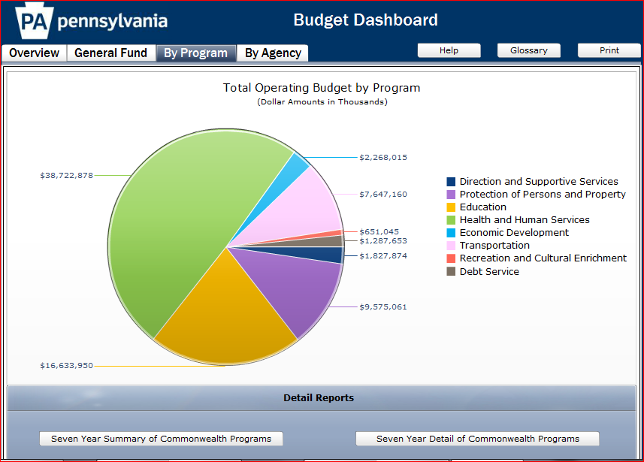
Part VI – Budget Dashboard Illustrations

The Pennsylvania Budget Dashboard
http://www.portal.state.pa.us/imageserver/budget2011/GBD_2011.html
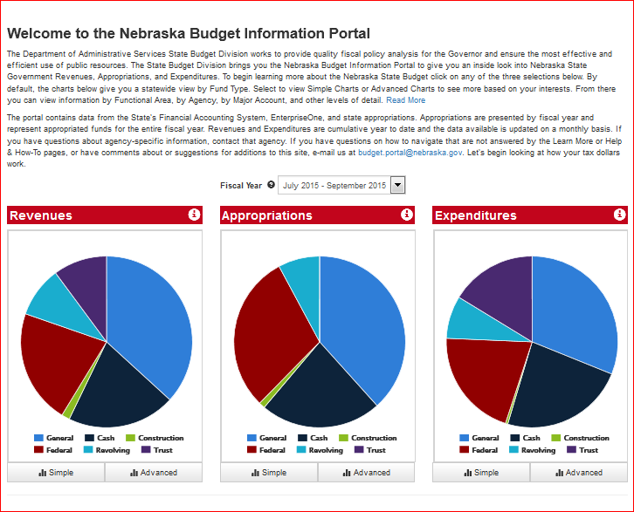
Nebraska Budget Information Portal, https://www.nebraska.gov/das/budgetportal/index.html

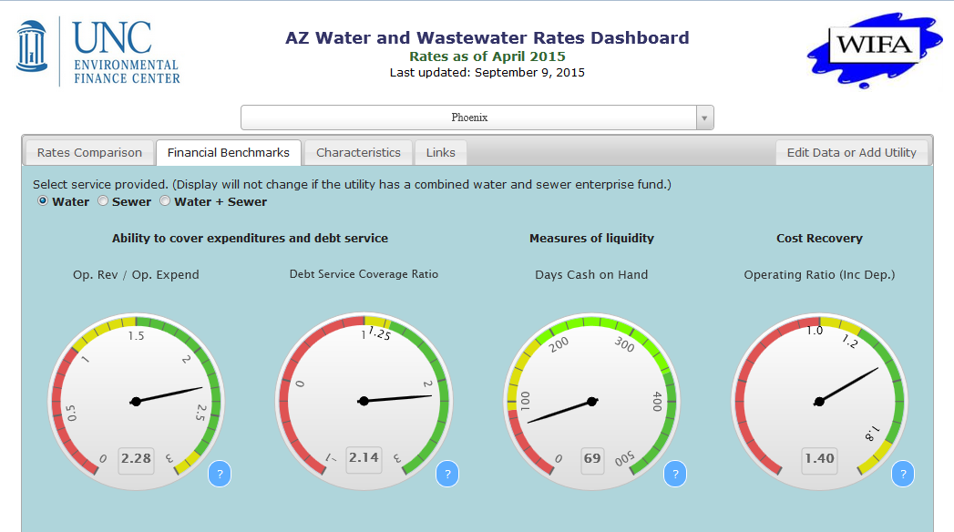
Arizona Water Infrastructure Finance Authority – Dashboard for a Water Utility
http://www.azwifa.gov/waterrates and http://www.efc.sog.unc.edu/reslib/item/arizona-water-and-wastewater-rates-dashboard#
MHI = median household income

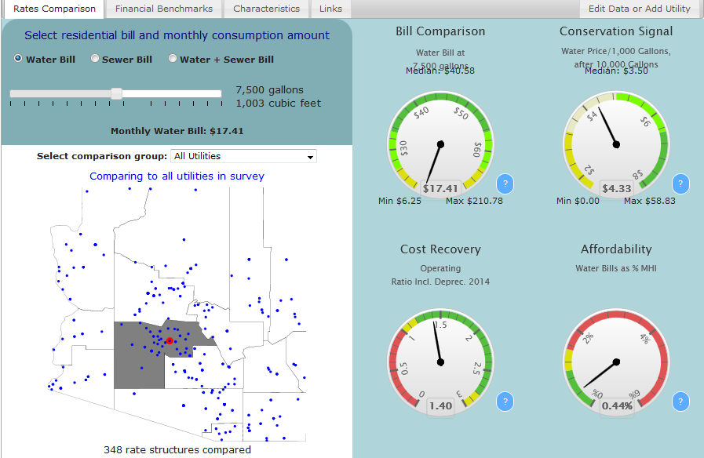
Arizona Water Infrastructure Finance Authority (continued)

Washington State Transportation Improvement Board, Performance Management Dashboard
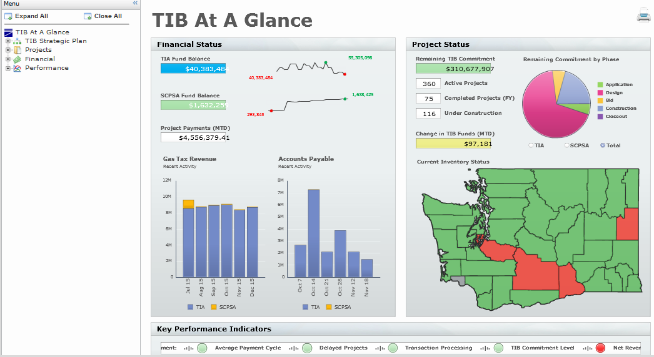
http://www.tib.wa.gov/TIBDashboard/

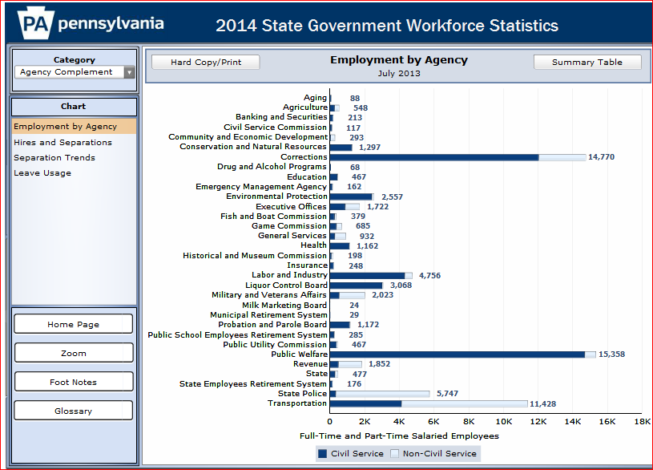
VII. Charting the Data (e.g., Workforce Statistics
Pennsylvania State Government Workforce Statistics
Source: http://www.oabis.state.pa.us/SGWS/2015/SGWS_MAIN.html
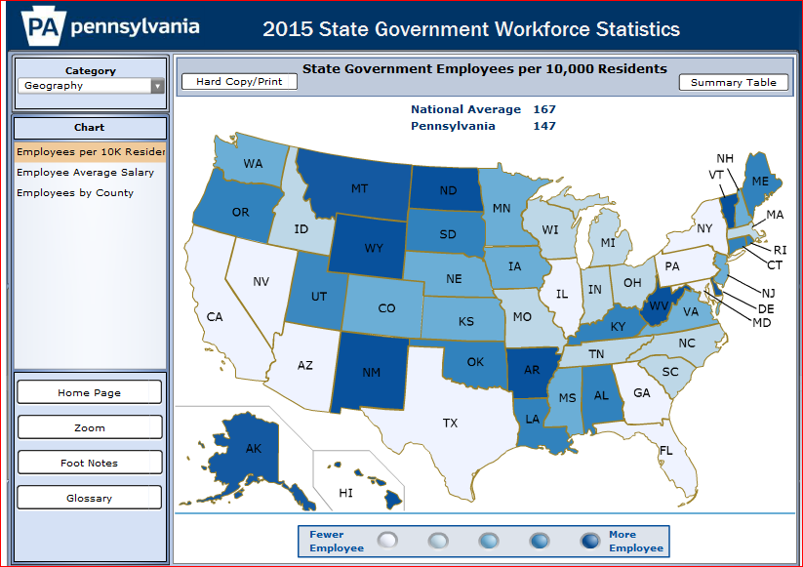
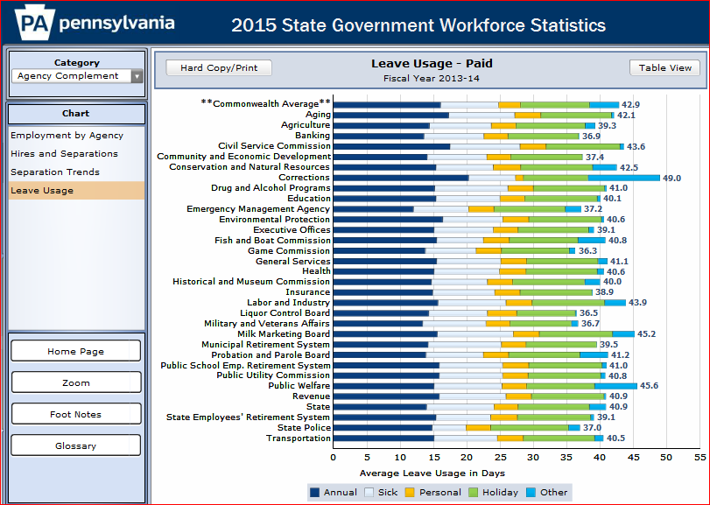
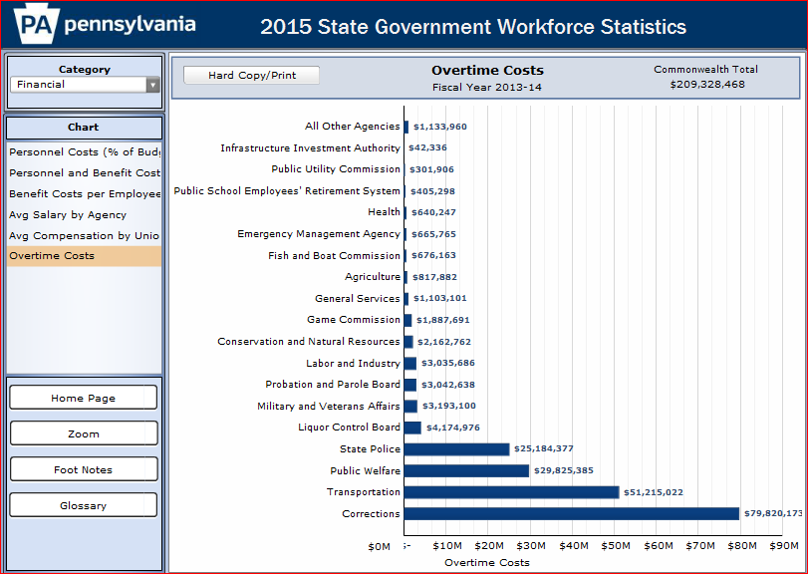
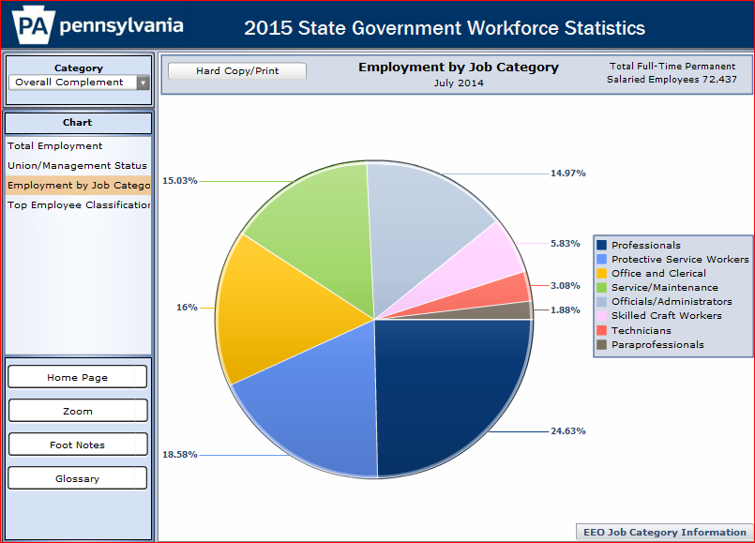
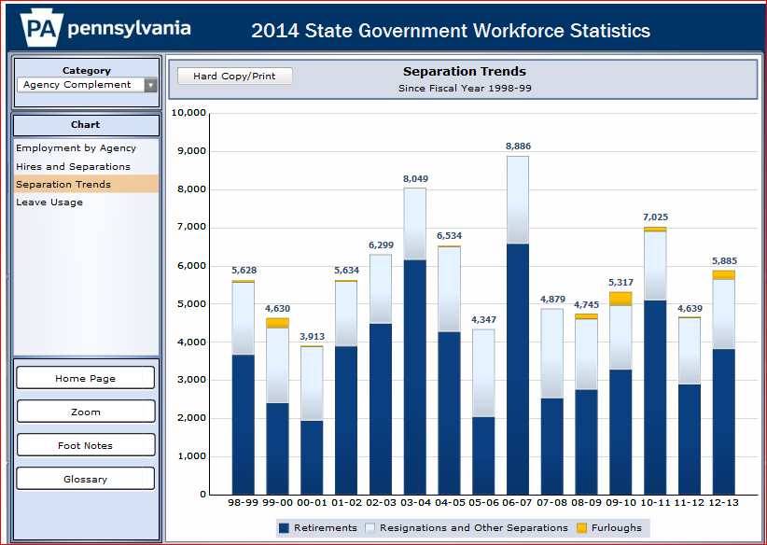
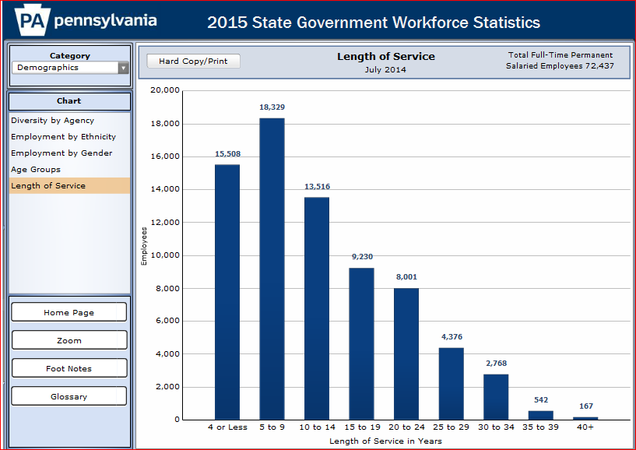

About the Author

A public policy consultant/government relations professional, Sharon Lawrence has an extensive background in federal, state, and local government. Past positions include Research Director for the National Association of Counties, Fiscal Director for the Oklahoma House of Representatives, and Director of Federal Affairs for the National Association of Towns and Townships. She also worked as a Government Relations Director and fiscal specialist for the National Conference of State Legislatures. In addition, she was a senior staff member for the US Advisory Commission on Intergovernmental Relations and a member of the US House of Representatives.

Ms. Lawrence earned a Bachelor of Arts Degree with Honors from the University of Nebraska – Lincoln and a Juris Doctorate degree from the University of Texas – Austin.

For the benefit of the public, links to social media should be in the top right hand corner. Agency logo, if one exists, should be placed appropriately as should be a comments/feedback button.
Click on item for more detail and/or to create a graphic display of selected data elements (e.g., bar graph, line graph, percentage graph, pie chart or stacked graph). Options would include percentage of total budget allocated to a given department, function (e.g., public safety) or object of expenditure. See the sample which follows of Winslow, Arizona’s graphic display options. By clicking on an item, users should be able to generate a report that ranks all agencies on that item (e.g., largest dollar value of onetime expenditures or percentage change in the budget from FY 2012 – FY 2015.
Click on an item to obtain all data from across the jurisdiction for an object code (e.g., fuel and outside legal counsel) and to identify lapsed funds.
Allocated to the purposes they are intended to advance, thus best included with the budgets for economic development, tourism promotion, and similar programs.
Partial listing.
Partial listing. For an excellent example of a government asset inventory, see the one prepared by Somerton, Arizona, Somerton, Arizona posts online its detailed asset inventory, https://onedrive.live.com/view.aspx?resid=971BF88323B037AF!548&app=Excel&authkey=!ANVZYK9ZEDIdJjI.
Include mapping capability.
Click on building/facility name for current photographs and/or video tour (subject to prudent security considerations).
Include mapping capability.
Click on building/facility name for current photographs and/or video tour (subject to prudent security considerations). Partial listing.
Include mapping capability.
Click on building/facility name for current photographs and/or video tour (subject to prudent security considerations).
Include mapping capability.
Partial listing.
Partial listing.
Standard categorizations such as fall or motor vehicle accident.
Categorize to include those terminated for conflicts of interest, criminal activity (on the job), criminal activity (off the job), misconduct, unsatisfactory performance, or workplace violence.
Categorize to include those resigning due to death or disability (indicating if work related or non-work related).
Click on item for more detail. Note that standardization of categories across agencies should be pursued in order to facilitate interagency comparisons. Wherever possible service location, time of day, day of week, month of year should be tracked and reported to help identify surge periods. With that information in hand, a flexible administrative professionals pool, for example, could be trained and deployed as necessary to move between agencies to meet surge. In the alternative, other solutions could be sought to level out the surge and thus enhance customer service.
Click on item for more detail and/or to create a graphic display of selected data elements (e.g., bar graph, line graph, percentage graph, pie chart or stacked graph). Options would include percentage of total budget allocated to a given department, function (e.g., public safety) or object of expenditure. The link to government webpage should be in top left hand corner; links to social media should be in top right hand corner. Agency logo, if one exists, should be placed appropriately.)
Click on item for more detail and/or to create a graphic display of selected data elements (e.g., bar graph or pie chart). See the sample which follows of Winslow, Arizona’s graphic display options.
Identify proceeds from data sales as well as other usual categories.
Detail should include description of the measure, estimated dollar value of achieving the measure (if applicable), actual dollar value achieved by reaching the performance goal (if applicable), and other indicators assessing progress toward achieving the target. Iowa has its agencies split performance measures into two categories, “Core Function” and “Activities, Products, and Services.” For each, agencies must list the: - Performance measure (outcome), - Performance target(s), and - Link to the appropriate goal(s) in their strategic plan. See http://www.dom.state.ia.us/planning_performance/plans_reports/index.html for detail.
Progress measures would be those that are agency specific, that relate to strategic goals.
Performance measures would be those that are applicable to each agency and relate to general management.
Elements to be measured would be clients served, facilities overseen, information requests received/answered, tasks/transactions completed, and website visitors, among others.

