February 9, 2016

|  |  |
| --- | --- |
| The Honorable Mitch McConnell Majority Leader United States Senate Washington, DC 20510 | The Honorable Harry Reid Minority Leader  United States Senate Washington, DC 20510 |
| The Honorable Paul Ryan Speaker United States House of Representatives Washington, DC 20515 | The Honorable Nancy Pelosi Minority Leader United States House of Representatives Washington, DC 20515 |

Dear Majority Leader McConnell, Minority Leader Reid, Speaker Ryan and Minority Leader Pelosi:

As the leaders of our nation’s state and local government associations, we respectfully urge Congress to restore state sovereignty by passing remote sales tax collection legislation, such as the Marketplace Fairness Act (MFA) or the Remote Transactions Parity Act (RTPA), when it considers any extension of the Internet Tax Freedom Act (ITFA).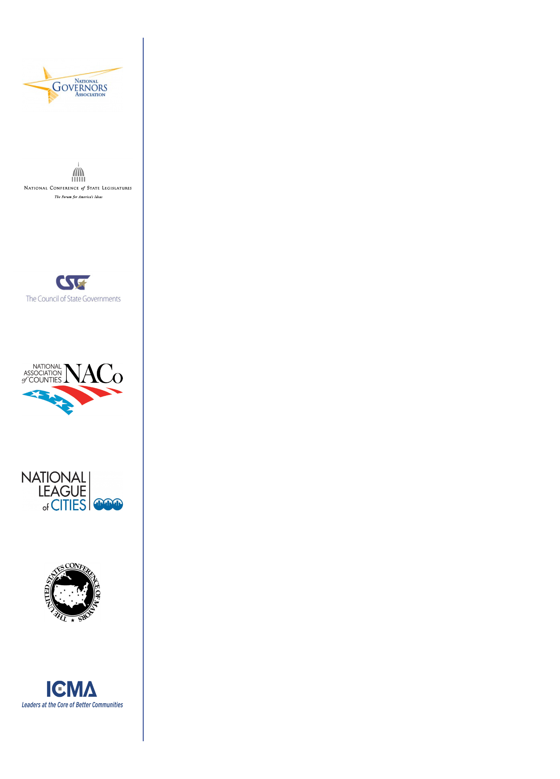­­  
  
We are disappointed that Congress is willing to vote on a permanent extension of ITFA, a federally imposed prohibition on state and local taxing authority, but is not willing to take up legislation to level the playing field for retailers and consumers. ITFA was designed to jump-start an emerging internet marketplace by temporarily prohibiting new state and local taxes on Internet access services for two years. That was 17 years ago. Today, as more and more commerce and services shift to the Internet, a permanent extension would not only prohibit taxes on Internet access, but according to the Congressional Budget Office, would also cost states hundreds of millions in existing revenues annually. Such an unfunded federal mandate would trample our most basic principles of federalism by indefinitely interfering with state and local governments’ authority to set their own tax policy.  
  
In contrast, enactment of remote sales tax collection legislation would restore budget autonomy to state and local governments and ensure that competition, not a tax loophole, determines who succeeds in the marketplace. The legislation would require states to simplify their sales taxes and ease compliance in return for the authority to collect the billions of dollars in taxes that are already owed. These revenues will be used to reduce other taxes, as well as be allocated for investments in infrastructure improvements, education advancements, and public safety.  
  
Passage of MFA or RTPA will prove to the small businesses on Main Streets across our country that Congress has not forgotten them and wants them to continue to thrive as the cultural touchstones of the American Dream. Main Street U.S.A. is an ideal that transcends political discord. We owe it to future

generations and the communities in which they will call home to preserve this hallmark of American life.  
  
Should Congress decide to extend ITFA, we call on the House and Senate to simultaneously commit to fair competition and the preservation of state and local authority by providing remote sales tax collection authority to the state and local governments.   
  
Sincerely,

|  |  |
| --- | --- |
| Scott D. Pattison Executive Director National Governors Association | William T Pound William T. Pound Executive Director National Conference of State Legislatures |
| David Adkins Executive Director/CEO The Council of State Governments | Matthew D. Chase Executive Director National Association of Counties |
| cid:image001.jpg@01D1629F.87EE2B70 Clarence Anthony CEO and Executive Director National League of Cities | Tom Cochran Tom Cochran CEO & Executive Director The United States Conference of Mayors |
| Robert J. O’Neill Executive Director International City/County Management Association |  |

