

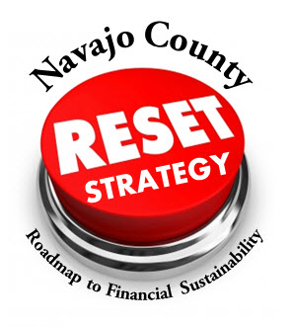

Presented by:

Leadership ICMA Class of 2015

**TABLE OF CONTENTS**

Acknowledgements 3

Project Team 4

Scope of Proposal 5

Executive Summary 6

Introduction 9

Pre-Visit Survey Summaries 11

Current Budgeting Methods 13

Redefining Fiscal Responsibility 15

*RESET Team* 17

Long-term Financial Planning Model 22

Fiscal Sustainability Threat #1: State Unfunded Mandates 26

Fiscal Sustainability Threat #2: Structural Deficit 27

Fiscal Sustainability Threat #3: Inadequate Reserves 29

Fiscal Sustainability Threat #4: Too Much Ownership 29

Fiscal Sustainability Threat #5: Political Will 30

*RESET* Tool #1: Prioritization & Resource Re-allocation 31

*RESET* Tool #2: Reductions 36

*RESET* Tool #3: Variance Exercise 37

*RESET* Tool #4: Creation of a Contingency Fund 37

*RESET* Tool #5: Review of New Programs 38

*RESET* Tool #6: Reserve Policy 38

*RESET* Tool #7: Revenue Enhancement 40

*RESET* Tool #8: Legislative Action 41

*RESET Strategy* Communications 42

*RESET Strategy* Managing Change 49

*RESET Strategy* Timeline 51

*RESET Strategy* Other Recommendations 52

Figure 1: Map of Navajo County 10

Figure 2: Long-term Financial Planning Model Fund Structure 24

Figure 3: Long-term Plan Structure 25

Figure 4: State Impacts to County Property Tax 26

Figure 5: Distribution of Property Tax Dollar 27

Figure 6: Navajo County General Fund 28

Figure 7: Navajo County General Fund Structural Deficit 28

Figure 8: *RESET Strategy* 31

Figure 9: *RESET* Services and Programs Scoring Tool 32

Figure 10: Economic Vitality Result Definition for Wheat Ridge, Colorado 33

Figure 11: Center for Priority Based Budgeting Scoring Scale 33

Figure 12: Navajo County Reserve Analysis 39

Appendix 1: Employee Engagement Survey Summary A-1

Appendix 2: Navajo County Fiscal Year 2016 Budget Development & County Services A-2

Appendix 3: Navajo County Capstone Project Interview Questions A-3

Appendix 4: Summary of Focus Group Meetings A-4

Appendix 5: Long-term Financial Planning Model A-5

Appendix 6: Possible Target Audiences A-6

Appendix 7: City of Tacoma Citywide Strategic Plan – Message Platform A-6

**Acknowledgements**

The Leadership ICMA Team would like to thank the following individuals for their support and partnership in completing this project:

* James Jayne, County Manager
* Homero Vela, Assistant County Manager
* Lynda Young, Community Services Director
* Mary J. Springer, Emergency Services Director
* James Menlove, Finance Director
* Paige Peterson, Accounting Manager
* Kimberly Eavenson, Human Resources Director
* Michael Penrod, Public Defender
* Susan Tegmeyer, WIA Executive Director
* Melissa W. Buckley, Clerk of the Board
* Bret Starns, Facilities Management Director
* Mary Herring, Health Director
* Kenneth Dewitt, IT Director
* Geneva Durkee, Library District Director
* Sherry Reed, Public Fudiciary
* Cammy Darris, Assessor
* Deanne Romo, Clerk of the Superior Court
* Bradley Carlyon, County Attorney
* Laura Sanchez, Recorder
* Kelly “KC” Clark, Sheriff – *special thanks to Sheriff Clark for touring Navajo County with the ICMA Team*
* Jeanine Carruthers, Deputy Director of Public Works
* Scott Flake, Accountant – *special thanks for data entry in the long-range financial planning model*
* Manuel Hernandez Jr., Treasurer
* Michala Ruechel, Presiding Judge
* Robert Higgins, Superior Court Judge
* Dale Nielson, Superior Court
* Ralph Hatch, Superior Court Judge
* Maria Randall, Court Administrator
* Arno Hall, Juvenile Director
* Shanda Breed, Chief Probation Officer
* Evelyn Marez, Justice of the Peace – Holbrook
* Boyce Little, Justice of the Peace – Winslow
* Fred Peterson, Justice of the Peace – Snowflake
* Susie Nelson, Justice of the Peace – Kayenta
* Stephen Price, Justice of the Peace – Show Low
* David Widmaier, Justice of the Peace – Pinetop-Lakeside
* Karen Van Ert, Executive Assistant City of Wheat Ridge
* Jon Johnson and Chris Fabian with the Center for Priority Based Budgeting (CPBB)

*A special thanks to all staff who participated in the department interviews and focus groups.*

**Project Team**

**Joe Grainger – Team Lead/*RESET Team* Development**

Joe served as the team lead, responsible for the project schedules and deliverable dates. He ensured tasks were completed and oversaw the development of the final report. He is the Assistant Fire and EMS Chief for the Stafford County Fire & Rescue Department, located in Stafford, Virginia. The department is an all-hazards response agency handling emergency calls for service including fire suppression, emergency medical services, technical rescue, marine firefighting and swift water rescue, and special operations. As the Chief of Operations, Joe is responsible for the leadership of 99 full-time employees as well as more than 250 volunteer personnel. Joe is a Nationally Registered Paramedic and has received his Fire Officer IV Certification through the National Board on Fire Service Professional Qualifications. He has completed studies in Emergency Medical Services from Northeastern University in Boston, Massachusetts, Leadership and Management National Fire Academy in Emmetsburg, Maryland, and Fire Science Administration in Waldorf College.



**Nadia Chandler Hardy – Team Member/Communications & Community Engagement Strategy**

Nadia was appointed Assistant to the City Manager in May of 2012. As part of the Executive Leadership Team, she oversees the TacomaFIRST Customer Support Center and the Office of the City Manager, and provides executive-level support to the City Manager. In addition, Nadia also serves as the organizational lead for interdepartmental and collaborative projects, civic engagement and innovation initiatives. In October 2014, Nadia was appointed Director of the Neighborhood and Community Services Department, providing executive leadership and general oversight support to 56 employees and managing a total budget of $40 million. Prior to her service in Tacoma, Washington, Nadia served as Management Assistant in the City Manager’s Office for the City of San Antonio, Texas, and has also served in various capacities for the City of Corpus Christi, Texas. Nadia earned both her Master of Public Administration and Bachelor of Arts from Texas A&M University-Corpus Christi.



**Heather Geyer – Team Member/ Long-term Financial Plan Analysis & Development**

Heather currently serves as the Administrative Services Director/Public Information Officer with the City of Wheat Ridge, Colorado.  She oversees the internal support services department consisting of: Human Resources, Information & Technology, Finance, Purchasing and Sales Tax.  Additionally, she serves as Budget Manager, Risk Manager and President of the Board of Directors for the Foothills Animal Shelter.  She began her career in local government management at the City of Greenwood Village as an intern.   Later she worked for five years as a Management Assistant in the Department of Parks, Trails and Recreation for Greenwood Village and served as Management Specialist for Community Outreach in the City Manager’s Office prior to becoming the Assistant to the City Manager for Wheat Ridge.  Heather received a Bachelor of Arts Degree in Political Science and Public Policy from the University of Denver and a Masters of Political Science with an Emphasis in Public Policy from the University of Colorado at Denver.  Heather championed the implementation of Priority Based Budgeting (PBB) which the City has used for the past three years.  She is the recipient of the GFOA Distinguished Budget Award for the 2013 and 2014 City Budgets.



**Scope of Proposal**

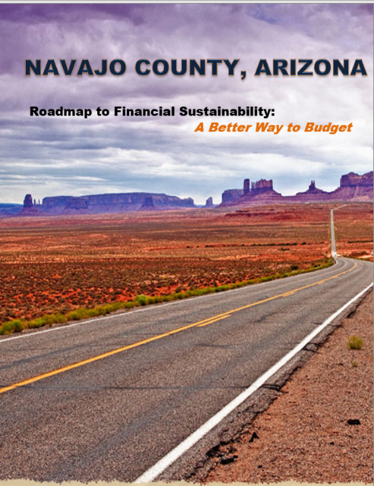The County of Navajo, Arizona requested the development of budgetary tools and long-term financial planning models that align with the County’s Strategic Plan in an effort to strengthen fiscal sustainability.

**Project Deliverables**

Satisfaction of Navajo County’s expectations (as outlined in request for service) include:

* Assessment of Navajo County’s current budget process *Current Budgeting Methods, page 13*
* A framework for a Financial Sustainability Team (FST)

*The RESET Team, page 17*

* Development of a long-range financial planning model

*Long-term Financial Planning, page 22*

* A roadmap for a better budget development process

*RESET Strategy Tools, page 31*

*“Navajo County will develop a budgetary model that strengthens financial sustainability, tie directly to our strategic plan, while delivering quality services to meet the public’s expectations. County administration, along with elected officials is tasked with strategic planning to be fiscally responsible. Navajo County’s belief that each employee, within each department, brings expertise and knowledge that affects the budget. Budget discussions between front-line employees and leadership will assist in the understanding of budgets per department and its effect on the County as a whole. This department-by-department review will provide insight into department programs and determine program expenses compared to department services provided. In addition, these meeting will further clarify services that the public expects. With a team of 600 strong, Navajo County believes that this must be a collective effort between diverse stakeholders, with departmental representation from cross sections of the County.*

*Information gleaned from these meetings will assist leadership to engage County employees to form a financial sustainability team that will then develop a cost reduction/cost saving program to help reduce and maintain costs without compromising public service expectations.”*

***Excerpt from Navajo County Leadership ICMA Project Proposal***

**Executive Summary**

Central to creating a “roadmap” to financial sustainability for Navajo County, herein referred to as the County, is the *RESET Strategy* presented in this report. Benjamin Franklin said it best with, “If you fail to plan, you plan to fail.” The County has not failed to plan; rather, the County has been faced with increasing demands to provide higher levels of service and unfunded mandates by the State of Arizona. The development of the County budget for 2017 is the appropriate time for the County to push the *RESET* button. In the July episode of *Navajo Connection*, County Manager Jimmy Jayne alluded to the lack of a sustainable financial path for the future. Given the challenges of the past and the challenges that lie ahead, the Leadership ICMA Team, herein referred to as ICMA Team, believes the County possess the ability to change its financial outlook and implement tools that will help build long-term financial sustainability.

**Teetering on the Fiscal Cliff**

The term “fiscal cliff” is used in reference to a situation where “a particular set of financial factors causes or threatens sudden and severe economic decline.” For the County, years of unfunded mandates by the State of Arizona have placed pressure on the County budget forcing it to the point of *teetering on the cliff*. This is not an exaggeration. Unfunded mandates and increased demands for service have crippled the County’s ability to be proactive, to plan and save for the future. Instead, the County does the best it can to survive, by balancing the General Fund budget year-to-year through flexibility transfers. The County’s financial outlook is bleak at best. The Finance Department has to closely monitor spending because there is no cushion in the County budget. How does the County change this course of direction? Is it even possible?

**A Look in the Mirror**

“There is no more important challenge that we face than to accept responsibility for not only what we are, but also what we can be.”

*David McNally*

The ICMA Team looked for themes and patterns driving their interactions with elected officials, department directors and staff. The intent of this report is to call attention to *what is helping* and *what is not helping* from a long-term fiscal sustainability perspective. Simply put, this report provides a look in the mirror.

***RESET* Strategy**

The Center for Priority Based Budgeting (CPBB) describes their prioritization methodology as “bringing vision into focus with a new ‘lens’.” The *RESET* *Strategy* has been uniquely designed for the County. The ICMA Team hopes that the implementation of the *RESET* *Strategy* repositions the County’s financial outlook and puts the County on a path to financial sustainability.

The *RESET Strategy* is based on the premise that the County determines its own path to financial sustainability. If the County continues to let the State’s financial dysfunction impact the County at the level it currently does, the County is going to lose sight of its mission and vision for the future.

The *RESET Strategy* has a priority based budgeting focus. What is priority based budgeting? It is a long-term organizational effort to align available resources with the priorities of the community to ensure financial sustainability and to create an environment of continuous improvement.[1] Priority based budgeting also known as priority-driven budgeting (PDB) is best described as, “Using PDB, the government identifies its most important strategic priorities. Services are then ranked according to how well they align with the priorities, and resources are allocated in accordance with the ranking.”[2] The budget conversations change and look different when an organization engages in priority based budgeting – for the better. Priority based budgeting is not about automatic cuts or taking programs and services away.

Local governments often use the seven most commonly used strategies to manage fiscal realities:

* *Rob Peter to pay Paul.*
* *Use of accounting tricks.*
* *Borrow.*
* *Sell assets.*
* *Make something up.*
* *Nickel and dime the employees.*
* *Delay asset maintenance or replacement.[3]*

Priority based budgeting is none of the above. “Priority-driven budgeting is a big change from traditional budgeting.”[4] The push of the *RESET* button involves the County changing its mindset and approach to budgeting. We often hear the definition of insanity is doing the same thing over and over again and getting the same result. The *RESET Strategy* is about changing the way the County budgets with the desire for different and new results.

The vision for the *RESET Team* outlined in this report provides the foundation and team approach for implementing the *RESET Strategy*. Central to this strategy are eight *RESET Tools* that if used collectively, will empower the County to harness better decision-making and prioritize programs and services. The long-term financial planning model is designed to be a “living document.” Once the *RESET Tools* recommended in this report are put into motion, the model can be updated to reflect the changes being made as the County moves toward building financial sustainability.

The *RESET Strategy* also includes recommendations for enhancing communications and engaging the community in determining program and service priorities. The *RESET Strategy* is designed to engage the County in prioritizing and ranking programs and services and engaging in meaningful dialogue by asking questions such as:

* What services is the County uniquely qualified to provide that will offer maximum benefit to citizens for their tax dollars?
* What is the County truly mandated to provide? What does it cost to fulfill those mandates?
* What programs are most appropriate to fund by establishing or increasing user fees?
* What programs are most appropriate for establishing partnerships with other community service providers?
* What services might the County consider “getting out of the business” and not providing?
* What are the apparent overlaps and redundancies in the community, caused by multiple entities providing similar services?
* Where is the County potentially competing against private businesses within its own community?[5]

The *RESET Strategy* will help the County determine how best to achieve financial sustainability by objectively determining how to match available resources with County priorities.

**Commitments**

While not recommended by the ICMA Team, to do nothing and maintain the status quo is always an option. Implementing the *RESET Strategy* will require hard work, difficult discussions, and sacrifice. Is Navajo County ready to push the *RESET* button? The ICMA Team challenges every elected and appointed official to ask themselves this question, “What will I do, as a leader, to ensure the financial sustainability of the County moving forward?”

**Introduction**

Jurisdictional Background: Navajo County, Arizona

*Proudly Serving, Continuously Improving Since 1895*

Established in 1895 by the Arizona legislature, Navajo County is one of 15 counties within the State of Arizona. Comprised of 9,960 square miles the County is located in the northeastern portion of the state, stretching lengthwise from the State of Utah boarder to the north and Graham County, Arizona to the south. The land mass of Navajo County is such that if it were to be recognized as a state it would be larger than Vermont, New Hampshire, New Jersey, Connecticut, Delaware, Rhode Island, and the District of Columbia. According to the 2010 U.S. Census Bureau statistical report, the population of Navajo County was 107,449 – a population that has increased with each successive census collection. Incorporated cities within Navajo County include the County Seat of Holbrook, as well as Show Low and Winslow. Towns include Pinetop-Lakeside, Taylor, and Snowflake.

Interstate 40 transects Navajo County in an east-west direction, with the City of Holbrook halfway between Gallup, New Mexico and Flagstaff, Arizona. Inclusion of this major highway within Navajo County adds its own character. As a primary commercial and passenger route across the southern United States, Interstate 40 is heavily traveled. The thoroughfare was an essential element in the designation of Navajo County as a High Intensity Drug Trafficking Area (HIDTA). Falling into the Southwest Border HIDTA, Navajo County works alongside regional, state, and federal partners in combatting illegal drugs and associated crime.

Accompanying the size of Navajo County is a vast cross-section of terrain and geography. The northernmost portion of the jurisdiction is desert including notable landmarks such as Monument Valley and portions of the Painted Desert and Petrified Forest National Park. The central portion of Navajo County is a transitional area between the desert area and forested woodlands. These flatlands are home to agriculture, livestock, farming, and ranching, and wind farming for the production of electricity. The southern portion of Navajo County is more alpine in appearance and hosts portions of the Apache-Sitgreaves and Tonto National Forests. The timber industry has historically been an essential piece of Navajo County’s economy.

Navajo County functions under a Council-Manager form of government. The Navajo County Board of Supervisors is comprised of representation from five separate electoral districts. The County Manager reports to the Board of Supervisors and is responsible for the overall management of the County. The County has several constitutional officers that provide leadership in providing services to citizens.

Native American history, with presence, is a cornerstone of Navajo County. Three separate Native American Tribes have sovereign lands within the County including the Navajo Nation, Hopi Tribe, and White Mountain Apache Tribe. More than half of the land area of Navajo County is tribal land. The relationships between Navajo County and these Sovereign Nations are an essential factor when understanding the management of the county. Property taxes cannot be collected on these tax-exempt areas; as such Navajo County depends upon federal payment in lieu of taxes (PILT) funds to assist in offsetting the loss of local revenue. Challenges at the federal level (debt ceiling, spending legislation, government shutdown) have created concern as to the sustained availability of PILT funds within the budget process. Navajo County maintains intergovernmental agreements with each of the Sovereign Nations, working cooperatively in efforts such as law enforcement with the Bureau of Indian Affairs Police, community-focused public health efforts with the Indian Health Service, and public works and transportation projects with the Navajo Nation Department of Transportation.

**Figure 1: Map of Navajo County, Arizona**

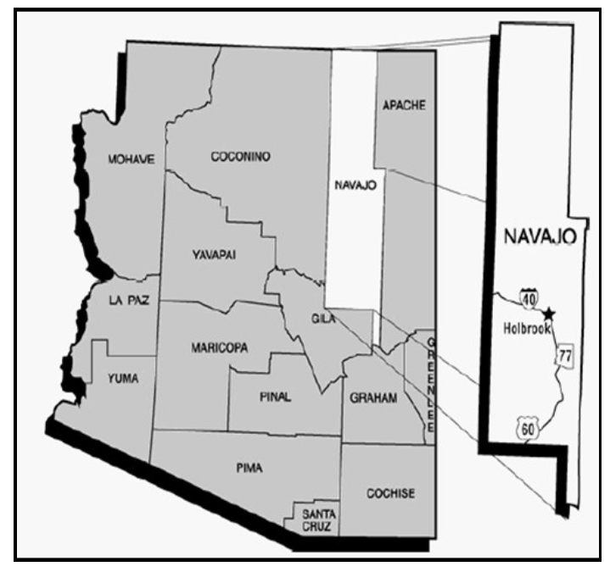

*Source:* Navajo County 2014-2015 Annual Budget

**Pre-Visit Survey Summaries**

Prior to the first site visit, the ICMA Team prepared and distributed a survey of about 15 questions to County all employees to gage employment morale and perceptions around engagement, understanding the organization’s mission, morale and professional development. A total of 364 (out of 620) employees responded, with some questions skipped. The overall survey response rate was 58 percent. Due to time restraints of the project and the challenge of scheduling executives, mid-level managers and frontline employees, the ICMA Team determined that the design of the survey should be simplistic in its approach and not as detailed as some employee-satisfaction survey instruments. As a result, this particular survey does not contain statistical interpretation, cross-tabulation data or findings of statistical significance. The employee engagement results are included in Appendix 1.

The survey can be divided into three major categories: Mission/Vision, Employee Morale/Appreciation, and Professional Development.

**Mission/Vision**

The Mission/Vision section contained 3 statements with 4 response options ranging from “disagree” to “strongly agree” to gage employee understanding of the purpose and function of the County and how their individual work contributes to the overall strategic path toward accomplishing that mission. Those statements were:

* “I understand the mission or purpose of Navajo County.”
* “The mission or purpose of Navajo County makes me feel like my job is important.”
* “I know what is expected of me at work.”

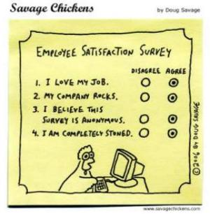An overwhelming majority of the 364 respondents rated this area positively. Most employees have a general understanding of what the County provides in terms of service and have a good understanding of the relationship between their work and the overarching mission of the organization.

Additionally, County employees have awareness about how important their particular position is in achieving the mission of the organization.

**Professional Development**

Responses to statements around professional development resulted in a close tie in both positive and negative experiences.

The professional development section was comprised of the following five statements:

* “In the last six (6) months, someone at work has talked to me about my progress”
* “I have the materials I need to perform my job duties”
* “In the last 12 months I have received my annual evaluation”
* “Someone at work encourages my professional development”
* “During the last twelve months, I have had opportunities to learn and grow.”

Overall respondents believe that professional development opportunities are available for continued growth in the organization. However, as it relates to documenting progress and growth areas, employees are not evaluated consistently. About 164 respondents have not received their annual evaluation within the last 12 months. Additionally, about 43 percent of the total respondents have not had professional development conversations in the last 6 months.

**Employee Morale/Appreciation**

Employee moral can be described/defined in a number of ways depending on the context and perspective in which the term is used. For this summary, the ICMA Team refers to employee morale as the overall outlook, attitude, satisfaction, and confidence that employees feel while at work and when thinking about their work/organization. Faith, trust and optimism in leadership, mission and organizational values play a critical role in building employee morale. As a result, daily decisions, communications, follow-through, appreciation and consistency must be commonplace within the organization to ensure success when building morale and fostering strong working relationships.

The section contained about five statements to include the following:

* “While at work, I have the opportunity to do what I do best everyday”
* “In the last three years, I have received recognition or praise on my work performance”
* “My supervisor, or someone at work, cares about me.”

The County received the highest score of positive result in this section, which was also noticed throughout the department interviews and the frontline focus group discussions. Staff in many of the County departments view each other as extended family and demonstrate sincere concern for each other’s well-being. However, employees also expressed concern around budget challenges that are beginning to have an impact on their morale. Staff has a desire to understand more about these challenges and is willing to share in the burden of balancing the County budget by offering up solutions and working collectively.

**County Services Questionnaire**

Prior to the first site visit, the ICMA Team also conducted a Fiscal Year 2016 Budget Development and County Services Questionnaire. These results are included in Appendix 2. The internal County survey had 165 respondents and there were only four respondents to the community survey. The intent of these surveys was to gauge the County’s readiness to having discussions around priorities and services. The survey results, including the comparatively low number of community participants, laid a foundation for including numerous internal and external communication recommendations as part of the overall Capstone project.

**Current Budgeting Methods – Survival Mode**

Like many localities across the nation, the County has employed short-term initiatives to respond to “the Great Recession” that resulted in economic decline between 2007 and 2009 in order to keep a balanced budget. The ICMA Team believes that the County has done all of the right things from a budgeting perspective to balance the budget on an annual basis and avoid having to make significant reductions and cuts in levels of service. As this report demonstrates, the long-term financial planning model provides a five-year outlook that is bleak. This forecast supports the need for the *RESET Strategy* outlined in this report. To its credit, the County has done as much as it can do with its current practices. The continued use of temporary methods such as reduced work weeks, not filling vacant positions, discretionary spending reductions and deferring capital purchases are all temporary fixes. Even with these short-term methods, inter-fund transfers are required to balance the General Fund budget alone.

Building a roadmap to financial sustainability will require different discussions to be had and engagement in the process by elected officials and staff at all levels of the organization. The ICMA Team believes that the *RESET Strategy* will assist the County in looking at the budget through a new “lens.” Collectively, the County has to push the *RESET* button in order to change what is within its control at this point in time.

**Award-winning Finance Team**

The ICMA Team took a comprehensive look at the County’s budget process and policies. The County has an excellent Finance Department. The County has received the prestigious *Distinguished Budget Award* for five consecutive years as well as the *Certificate of Achievement for Excellence* in financial reporting for four consecutive years. Essential to implementing the *RESET Strategy* is making sure that the organization has the right individuals in key leadership positions to move this strategy forward. The ICMA Team believes the County has the capacity, the talent and the will to move the *RESET Strategy* forward.

**Short-term Fixes**

In the Fiscal Year 2014 – 2015 budget, the Board of Supervisors adopted several guidelines to provide direction and guidance to elected officials and department directors:

1. Protect employees:
   1. No new non-grant funded employees
   2. Hold positions open when possible
   3. Utilize special revenue funds for personnel and other expenses when possible
   4. Allowance for salary adjustments depend on economic factors
2. No non-grant department budget increases with the exception of expected increases for employee related expenses (ERE)
3. Limited capital expenditures for vehicles and equipment

Additionally, short-term initiatives include:

* Voluntary cost savings policy
* Vacancy management strategy
* Capital purchases[6]

The short-term fixes described above are not enough. How does the County head down a path of long-term financial sustainability?

The Government Finance Officers Association (GFOA) outlines “five pillars” of the financial planning process:

1. ***A long-term service vision****. Define the future the community wants.*

* *Service visioning is a great chance to engage elected officials in the planning process.*
* *A service vision makes planning more meaningful to participants, especially those without a financial background.*
* *It is essential for aligning financial strategy with service strategy.*

1. ***Financial policies****. Define the standards of stewardship of the publics’ tax money.*

* *Policies are the basis for accountability and increasing trust in government.*
* *Policies define standards against which performance can be assessed.*
* *Policies can be a crucial point of elected official involvement.*
* *See GFOA's Financial Policies book for more information*

1. ***Technically sound analysis and forecasting****. Provide accurate and credible financial foresight.*

* *A credible forecast is essential for stakeholders to have confidence in the planning process.*
* *Use scenario analysis to explore different possible futures.*
* *Make sure the forecast is adaptable to changing conditions and requirements.*

1. ***Collaborative and participative process****. Gain the benefit of different perspectives.*

* *Improve plan quality by getting different vantage points and accessing different expertise.*
* *Build a wide basis of support for financial strategies.*

1. ***Connection to other plans****. Long-term financial planning is part of a complete planning portfolio.*

* *Integrate with strategic planning to get the long-term service policies and to inject financial realities into service visioning.*
* *Integrate with capital planning to understand long-term capital and operating expenditures and to better model debt scenarios.*
* *Integrate with the budget to put into action long-term financial strategies.*
* *Integrate with land use planning to reveal land use trends that impact financial conditions and to emphasize land use implications for financial condition[7]*

The County has an opportunity through the *RESET Strategy* to build on their current budgeting process.

**Redefining Fiscal Responsibility**

In the July episode of *Navajo Connection*, Brad Carlyon, County Attorney stated, “innovation doesn’t do it anymore,” in response to a question about the County’s budget challenges. Mr. Carylon is correct. The County has made a concerted effort to focus on improving efficiencies and implementing innovative programs to generate cost-savings. As part of the *RESET Strategy*, the ICMA Team recommends that the County redefine the current fiscal responsibility goal included within the County’s Five-Year Strategic Plan document. Redefining what fiscal responsibility looks like over the next five years is an important next step for the County once the *RESET* Team is established.

The current Fiscal Responsibility strategic goal is currently reflected by the following goal statement:

**Navajo County’s Five-Year**

**Strategic Plan**

* Preserve & Protect
* Economic Development
* Regional Leadership
* **Fiscal Responsibility**
* Excellent Service
* Communication
* Team Development

***Goal:*** *Fiscal Responsibility is currently defined as:*

As a responsible steward of public monies, Navajo County demonstrates fiscal accountability, while providing innovative and quality services.

***Objective:***

Demonstrate accountability and transparency.

***Action:***

* Provide timely reporting of how dollars are used
* Evaluate staffing needs
* Maintain software system for up-to-date financial information for departments
* Utilize energy-efficient and environmentally-sustainable methods for construction, technology and operations
* Pool resources through partnerships
* Continued departmental involvement in the budget process
  + Provide justification for large purchase/projects during the budget process
  + Continue to monitor economic trends and fluctuations
* Validate notice of claims (risk management)[8]

The ICMA Team recommends that the *RESET Team* develop a stronger, more specific definition for what financial sustainability will look like. The current definition is good; however, it does not accurately depict the severity of the County’s financial outlook and action steps necessary to change the current mode of operation.

**Recommended Financial Sustainability Strategic Goal**

The ICMA Team recommends revising and renaming the County Strategic Plan goal from Fiscal Responsibility to Fiscal Sustainability.

*Goal:*

**Navajo County’s Five-Year**

**Strategic Plan**

* Preserve & Protect
* Economic Development
* Regional Leadership
* **Fiscal Sustainability**
* Excellent Service
* Communication
* Team Development

As a responsible steward of public monies, Navajo County achieves fiscal sustainability through the prioritization and allocation of programs and services based on community need and available funding through long-term financial planning.

*Objective:*

Implement the *RESET Strategy* – a roadmap to financial sustainability beginning in 2016 and continuing in the development of the 2017 proposed County budget.

*Action:*

* Prioritize all County programs and services (*RESET* Tool #1)
* Identify opportunities for resource re-allocation (*RESET* Tool #1)
* Spend within County’s means – reduce expenditures (*RESET* Tool #2 & #5)
* Understand Variances (budget vs. actual) (*RESET* Tool #3)
* Establish and maintain reserves (*RESET* Tool #4 & 6)
* Engage the community (*RESET Strategy* Communications)
* Champion managing change (*RESET Strategy* Managing Change)

**The *RESET* Team**

The County is an expansive jurisdiction with a number of unique characteristics. While these characteristics make the County special, they also add layers of complexity to the management of local government. Services provided, work performed, and demands from throughout the jurisdiction have stretched the organization to the point where a significant budget shortfall is imminent. The leadership and management roles and responsibilities within the County are well-founded and professional; however, continuation of past practices will not create financial sustainability. There is evidence that change is necessary, and it is the impression of the ICMA Team that the County is primed for an organizational reset. The goal of creating a *RESET Team* is to afford the organization with the greatest opportunity for success, as they lead personnel through a redesigned budget development process that focuses on priorities.

As a portion of the Capstone Project, the ICMA Team completed a number of individual and focus-group interviews during on-site visits to the County. Individual department heads and elected officials were invited to speak with the ICMA Team concerning their involvement in the budget development process. Ten pre-set questions, included in Appendix 3, were asked consistently in all interviews.

It is evident that supervisor engagement is high within the County, as participation levels were nearly 100 percent. Of the various constitutional and appointed employee divisions, only one department did not meet with the Team during the one-on-one interviews. In addition to valuable participation it was also evident that department heads were interested in the financial state of the County, future fiscal challenges, and in learning about the goals of the ICMA Team.

The common threads from the department head meetings are included below:

* “*We are dealing with a flat budget, year after year…”*
* *“Positions have been left open and unfilled since the recession…”*
* *“There is no budget development process…we don’t have funds to create anything different…”*
* *“Our staff is required to complete the same level of work with less personnel…”*
* *“Arizona counties have been forced to transfer more and more funds to the state…”*
* *“It is what it is…”*

In addition to these sentiments, the Team noted that almost all department heads understand the financial constraints of the County. When asked to describe the financial future, words such as *“bleak”* and *“desolate”* were used by some department heads. Although there is frustration associated with the lack of revenue and the redundancy of the budget development process, the one-on-one interviews showed that department heads were proud of their personnel and of the work that their offices accomplish for the County.

Department heads referenced the leadership team meetings as being useful for information sharing. Additionally, the County’s Leadership University for professional development was noted as a valuable training program. Access to the strategic plan for guidance in understanding the County’s vision was also mentioned as important document used by department heads. A commonly found theme; however, is there appears to be departmental silos in place and there is not an all-encompassing unification surrounding the core services provided by the County.

Likewise, interdepartmental cooperation and cost sharing that would support the County’s efforts for financial efficiency have not been identified and acted upon. The *RESET Team* will have the opportunity moving forward for the implementation of such initiatives.

The ICMA Team also met with management staff and front-line employees during group sessions, to discuss their views on the budget development process and what it meant to them to work for the County. Findings from these focus group sessions are included in Appendix 4.

For the manager’s focus group, 18 participants were asked the following questions:

* What disconnects exist in the budget process?
* Describe the budget development process in one word.
* Describe the organization’s culture in one word.
* Describe the county organization in one word.

For the front-line employee focus group, 21 participants were asked the following questions:

1. Does the budget reflect the County’s mission and priorities?
2. Are we able to meet short-term demands without compromising long-term vision?
3. Is there agreement on the five-year strategic plan?

The findings from each of the focus groups assisted the ICMA Team with gauging the pulse of the organization in respect to level of understanding and awareness of the current budget development, perceived challenges, and financial hardships. Additionally, it was useful for the employee groups to participate in facilitated group discussion surrounding changes that the labor force had dealt with since the Great Recession. Moreover, the ICMA Team was able to more accurately gauge the County’s workplace culture and to develop a better feel for what it was like to work within the local government. Both the front-line employee group and the manager’s focus group included knowledgeable, kind-hearted, motivated, and friendly employees who shared openly with the ICMA Team. Together with the pre-visit surveys, the ICMA Team was able to more accurately gauge the County employee group’s ability and willingness to openly discuss both budget development and the evaluation of programs.

***Vision for the Navajo County RESET Team***

The *RESET Team* will be among the most important tools for the successful management of Navajo County’s financial constraints. Effective implementation of the *RESET Strategy* depends upon three steps: Vision, Creation, and Organizational Implementation. Identifying the “roadmap” to financial sustainability involves a number of tasks: understanding current fiscal realities and forecasting future fiscal challenges, utilizing processes that accurately determine program necessity for county functions, developing a communications model for sharing information both internally and externally, and finally implementing a budget adoption process that efficiently and effectively meets the needs and desires of the community while ensuring that the financial welfare of Navajo County is protected. The vision for the *RESET Strategy* is one that must be adopted by executive level staff, as well as the policy making body of the jurisdiction, and championed throughout the organization by the *RESET Team*.

***Creation of the Navajo County RESET Team***

The creation of the RESET Team will be the foundation for the success of the RESET Strategy. The selection of individuals for participation on the RESET Team will afford the County will a cross-section of personnel who can focus on not only discussing opportunities for improvement, but taking specific action for organizational betterment. It is a recommendation of the ICMA Team that Navajo County evaluate the ability to add a full-time Management Analyst onto staff. Identifying an appropriate employee to fill the Management Analyst position would allow the County to have a staff member that can not only participate on the RESET Team, but an individual that can provide in-depth analysis of challenges raised and focused evaluation of topics tackled by the group.

From executive level leadership, through personnel with expertise in finance and budget, and culminating with internal and external communications, every *RESET Team* member will have a critical role. The three-time Pulitzer Prize winning journalist Herbert Bayard Swope sums up the reality of management during challenging times stating, “I cannot give you the formula for success, but I can give you the formula for failure – which is: Try to please everybody.”

The scope of work for the *RESET Team* is very large, however it is not insurmountable. The ICMA Team has identified and provided a number of useful tools that should be implemented by Navajo County. The first and most important step of the *RESET Strategy* is to acknowledge the current and future fiscal realities faced by the County, and to clearly communicate them throughout the organization and to the community. These fiscal realities are described in this report as five fiscal sustainability threats, beginning on page 26. Following the acknowledgement of a challenging financial future and need for change, the *RESET Team* will encompass a number of other difficult responsibilities including; assisting with the reduction and reallocation of funds, repairing the structural deficit, and creating a financial reserve for Navajo County. These changes are included in eight *RESET Tools* beginning on page 31.

Revamping financial processes such as these are not foreign to local governments, especially following “the Great Recession.” Some counties and cities have been successful, tapping resources and finding efficiencies they may not have discovered had it not been for their loss of revenue. Others have experienced continued financial hardships, including bankruptcy, and implementation of court appointed management. Successful implementation depends upon a number of factors; however, ensuring transparency in processes and garnering buy-in from all involved is essential. An excellent case study of multiple jurisdictions facing similar challenges comes from the *National Civic Review*. Included below is an excerpt from the article entitled *Key Findings on Fiscal Sustainability for Local Governments in Southern California*, from 2014.

“Sustainable fiscal decisions do not happen by accident. Elected officials and senior appointed staffs do not need to have identical interests, but their willingness to work with each other is a critical precondition for success. Reputable and professional chief executives play an important role in leading and maintaining a budgetary process that takes into account a broad range of interests in the entire community from a long term perspective. To be successful, executives have to be empowered by elected officials to present the realities of the fiscal condition of the jurisdiction, both short and long term, regardless of the political consequences. Effective relationships between elected and appointed executives correlated in the case studies with transparent and forward-looking budgetary processes.”[9]

***Organizational Implementation of the RESET Team***

There are a multitude of tasks and responsibilities associated with membership on the *RESET Team*. That being said, the success of the organizational restructuring depends solely upon the productivity of the group that is established to carry out the new processes. The importance of the *RESET Team’s* work cannot be overstated. The *RESET Team* must create a methodology for the measurement of programmatic and departmental performance. This tool will be used by all departments to ensure accountability and transparency throughout the organization. In the event the *RESET Team* believes that a group of internal stakeholders should take on the task of creating the performance measurement tool, they may choose to appoint a Task Force. The Task Force would be led by a representative from the *RESET Team* and used solely for the purpose of creating the performance measurement tool, after which the Task Force would be dissolved.

The *RESET Team* will spearhead the program scoring process which will be used to evaluate all County programs in anticipation of the upcoming budget development process. Additionally, the program scoring process will allow for facilitation and repair to the Navajo County budgetary structural deficit. The *RESET Team* will be a standing workgroup that is maintained year-to-year. In an effort to address the structural deficit, the *RESET Team* will utilize the program scoring process in subsequent fiscal years. It is recommended that the *RESET Team* meet monthly to review revenues and expenditures, identify ongoing organizational efficiencies, and maintain accountability within Navajo County’s financial system.

“Prioritization is a way to provide clarity about how a government should invest resources in order to meet its stated objectives (and about what services could be funded at a reduced level without impacting those objectives). Prioritization as a process helps us better articulate why the programs we offer exist, what value they offer to citizens, how they benefit the community, what price we pay for them, and what objectives and citizen demands they are achieving.”[10]

**Long-term Financial Planning Model**

The long-term financial plan is a core component of the *RESET Strategy* and the complete model is included in Appendix 4. The creation of the long-term financial planning model for the County is intended to be used as a “roadmap” by staff and elected officials.

Long-term financial planning is a best practice recommended by the Government Finance Officers Association (GFOA). According to GFOA, “Long-term financial planning is the process of aligning financial capacity with long-term service objectives.”

GFOA best describes what a long-term financial plan is:

* **A combination of technical analysis and strategizing.** Long-term forecasts and analysis are used to identify long-term imbalances. Then, financial strategies are developed to counteract these imbalances.
* **A collaborative and visionary process.** A plan does not just forecast the status quo into the future. It considers different possible futures. It also involves other stakeholders. Elected officials, operating departments, and the public can all help identify financial issues, develop consensus strategies, and ensure a successful implementation.
* **An anchor of financial sustainability.** A plan develops big-picture and long-term thinking among elected and appointed officials.[11]

**Why a long-term financial plan?**

*“Financial planning uses forecasts to provide insight into future financial capacity so that strategies can be developed to achieve long-term sustainability in light of the government’s service and financial challenges.”*

*GFOA*

A long-term financial plan must be aligned with the organization’s overall strategic plan. Increased service levels, program enhancements and innovative efforts all come with associated costs. The cost of providing County services has increased as well as unfunded mandates by the State of Arizona. Changes in political leadership comes with new expectations or desires to fund certain programs and services. Can the County satisfy demand for increased levels of services?

Currently, the County’s strategic plan is not in alignment with a long-term financial plan that provides the information on what the organization can afford. While the County has a good system for identifying goals and priorities each year, the ICMA Team believes there is room for improvement. A higher level strategic discussion needs to take place surrounding the long-term financial plan and demands for level of service in order to determine what the County can afford to budget. GFOA encourages communities to develop a long-term financial plan whereby, “The budget is the most important execution tool, because the budget is where the final financial decisions are made. Design clear links from the financial planning process to the budget.”

**Who benefits from having a long-term financial plan?**

The County is a service organization; therefore, stakeholders and customers benefit from long-term financial planning, such as:

* *Citizens* – Good fiscal management and long-term financial sustainability enhances the quality of life for a community because the resources are available to support and provide services.
* *Elected officials* – A long-term plan serves as a roadmap to aid elected officials in making decisions that benefit the community.
* *Business community* – Long-term financial plans can increase the attractiveness and desirability of a community as a place to locate when business owners know and understand the vision of the community.
* *County staff* – Employees benefit from having a clear picture of the County’s financial future. Staff is a service organization’s biggest asset and key in implementing the budgeting tools recommended in this report.

The Leadership ICMA Team has recommended a community engagement strategy that is discussed in the *RESET Strategy* Communications section of this report, beginning on page 42.

**Long-term Plan Scope**

The long-term financial planning model developed for the County consists of financial forecasting. GFOA defines financial forecasting as, “the process of projecting revenues and expenditures over a long-term period, using assumptions about economic conditions, future spending scenarios, and other salient variables.”

The County budget is a large multi-million dollar budget and it is complex. The long-term financial plan was created in Microsoft Excel and is intended to be a “living document” updated annually or as necessary by County staff. The structure of the plan consists of several sub-plans that make up an overall long-term financial plan model. Each sub-plan is organized by fund type and is laid out using the comprehensive annual financial plan format. Use of this layout allowed the Leadership ICMA Team to capture relevant financial data on a bigger picture level. This layout was also doable within the scope of this project. The County may choose to expand the level of data included in the long-term financial plan model in the future.

In total, there are 22 sub-plans. Each plan is noted by a numerical number and the fund name. For example: Fund #1 – General Fund. The organization and numbering of the long-term financial plan model is included in Figure 2.

**Figure 2: Long-term Financial Planning Model Fund Structure**

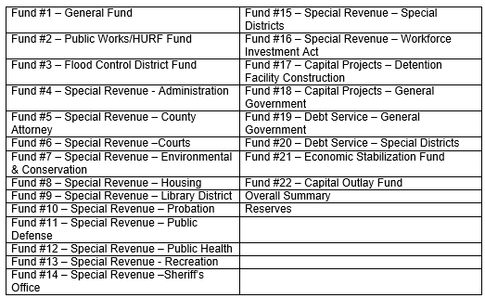

Figure 3 on page 25 provides a snapshot of the structure of each sub plan. Each sub-plan includes the following information:

* **Long-term Plan Time Horizon** – the time horizon for the County long-term plan is a five-year outlook with the proposed 2016 budget looking forward to year 2021. Typically, localities use scenarios with either a five or ten year outlook. As the County implements the RESET Strategy recommendations, identification of a longer term outlook would be appropriate. The plan includes a historical look back beginning in 2010 to present 2015.
* **Revenues** – each long-term plan includes actual revenues for prior fiscal years and projections by revenue type.
* **Expenditures** – each long-term plan includes actual expenditures for prior fiscal years and projections by expenditure type or general label expenditures.
* **Excess of revenues over expenditures** – this row shows if the budget is balanced (meaning revenues and expenditures are the same) before transfers in and transfers out are made.
* **Transfers in and transfers out** – these two rows in each long-term plan are very important. These rows reflect where funds are moved in and out which helps balance the fund.
* **Fund Balances, July 1st**– this is the beginning fund balance amount for the fund at the beginning of the fiscal year.
* **Fund Balances, June 30th** – this is the ending fund balance amount for the fund at the end of the fiscal year.

**Figure 3: Long-term Plan Structure**

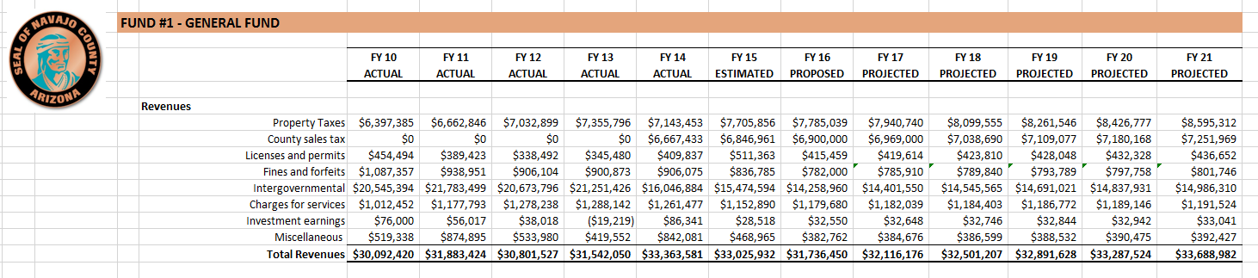

Time Horizon

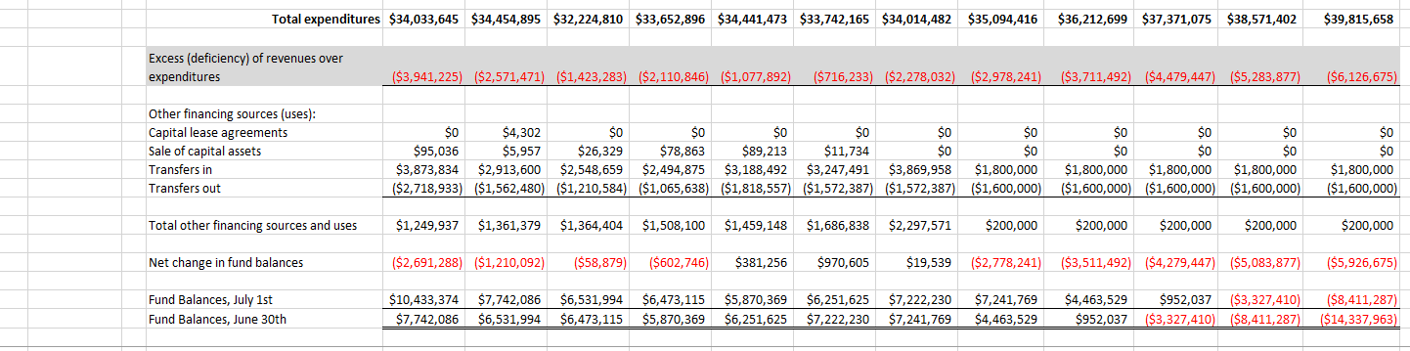

Fund balances

***Disclaimer: It is important to note that based on the timing of the Leadership ICMA project and the start of FY 16, all FY 16 budget at the time of writing this report are proposed and some of the data included in the long-term financial planning model is not available. Once FY 15 is closed out and the FY 16 budget is adopted, the numbers in the model will be updated.***

* **Long-term Plan Projections** – Leadership ICMA Team worked with Finance Department staff to develop projections for Fiscal Year 2017 – 2021. Figures proposed for Fiscal Year 2016 were used, as available, at the end of June 2015. The long-term financial planning model forecasts both revenues and expenditures:
* *Revenues* – are impacted primarily by external forces outside of the County’s control.
* *Expenditures* – can be controlled through management decisions; however, there are several expenditures that are unfunded mandates by the State of Arizona. Because the County is required to adopt a balanced budget each year, expenditures are matched to available resources. However, for the purposes of the financial model, out-year forecasts are not balanced in order to demonstrate the structural deficit that exists.
* **Long-term Plan Frequency –** the County fiscal year is July 1st to June 30th. It is recommended that the County use the long-term financial planning model throughout the year and at minimum update the model at the end of each fiscal year.

**Fiscal Sustainability Threats**

The ICMA Team identified five threats to developing fiscal sustainability in the County; these threats outlined in the following section include:

1. State unfunded mandates
2. Structural deficit
3. Inadequate reserves
4. Too much ownership
5. Political will

**Fiscal Sustainability Threat #1: State Unfunded Mandates**

Navajo County estimates that the State has decreased **Highway-User Revenue Fund (**HURF) funding by over $6 million dollars. Additionally, the County is required to pay 25 percent of the bill for juvenile corrections. These are two examples of continued, unfunded mandates by the State that puts pressure on the County’s General Fund. The County has acknowledged on several occasions that the use of flexibility transfers, allowed by the State, has enabled the County to balance the General Fund. If the use of flexibility transfers in the future is restricted or eliminated, this will be devastating to the County’s General Fund budget. Figure 4 below demonstrates the impact of unfunded mandates on the County’s property tax. Property tax is the primary revenue for the County and as illustrated only 20 percent remains to fund County programs after commitments to the State are fulfilled. In Fiscal Year 2015, the County property tax revenue totaled $6,916,474. The remaining 20 percent equates to $1,236,188 available to fund County programs.

**Figure 4: State Impacts to County Property Tax**

Another way of understanding the County’s fiscal realities is in Figure 5. This figure breaks down the amount of funding the County from property taxes as compared to other taxing districts. The County receives 8 cents of one dollar to fund programs and services.

**Figure 5: Distribution of 2014 Tax Dollar**

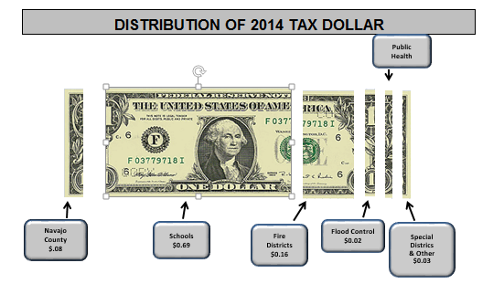

**Fiscal Sustainability Threat #2: Structural Deficit**

The biggest threat to the Navajo County budgeting process is the structural deficit that exists in the General Fund. Even though the State requires the County adopt a balanced budget at the time of adoption, the long-term financial planning model demonstrates expenditures have exceeded revenues for several years. This not as a result of unnecessary spending or lack of good fiscal judgement. The continued placement of unfunded mandates by the State makes it increasingly difficult to balance the budget. This systemic issue has been managed through the use of flexibility transfers where the County has transferred funds between several funds. As noted earlier in this report, the ICMA Team did not balance the five-year forecasting of revenues and expenditures in order to demonstrate the structural deficit that exists. If the ICMA Team did balance the long-term financial planning model, the result would show the need for significant reductions or an identified amount to cut. The ICMA Team did not believe this exercise would be useful. Identification of the structural deficit helps begin the conversation about available resources to fund services.

For example, the proposed 2016 budget includes the following:

**Proposed Revenues** $31,736,450

**Proposed Expenditures** $34,014,482

*Structural imbalance (deficit)* $ 2,278,032

Again, the structural imbalance that is visible when looking at Figure 6, shown on page 28, is addressed by making transfers in from other special funds.

The County will continue to have a structural deficit unless one of two things occur: 1) new revenue is generated that meets the current rate of spending and the reliance on inter-fund transfers is lessened or eliminated over a period of time or 2) reductions in level of service are made across the County. Option #2 is the less popular option and would have the biggest impact on the community. If changes do not occur moving forward, the structural deficit will continue to compound and the County will fall off the fiscal cliff. The ultimate worst case scenario for the County would be to declare bankruptcy or to have to ask the State for assistance.

**Figure 6: Navajo County General Fund**





Addressing the structural deficit in the General Fund absolutely has to be a priority in Fiscal Year 2017. As you can see from Figure 7 below, expenditures have historically exceeded revenue in the General Fund. The County will not be able to continue to balance the General Fund with use of inter-fund transfers from other funds (such as the Flood Control District Fund #3) in the long-term financial planning model.

**Figure 7: Navajo County General Fund Structural Deficit**

**Fiscal Sustainability Threat #3: Inadequate Reserves**

The idiom “the straw that broke the camel’s back” comes to mind to best describe the severity of the structural deficit as it relates to the County not having adequate reserves on hand. What will the straw be for the County? Will it be a natural disaster? Will it be the closure of the railroad? Will it be the closure of the pig farm? Will it be one more unfunded mandate from the State? Will it be the next recession?

Regardless of what it might be, the County has to take control and manage what it can, given the economic realities. Operating in a manner without adequate reserves creates greater risk and potential the County would be unable to respond to a catastrophic event.

**Cash Flow Issues**

The Finance Department regularly monitors spending to ensure that there is enough cash on hand for payroll and accounts payables. Think of this issue as the County living paycheck-to-paycheck and probably in some instances charging too much on credit cards.

On the surface this may appear to be a good financial practice. However, the root cause of the practice is driven by a cash flow problem that exists because the County does not have a large enough fund balance to ensure there is sufficient cash on hand to pay bills throughout the year. In order to monitor departmental budgets, discretionary spending limits are put into place so departments are really operating at a lower spending level than the adopted County budget.

As the Leadership ICMA Team learned during interviews with departments, the primary method used to address the County’s cash flow issue is to use discretionary spending limit approach. Approvals are often required through Finance to make certain purchases which takes autonomy away from departments in managing their budgets. This is not an effective way to manage a budget. The time and energy involved in managing the County budget in this manner could be better used on strategic initiatives.

**Fiscal Sustainability Threat #4: Too Much Ownership**

The County consists of very hardworking and passionate employees. One reoccurring theme heard during interviews with departments included statements such as “we are an extension of the State,” “we are mandated to provide this program,” and “we cannot eliminate this program.” The County is an extension of the State from a statutory perspective. However, employees who work for Navajo County work for the County not the State of Arizona. It is unfortunate that the State continues to place unfunded mandates onto counties. The following questions need to be discussed:

* Is this program or service mandated by the Federal government, State government or by the County?
* If a program or service is mandated, at what level is the County required to fund the program?
* If the program is not mandated, why is the County providing the program?

The County is mandated to provide certain programs and services without subsidy from the State. Using the *RESET Strategy* requires asking the question – providing at what level are we required to provide services? Are we providing services at a higher level of service than the state mandates?

Too much ownership that results in territorial issues and personal agendas will not help the County build financial sustainability. This is an important distinction to make in the discussion of fiscal sustainability, because while it may be a natural defense mechanism to justify a program or service, this position is counterproductive to moving the vision and strategic priorities of the County forward.

**Fiscal Sustainability Threat #5: Political Will**

Does the political will exist to move the *RESET Strategy* forward? The Leadership ICMA Team recommends that every elected and appointed official ask themselves this question. Do you want to be part of the solution or part of the problem? Authors in the National Civic Review identified the following in building financial sustainability, “Understanding all capital, operations, and maintenance costs projected over time is essential. Equally important is an understanding of revenue stream projections. Elected and appointed officials must have a shared understanding of both long-term costs and revenues in order to develop strategies for attaining fiscal sustainability…”[12] The greatest test of political will in implementing the *RESET Strategy* will come with elected and appointed officials collectively making decisions to reduce levels of service. Partnership is essential to addressing the structural deficit that exists in Navajo County. The National Civic Review authors noted, “Addressing the mismatch between the demand side and supply side requires creating community and inter-sectorial problem-solving partnerships.”[13]

Given the threats that exist to creating fiscal sustainability in the County, the ICMA Team has developed eight better budgeting tools described in the next section of this report.

***RESET Strategy Tools***

The ICMA Team identified eight tools for better budgeting; that if implemented, collectively will produce results. These tools include:

1. Prioritization & Resource Re-allocation for Existing Programs
2. Reductions
3. Variance Exercise
4. Creation of a Contingency Fund
5. Review of New Programs
6. Reserve Policy
7. Revenue Enhancement
8. Legislative Action

The *RESET Strategy* is intended to be a dynamic process as shown in Figure 8 below.

**Figure 8: *RESET Strategy***

***RESET Tool #1: Prioritization & Resource Re-allocation for Existing Programs[14]***

# The ICMA Team recommends the County implement a prioritization and resource re-allocation process modeled after the Center for Priority Based Budgeting’s (CPBB) methodology. Budgeting for outcomes and performance measurement are commonly used tools; however, it is important to note that this *RESET Tool* is neither.

# Prioritization is the process of ranking all County programs and services and budgeting accordingly. Resource re-allocation is the process of redirecting funds to new or modified programs and services based on priorities. Therefore, for the Fiscal Year 2017 budget development, County departments have an opportunity to prioritize programs and re-allocate resources based on the *RESET* Services and Program Scoring Tool included in Figure 9 shown on page 32. This tool will assist the County in identifying what resources can be re-allocated based on strategic priorities.

**Figure 9: *RESET* Services and Programs Scoring Tool**

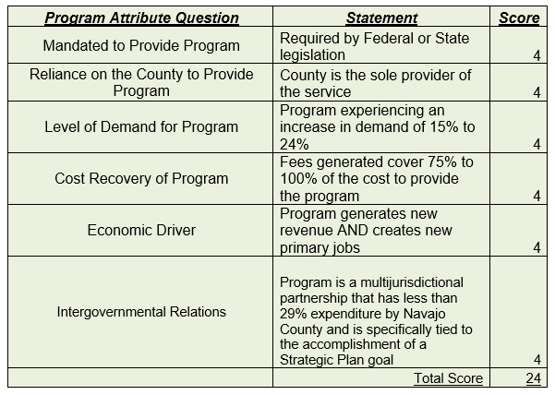

# The biggest threat to this process discovered in the focus group sessions and interviews was hearing “this program is mandated.” In order for this budget tool be effectively used, no programs are untouchable and not every program is mandated. The resource prioritization & resource re-allocation exercise provides a new “lens” for County officials to manage and make budget decisions. This process is not driven by trying to achieve a percentage in reduction or a dollar figure in reductions.

# “The objectives of implementing a successful prioritization initiative allows us to:

* Evaluate the services we provide, one versus another.
* Better understand our services in the context of the cause-and-effect relationship they have on the organization’s priorities.
* Provide a higher degree of understanding among decision-makers as they engage in a process to rank services based on priorities.
* Articulate to people in the organization and to the public how we value our services, how we invest in our priorities, and how we divest ourselves of lower-priority services”[15]

Additionally, the CPBB advocates that successful prioritization is the result of three important factors:

* “The right results. Accurate prioritization of programs depends on comprehensive identification of results we are in the business to achieve.
* The right definitions. Precision in prioritization results from the articulation of the cause-and-effect relationship between a program and a result. With clearly defined causality and an understanding of the influences on results, we can minimize subjectivity in linking programs with results.
* The right valuation. With the right results and with clear definitions we can accurately value our programs relative to their influence on achieving results.”[16]

While the ICMA Team has developed the *RESET* Services and Programs Scoring Tool using the CPBB methodology, a core piece of their methodology known as resource allocation scoring against result definitions is not included in this project. When using result definitions such as “Economic Vitality” or “Safe Community,” programs are then measured in terms of relevance in achieving the defined result. An example of a result definition from the City of Wheat Ridge, Colorado is included in Figure 10.

“Designing a process that is fair, accessible, transparent, and adaptable is a challenge. However, it is also an opportunity to customize a priority-driven budgeting process that fits your organization best.”

*Government Finance Review*

The ICMA Team recommends the County focus on review and prioritization of programs and services and at a future point add the tie to community results see Figure 11. Development of result definitions typically involves engagement from elected officials and the community. The result definitions may look different or similar to the Five Year Strategic Plan Goals. The Team believes the County will be ready to take this step in 2017.

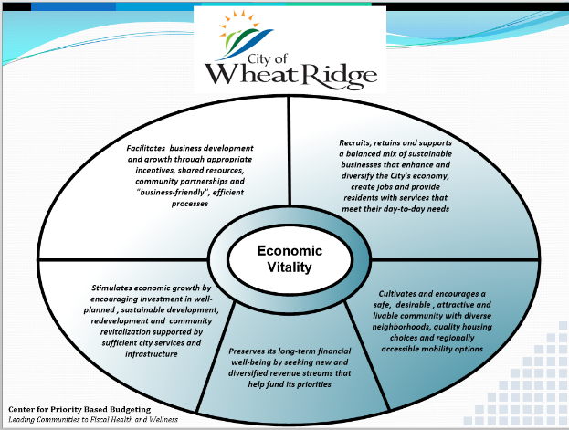**Figure 10: Economic Vitality Result Definition for Wheat Ridge, Colorado**

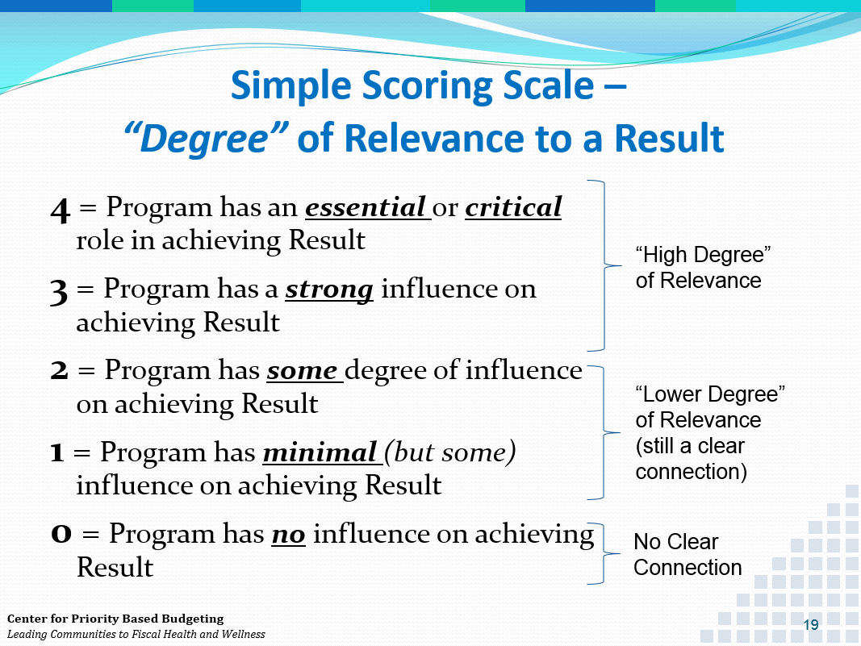**Figure 11: Center for Priority Based Budgeting Scoring Scale**

For the implementation of the *RESET Strategy*, programs will be prioritized using the program attributes criteria shown earlier in Figure 9. The program attributes developed for the County used the CPBB’s program attributes with the addition of two attributes the ICMA Team designed unique to the County: 1) Economic Driver and 2) Intergovernmental Relationships. Each program attribute and the related scoring is described below:

* **Mandated to Provide Program – the grading criterion established to score programs is on a scale of 0 – 4.[17]**

*Programs that are mandated by another level of government (i.e., Federal or State) will receive a higher score for this attribute compared to programs that are mandated solely by the County or have no mandate whatsoever.*

* + 4 - Required by Federal or State legislation
  + 3 - Required by Charter or incorporation documents OR to comply with regulatory agency standards
  + 2 - Required by Code, ordinance, resolution or policy OR to fulfill franchise or contractual agreement
  + 1 - Recommended by national professional organization to meet published standards or other best practice
  + 0 - No requirement or mandate exists
* **Reliance on the County to Provide Program – the grading criterion established to score programs is on a scale of 0 – 4.[18]** 
  + 4 - County is the sole provider of the service
  + 3 - Program is only offered by another governmental, non-profit or civic agency
  + 2 - Program is offered by only one other private business in the immediate area
  + 1 - Program is offered by other private businesses outside County limits
  + 0 - Program is offered by other private businesses within County limits
* **Level of Demand for Program – the grading criterion established to score programs is on a scale of -4 to 4.[19]**

*Programs demonstrating an increased demand will receive a higher score for this attribute compared to programs that show no growth in demand for the program or service. Programs demonstrating a decrease in demand for the service will actually receive a negative score for this attribute.*

* + 4 - Program experiencing an increase in demand of 25% or more
  + 3 - Program experiencing an increase in demand of 15% to 24%
  + 2 - Program experiencing an increase in demand of 5% to 14%
  + 1 - Program experiencing an increase in demand of 1% to 14%
  + 0 - Program experiencing no change in demand
  + -1 - Program experiencing a decrease in demand of 1% to 4%
  + -2 - Program experiencing a decrease in demand of 5% to 14%
  + -3 - Program experiencing a decrease in demand of 15% to 24%
  + -4 - Program experiencing a decrease in demand of 25% or more
* **Cost Recovery of Program – the grading criterion established to score programs is on a scale of 0 – 4.[20]**

*The ability of a program to “pay for itself” through user fees, intergovernmental grants or other specifically dedicated revenues. Programs will be graded on their ability to cover their costs through program fees.*

* + 4 - Fees generated cover 75% to 100% of the cost to provide the program
  + 3 - Fees generated cover 50% to 74% of the cost to provide the program
  + 2 - Fees generated cover 25% to 49% of the cost to provide the program
  + 1 - Fees generated cover 1% to 24% of the cost to provide the program
  + 0 - No fees are generated that cover the cost to provide the program
* **Economic Driver – the grading criterion established to score programs is on a scale of 1 – 4.**

*The ability of a program to generate new revenue and jobs.*

* + 4 - Program generates new revenue AND creates new primary jobs
  + 3 - Programs generates new revenue, OR creates new primary jobs or revitalizes lost jobs
  + 2 - Program generates new revenue
  + 1 - Program does not generate new revenue, create primary jobs or revitalize lost jobs
* **Intergovernmental Relations – the grading criterion established to score programs is on a scale of 0 – 4.**

*The ability of a program to generate partnerships that benefit the County as a whole as well as local jurisdictions.*

* + 4 - Program is a multijurisdictional partnership that has less than 29% expenditure by Navajo County and is specifically tied to the accomplishment of a Strategic Plan goal
  + 3 - Program costs are shared between partners with Navajo County’s expenditures ranging between 30-49%
  + 2 - Program costs are shared equally between partners
  + 1 - Program costs are shared between partners with Navajo County’s expenditures ranging between 51-84% and a majority of the program work is administered by Navajo County Staff
  + 0 - Program is not multijurisdictional

The ICMA Team believes the most significant contribution scoring criteria will bring to the County is objectivity. This criteria is intended to change the budget conversation. Through discussions with department heads and staff, the Team acknowledges that performance-driven questions are being asked in budget discussions; however, the program prioritization will be a comprehensive County-wide exercise that will provide new information and insight.

**Program Ranking**

In order to keep the program prioritization manageable, it is recommended that the *RESET Team* manage program prioritization lists first by department and then the County overall. The following big picture questions are recommended for the *RESET Team* to encourage departmental engagement when program prioritizations are developed and reviewed:

# Identify programs or services that the County could *stop doing*

* Identify opportunities for *improved efficiencies* in the delivery of County services
* *Re-allocation of existing funding* to support the creation of new programming tied to the County’s strategic priorities[21]

The goal of the prioritization process is to look at programs and services through a new lens. What can the County do differently from a programmatic cost perspective that supports the long-term financial sustainability of the County?

The ICMA Team recommends that the *RESET Team* develop ranking thresholds after all the programs and services are ranked. The RESET Team will see natural breaks or shifts in program scores and these will be points where decisions can be made around what programs and services to continue to provide.

Re-allocation of County programs and services will only be successful if County leadership is willing to look forward and find new and better ways to provide services. In many instances, this type of re-allocation of County services will involve letting go of resources which may include positions. Ultimately, these strategies call for necessary changes in service delivery to generate cost savings and reductions.

The County has an opportunity in late 2015 to hire a new Assistant County Manager. The ICMA Team believes that this new position can help champion the *RESET* Strategy moving forward. The Team recommends the individual hired possess a strong budgeting and financial management background coupled with experience in organizational development and performance management. Performance audits is a tool that is recommended for use internally by the County Manager’s Office after initial program inventories and prioritization is established.

*Responsibility: RESET Team establishes review process for prioritization and resource re-allocation. This is the responsibility of all departments and elected officials in the County.*

***RESET Tool #2: Reductions***

The ICMA Team is recommending the County implement reductions that are strategic and tied to the use of *RESET* Tool #1. Across-the-board cuts or reductions based on a percentage of budget are two common yet ineffective ways to manage a budget imbalance. This approach usually does more harm than good when striving to achieve fiscal sustainability. The *RESET Team* will need to identify what level of reductions will be made in order to address the structural deficit in the General Fund and to increase the reserve level. Additionally, the creation of a contingency fund or *RESET* Tool #4 is recommended.

Reductions will come from what the County can stop doing. The *RESET* Team needs to identify how much in reductions can be identified after going through the prioritization exercise. It is up to the County to decide whether or not reductions need to be made. Two examples of programs that the County is not required to fund that the ICMA Team was informed about during the first site visit include:

***Example 1:*** The actual cost to provide juvenile detention services is $1.2 million annually. Apache County recently closed their facility and will pay the County approximately $100,000. There is also an opportunity to partner with Coconino County. This program is an example where the County has an opportunity to evaluate fees for service. What level is the County required to fund this program at?

***Example 2:*** The County currently funds a Child Support Program. The State of Arizona funds and provides a child support program. The County is required to provide a $250,000 grant match for this program and the State only reimburses the County 66 percent of program costs. This program is an example of a County program that is funded above the state mandate and does not have high cost recovery. Can this program be scaled back? Should this program be eliminated and resources directed to other County priorities.

The two above examples are just two examples in order to demonstrate the shift in thinking that needs to occur as part of the *RESET Strategy* implementation.

***RESET Tool #3: Variance Exercise[22]***

It is recommended that the *RESET* Team conduct a variance exercise for the development of the Fiscal Year 2017 Budget. The ICMA Team believes there is a good understanding of this budgeting concept and to a certain degree the County is already doing. The threat in using this budget tool is in situations where elected officials refuse to “let go” or “give up” or re-allocate funds to other purposes.

*How the variance exercise works:* this is a simple exercise where comparisons are made between budgeted funds and actual funds spent. This is a way to capture the “low hanging fruit” and identify funds that can be re-allocated to other strategic programs and services.

Example:

Department A budgets $50,000 for x service in Fiscal Year 2015

Department A actually spent $30,000 for x service in Fiscal Year 2015

***Variance*** is $20,000 in funds not spent

Why does a variance exist? This is the primary question that needs to be asked. The ICMA Team recognizes that County staff does ask this question to some degree; however, use of this tool with the other better budgeting tools is recommended.

Successful use of the variance exercise includes identifying a minimum variance threshold, such as $5,000. The threshold can be as low or as high as the County would like it to be. This threshold should be set by the *RESET* Team.

The ICMA Team strongly recommends that the County *RESET* expectations surrounding full-time equivalent positions (FTE) in the annual budget. Several positions are budgeted and are not filled because funding is not available for these positions. This practice has created an artificial variance when comparing budgeted amounts to actual amounts at year end. Central to the success of the *RESET Strategy* is letting go of position counts and having the adopted County budget reflect the actual FTE count today. The Team recognizes this has been a way to hold the line. It is a new time, a new day, and Navajo County cannot afford to hold onto what was pre-recession. The County needs to account for the positions that currently exist and determine what is needed in the future without attaching political strings.

*Responsibility: RESET Team establishes minimum variance threshold in all funds.*

***RESET Tool #4: Creation of a Contingency Fund***

The creation of a contingency fund is a tool used hand-in-hand with the variance exercise explained above. Because the contingency fund is created by making reductions based on budgets to actuals, a contingency fund can provide a resource for staff to tap into if funding is needed. The key to the success of using a contingency fund is not to use it on new requests or programs; rather to only use the funds on items that were reduced.

*Example:*

* The variance exercise yields $500,000 in funds that could be reduced or re-allocated.
* County Administration budgets $375,000 in the form of a contingency fund.
* $125,000 is generated in reductions that can either be used in the form of resource re-allocation recommended in *RESET* Tool #3 or reductions in *RESET* Tool #4.
* A contingency fund is created by consolidating amounts in several program budgets into one line item account.
* A process is created by which department directors request use of contingency funds through the County Manager.

If the contingency funds are not spent at the end of the fiscal year this is a good thing as the remaining funds increase the available fund balance. The ICMA Team recommends the County look at establishing a contingency fund amount of at least $100,000, meaning reductions in this amount would need to be identified in the General Fund.

*Responsibility: RESET Team establishes annual contingency fund amount.*

***RESET Tool #5: New Programs[23]***

In moving forward, the ICMA Team recommends that all newly proposed programs and services, even if mandated by the State, are evaluated using the *RESET* Services and Programs Scoring Tool. It is recommended that the *RESET Team* develop a threshold using the scoring tool when new programs score high enough to justify adding the program to the County 2017 Budget.

***RESET Tool #6: Reserve Policy***

Reserves are a portion of the County fund balance set aside to use for emergency situations. The County has a reserve policy requiring a minimum of 10 percent set aside in the General Fund and whenever possible they do the same in other special funds. The ICMA Team recommends that the County reevaluate their reserve threshold and adopt a new, stricter reserve level for both the General Fund and special funds. As noted on page 22 of the County 2014-15 Budget document, reserves play an important role in ensuring cash liquidity. However, the County has liquidity problems as discussed earlier in this report. To assist the County, the ICMA Team has included reserve analysis included in Figure 12. This spreadsheet is tied to the long-term financial planning model and includes recommendations on different reserve thresholds based on a percentage of General Fund expenditures.

The ICMA Team recommends that the County work towards building a minimum 17 percent reserve in the General Fund over the next five years. This change would result in an increase from the County’s current 10 percent reserve requirement. Again, Figure 12 includes a breakdown of reserve target levels of 17 percent, 25 percent and 35 percent.

The *RESET Team* could choose to adopt a higher level say at 25 percent; however, doing so would require more reductions in the General Fund. The ICMA Team recommends starting with 17 percent and working towards achieving higher reserve levels in other special funds first.

The following example has been included to demonstrate the additional funds that would be needed resulting from reductions in the General Fund in order to meet the recommended 17 percent reserve minimum:

* Fiscal Year 2016 Proposed General Fund Expenditures $34,014,482
* Current 10 percent requirement $3,401,448
* Recommended 17 percent minimum reserve $5,782,462
* Additional amount needed to build reserve level $2,381,014

**Figure 12: Navajo County Reserve Analysis**

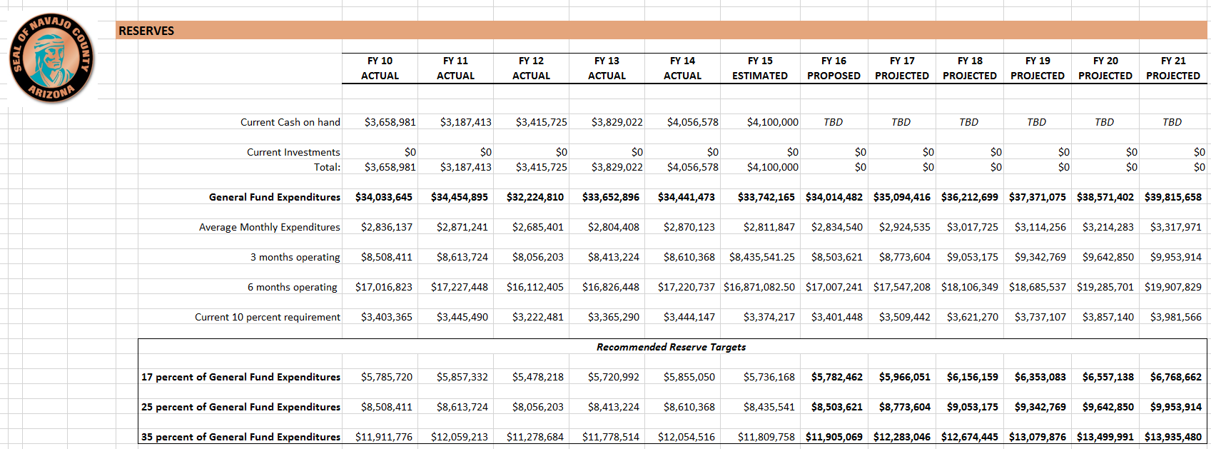

*Note: Information from the City Treasurer was not available as to how much funding the County has invested. This spreadsheet will need to be updated to reflect that amount.*

*Responsibility: RESET Team recommends new reserve threshold and seeks Board of Supervisor approval.*

***RESET Tool #7: Revenue Enhancement***

The County has seen firsthand the impacts of decisions by Federal and State lawmakers which has continued to create unfunded mandates and shift the responsibility for subsidizing programs to the County at a higher level. Critical to revenue enhancement is the County making economic development decisions and marketing high priority development areas in the coming years. County Administration’s decision to hire Paul Watson, Assistant County Manager/Economic Development Director is a step in the right direction. Because revenue enhancement is critical to the long-term financial sustainability of the County, the Leadership ICMA Team added two program attributes to the Services and Programs Scoring Tool:

* Economic Driver
* Intergovernmental Relations

These two attributes were developed specifically for the County. The Leadership ICMA Team believes that using these attributes when completing the services and programs scoring process will provide new information or a different “lens” to help determine level of service priorities. These program attributes measured against program mandates will help the County balance perspective in terms of what must be done and what they need or envision for the future.

* *Economic Driver*
  + Program generates new revenue AND creates new primary jobs
  + Program generates new revenue, OR creates new primary jobs or revitalizes lost jobs
  + Program generates new revenue
  + Program does not generate new revenue or create primary jobs or revitalize lost jobs
* *Intergovernmental Relations*
  + Program is a multijurisdictional partnership that has less than 29% expenditure by Navajo County and is specifically tied to the accomplishment of a Strategic Plan goal
  + Program costs are shared between partners with Navajo County’s expenditures ranging between 30-49%
  + Program costs are shared equally between partners
  + Program costs are shared between partners with Navajo County’s expenditures ranging between 51-84% and a majority of the program work is administered by Navajo County Staff
  + Program is not multijurisdictional

The ICMA Team recommends that the County share the program scoring prioritization with cities/towns within the County and look for opportunities to leverage partnerships and continue to foster existing ones. One anecdotal example of the challenge with economic development that was shared with the ICMA Team on the second site visit, included the story of the Town of Holbrook and the challenge the Town faced in some community members not wanting a Subway. This is lost revenue for the Town of Holbrook and a loss of economic growth for the County as well. As the County moves forward with the RESET Strategy implementation, tough discussions need to occur. Can the Town of Holbrook afford not to have a Subway? What is at risk by welcoming a Subway to town? What is at stake by welcoming a Subway to town?

In order to help facilitate what the overall vision for the future of the County could look like, the ICMA Team recommends the County seek assistance from the Urban Land Institute Advisory Services program.

*Urban Land Institute Advisory Services Panel (ULI)*

*“Advisory Services panels provide expert, independent, timely, candid, and unbiased input from national real estate, land use, design, and planning experts. Panels bring outside points of view to help kick-start critical conversations and move beyond decision-making dead ends. They help communities gain fresh insight and come to innovative solutions for complex land use and real estate development challenges.” ULI*

*This program helps communities find strategic and practical solutions for the most challenging issues facing today’s urban, suburban, and rural areas. ULI Advisory Services forms a panel of industry leaders from “its diverse memberships, including developers, planners, financiers, market analysts, designers, economists, architects, and public officials to provide objective advice that is not available from any other source. The Team believes this unique approach would greatly benefit the County in seeing what is possible from an economic development perspective.*

More information can be found on the ULI Website here:<http://uli.org/programs/advisory-services/advisory-services/>

Employing the assistance of ULI could be through a regional partnership with local governments. The ICMA Team recommends that the County invest resources in building regional partnerships through projects such as this one.

***RESET Tool #8: Legislative Action***

The Leadership ICMA Team recommends the County begin to actively lobby the State of Arizona for constitutional reform of mandated positions such as the Constables that are antiquated and inefficient. Following the completion of RESET Tool #1: Resource Re-allocation & Prioritization, the Leadership ICMA Team recommends an education piece be developed to communicate to State Legislators the cost of unfunded mandates. An important element of this education piece is to include the amount of reductions that the County will have made as a result of using RESET Tool #2.

***RESET Strategy* Communications**

Navajo County’s successful implementation of the recommended financial sustainability roadmap depends on the organization’s willingness to cultivate an environment conducive to change. Establishing such an environment requires deliberate, strategic and effective communications.

Given the current trends in public management, the towering presence of social media, access to information and exponential growth in cultural diversity, governments across the nation and the world are being held to higher standards and expectations. Communication is now recognized as a key element in almost any institution, whether non-profit, corporate or government agency. Efficient communication is more than a transfer of information: it must be multi-directional, and open to receive communications or information in exchange and feedback.

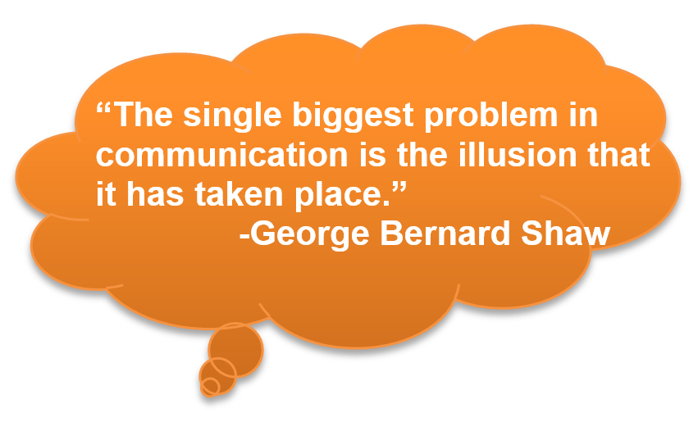Similar to many other localities, the County is experiencing the roughest of times in the aftermath of “the Great Recession.” However, some impacts experienced by staff, community partners and the County at-large are the result of a delay in financial impacts mitigated through efficiency exercises that are now circling the drain. It is no secret that the County has come to a *“do or die”* crossroads in its financial planning and budget development*.* Nevertheless, the ICMA team is confident the County can pull through successfully by realizing their financial position, making difficult but strategic decisions and lastly, implementing an internal and external communication program that is inclusive of the organization and the community.

In the original scope of work, the ICMA Team was to provide a civic engagement model to be utilized as part of the new approach toward building the County’s fiscal strength. However, throughout the interviews with staff from various departments, the team learned that in many cases, significant budgetary decisions were made post department discussion without notice or reason. Additionally, staff expressed a desire to engage County management in the finer details of the budget as it related to the thought process behind imposed caps/limits within each department’s budget. Additionally, staff expressed a desire to understand how this is done without establishing a true reserve fund to capture the funds within the capped portion. It was evident that the lack in transparency and proactive communication has drained employee morale, and as a result, the trust relationship between management and staff has been impaired. As a result of these findings, the ICMA Team agreed to amend the scope of work to include an internal communications strategy model to re-establish and strengthen the organization’s communications and rebuild trust relationships across the organization, from executive staff down through professional and frontline employees.

The adoption and implementation of an internal and external communication program contributes to the integration of staff and community members. It fosters a sense of belonging to the County and creates a healthy work and community environment, spirit of collaboration and better work relations. Inclusivity buffers the anxiety and pressure of facing the uncertainties that come with change, because all, bear the burden and are equally responsible, and are most willing to seek resolution.

***“***[***Communication leads to community, that is, to understanding, intimacy and mutual valuing.***](http://www.brainyquote.com/quotes/quotes/r/rollomay389414.html?src=t_communication)***”* -**[**Rollo May**](http://www.brainyquote.com/quotes/authors/r/rollo_may.html)

|  |
| --- |
| **Effective communications are built upon the following principles:**  **Organizational Communication is a management process** with a specific business purpose and disciplined methods of development, implementation, and measurements. It is accomplished through a strategic communication plan that is reviewed and approved by senior management. It is as equally important that management follow the process. Exceptions at the management level can be detrimental to the successful communications throughout the organization.  **Communication is a change agent.** The purpose of communication is not just to convey information, but to influence behavior. It influences behavior by persuading people to take action toward the organization's objectives. One of the major points of contention between County staff and leadership is that communications during the budget development process are more directive and do not provide opportunities to change decisions made as it relates to transparency, creativity, and inclusivity. It is critical that this current form of communications evolve to include staff as part of the *RESET Strategy*, promote innovation and encourage feedback on improvement strategies.  **Executive Leadership is responsible for internal communication.** Believe it or not, proactive face-to-face communication with staff is **still** the most effective form of communication, and is the way employees prefer to receive information relating to their job. Executive staff must also communicate a unified message and ensure messaging is pushed throughout every level of the organization.  **Communication is a social process.** Communication is a social process based on transparency, sharing, and participation. Communication must recognize and leverage the basic human need for knowing and relating. Communication must be open, flowing vertically and horizontally throughout the organization.  **To be understood, communication must be rooted in the interests and language of the receiver.** While it seeks to achieve the organization's strategic objectives, it cannot do so effectively unless it uses a receiver-focused approach in both content and context. Speak the language of the audience in order to achieve the highest level of clarity and comprehension. Steer clear of technical terminology, government-speak and “legalese”. For Navajo County, communication efforts must reflect and appreciate the values, and customs of its diverse constituency of residents and stakeholders. This includes meeting the intended audience on their terms…and possibly at their location  **To be noticeable, communication must be compelling and perpetual**. As it must compete for the receiver's attention, communication must use highly compelling and creative ways to deliver its message. To be remembered and adopted by the organization, communication needs to be continuous and consistent. The County cannot afford not to communicate…and they must communicate frequently.  **To be influential, communication must be credible.** Without a high degree of credibility, the integrity and believability of the message will be lost, and the whole communication process will be a waste of resources. The County must follow through. In cases where much of an organization’s credibility has been compromised, leadership must first begin with small wins over long periods of time that help establish an environment conducive to re-building trust between the organization, it’s employees and the community it serves. |
| **Effective communications established in six steps**  The following serves as a framework and approach for developing a standard process for communications management:    **Step One – Analyze current situation**  Start communications planning with some research. Research can be as extensive as commissioning a public opinion poll or as simple as talking with clients or staff on an informal basis. It also means asking the following questions about the current situation and what affects it:   * What are the County’s goals, strengths and weaknesses? * What resources are currently available? Budget restraints? * Is there any current research that will help? * Has this type of communications activity taken place before? If so, what was the result? * What are the major communications opportunities?   + Local newspaper(s) not just the mainstream, but grassroots publications as well:   + Public access channels   + County website   + Social Media (Facebook, Twitter, Instagram, etc.)   + Community events (booth rentals)   + Public engagement tools (Mind Mixer, Mind Quest, etc.)   + County website * What are the major communications impediments?   + Identify champions (and opposition)   + Languages? Translated materials are critical.   **Step Two – Outcomes and milestone achievements**  Define outcomes and milestone achievements. Outcomes are the overall changes desired. Milestone achievements are the short-term, measurable steps you take to reach the intended goal.  When deciding on objectives, ask:   * Are we seeking to provide new information? * Are we calling the audience to action? * Are we seeking to change behavior?   Milestones should form a clear statement of what is being accomplished. They should be specific, realistic and listed in order of importance. They should also be measurable. When preparing a communications plan, measure results against milestone achievements.    **Step Three – Target Audience**  The next step in the planning process is to determine target audiences by: listing the groups to communicate, and analyzing each group.  The more clearly the audience is defined, the easier it will be to make choices about messages and communication vehicles. Appendix 5 includes possible target audiences for consideration. When analyzing each group, consider:   * What do they already know? * How are they likely to react to your message and why? * What are some factors influencing the audience that receives your message – for example: literacy levels or multicultural differences? * Are there any difficulties in communicating with each group?   **Step Four – Message Platform (Elevator speech)**  Develop the message platform or key messages for target audiences. Write down each message in a simple, specific statement. Elevator speeches should be brief, succinct, and presented in a way that is catchy and memorable. An ideal elevator speech is less than 6 lines or bullets.  Taking into consideration objectives and target audiences, identify the essential idea or set of ideas to communicate. Ask - What does the audience already know about this issue? What does the audience need to know? What do we want to tell the audience? Demonstrating a commitment to fulfill the audience’s need is a sure way to gain buy-in. A clear description of the benefits will help ensure that your message is received, understood and acted upon.  The following is an example of elevator speeches prepared for the City of Tacoma’s 2025 Visioning and Strategic Plan steering committee, City Council and staff:  *“Tacoma is one of the nation’s healthiest, safest, and most playful cities. We have daily access to stunning natural surroundings and a great quality of life. We recognize just how lucky we are, but we know we can make it better. Through a series of community events, stakeholder work sessions and online opportunities, the City of Tacoma invites you to engage in this visioning process and share your thoughts. We have a unique, once in a lifetime opportunity to identify a shared vision for Tacoma’s future and take the steps needed to achieve it. What is your vision for Tacoma in 2025?”* Message platform examples are included in Appendix 7.    **Step Five – Communication Strategy**  There are many communication vehicles available from which to choose; the narrow options to the communication vehicles that:   * Fit with current resources * Are the most effective to reach target audiences and include them with your message(s) * Help achieve goals and deliver desired outcomes   Timing is another very important consideration when choosing communication vehicles. Communication plans may need a theme to tie them together. The theme line should be a short, punchy version of the main message and should be the link between all activities and materials.  Organization is also critical to successful communications. Make a “to-do” list of what needs to be done before the event/activity. For example:   * List all the highlights of the event that you would like to feature * Prepare a distribution/mailing list * Write new releases and schedule a date to distribute * Respond to media inquiries generated by the news releases   If developing a long-range communications plan, build milestones to assist in tracking progress.    **Step Six – Evaluation (Continuous Improvement)**  Process evaluation and course correction are vital to the longevity and productivity of how services are delivered by the County. It also demonstrates a willingness to identify hiccups in the flow of a service, and a commitment to do better, which helps build credibility. There are a variety of formal techniques for measuring the results against objectives, such as readership surveys, attitude audits, and focus group sessions.  Less formal assessments, such as media coverage and talking to clients are quick and efficient methods to gather feedback. Was the information released to the public in a way that was creative, meaningful and effective? The evaluation of the first plan should form the foundation of the next communications plan.  **Director of Communications**  As it relates to building a strategic and credible communications system that meets the needs of Navajo’s uniquely diverse community, it is imperative to establish leadership and solely responsible for the County’s communications efforts and will employ communications strategies that promote County initiatives and provide public access to information.  Currently this role is covered by the Community Services Director (a newly created position), which is structurally located within the County Attorney’s office, but executes a number of duties within the County Manager’s Office. The varied capacities of the role include financial auditing, grant management, marketing/branding and special projects (such as the Leadership ICMA Capstone). This this creates some confusion as it relates to the duties and authority of the position. The title itself is misleading. The ICMA Team sought clarification through a number of conversations to better understand the Community Services Director’s role. While the incumbent executive in this role is well able and capable to carry out assignments varying from auditing to communications and branding, the County Manager must clarify the purpose and function of this position (including the position title) in order to build credibility and move the needle concerning strategic communications.  **Recommendations for civic engagement in Navajo County**  In addition to solidifying a key executive responsible for managing the development of an internal communications strategy and messaging for the entire organization, the ICMA Team recommends the following key focus areas in establishing a strategy for civic engagement:  **Key Focus Areas**   1. **Establish community leadership network (3-5 individuals minimum)**    1. These are visible and credible individuals in the County who have developed and maintain a strong and broad circle of influence.       1. These will be your community collaborators and unofficial County spokespersons.       2. Individuals on this team must express their commitment to promoting county communications. At times these positions may require some financial or in-kind support or sponsorship    2. Seek out individuals who represent all sectors of the County to participate in the network.    3. Include at least two members between the ages of 16-24 2. [http://image.slidesharecdn.com/behaviours4collaboration-141212072756-conversion-gate01/95/behaviours4collaboration-2-638.jpg?cb=1418369437](http://www.google.com/url?sa=i&rct=j&q=&esrc=s&source=images&cd=&cad=rja&uact=8&ved=0CAcQjRxqFQoTCPnS8J_h78YCFVCsgAodYZ4PBg&url=http://www.slideshare.net/EEPaul/behaviours4collaboration&ei=fhWwVfmbKdDYggThvL4w&bvm=bv.98197061,d.eXY&psig=AFQjCNGUAE3meQTNt5IVjsuHEslKJl0v0Q&ust=1437689567619814)**Establish staff communications team**    1. Select at least one employee from each operational area who possess strong communication skills, poise and a specialty within their area of work    2. Develop a communications calendar for all outreach efforts on policy, programs and events       1. May use a Gantt chart to assist with scheduling materials prep/design/communications 3. **Develop a comprehensive civic engagement plan/process**    1. Identify all community groups, associations, grassroots efforts and develop a directory of contacts    2. Establish a listserv and register each group to receive County communications    3. Identify all potential venues across the County that could be used for engagement events 4. **Promote diversity, equity and empowerment**    1. True engagement seeks out the alternative perspective    2. Include students (k-12, post HS, college, post-graduate)    3. Focus on underserved areas and minority groups 5. **Develop and implement a media training program for both internal and external teams**   **Other considerations:**   * Maximize cable channel with standing/reoccurring news show on Navajo County to include the following:   + Develop a news show on the County with an “anchor”, special features and remote pieces   + Develop a concept for the Health Department, as they are one of the County’s most active departments in the community. * Develop YouTube channel and upload a minimum of two short-story videos each month (two to eight minutes each) * Partner with municipalities and other agencies to conduct joint outreach/engagement efforts * Strengthen County’s branding   + Hashtag campaigns at special events (#wearenavajo, #navajo)   + Transform County programs and services using marketing strategies and call-to-action rallying in the community     - EXAMPLE:       * City of Tacoma’s domestic violence program “COURAGE INITIATIVE”       * New York City’s nutrition and wellness program “Eat Well; Play Hard”       * City of Wheat Ridge Code Enforcement service Traffic Safety, Life Quality, and Crime Reduction “TLC” for proactive code enforcement program       * ICMA’s “Life, Well Run” campaign initiative |
|  |

***RESET Strategy* Managing Change**

Implementation of the *RESET Strategy* will require the organization to execute several changes throughout the organization. The following foundational elements to change management have been included to assist with the implementation strategies discussed earlier in this report:

1. **Awareness of the need for change:**

Understanding whychange is necessary is the first key aspect of successful change. This step explains the reasoning and thought that underlies a required change. Planned communication is essential. When this step is successfully completed, employees will fully understand why change is necessary.

1. **Desire to participate in and support the change:**

In this step employees are able to reach a point where they make a personal decision to support the change and participate in the change. Naturally a desire to support and be part of the change can only happen after full awareness of the need for change is established. Building desire is partly achieved by addressing incentives and creating a desire to be a part of the change.

1. **[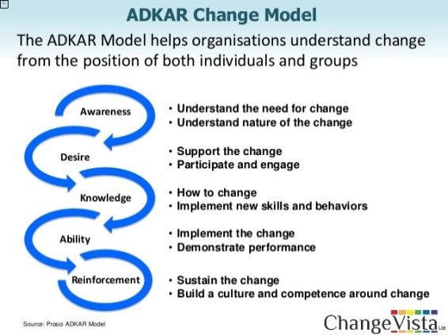](http://www.google.com/url?sa=i&rct=j&q=&esrc=s&frm=1&source=images&cd=&cad=rja&uact=8&ved=0CAcQjRxqFQoTCMLCpsaw8sYCFRYtiAodTBkNhQ&url=http://www.slideshare.net/assocpm/enabling-change-neil-white&ei=FXWxVYLkB5baoATMsrSoCA&bvm=bv.98476267,d.cGU&psig=AFQjCNG9G-BhbA31LdBlpIQ5in0ku_7OqQ&ust=1437779505621710)Knowledge on how to change:**

The third building block of the model, providing knowledge about the change, can be achieved through normal training and education methods. Other methods of transferring knowledge, such as coaching, forums and mentoring, are equally useful, so don't limit this process to formal training. Two types of knowledge need to be addressed: knowledge on how to change (what to do during the transition) and knowledge on how to perform once the change is implemented.

1. **Ability to implement required skills and behaviors:**

In this model Ability is understood to be the difference between theory and practice. Once knowledge on how to change is in place (theory) the practice, or actual performance, needs to be supported. This can take some time and can be achieved through practice, coaching and feedback.

1. **Reinforcement to sustain the change:**

This final stage of the model is an essential component in which efforts to sustain the change are emphasized. Ensuring that changes stay in place and that employees do not revert to old ways can be achieved through positive feedback, rewards, recognition, measuring performance and taking corrective actions.This is often the part of change management that is most difficult. However, for successful change, reinforcement is essential to ensure that changes are maintained and new outcomes can be measured.

***RESET Strategy* Timeline**

The Leadership ICMA Team has developed the following recommended timeline for implementation of the *RESET Strategy.*

The Leadership ICMA Team acknowledges that the above timeline is an aggressive one. The sooner the County addresses the structural deficit in the General Fund and implements the *RESET* Tools, the sooner the County will be on a path towards financial sustainability.

***RESET Strategy* Other Recommendations**

***Partner with the Center for Priority Based Budgeting (CPBB)***

The Leadership ICMA Team has put together a roadmap to financial sustainability for the County to use moving forward. If the County does not believe the in-house resources are available to implement RESET Tool #1 (Prioritization & Resource Re-allocation), the ICMA Team recommends exploring a partnership with the Center for Priority Based Budgeting (CPBB) to complete this piece of the *RESET Strategy*. This partnership would likely cost the County between $20,000 - $30,000. The Leadership ICMA Team believes that the County is ready to take on this project. The benefit of this partnership would be use of automated online tools, scoring process, and information which is beyond the scope and timeline of the ICMA Team. If funding this work becomes an issue, the Leadership ICMA Team recommends exploring a partnership between Alliance for Innovation, the International City County Management Association and the Arizona Association of Counties to see if the project could be funded as part of a case study. For more information on CPBB visit: [www.pbbcenter.org](http://www.pbbcenter.org)

***Performance Measurement***

The ICMA Team recommends the County design a performance measurement framework in 2017. The Team does not recommend implementing a framework in 2016. The first step is the prioritization of programs and services. The discussions that will develop from this process will be useful in the development of a performance management framework. Managing a performance management program requires time and energy and it is recommended that the immediate focus be on identifying program priorities and ensuring resources are allocated accordingly.

***Compensation Study***

It was brought to the ICMA Team’s attention that job descriptions are out of date and a market-driven compensation plan does not exist. This is not uncommon as local government organizations are still recovering from “the Great Recession.” The Leadership ICMA Team recommends that the County budget for a compensation plan to be conducted in 2017 or 2018. The County has been in a transition period where temporary approaches to staff compensation have been used. The County may need to continue to do this for a few or more years. The purpose of budgeting for a compensation plan is two-fold: 1) commit to looking at staff compensation while knowing that the old/current system that is no longer in use is not fiscally feasible, 2) commit to developing a new approach to compensation that will be feasible moving forward for a three to five year period of time.

Recognizing that reductions are recommended in this report, the ICMA Team believes that an incentive program that would reward staff who assume additional responsibilities without reclassification or job title change.

1. Center for Priority Based Budgeting (CPBB).
2. Government Finance Review, “Anatomy of a Priority-Based Budget Process,” April 2010, page 9.
3. Public Management, “Getting Your Priorities Straight,” June 2008, page 15.
4. Government Finance Review, “Anatomy of a Priority-Based Budget Process,” April 2010, page 16.
5. Center for Priority Based Budgeting (CPBB).
6. County of Navajo, Fiscal Year 2014-2015 Budget, page 11.
7. Government Finance Officers Association (GFOA) Website, The Pillars of a Sound Financial Planning Process, <http://204.12.67.77/pillars-sound-financial-planning-process>
8. Navajo County Five-Year Strategic Plan 2013 – 2017, page 8.
9. National Civic Review, 2014.
10. Public Management, 2008.
11. Government Finance Officers Association (GFOA) Website, What Is A Long-Term Financial Plan? <http://www.gfoa.org/what-long-term-financial-plan>
12. “Key Findings on Fiscal Sustainability for Local Governments in Southern California,” 2014 National Civic League
13. “Key Findings on Fiscal Sustainability for Local Governments in Southern California,” 2014 National Civic League
14. Center for Priority Based Budgeting (CPBB).
15. Public Management, “Getting Your Priorities Straight,” June 2008, pages 16-17.
16. Public Management, “Getting Your Priorities Straight,” June 2008, pages 17-18.
17. Center for Priority Based Budgeting (CPBB).
18. Center for Priority Based Budgeting (CPBB).
19. Center for Priority Based Budgeting (CPBB).
20. Center for Priority Based Budgeting (CPBB).
21. City of Wheat Ridge Budget Process, 2015.
22. Center for Priority Based Budgeting (CPBB).
23. Center for Priority Based Budgeting (CPBB).