2015 Local Government Excellence Awards Program
Program Excellence Awards Nomination Form (All programs nominated must have been fully operational for a minimum of 12 months, prior to January 31, 2015)

Deadline for Nominations: March 3, 2015

Complete this form (sections 1 and 2) and submit with your descriptive narrative.

SECTION 1: Information About the Nominated Program
Program Excellence Award Category (select only one): Community Health and Safety
Community Partnership

Community Sustainability

Strategic Leadership and Governance

Name of program being nominated: | Limestone Drive Project
Jurisdiction(s) where program originated: | Arlington, Texas
Jurisdiction population(s): | 375,600
Please indicate the month and year in which the program you are nominating was fully implemented. (Note: All Program Excellence Award nominations must have been fully implemented for at least 12 months prior to January 31, 2015, to be eligible. The start date [on or before January 31, 2014] should not include the initial planning phase.)
Month: | January | Year: | 2014
Name(s) and title(s) of individual(s) who should receive recognition for this award at the ICMA Annual Conference in Seattle, Washington, September 2015. (Each individual listed MUST be an ICMA member to be recognized.):
Name: | Trey Yelverton
Title: | City Manager | Jurisdiction: | Arlington, Texas
Name:
Title: |  | Jurisdiction:
Name:
Title: |  | Jurisdiction:

SECTION 2: Information About the Nominator/Primary Contact

Name of contact: | Os Flores
Title: | Deputy Police Chief, Community Support | Jurisdiction: | Arlington, Texas
Street address: | 620 W. Division St.
City: | Arlington | State/Province: | Texas
Zip/Postal Code: | 76010 | Country: | USA
Telephone: | 817-459-5713 | Fax: | 817-459-5722
E-mail: | Osbaldo.Flores@arlingtontx.gov

In August of 2013, the Arlington Police Department (APD) implemented Procedural Justice into the framework of the organization. This integration was a culminating process that originated in discussions on police legitimacy in late 2010 and an evaluation on Procedural Justice Concepts in March 2012. Procedural Justice promotes positive change, partnership building and problem solving within organizations and the community. With Procedural Justice, the focus is on fairness and transparency in decision making with the goal of creating legitimacy. APD shares responsibility in addressing quality of life issues. We use a problem- solving approach to reduce crime and make long-term investments with our community.

Problem assessment, the challenge or need that prompted the Arlington Police
Department utilize this program
Police Reporting Areas (PRAs) 377 and 376 consistently led the Beat (480) in property
crimes. The main offenses were residential and apartment burglaries. More specifically, there had been numerous calls for service in the area of the 2400 block of Limestone Drive and Timberview Lane about gunfire being heard and reports of suspicious activity. The residents in this area live in duplexes that they own or lease and many of the properties were in disrepair.

The following map details the boundaries for the target area.
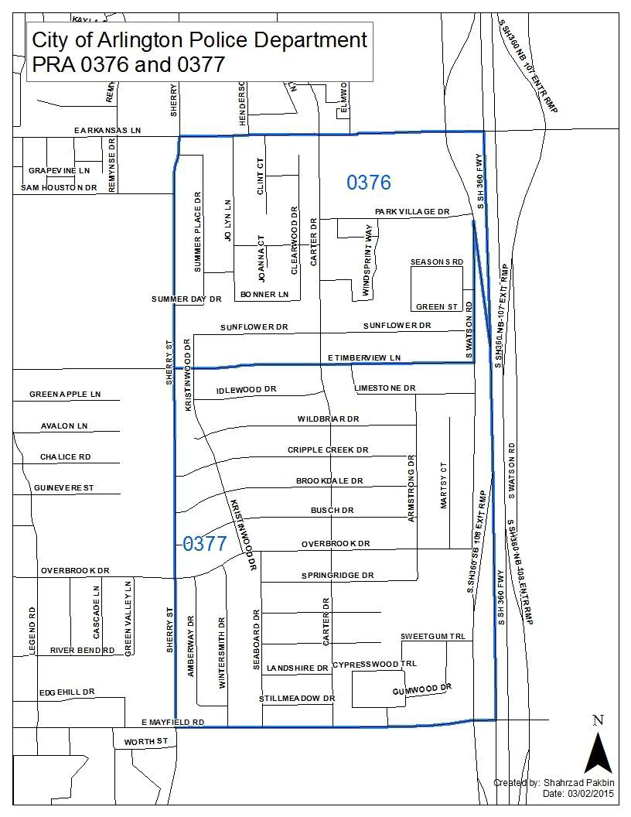

Following is a profile of this area:
− 68 dwelling units housed in 34 townhome structures
− 10 dwelling units are owner occupied (15%)
− 58 dwelling units are rental units (85%)
− Average age of structures is 32 years

Additionally, Limestone Drive is an extremely narrow street where all the tenants routinely park their vehicles on the street in front of their residences instead of in the provided parking in the rear of the duplexes due to lack of lighting. These issues led to an ongoing traffic dilemma on the street where two vehicles going in opposite directions have a difficult time passing each other.

The following table shows that in 2008, we were above average in calls for service in the 4th quarter from October through December. In 2013, we had a spike in calls for service. When the initiative began in November 2013 we had a large spike for calls for service. In the following months, APD saw a decrease in calls for service by 35%.

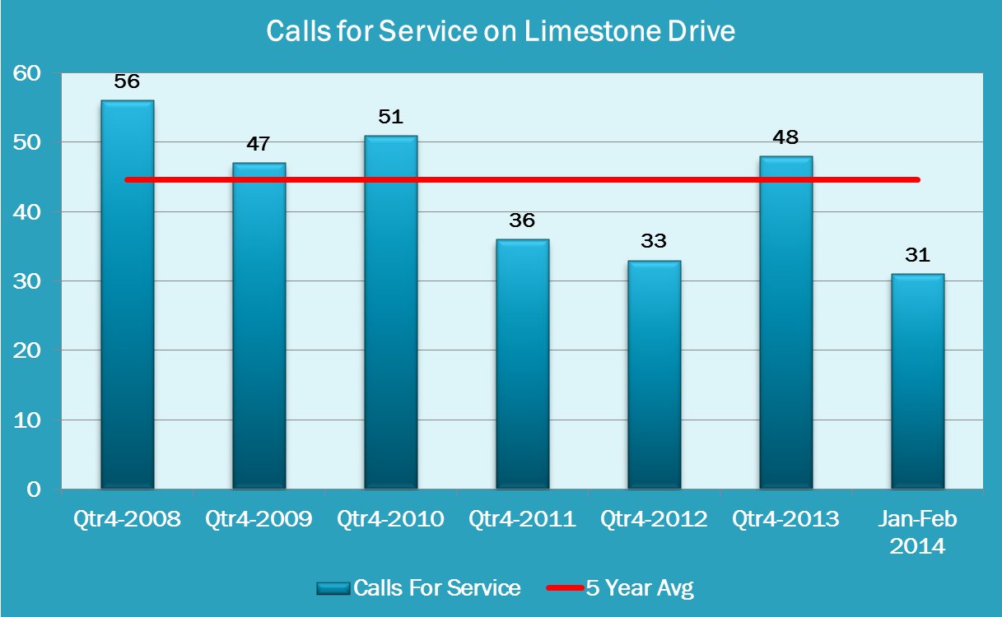

Program implementation and costs
The dilapidated conditions observed in the neighborhood included junked cars, broken down
fences, trash and other unsanitary conditions. These environmental conditions made it clear that this area was more than just a police problem and to mitigate these issues it would take “an all hands on deck” approach involving not only APD but other City departments and the community.

APD developed a plan centered on community engagement that included:
− A “Walk the Block” initiative that involved addressing quality of life issues. This meant various City departments, including but not limited to Code Enforcement, Fire department, Animal Control, Public Works, coming together. City departments

walked together going door- to-door gathering information from residents about their concerns.
− The creation of a Community Watch Group in the area to build, improve and maintain strong relationships and increase citizen contact.
− The start-up of a Cop Mobile program which involves using trained citizens to patrol their neighborhoods in City-owned vehicles. This provides residents with a sense of pride and ownership in the community.
− Maintaining visibility, conducting directed patrols on the street and in the alleyways in order to make the residents feel safe.

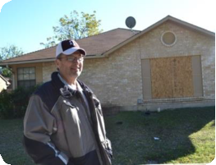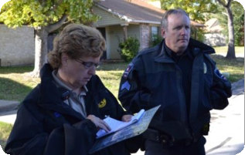The following images were taken during APD and City departments canvassing of the neighborhood.

APD gathered intelligence by monitoring weekly crime stats. In addition, APD followed up with residents’ concerns as well as tips by the City departments. During the initial work from November 2013 to February 2014, APD found numerous code violations, lighting issues, and we learned that residents, in general, felt unsafe. We began to address these issues by:
− increasing police enforcement,
− executing a warrant roundup,
− helping to enforce code violations, and
− educating residents about resources that are available to them.

We completed comparative analysis of quarterly trends and a multi-year plan. This plan included:
− continued visibility and community engagement by APD,
− continued monitoring of the area every 6 months by Code Compliance,
− continued development and eventual partnering with an area Community Watch
Group, and
− maintaining good working relationships with property owners and tenants.

Tangible results or measurable outcomes of the program
Following are results from this multi-departmental effort led by APD from November 2013
through February 2014.
− 64 notice of violations issued (62 Code and 2 Animal)

− 42 citations issued
− 5 notice of abatements issued
− 1 emergency abatement of a street obstruction and two or more large illegal dumping
sites abated by Public Works
− 4 smaller illegal dumping sites abated by Code Compliance

By mid-February 2014, all but 1 of the violations was owner-abated (a 99% compliance rate).

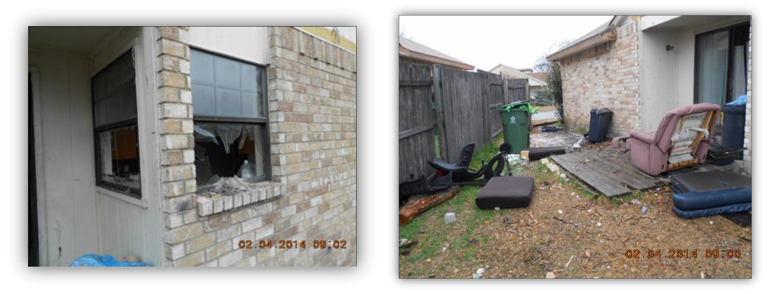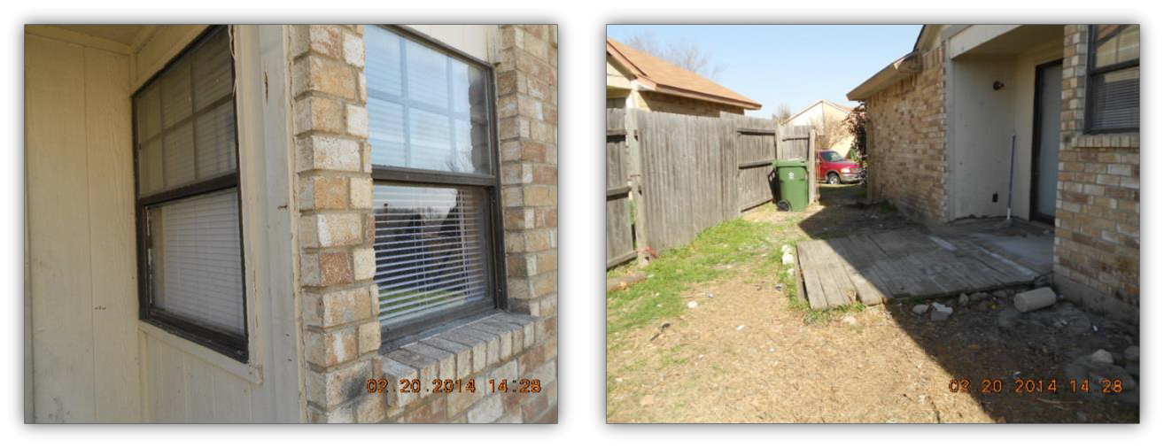The following are before and after photos of environmental conditions in the neighborhood.

The Uniform Crime Reporting (UCR) Program divides offenses into two groups, Part I and Part II crimes. Each month, contributing agencies submit information on the number of Part I offenses known to law enforcement; those offenses cleared by arrest or exceptional means; and the age, sex, and race of persons arrested for each of the offenses. Contributors provide only arrest data for Part II offenses.

The UCR Program collects data about Part I offenses in order to measure the level and scope of crime occurring throughout the country. The program’s founders chose these offenses because they are serious crimes, they occur with regularity in all areas of the country, and they are likely to be reported to police.

UCR Part 1 Crimes include: homicide; rape; robbery; aggravated assault; burglary; theft; and motor vehicle theft.

The following table shows UCR Part 1 Crimes in the neighborhood over time. As the table indicates, there was a decline in these types of crimes as a result of the work by APD and City departments.

4th Quarter UCR Part 1 Crimes - Limestone Dr.

6
5 5
5

4

3 2 2 2
2

1 0
0
2008 2009 2010 2011 2012 2013 Jan-Feb
2014

4th Quarter 5 Year Avg

Lessons learned during planning, implementation, and analysis of the program
Code Enforcement continues to conduct follow-up inspections of the area every 6 months.
When Code has completed inspections, violation notices and follow-up citations are issued. APD officers will continue their presence in the area to help with building relationships with the residents. A letter will be mailed to residents reminding them of the accomplishments to date. Overall, since the program’s inception, there has been a general downward trend of offenses occurring on Limestone Drive. Tackling community problems by leveraging our city departments and working together in a collaborative effort has proven to be effective and sustainable.

