Leadership ICMA 2015 – Team Tacoma, Washington

Human Services Funding: A Framework for Improved Outcomes Through Strategic Investments | 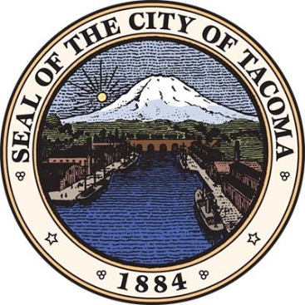
The Team evaluated the current funding processes for Human Service delivery by the City of Tacoma, WA. This evaluation focused specific attention to strategic goal alignment, data collection, metric suitability and consideration of funding only evidence-based models for service delivery.

Ultimately, the team provided that funding decisions should better align with the community vision and drive towards measurable outcomes. The vision set out in the city’s strategic plan: Tacoma 2025 – and the focus areas that support it – provide many opportunities where the Human Services Division can lead. A more data-driven approach, led by a division that unwaveringly assumes the role of backbone support organization for the community -alongside the introduction of steps in the application and adjudication processes – can ensure that progress is made. Due to the breadth of the city’s service areas, utilizing only evidence-based models may prove too rigorous to implement and in some cases may stifle innovation among smaller niche providers.

The recommendations that the Team proposed for the City of Tacoma range widely, but they align into two main themes or categories:

Finding Area 1
The funding framework, which includes considerations around the importance of using the newly minted strategic vision: Tacoma 2025, a strong coordinating role for the City of Tacoma, data-driven decision-making, accurate identification of community needs, and evidence-based programs.
Why this may apply to other jurisdictions
With a sharp, clear vision in hand, the City of Tacoma has a beacon that it may use to guide all of the other plans and processes nested beneath it. Don’t let strategic plans just sit on the shelf, use them in decision-making processes, garnering support from the community derived goals. Focus investments on programs that pursue those same goals. Of course, broad, far reaching goals need specificity and continual reengagement of stakeholders. For this purpose, a data-driven approach should be utilized. It is not likely that the human service community will be able to centralize its data alone. As a public good, the City of Tacoma should continue its efforts in creating an open data platform that the community can use for more informed decision making not only for staff but for citizens and organizations alike.

Finding Area 2
There are process improvements to the funding process, which considers dimensions of the City’s approach to administering different funds, the competitive process, the level of technical assistance available to service providers, and the role of human services staff and the Human Services Commission

Why this may apply to other jurisdictions
It is important to continually evaluate what is working and what is not. Changes in the volunteer structure, as well as new requirements for funded organizations, led to a situation where the application and award process became burdensome and confusing for many. As a key finding, transparency in both the goal setting and the award process becomes a keystone in finding efficiencies. As an adjunct, the sheer volume of applications necessitates that some programs be moved out of multiple shorter duration competitive processes, particularly if they are genuine evidence-based models, and moved to longer-term continuing contracts. The application process itself may benefit from a smaller RFI process or issuances of letters of intent. Additionally, increased technical assistance for partner organizations, the continuance of funds that enhance stabilization, increase capacity as well as promote innovation are all funding programs that not only should continue but be expanded upon. Finally, It is sometimes difficult to carve out dollars that don’t directly support programs, but significant investment should be made for resources that support data collection and backbone supporting activities for the human services community.

For more detail or a copy of the Tacoma Team’s report, please email Nedra James at njames@icma.org

Team Members
Alex Lopez: City of San Antonio, Texas
Jenifer Henry-Jones: Fairfax County, Virginia
JP Murphy: Town of Belleair, Florida
Lindsey West: Birmingham, Alabama
Matthew Wispinski: Edmonton, Alberta, Canada

