All-America City Awards:
recognizing Innovation and Excellence in Civic Life

About the All-America City Award
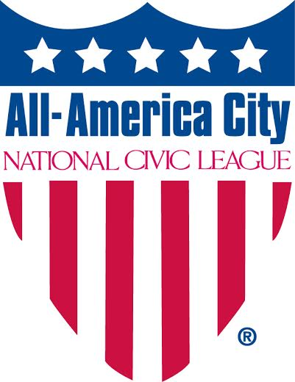
Established in 1949, the All-America City Award (AAC) is given by the National Civic League (NCL) to ten communities in recognition of their outstanding civic accomplishments. The AAC Award spurs communities to innovate and create stronger connections between residents and nonprofit and government leaders. The award is built on the recognition that innovation starts at the local level. It starts with neighbors and community groups coming together to take action. And when those ideas and actions take root they spread and inspire others. The AAC Award is a celebration of those efforts and a platform for sharing innovation, inspiration and insight with other communities around the country.

The AAC Award is unique in that it offers the opportunity for both recognition and reflection. Applications require communities to come together to assess their strengths and challenges. The process of applying for the award provides an opportunity to mobilize local groups to work together and display on a national stage the people and projects that make our communities a great place to live, work and play.

Since 1949, more than 600 communities have won the award – some as many as five times –demonstrating innovation, inclusiveness, civic engagement, and cross-sector collaboration by tackling and creating impact on pressing local challenges. Described by George H. Gallup as the “Nobel Prize for constructive citizenship,” the Award celebrates exemplary grassroots community problem-solving and is given to communities that come together to tackle the pressing challenges and achieve stunning results.

Inclusive and community-driven

The AAC celebrates innovation and excellence in the full diversity of American communities – from neighborhoods, small towns and tribes, to cities, counties and metropolitan regions. The smallest town and largest cities compete on equal footing – judged on the impact of their work and excellence of their engagement not reputation or size. Leaders from local government, nonprofits, community foundations, libraries, chambers of commerce and youth have all led their communities to apply for AAC. To win, communities must demonstrate innovation, impact, inclusiveness, civic engagement, and cross sector collaboration by describing three successful efforts to address pressing local challenges. The process culminates in a three-day event where community delegations tell their stories of change to a national jury of business, nonprofit, and local government experts.

The Impact of Winning the All-America City Award
“I could not begin to imagine how exciting and rewarding the All-America City Award process was until our city participated. You will learn more about your community than you know now, realize how people of all racial and socio-economic backgrounds can join forces for a common goal, and experience a life-changing event. ~Mike Dougherty, Dir. of Economic Development, Eden, NC
Every year at the All-America City Awards communities learn from each other, collaborate with each other and spur one another to seek and achieve greater impact. AAC is an experience in which people are transformed – where their passion and love of their community is rekindled and their commitment to improving it is redoubled. For those involved in the process it is a once in a lifetime experience that draws together all sectors of a community fostering a real sense of pride and the confidence that together people can address even the most challenging problems. Furthermore, the Award event itself provides incredible benefits for communities as residents and leaders network with their peers and civic activists from across the country. These connections continue throughout the years, as winners are part of a network of communities sharing best practices, new models and innovative approaches to tackling pressing problems.
The All-America City Award “helped us land a BIG project in the midst of major economic recession in 2009/2010. IBM located their first data center in 10-15 years in downtown Dubuque and created 1,300 new jobs with an annual payroll of 58 million!” ~ Cynthia Steinhauser, Assistant City Manager of Dubuque, IA (’07, ‘12 & '13 AAC Winner)
Back home, the Award reinvigorates a community's sense of civic pride. People are proud to live in an All-America City and they work hard to live up to the name. The award often has powerful economic benefits for communities. Many say the designation helped their community to win new grants and attract new employers. People want to live in cities where the community comes together to solve problems and everyone is included – and employers know that winning the AAC Award is proof of a community that does just that.

