by PegNews wire

August 30, 2011

# Volunteers extend Rockwall shelter hours

The Rockwall Animal Adoption Center will now be open on Saturday, Sunday, and later on Tuesday.

[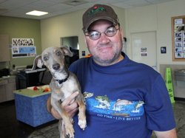](http://pegasusnews.com/media/img/photos/2011/08/30/thumbs/Rodney_White_Leo.jpg.728x520_q85.jpg)Proving their dedication to making the Rockwall Animal Adoption Center more customer-friendly, shelter volunteers are extending the facility’s hours. The volunteers, organized by the nonprofit organization Rockwall Pets, are hoping the new hours will make visiting the shelter more convenient for working families.

As in the past, the shelter will be open Mondays, Wednesdays, Thursdays, and Fridays from 9 a.m. - 6 p.m. The new expanded hours include Sundays from noon - 4 p.m., Tuesdays from 9 a.m. - 8 p.m. (6 - 8 p.m. is designated as “Yappy Hour”), and Saturdays from 8 a.m. - 5 p.m. Volunteers will also open the shelter from noon - 6 p.m. on Labor Day.

Rockwall Pets is working toward making Rockwall a No Kill community with no additional financial burden on city taxpayers. Using 100% volunteer labor during the extended hours will have zero impact on the city budget. But the nonprofit organization anticipates that the expanded hours will translate into increased adoptions.

The Rockwall City Council recently voted to mandate a minimum 90% live outcome rate at the city’s open-admission municipal shelter. The city must now adopt, return to owner or save the lives of at least 90% of the animals it takes in, which will make Rockwall one of the first No Kill communities in Texas. The No Kill Advocacy Center established what has become the industry standard, allowing a maximum euthanasia rate of 10% for animals who are gravely ill or irredeemably aggressive.

The volunteers are planning to make the extended hours more festive for potential pet adopters. For instance, this Sunday and Labor Day will feature a 1960s party to celebrate the extension of the Rockwall Pets “Summer of Love: 60s Power!” promotion. Once the NFL season kicks off, volunteers will be hosting “Tailgate Parties” at the shelter each Sunday afternoon.

More information is available at www.rockwallpets.com. The expanded hours campaign is being underwritten by donations to Rockwall Pets, a nonprofit organization dedicated to the adoption of Rockwall’s shelter pets. (Source: RockwallPets.com)

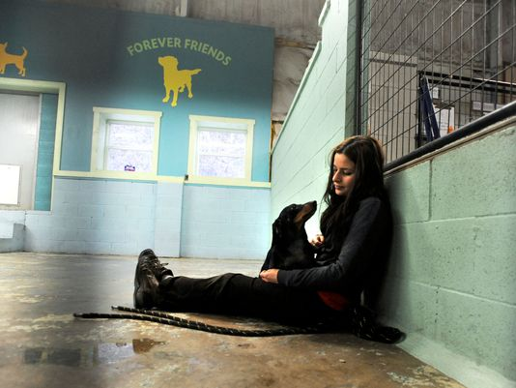**Could all Buncombe County animal shelters soon be 'no-kill'?**

[Beth Walton](http://www.citizen-times.com/staff/29503/beth-walton/), [bwalton@citizen-times.com](mailto:bwalton@citizen-times.com) (January 29, 2015)

ASHEVILLE – Cookie would have been given little chance had she been left at the animal shelter a couple of years ago, one leg so badly damaged that amputation was the only option. Today she is helping others get through their own health struggles.

As much as any dog or cat, the black terrier-Chihuahua mix serves as an example of a dramatic turnaround for the Buncombe County Animal Shelter and the Asheville Humane Society, which partners with the county to operate the facility. The shelter takes in unwanted or abandoned animals, while the Humane Society works to make animals more adoptable.

Boosted in part by changing public attitudes toward dogs and cats left at shelters, the organizations had live release rates in November and December of more than 90 percent, a common threshold for being considered a "no-kill" shelter.

The Buncombe County Animal Shelter has not euthanized an animal for space since it opened its new campus in 2010, said Sarah Hess, interim executive director of the Asheville Humane Society.

The organizations also have increasingly found new ways to spare animals that could not have been kept alive before. That includes turning to groups such as Brother Wolf Animal Rescue, which takes hard-to-place animals from the county shelter and rehabilitates them before adoption.

The Buncombe County Animal Shelter took in 7,200 dogs and cats in 2008 and euthanized nearly 62 percent of them. The number of dogs and cats arriving at the shelter last year dropped to 5,900. Just less than 1,000, or 16 percent, were euthanized. About half were owner-requested and the other half were either too injured, sick or aggressive to be safely placed in the community. The shelter offers a service for families who can't afford end-of-life veterinary care for injured or sick animals.

Last year, the Asheville Humane Society released 4,800 healthy animals back into the community. Of those, about 62 percent were adopted; 20 percent were returned to their owners, 17 percent were given to other shelters and 2 percent were feral or community cats that were sterilized and then returned to the field.

Cookie was brought to the shelter after being seized because she was being abused. She sat at the adoption center for weeks in January before being adopted, said Heather Hayes, marketing and design manager for AHS. "She is going to be a therapy dog," Hayes said. "She is going to go to a hospital with her three legs to show people that she is a survivor." "Several years ago, we would have had to put her down, but now that is not even a question," she said.

Not only do shelters have more money now and pets are abandoned less often, but public opinion has changed, said Patricia Norris, a veterinarian who is the director of animal welfare for North Carolina's Department of Agriculture. "It's gone from, vehemently, you don't want to get a dog from the pound because it's damaged goods, to it is the good thing to do," Norris said. "You feel good about yourself and the message is, 'these animals are wonderful.'"

Animal owners are also able to turn to other organizations for help more so than in the past, she said. "Five years ago, I had never heard of a food bank for animals, and now I see them coming up more and more," Norris said.

The number of pets being sterilized also has increased due to accessibility and low-cost options.

Pairing public money with private donations has greatly increased the number of pets that can be adopted, Hess said. The county spends about $175 per animal for basic health care, but an additional $73,000 in private donations was spent on animal health in 2014. The Buncombe County Animal Shelter operates on $686,000 a year.

Asheville Humane Society's Lily Grace Fund pays for additional medical care such as diagnostics, dental treatments and tumor removal. Dogs and cats have left the adoption center amputated or in a wheelchair, Hess said. Once, the fund paid for a cat to undergo acupuncture. "I feel that we are the stewards of these creatures. We are their voice and we have a responsibility in the way we treat them," she said.

There are always special needs pets at the adoption center — animals with specific medical or behavior needs that normally would be euthanized, but now, due to better programming and more resources, can be saved, Hess said.

The humane society's Safety Net program is helping people be better pet owners, offering pet food and care assistance to low-income families in need, she added. "We're trying to keep them out of the shelter and keep them at home where they are loved and wanted in the first place," Hess said.

Like the humane society, more shelters are seeing success through innovation, Norris said. Shelters are seeing the problem holistically and doing more community outreach to help people keep their pets, Norris said.

Nationally, there are some shelters that have 90 percent euthanasia rates, she said. In North Carolina euthanasia has dropped 26 percent since 2008, while intake has decreased by 7 percent. Statewide, the euthanasia rate was 56 percent in 2013.

It's a complicated issue that can depend on a lot of factors, including economics, demographics, geography, available resources and capacity of local organizations.

"Asheville Humane Society has a national reputation for being at the forefront of programs," said Norris, who came to the state from New Mexico last year. "They are setting the example for other communities. Even out west, I was hearing about AHS. They are quite the leaders in the field."

**The major players**

The Southeast in general suffers from pet overpopulation, but efforts in Western North Carolina have become a model for the country, said Kimberley Alboum, the state director of the Humane Society of the United States. The advocacy organization provides resources and support to shelters across the U.S. It has no official relationship to the Asheville Humane Society.

In Buncombe, the focus is more on community than on a single shelter, she said. "The one fact we know to be true is that if animal shelters have a strong community group to belong in, they have a better rate of adoption and placement." "There is more collaboration between shelters and rescue groups than there has ever been before," said Alboum, pointing to a 2013 U.S. Humane Society survey of 83 North Carolina shelters.

Earlier this month, the American Society for the Prevention of Cruelty to Animals announced its plans to [build a $9 million, 35,000-square-foot dog rehabilitation center in Weaverville](http://www.citizen-times.com/story/news/local/2015/01/10/aspca-plans-million-rehab-center-weaverville/21562661/).

Some of the 1.3 million dogs euthanized in shelters across the country each year are put down because they suffer from behavioral conditions that are the result of cruelty, abuse and neglect, said Matthew Bershadker, president and chief executive officer of the New York-based nonprofit. These animals come to shelters from places like puppy mills, hoarders and dog fighters where they were never socialized, he said. The national nonprofit, which has a $202 million operating budget, specifically chose Asheville because of its progressive animal welfare community.

The Society for the Prevention of Cruelty to Animals has provided more than $6 million in grants and immeasurable expert resources to Buncombe County service providers over the past 10 years, yielding life-saving results, Bershadker added. Since receiving the society's support, the county's live release rate increased to 71 percent in 2013 from nearly 36 percent in 2007, he said.

Area animal welfare nonprofits and business lobby groups, especially the Humane Alliance, lured the national group to choose Buncombe County, Bershadker said.

The Humane Alliance, a national nonprofit organization that focuses on high-volume, high-quality, low-cost companion animal sterilization, has been operating locally for 20 years. Since its opening in 1994, the institution has spayed and neutered 350,000 companion animals, becoming a model for some 1,200 veterinarians and students coming from 13 different countries to learn its techniques.

About 2.7 million dogs and cats are euthanized in the U.S. each year, Bershadker said. "That's a tremendous drop from the 15 million that were being euthanized in this country not so long ago," he said.

**The "no-kill" debate**

While there has been progress, more could be done, said Denise Bitz, who founded Brother Wolf Animal Rescue in 2007 as an alternative to the county shelter. Brother Wolf says it is the state's largest no-kill animal shelter. The organization hosted 5,017 rescued animals last year. It euthanized 16. It took 441 animals from the Buncombe County Animal Shelter in 2014 to help rehabilitate more pets.

"We believe every animal can be saved, unless they are truly suffering or dangerous to the public," said Bitz, who would like to see more resources for low-cost or free veterinary care and increased hospice facilities for very sick animals. "It doesn't have anything to do with percentage," she said. "I truly believe way more than 90 percent of the animals that come across our paths can be saved."

Private animal organizations that have limited intake can stop when they are full and direct the animals to local open admission shelters like Buncombe County, said Hess, who recently became the humane society's interim executive director. "Here, no animal — dog, cat, horse, pig, rabbit, raccoon, chicken, lizard, parakeet, etc. can or will be turned away. That's an important distinction to understand the overall picture."

**Getting along**

The humane society and Brother Wolf both admit to tension. Service providers have organized the Animal Coalition of Buncombe County and meet frequently to make sure they are working together. Yet, as often happens when you put a group of passionate people in the room, arguments abound, Bitz said. The word trust is key, Alboum added, referring to the Humane Society of the United States' North Carolina survey.

Shelters were asked to distinguish if they had simple "resource partners" — groups to share services or shelter space with, or "trusted partners" — groups working together strategically to place animals. "That was the key word," she said. "If it's not a strategic partnership, it's not going to work."

Despite different philosophies, Hess said the one thing that bring providers together are the animals themselves. "Pets are important," she said. "They are the source of unconditional love and companionship. For certain people, pets are their sense of purpose, their reason to get up in the morning."

"There are so many studies that show how pets help our blood pressure and help our activity level, how the loss of the pet is mourned, in many cases, the same as the loss of a human family member," Hess said. "No one in the work we do would ever underestimate the value and the power of that human bond. That is the common thread."

Animal Services, HOPE Foundation join forces

# County Aims to ‘Fix’ Unwanted Pet Problem

By Eiji Yamashita , Hanford Sentinel

September 12, 2011

Want free vaccination shots and spay-neuter services for your dogs? Get in line. Apparently, that was an offer many dog owners in and near Hanford found difficult to refuse. More than 100 local dog owners showed up with their four-legged companions to a vaccine and spay-neuter clinic hosted by Kings County Animal Services Saturday. Half an hour before opening, the line was already 50 yards long.

Still, the community’s strong response even surprised the organizers. “This is better than I expected,” said Teri Rockhold, Kings County Sheriff’s Department’s animal services director. “I’m thrilled because everything that gets fixed here ... translates to low euthanasia rates and to less suffering. It’s fantastic.”

Pet overpopulation is a persistent problem facing Kings County, especially in areas where residents have trouble paying for veterinary care. Last year, the Kings County Animal Services took in about 7,500 abandoned animals. That’s an improvement over an estimated 10,000 the agency saw four years ago, Rockhold said, but the agency still has along way to go.

The county joined forces Saturday with HOPE Animal Foundation of Fresno to turn the tide on those numbers locally by hosting the clinic aimed at helping families keep their pets while preventing additional pets from being born and abandoned. They had previously held similar events for residents of Home Garden and Kettleman City.

“This is very convenient,” said Joyce Salel of Hanford, who was joined by her Chihuahua mix “Wilber” that she saved about a month ago while he was wandering on Highway 43. “I find it very helpful.”

“Even at a low-cost place like Valley Oak SPCA, it costs $70 to fix a dog,” said Alice Barnes, who was with Salel. “You would be paying $100 or more if you go to a regular vet.” Barnes said she cares for nine dogs and 13 cats and also takes in four or five dogs each year and tries to find homes for them. If not for a program like this, it would be difficult for her to continue saving animals, she said.

Saturday’s event — known as Kings County Fix — is part of the community outreach Animal Services is doing more and more of lately to work toward the goal of ending euthanasia of homeless pets. Thanks to efforts, the number of stray pets has dropped steadily in recent years, Rockhold said. How long the residents may enjoy the program made available through the partnership with HOPE will depend on how much the residents use the program, Rockhold said.

On Saturday, the dogs brought to the event were receiving rabies and distemper/parvo shots for free or for small fees, while others were also getting spayed or neutered.

The immunization is important because it saves lives, both people’s and pets, said Mark Dierberger, a veterinarian working with HOPE. “We have a rabies problem in the state in wildlife,” he said as he deftly and quickly gave shots to the animals. “Pets are potentially exposed to that from the wildlife. Then people who are in contact with the pets are susceptible to rabies. Once a person or an animal contracts rabies, it’s nearly 100 percent fatal.” Parvo virus is also deadly for dogs, although it cannot pass on to humans, Dierberger said.

[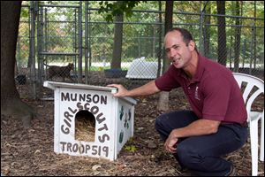](http://www.toledoblade.com/image/2011/10/17/800x_b1_cCM_z_cT/Matt-Granito-Geauga-County-Dog-Warden-shows-off-donated-dog-house.jpg)[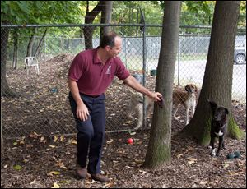](http://www.toledoblade.com/image/2011/10/17/800x_b1_cCM_z_cT/Geauga-County-Dog-Warden-Matt-Granito-dogs-outdoor-runs.jpg)

(Left) Geauga County Dog Warden Matt Granito spends time with the dogs in one of the outdoor runs. Sworn in eight years ago, his early efforts were met with skepticism, but now he’s won the community’s support. (Right) ….Granito, who also is president of the Ohio County Dog Wardens Association, shows off a donated dog house. Mr. Granito’s approach and creativity have won over the community and made it easier to find much-needed donors.

~~~~~

SECOND OF TWO PARTS

# Active volunteer force keeps dog deaths down

Geauga Co. shelter kill rate less than 3%

By Tyrel Linkhorn, Toledo Blade Staff Writer

October 17, 2011

CHARDON, Ohio — When Matt Granito was sworn in as dog warden eight years ago in a rural county east of Cleveland, he took over a department that was killing about half the dogs it collected. Seeing an opportunity to introduce himself and do a little public relations work, the new warden joined in the town’s popular Maple Festival parade that spring.

He got booed.

Mr. Granito, 40 and lean, with broad shoulders and an easy laugh, can’t help but chuckle as he describes those early days. The dog catcher isn’t favored in many popularity contests, though he hadn’t expected to be dressed down quite so publicly. But Mr. Granito doesn’t fit the traditional — and often vilified — role of a catch-and-kill warden. After spending a decade at the Cleveland Animal Protective league, he came to Geauga County to help dogs, not hunt them.

Reducing euthanasia has to start with a desire to do so. It is also important to separate enforcement out on the road from service inside the shelter, Mr. Granito said. “You’ve got to be strict when you’re out there, but once they come into your shelter, you’ve gotta run it more like a humane society. You’ve got to rely on volunteers, rely on donors, rely on public relations to get their name out there,” he said.

Though he had the support of the county commissioners, many of his early efforts were met with skepticism. No one had volunteered at the pound before. When Mr. Granito chewed over asking for donations, one commissioner told him the public wouldn’t react warmly to government sticking out its hand for more cash. The local humane society balked at invitations to move some of its dogs there when the pound had extra space.

But success would come. Now his volunteer roster carries more than 100 names, including trainers who work to rehabilitate dogs. Large outdoor kennels, bought and built without a cent of county money, surround the facility. Every year, donors contribute tens of thousands of dollars, much of which goes toward medical care or training for the dogs.

The result: Geauga County’s euthanasia rate fell to less than 3 percent. “The community understands what we’re doing,” Mr. Granito said in a recent interview. “They’re happy about what we’re doing and they know we’re trying to help the animals.”

**Point of pride**

Geauga County, population 93,389, is largely a bedroom community for Cleveland and northeast Ohio’s other large cities. It’s picturesque, especially in autumn when the trees burst into warm colors and the county’s large Amish population goes to work on the fall harvest. The dog pound sits in a small clearing on a wooded hilltop about six miles from Chardon’s town square, tucked among the sheriff’s office, the department of emergency services, and the sixth green at Pleasant Hill Golf Course.

The Geauga County Animal Shelter in Chardon, Ohio, relies on volunteers, donors, and public relations in its efforts to reduce the rate of euthanasia.

“One of the [golf course] owners I know donates to us,” Mr. Granito said. “I talked to him early and asked if he was going to have a problem and he said no problem at all. He loves the idea of having kennels out here.”

Course regulars have come to expect a little yipping from the canine gallery as they near the green, though Mr. Granito, himself a golfer, admits with a slight grin he occasionally hears someone yelling their ire through the tree line.

Mostly though, the office of the dog warden has gone from a point of contempt to one of pride. County officials wholly credit Mr. Granito.

“He’s very aggressive in getting animals placed and utilizing volunteers. We have the right kind of environment where that’s probably easier to accomplish than a more urban environment, so we’re blessed somewhat just by circumstance,” county Administrator Dave Lair said. “But we’re also blessed that Matt Granito is a very energetic young guy who works very, very hard at the job. He’s a bundle of energy and he does a fantastic job for us.”

**Low kill rate**

In 2010, Geauga County took in 780 dogs. Only 21 were killed — all of them because of either extreme aggression or their quality of life. The county doesn’t kill for space, and dogs don’t have to pass a temperament test to stay when their mandatory three-day holding period is up.

“We do a lot of observing,” Mr. Granito said. “I’ve seen the SAFER test, I’ve seen all those tests. We’ve tried it. The hard thing with that is you’re pushing those dogs into a stressful situation and they’re already in a stressful situation. I feel sometimes that will push a dog over the edge unnecessarily and it’s just tough.”

Mr. Granito said his office gets a relatively small number of “pit-bull”-type dogs, but that those dogs are not treated any differently than the other dogs that come through his doors. He acknowledged that based on his years working in Cleveland, dog wardens in urban areas are likely to see a larger percentage of more aggressive dogs.

Mr. Granito has accomplished a low kill rate without a large staff or a big budget. The office has three employees aside from the warden, and last year spent a modest $259,000. Two years ago, he sought to raise the dog license fee to $12 from the current $10, but commissioners denied his request.

Instead, the warden relies on donations, which amounted to nearly $88,000 last year, and volunteers such as Roger Neiswander to do nearly everything from cleaning the kennels to socializing the dogs.

Volunteer Roger Neiswander works with the dogs to make them more adoptable. ‘Seeing them turn around, that’s a real joy,’ he said. He is one of more than 100 volunteers and spends at least 10 hours a week at the pound.

Mr. Neiswander, a 70-year-old retiree who recently became a grandfather for the second time, spends at least 10 hours a week at the pound. He lives nearby and often comes in the evening to bring the dogs back inside for the night. More rewarding for Mr. Neiswander is working with the animals to make them adoptable — doing things as simple as socializing them with other dogs, teaching them to walk on a leash without pulling, or sitting with them to ease their anxiousness of human contact.

“Seeing them turn around, that’s a real joy. That’s what I do a lot. I just kind of pitch in wherever it’s needed,” Mr. Neiswander said.

The volunteer programs seem almost endless. Every year, volunteers stuff the 12,000 envelopes sent out for license renewals with a card thanking the community for its support, explaining how donations are spent, and asking dog owners to consider a contribution. Later, they follow up with phone calls to anyone who doesn’t renew a license. Each Saturday, a trusted volunteer takes a dog to a donated space at a farmer’s market in nearby South Russell. There they act as ambassadors for the office, try to find the dog a new home, and pass out pamphlets detailing the operation — and what people can do to help.

There’s really nothing Mr. Granito doesn’t trust his volunteers to do, and if volunteers are willing, there’s nothing they can’t do, short of working with animals deemed by staff to be aggressive and dangerous.

**Playtime**

Another key to keeping dogs healthy and mentally unburdened at the Geauga County dog pound is the way dogs are allowed to play together. Each dog’s indoor kennel has a card that includes the dog’s name, sex, breed, and weight, along with a list of its doggy pals. For example, Rave, a female hound, gets along well with Gopher and Gospel. During the day, they’ll share the same outdoor kennel or run, where they’re free to run, play, and have all the fun they want.

Mr. Granito said workers will watch how different dogs interact, see who seems interested in each other, and leash them in the same area. “Once we feel comfortable enough we’ll take them off leash and you’ll see what you see out there,” he said of the runs out front. “They just start bonding with each other. They actually become more relaxed, more laid back, as one follows the other. It’s more easy to work with them and they become more sociable.”

The dogs seem happy that way. In general, the larger, more active dogs get the larger runs, while the smaller ones are occupied by smaller breeds or less energetic dogs. They will go to the same outdoor kennel with the same friend every day. Dogs that are ill or recovering from surgery or illness are kept separate.

Aimee Sadler, a national expert on no-kill shelters and behavior and training program director for the Longmont Humane Society in Longmont, Colo., said allowing animals to play together is one of the best ways to keep the dogs engaged, encourage adoptions, and even better use staff time. If all the animals are out of their kennels at once, she said, it’s easier for the kennel workers to quickly do the daily cleaning. She said if workers are careful, concerns of animals spreading sickness or fighting are often overblown. “The best thing for your buck at most shelters no matter what level of resource is to be implementing play groups,” she said.

It’s also where staff can learn the most about the dogs and help make better adoption matches. Mr. Granito said if they have someone come in searching for two pets, they’ll point them toward a pair of dogs that already are proven to get along.

Ms. Sadler gives those programs similar marks. “It has so much to do with making better adoption matches. Many people have dogs already in the home or want to be able to live a lifestyle where their dogs can interact with other dogs in public. When you’ve already had dogs playing with other dogs in a group, you get a better picture of what their capacity is with it,” she said.

**Behavior training**

Mr. Granito only has space for about 26 dogs, though he’s willing to keep problem dogs for weeks while his volunteers straighten them out. He’s able to do that, he says, by adopting out animals nearly as quickly as they come available and aggressively pitching his animals to other rescue groups.

The county also frees space by shipping nearly all its puppies to the local humane society, allowing more freedom and space for working with the older dogs. Additionally, a policy in place before Mr. Granito began requires owners who want to surrender their dogs to go to the humane society.

Geauga County can’t afford to hire a behavior trainer. It is blessed, however, to have volunteers who are happy to do the work. Carol Peter, a certified professional dog trainer who owns and operates Cold Nose Companions, a private training business, drops in once or twice a week. Most of what she does is basic manners training, something she said no dog is too old to learn. But she also works with dogs that have deeper issues such as resource guarding, food guarding, dog aggression, and fear-based behaviors.

“If we identify a project dog, somebody who really needs some work to get turned around, we’ll put together a game plan and very often I’ll make a suggestion for what that program should be that the staff and this other volunteer will follow,” she said. “That gets us a little farther on the line than it would otherwise be.”

Some dogs might need two weeks of work; others might need two months. Ms. Peter said the pound has been very successful.

One of the more common problems staff there encounter are dogs that are shy or fearful of people, a condition that routinely results in dogs being killed at the Lucas County pound. Ms. Peter has recently been working with one such animal. She said it’s just a matter of time before that dog will turn around. “I work with her when I get there to hopefully create a better experience with her with people, and start to teach her interacting with people can be a very rewarding thing,” she said.

Dogs also are occasionally sent to professional trainers elsewhere. Mr. Granito recently sent a beagle that needed particularly intensive hands-on training to temporarily live with a Columbus-area trainer. The $300 fee came from a donor.

**Positive image**

By law, no Ohio dog warden has to work to find seized dogs new homes. But Mr. Granito, who is president of the Ohio County Dog Wardens Association, said officials are beginning to understand that the people they serve won’t stand for catch-and-kill shelters.

“They’re realizing that the public is pushing that shelters start becoming more proactive with their adoptions, more public-friendly, public-oriented. We are seeing that throughout the state with our association and members. There are groups all over wanting to push those envelopes,” he said.

Mr. Lair, the Geauga County administrator, said the positive record of the dog warden helps paint a positive image of the county. “It just shows that this is a county that cares about life of all kinds and the residents that live here feel that way. We have some residents that are big time into animal rights and animal activists, and to have that voice acting as the conscious of a community is a good thing,” he said.

That care is part of the equation for a high quality of life — so high, in fact, that Geauga County was named by Forbes in 2008 the fourth-best place in America to raise a family.

Mr. Lair also said that quality of life has helped a county that boasts no port, rail lines, interstate highway, or major airports, lure in larger businesses that might not often consider a community without those traditional economic drivers.

What really sets Geauga County apart from other public shelters, though, is Mr. Granito’s attitude and creativity. Right now, he’s researching whether he could sell the naming rights of his shelter to a business. “It’s just an idea,” he said. “If I can’t get back taxpayer money, I’ll find someone to donate and help me out with the facility.”

It seems to be getting easier finding donors. On his way out, Mr. Neiswander points to the bench outside his pound where donations of food and blankets were left while he was inside answering questions. “People in this county are wonderfully generous,” he said

~~~~~~~~~~~~

**New Maternity Ward Opens**

by JessiFreud, Austin Pets Alive!

[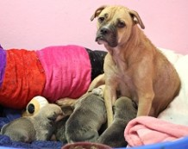](http://www.austinpetsalive.org/2012/07/new-maternity-ward-opens-at-apa-at-town-lake-animal-center/maternityward1a/)Sweet Pea’s Maternity Ward is open! The idea for a maternity ward at our Town Lake Animal Center (TLAC) site came from the need to be able to immediately save a pregnant mom or mommy dog and her babies at a moment’s notice. Pregnant moms and their families are two groups highly at risk at Austin Animal Center (AAC) because they are not eligible for adoption until eight-weeks-old, so they take up kennel space that the city cannot spare. They can also be tricky to place in foster as the responsibility for caring for a mom and her babies for an eight-week duration is a long commitment. So, in order to be able to take them in immediately while we wait for foster homes to come forward, we needed a solution: a special space just for them, a maternity room!

The namesake of the ward is Sweet Pea. Sweet Pea is a recent intake from Austin Animal Center (AAC) who came to us very pregnant during AAC’s overcrowding crisis earlier this season. While we plead and plead for fosters, we had no one come forward to take this baby momma and give her a place to have her babies in peace. So, being the sucker that I am – I took her!

And, it could not have been more rewarding. I would do it 100 times over. Sweet Pea was as pregnant as we estimated: three days into being home with me she had NINE babies. I was so thankful I was in a position to make sure her seven-hour delivery went smoothly, everyone was healthy, and she had the clean, comfortable space she needed to nurse, and constant food and water to keep her energy up to take care of her brood.

[](http://www.austinpetsalive.org/2012/07/new-maternity-ward-opens-at-apa-at-town-lake-animal-center/imag0641/)Moving forward, I wanted to make sure that had another dog, like her, come into our program we had the right accommodations to provide to take the best care of her and make this experience as pleasant as possible. So I happily took on the project of getting the maternity ward squared away.

Made possible by a private donor, we were able to convert one of the former administrative offices into two condo-style runs. When contemplating on the construction, we had two main goals in mind: safety and privacy. The runs are separated by a thick, nearly 5-foot high partition. And, each run has a secure door with frosting spray on the glass so the neighboring dog is not disturbed by caretakers or the other dog coming out of their run for a walk. We put in two dim-lighted lamps so we can keep the overhead fluorescent lights off, and keep the space calm and den-like. A CD player is also left on with music to drown out some of the unavoidable shelter sounds. The air-conditioned space also has its own stash of supplies and everything our volunteers need to keep these families comfortable while they wait for foster.

Coincidentally, the morning the maternity ward was ready to officially open, we had our first family in need. Butterfly and her seven puppies were found under a house by a Good Samaritan who kept them for two-weeks to get them over the most risky period after birth, but then had to surrender them to AAC. As soon as we were told Butterfly and her babies needed us, we were able to take them into our program immediately because of the maternity room. We are thrilled this sweet Inaugural Family was able to benefit from our new resource.

~~~~~~~~~~

**[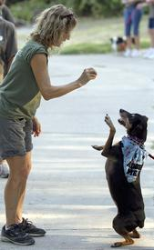](http://www.statesman.com/multimedia/dynamic/01542/pvilldogs_1542519c.jpg)Pflugerville Animal Shelter Enriches Dogs' Lives With Walks In The Park**

By Marques G. Harper, Austin American Statesman

August 18, 2012

PFLUGERVILLE — About a dozen volunteers from the Pflugerville Animal Shelter spent 1 1/2 hours Thursday walking dogs at Gilleland Creek Park, wandering the park and allowing the dogs to cool off in the creek.

Shelter volunteers have been walking dogs available for adoption in city parks to raise awareness of the shelter, recruit volunteers, and get new homes for the dogs. The volunteers wore Pflugerville Animal Shelter T-shirts, while the leashed dogs, including Minnie, Jackson, and Bailey, wore handkerchiefs around their necks that said, “Adopt Me.”

The dogs stay at the shelter on Waterbrook Drive, but volunteers say they need social interaction and the chance to explore nature. “Some of the dogs have been getting stir crazy,” Pflugerville police Lt. Laura Wilkes said while holding the leash of Cane, a young terrier.

Wilkes, a self-described dog lover, oversees the shelter, which has about 40 active volunteers. It primarily has dogs and cats available, though adoptions typically slow down in the summer, Wilkes said. The shelter also takes part in various events, including Adoption Days from noon to 4 p.m. on the first and third weekends of each month at the Petco store at Stone Hill Town Center. The city is expected to spend $56,000 to operate the shelter and $135,919 for personnel in the current budget year.

Wilkes said a number of pets have ended up at the shelter because people couldn’t afford to keep them. “There’s nothing worse than a dog that has no owner,” she said.

Volunteer Patsy Van Geem, a retired teacher, held the leash of Darlene, a Manchester terrier mix. Darlene is the first dog they started bringing to the park, Van Geem said. Turning to the dog, she said, “Show them how you sit up.” The dog hopped up on her back legs before getting a treat from Van Geem.

Volunteer Peter Corpus, a certified training and behavior specialist for the Austin-based dog training service A Pack Nation, said socialization helps dogs adapt to people, sounds, and new environments while developing manners. “Rather than use a 6-foot leash, using a long leash lets these dogs move,” he said as Roxy, a terrier mix, cooled off in the water. “You give a dog what they want, and they are happy campers.

**Hard Luck Hounds Gives Unlucky Dogs A Chance**

Volunteer Group Aims To Help Least Desirable Shelter Pooches Get Adopted

By Patrick Beach, Austin American – Statesman

May 29, 2012



Sunnie is a 4- or 5-year-old pit bull mix, heartworm-positive and a little on the shy side, not the kind of dog likely to make the short list when prospective adopters come looking for a pet at the Austin Animal Center and exactly the kind of dog David Pasztor sees as a prime candidate to be a Hard Luck Hound. “This dog could go into any household right now,” Pasztor said as he visited Sunnie.

Pasztor and a small group of volunteers identify dogs at the shelter that are most likely to be passed over or most likely to be euthanized and put them in the Hard Luck Hounds program, which aims to get dogs with two strikes another chance.

The shelter, which must give permission for dogs to be placed in the program, waives adoption fees for the hounds, and the Hard Luck Hounds, which is a program of Friends of the Austin Animal Center, kicks in a crate, “concierge service”, and sometimes obedience training for dogs that need it.

These dogs didn't have much of a chance before the City Council voted in 2010 to make Austin the first major no-kill city in Texas and before the new, $12 million facility with room for roughly 280 cats and 280 dogs. No-kill means no more than 10 percent of the animals at the shelter can be euthanized; at the old shelter along Town Lake, Pasztor says, that number was often more like 40 to 60 percent. And the old shelter is where the idea for Hounds started. Volunteers, including Pasztor, get to know animals in their care for weeks and months at a time.

In May 2011, two dogs, Emily and Diamond, were put down suddenly. “We knew they were adoptable dogs,” Pasztor said. “It caught us by surprise and made a lot of us very, very angry.” So Pasztor put together a plan. “We launched the first week of last September,” said Pasztor, a former staffer for the American-Statesman and editor of the Texas Observer. “It was just me with a T-shirt” and 10 information sheets on the animals, he said. “The first day, we adopted out Jake, the longest-stay dog at the shelter that day.”

Adopters have their standard fees waived, and the group provides new owners with a crate for the animals from a city surplus that's now dwindled to about 10. If training is necessary, the city may provide a voucher. Costs are low; Pasztor estimates he and his fellow volunteers have chipped in a few thousand dollars.

In less than a year, they're closing in on their 100th adoption. Pasztor plans to wear a tuxedo for the event. And yes, they take donations. (Go to http://hardluck hounds.com.)

“They're not the same as other rescue organizations,” said Amber Rowland, the behavior program manager at the shelter. “Their efforts augment what we're able to provide. They try to choose the dogs that have been there for the longest time. Sometimes the shelter has to nudge them into picking some that haven't been there for so long and aren't so hard to place. You have to be pragmatic at some point. You have to understand limited resources and an overabundance of animals.”

“It's definitely a point where reasonable people can disagree,” Pasztor said. “We gravitate to the harder-to-adopt dogs because that's what we set out to do. ... They have institutional pressures they have to deal with. We are trying to do everything we can to pick off those dogs that get crunched by those institutional pressures.” (Pasztor also allows that returns for Hard Luck adoptions are probably higher than the shelter average. Sometimes it takes a dog two or three adoptions before the right match is made.)

One of them is King, who lives in Pflugerville with his humans. He's maybe 7 years old, black, described as an American Staffordshire, and he'd been in and out of shelters since at least 2009. When Shauna Kepler and her three children, ages 2, 7 and 9, first saw him, he'd fouled himself and his cage. “It was just gross,” Kepler said. “It was all over him and his paws. Still, something pulled us to him.” Pasztor got King cleaned up, and the family met with him, then with their 5-pound toy terrier mix.

He played nice with everybody, although he was withdrawn, which Kepler attributes to having been locked up for some time. They took him home, and he immediately starting opening up. That was in January.

“He is a completely different dog,” Kepler said. “His personality is perfect. He's well-behaved, knows a bunch of commands. He is at my side and at my feet no matter where I go. I can't believe he was on the euthanasia list. He is the best dog I have ever owned my entire life.”

~~~~~~~~~~

**Awesome Austinite: Teenager Turns Time and Talents to Saving Hard Luck Hounds**

By Chantelle, Austin Post

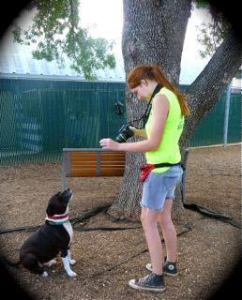Sep 8, 2012

A tall, red-headed teenager holds up a treat and aims her camera at an adorably-rotund dog who sits and stares attentively. After a few shots are taken, the dog is rewarded with the treat and petting.

The photographer is Camille Akin, 17, a senior at Premier High School. The dog is Buddy, a perky pit bull mix awaiting adoption at The Austin Animal Center. Akin spends most of her free time working tirelessly to save lives like Buddy's by using her photography talent and nine years of dog-training experience.

Akin's passion for pooches began when she was six years old and her parents gave her a rescued pit bull mix named Star. “Star raised me,” Akin says. “She also raised my family's 14 foster puppies and kittens.”

Star recently died, but her memory serves as Akin's inspiration to restore the reputation of the much-maligned pit bull type dog, and place them in the homes of responsible adopters.

“Pit bull types are the most enjoyable dogs to train because they are so eager to please,” Akin says. This desire to please people is why she believes some of them get into trouble. “They often attract the wrong types who want them as guard dogs or fighters, and some will do these things as a way to please their owner. When the right people give them a chance and adopt them, they are fantastic family pets.”

As evidence, she cites numerous successful adoptions of which she has played a pivotal role with her marketing efforts via Craigslist and community bulletin boards. Akin has an average of five ads running at any given time for long-stay shelter residents that are a part of Hard Luck Hounds. The program is a volunteer-led effort to help Austin Animal Center's harder-to-place pups find families via enhanced marketing, adoption perks such as training vouchers, and follow-up “tech support” for questions or issues adopters have. The group's adoption aim for the year was 58 dogs. This month they celebrate their one-year anniversary during which time they have adopted out more than double their original goal - 125 last-chance dogs.

”Before Austin's 2010 no-kill initiative, the dogs in the Hard Luck Hounds program would have been euthanized,” Akins says. “They are the dogs all other rescue groups have chosen not to pull.”

One such dog was Valentine, a blue pit bull mix who was found starving and sickly with her puppies, all of whom died. Because of being chained up for so long, Valentine arrived at the Austin Animal Center with a malformed pelvis and leg that will always pop out of place. Hard Luck Hounds paid for Valentine's vet care and Akin's family fostered her until a young man answered Akin's Craigslist ad. After a few phone calls with the potential adopter, Akin realized Valentine had found her “match made in heaven”. When the man met Valentine he told Akin, “This is the dog I've been waiting for”. Valentine now lives on a hilltop ranch near Lake Travis with five acres, a pool, and two devoted parents.

Stories such as Valentine's are why Akin remains a committed two-year veteran of shelter volunteerism despite the inevitable heartbreaks that happen. “As a volunteer you can literally save lives just by taking dogs on walks and hanging out with them,” she says. “You can make dogs' lives better and help people find their new best friend. It's such a happy, rewarding experience.”

Akin plans to attend Texas A&M next year and eventually become a veterinarian. She says working with dogs has given her the confidence to pursue her goals and overcome peer pressure.

“Dog are these all-accepting, pure beings who don't care about your race, looks, or how you dress,” Akins says. “They give you the acceptance that everyone needs.”

**WOOF Matches the Formerly Homeless with Homeless Pooches[[1]](#footnote-1)**

[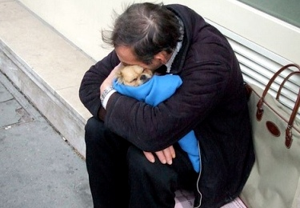](http://www.ilovedogs.com/wp-content/uploads/2012/06/homeless_man_hugging_dog.jpg)

In what sounds like a win-win for both two and four-legged participants, a privately funded new program called WOOF will match up some formerly homeless people with special-needs dogs in San Francisco this summer.

Wonderful Opportunities for Occupants and Fidos will pay supportive housing residents up to $300 a month to care for young shelter dogs with behavior issues. The residents will also receive training from an animal behavior specialist and free dog food, supplies, toys and veterinary care.

The goal of WOOF is to teach the people new skills while helping the dogs become ready for adoption.

Matt Traywick, a formerly homeless man, suffered from severe depression while living in a hotel in the rough Tenderloin district. Things turned around for him last year when he adopted a Dachshund-Bichon mix named Charlie from the city shelter. The two have become the “poster couple” for WOOF. “Once I saw Charlie, I fell in love,” Traywick told KTVU. “They had just brought him in. He weighed about half of what he weighs now. This entire neighborhood has adopted him and it’s been 100-percent positive.”

Rebecca Katz, director of San Francisco Animal Care and Control, said supportive housing residents like Traywick would make ideal foster parents because they can be with the dogs all day long. “We have rowdy, adolescent dogs that need some boundaries, taught to sit, come, not jump up on people. We have under-age puppies that can’t be made available for adoption until they’re at least eight weeks old,” she told KTVU. Her department is partnering with the city’s Housing Opportunity Partnerships and Engagement (HOPE) department to run the program.

Another of WOOF’s goals is to discourage participants from panhandling. After spending 18 years in the top position, San Francisco fell to No. 2 as a favorite tourist destination in the Condé Nast Traveler poll last year. Joe D’Alessandro, head of the San Francisco Travel Association, told the San Francisco Chronicle the drop could be attributed to the rise in homeless people and aggressive panhandlers.

If a WOOF participant is caught begging with a pooch, the dog will be returned to the shelter. HOPE Director Bevan Dufty told the Los Angeles Times “I can’t make panhandling go away. But I can make a better offer.”

Katz told the San Francisco Chronicle that since the recession began, the shelter has received 500 more dogs each year, turned in by owners who can no longer afford to care for them. She said about 15 percent of those dogs end up euthanized because of behavior issues such as shyness or hyperactivity.

WOOF will launch on August 1. It’s starting small, with just a few match-ups. Dufty told the San Francisco Chronicle he hopes to expand it to include many more participants along with additional training in grooming, dog walking and other skills.

To qualify for the program, participants must be living in supportive housing. A screening process will weed out anyone who has a history of violence, hoarding, severe mental illness, or untreated addictions. If, after a few weeks, any WOOF participants happen to fall in love with their foster furkids, they will have the opportunity to adopt the dogs, Katz told the San Francisco Chronicle.

She said she still carries a letter Traywick sent her last year. “My case manager dubbed him TLC – Tenderloin Charlie – because everyone needs a little TLC now and then,” Traywick wrote to her, three months after adopting his pooch. “If I do a decent job as a parent, he’s going to be a magnificent animal when he grows up. I can’t believe how lucky we both are.”

WOOF is scheduled to run through October. This first-of-its-kind program was created thanks to a $10,000 grant from San Francisco philanthropist Vanessa Getty. If all goes well, the city will look for additional funding to keep the program going.

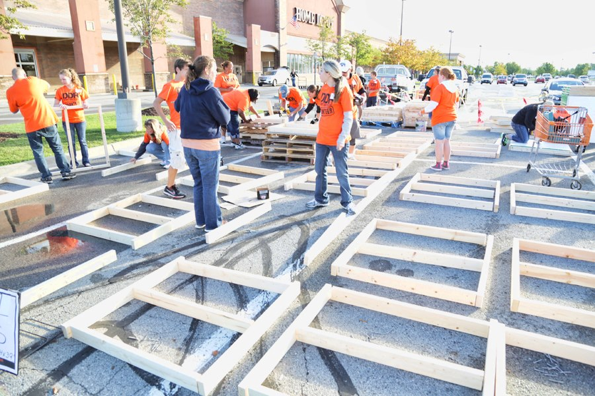

BD21315_**100 Roofs for Woofs Building Blitz**

An army of volunteers turned out in Detroit for the 100 Roofs for Woofs Building Blitz. The 100 dog houses made during the one day effort were distributed to dog parents around the city to house their outdoor dogs. (Detroit Dog Rescue, September 2012)

**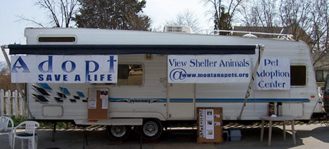The Mac**

**a.k.a. Mobile Pet Adoption Center**

**of the Montana Company Animal Network**

Come visit our mobile adoption center. Our trailer is available for all animal shelters and rescue groups as well as individuals who are sincerely seeking caring homes for their animals. All of our animals are ready to go; spayed or neutered, healthy and up to date on their shots. We will network statewide to help find the companion animal that is just right for you!

Our purpose is to provide a relaxed, clean, comfortable environment where people can meet and find companion animals in need of loving homes in a variety of locations throughout the local community.

Our goals are:

* To enrich loving homes with homeless, deserving animals
* To increase public awareness of the pet overpopulation problem and proven solutions
* To provide humane education for proper care and maintenance of companion animals

Requirements for all animals utilizing the center:

* Proof of Spay or Neuter
* Current vaccinations validated by a veterinarian, shelter or rescue group
* Healthy, well-groomed appearance
* Non-aggressive behavior
* Each animal must be accompanied by an owner or agent

Note: This mobile adoption trailer is a converted 26 foot “toy hauler”. T he MAC is kindly provided by Ragged Mountain Antler Chandeliers and Ragged Mountain Dog Rescue of Hamilton.

# A look inside the Capital Humane Society's new home

# Lincoln Journal Star (June 29, 2013)

It’s like walking out of a dollar store and stepping into Von Maur. In other words, there is no comparison between the Capital Humane Society’s longtime home at 2320 Park Blvd. and the new Pieloch Pet Adoption Center on the corner of 70th Street and Nebraska 2.

Park Boulevard is dark, dingy, loud and well off the beaten path for most Lincolnites. The Pieloch Pet Adoption Center is bright, welcoming, quiet and easily seen by the estimated 70,000 plus vehicles driving past each day -- a definite perk for piquing potential pet owners’ interest, said Bob Downey, executive director of the Capital Humane Society.

When the adoption-only facility opens at 11:30 a.m. Tuesday -- it will become the city's only humane society site for adopting a furry family member. The old facility will continue to be used for lost and surrendered pets, veterinary surgery and animal holds, Downey said.

The Pieloch Pet Adoption Center is named for Mark Pieloch and his family. Pieloch is the former owner of the Syracuse Pharma Chemie animal supplement company. An animal lover and long-time friend of Downey’s, Pieloch donated $1.5 million toward the humane society’s Celebrate Me Home capital campaign -- putting it well over the top of its original $2.9 million goal.

“It’s a very beautiful facility inside and out,” Pieloch said in a telephone interview from his business in Melbourne, Fla. “It should get a lot of use and hopefully will save the lives of lots of dogs and cats.”

The new adoption center is a place of windows -- inside and out. Large outside windows allow people to peer in and see cats and dogs playing in glass enclosed homey rooms. Inside there are even more windows -- glass walls and doors replace the chain-link fencing and bars that once separated pet cages and kennels. The glass not only creates an aesthetically pleasing environment, but significantly reduces the stress-inducing noise of yammering cats and barking dogs.

While some animals live in glass cages, others live in glass houses -- otherwise known as colonies and rooms. There is even a glassed in area for ferrets, gerbils, bunnies and guinea pigs awaiting forever families.

“I love the openness,” Downey said. “The daylight coming in. All the windows.” He also likes a bit of whimsey -- stainless steel paw prints guide visitors to the dogs and cats. Eventually they will be part of the humane society’s storybook “Night at the Animal Shelter.” The story will be a take-off of the popular movie “Night at the Museum” taking families on a fantastical expedition through the adoption center after normal business hours.

The $4 million adoption center is more than a pretty building. It is a building designed with the physical and mental well-being of the animals -- and people -- at the forefront, Downey said. In addition to working with Lincoln’s Bahr-Vermeer-Haecker Architects, the humane society also subcontracted with Animal Arts, a Boulder, Colo., company specializing in designing animal shelters, veterinary clinics and pet resorts.

At 15,000 square feet, the adoption center is actually about 4,500 square feet smaller than the Park Boulevard facility, said Downey. However, the new building, designed for efficiency and creative use of space, actually has room for more animals than the shelter -- 30 to 40 dogs and 60 cats, compared to 22 dog kennels and 24 cat kennels in the Park Boulevard adoption rooms. The new center is also energy efficient and eco-friendly, using radiant heat and a kennel cleansing system that uses less water.

The combination of sites means the humane society can house more animals (although Downey said he hopes that is not needed), keep animals longer, train those who come in with hard-to-adopt behaviors, showcase those irresistible fuzzy faces and create a comfortable setting that will entice people to linger and visit often.

Plans to build an adoption center were announced in June 2011. Five months later, Pieloch’s donation put the capital campaign over its goal. Construction began early spring 2012 and was completed this past May. Damage to the floors delayed the center’s June opening by one month.

Downey credited generous donations with making his long-time dream of an adoption center into a reality. Dave and Mary Jo Livingston sold the 2.5 acre parcel of land to the humane society for $500,000 -- less than half of its $1.1 million appraised value.

While the Pieloch name graces the outside of the adoption center, inside the generosity of dozens of pet lovers is etched into the walls and windows of colony and adoption rooms. Outside the cat cages, donor plaques serve a dual purpose, shielding cat litter boxes from public view, Downey said.

Among the major donors: the Abel Foundation, the Lincoln Community Foundation, the late Marguerite A. Hac and the Jan K. Pitsch Dog Shelter endowed funds. In addition, the Peter Kiewit Foundation and an anonymous trust provided matching grants for $350,000 in donations.

Park Boulevard is a testament to its time, when government facilities looked more institutional, Pieloch said.

The humane society built and moved into the site in 1966. Back then, Lincoln had a population for about 170,000 people. Today, 65 percent of the more than 250,000 people who call Lincoln home have at least one pet.

Days before the grand opening, Downey walked through the new center, checking on cats who had just moved in. The room was virtually silent as cats rolled in catnip and explored their new digs -- a far cry from the constant meowing echoing off walls at Park Boulevard.

Downey pointed out the horizontal bars at the top of the cages. Studies found that typical vertical bars made it difficult for cats to focus on things outside of the bars, he said. The horizontal bars allows them to keep their eyes at one level when looking out and thereby reduce stress on the animal.

There are six colony rooms in the adoption center. Each will hold a handful of cats who will have colorful structures to climb, play and snooze on. One colony room has a recessed floor -- allowing youngsters to be eye-level with wide-eyed felines.

By design, people must walk by the cats to see the dogs, Downey said. It’s a marketing tool to get people to notice -- and hopefully adopt cats, which currently have an adoption rate of 54 percent compared to the 84 percent adoption and reunification rates for humane society dogs.

The adoption center has seven “interaction rooms,” in which people can meet and play with pets they are considering for adoption. The Park Boulevard facility had only three interaction rooms -- which were often used for other purposes, Downey said. Computers allow the entire adoption process to be completed inside the interaction rooms.

There are two rooms of kennels at the adoption center. The larger room is for younger dogs. A smaller room is designed for older dogs who may be stressed by the noise of other dogs.

Outside the kennels are two gravel runs, and a grass dog run. The facility also houses:

\* A new Lincoln Police Department substation.

\* Offices, locker room and shower.

\* Meal prep kitchen for the animals.

\* A grooming and veterinary room.

\* A small isolation room for cats who may have respiratory viruses.

\* A multipurpose room to be used for meetings, training classes and special programs.

\* Space for sanctuary boarding -- free temporary boarding for animals whose owners are seeking shelter with Friendship Home, St. Monica’s, Voices of Hope and the American Red Cross.

# Miley the Cat Keeps Ailing Veterans Company

By Caroline Golon, San Francisco Chronicle (November30, 2013)

There’s an unusual staff member at the Veteran’s Affairs Medical Center at Fort Miley in San Francisco. He had virtually no job experience before he joined the team, but he’s uniquely qualified for his position.  
  
He’s Miley the Cat and, according to the San Francisco Chronicle, he’s been roaming the halls of the center, calming, comforting and keeping the residents company since 2010.  
  
“He calms me down,” resident Clark Wood told the Chronicle. Wood, like many other residents, enjoys Miley’s company and waits patiently for his turn to hold the cat on his lap for some furry therapy.   
  
While residents like to surmise that Miley came out of the woods behind the center one day, strode in and made himself at home, the real story isn’t as dramatic. A former feral, Miley was adopted from the San Francisco SPCA as part of a special program to make VA nursing homes more inviting. From his previous life on the streets, Miley has seen his share of the battlefield and seems to be grateful for his current retirement digs.

He has his own little “apartment” in a converted telephone booth, complete with toys, a cat tree and a bed. But he spends most of his time making his rounds or keeping tabs on goings on from various chairs – or laps - throughout the center or from atop a computer at the nurse’s station.   
  
Miley also meets visitors at the elevator and follows them wherever they’re headed. Not surprisingly, visiting kids take a special liking to the friendly cat, who puts them at ease.  
  
During his frequent rounds, Miley checks on his patients, one time even raising the alarm when resident Pat Collins was having a seizure. The cat jumped off the man’s bed and ran across the hall to Wood’s closed door, mewing incessantly. “I’ve never heard him cry before and I’ve been here quite a while,” Wood told the Chronicle. “He was trying to tell me that Pat was having a seizure.”  
  
Miley takes his duties seriously. He jumps up onto the patients’ beds for a visual (and likely a chin scratch) and is known for his impeccable timing – arriving just as dinner is being served.  
  
As much love and attention as Miley gives, he gets plenty in return. The residents dote on him. “He’s cute as the devil,” another resident Arnold Levagetto tells the Chronicle. “Animals are very good for patients. It’s undivided love.”

Miley, who is named after Fort Miley and is a 7-year-old rescue, has been living at the facility for about three years.

“I think [getting Miley] changed the way we view this place,” said Social Worker Lisa Dipko, who is also referred to as “Miley's Mom”. “We see it as a home now,” she added. Miley has been known to welcome new patients by visiting their rooms and sleeping with them for the first few days they arrive. The staff says he “goes on rounds”, wherein he walks down the hallways and checks in on all of the patients, pausing at each door before moving on. Staff, patients and visitors alike seem to enjoy his presence, which took the center about a year to arrange. Photo: Leah Millis, The Chronicle

Fannie Finds a Home

# Fannie Austin pets aliveFannie finds a home: In no-kill Austin, the remarkable story of long stay shelter dog

By [Katie Friel](http://austin.culturemap.com/author/katie_friel/articles/), Culture Map – Austin

February 14, 2014

In the nearly four years since Austin was declared a no-kill city, residents and animal rescue organizations have rallied together to save the lives of thousands of our four-legged pals. Of these organizations, none has been as prominent as [Austin Pets Alive!](http://www.austinpetsalive.org/), the nonprofit started in 2008 by [Emancipet](http://emancipet.org/) founder Dr. Ellen Jefferson.

Over the past six years, from the shelter on Cesar Chavez, a pop-up shop on South Congress and the Tarrytown adoption center, APA! has found forever families for thousands of homeless animals. But not all dogs are adopted equally. While pups and small dogs tend to be swooped up quickly, bigger dogs — especially older pit bull mixes — can stay for weeks, months and even years. For those animals who take a bit longer to adopt, either because of age, breed or disability, APA! started the Lonely Heart Dogs.

While pups and small dogs tend to be swooped up quickly, bigger dogs — especially older pit bull mixes — can stay for weeks, months and even years.

A member of the Lonely Heart Dogs, Fannie, a 12-year-old Boxer and pit bull mix sat in the shelter at Austin Pets Alive! for 734 days, making her one of the longest stay animals at APA! ever. “She came in with her sister. They had been chained in a back yard, bred and over and over again,” explains APA! director of operations Faith Wright.

Heartworm positive and suffering from severe separation anxiety, which, coupled with her age, made Fannie a difficult dog to adopt out. While her sister quickly found a home, Fannie remained. Destructive, depressed and in need of training, APA! volunteers worked with Fannie, eventually getting her housebroken and on a Prozac prescription that Wright says curbed her separation anxiety.

Using social media, volunteers relentlessly put the spotlight on Fannie, highlighting her sweet disposition, love of walks and attributes as a wonderful companion dog. But still, she waited. For exactly two years and four days, Fannie and the legions of friends and followers she made through Austin Pets Alive! waited for a family willing to give her a shot.

Then on Tuesday, February 11, Fannie found her family. Or, rather, her new family found her. After seeing her video and profile online, an active member of the military drove from Killeen to meet Fannie. Suffering from PTSD induced anxiety, the solider thought Fannie would be the perfect companion. With a stay-at-home mom and a toddler who, according to Wright, kissed Fannie on the nose upon meeting her, her new family seems the perfect fit for this beloved dog. “[Fannie's adoptive dad] said 'I just want to give her a chance,'“ says Wright. Her new family is working to get her licensed as a companion dog for the soldier.

Reaction to her adoption in the APA! office was swift, with staff members and volunteers coming in on their day off to say goodbye to the beloved Fannie. “What my staff learned is there is someone for every dog, it may take a long time, but they're out there,” says Wright, who confesses she can't tell the story without tearing up. After posting her story on the APA! Facebook page, the story garnered more than 19,000 “likes” and was shared more than 1,600 times.

For many folks in Austin, this unshakeable dedication to our four-legged pals isn't that surprising. After an aggressive campaign from [No Kill Austin](http://nokillaustin.org/) and widespread public support, the Austin City Council unanimously voted in March 2010 to make Austin no-kill. In order to maintain a no-kill status, euthanization may be performed only for issues of health or behavior and the city must keep the monthly survival rate of all rescued cats and dogs at 90 percent or more. In February 2011, less than a year after the Council's vote, Austin hit that goal, as it has every month since. In January 2014, the City of Austin [reported at 93.28 percent](http://www.austintexas.gov/sites/default/files/files/1-2014_Monthly_Report.pdf) success rate, a 1 percent growth from the previous year.

Austin's support of the no-kill city has raged on, with APA! being the frequent benefactor to everything from bar room benefits to the citywide fundraising day known as Amplify Austin. In 2013, APA! was the sixth most popular nonprofit, [receiving more than $42,415](https://amplifyaustin.s3.amazonaws.com/leaderboard.html) in donations in a 24-hour period.

Wright says she hopes that Fannie's story changes people's perspective on adopting older dogs. “Everybody comes to adopt puppies but people don't realize that the highest rate of return [at APA!] is from puppies that come back as adults with behavior issues,” explains Wright. She urges people looking to add a pup to their home to look into older animals.

**Downtown Dog Rescue (Pasadena, CA)**

March 21, 2014

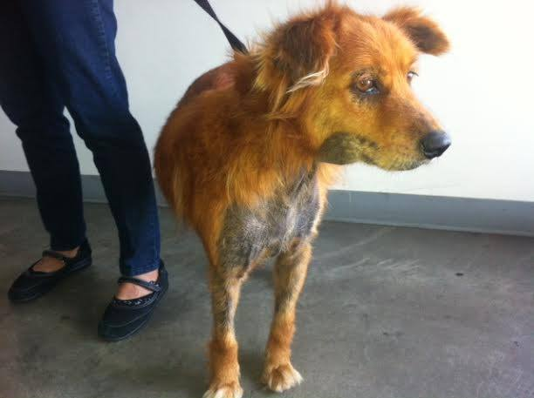

Yesterday, this senior dog (Frannie) came to the South LA shelter to be surrendered not because the owner didn't want to keep her dog but because she had spent hundreds of dollars trying to care for her dog's chronic skin issues.

Being on a fixed income, she simply could not afford to pay anymore and the skin problem was not getting any better with all the visits. She felt her dog was suffering and she did not know where to turn.

Amanda counseled her that another opinion was needed and skin allergies or mange might not be the condition to treat. Within a couple hours, at a low cost vet we use, we paid for the exam and found out that this senior dog had a severe thyroid condition that needed daily medication probably for the rest of her life. Her owner can afford the medicine and was so relieved to have an answer.

So why didn't she get a second opinion before, two possible reasons. First, many of us will take what a professional tells us as the answer and not challenge it, whether it's an MD or a Veternarian. Second, there are not a lot of animal hospitals in South LA and if one doesn't drive, one is very limited to walking or the kindness of a friend or family member to drive the pet and owner to a vet. Add in all the standard challenges of poverty, lack of reliable phone service, lack of access to the internet, lack of ability to research the internet for resources and you have this situation.

Imagine how many pets we could keep out of all shelters if we had a volunteer or staff member to offer resources instead of accepting surrendered pets.

|  |
| --- |
| **Cat spaying, neutering effort breaks records** |
| by The North Platte Bulletin, April 7, 2014 | |
|  |  |
| The “Love My Cat” effort in February to spay and neuter cats was a record-breaking success, spokeswoman Jo Mayber said Monday. “We are delighted with the response,” Mayber said. “Without the media’s commitment to get the message out and veterinarians and vet techs’ hard work, this couldn’t have happened. The clinics should be really tired of hearing from us for awhile.”  In February and into March at some clinics, 506 cats were helped through Love My Cat -- 292 cats spayed and 214 cats neutered, Mayber said.  During Love My Cat, all veterinary clinics in North Platte and Sutherland spayed and neutered cats at a reduced rate. Cat owners paid $25 and the rest of the fee was paid by Paws-itive Partners and P.A.L.s (Prevent-A-Litter.)  An average cat litter is five. If a cat causes or delivers a litter of kittens every six months, the Love My Cat effort prevented 2,500 kittens over six months. Mayber said unwanted cats are a major problem with companion animals. Not enough people adopt cats and kittens to provide homes for all.  The Love My Cat project offered discounts on spaying and neutering, and it was open to domestic, stray and feral cats. Most cats that were treated had homes, but there were a number of un-owned cats as well. “We appreciate people who trapped neighborhood strays or feral cats. It’s a dedicated person who will take time to help these special cats,” Mayber said.  Mayber said the cost of Love My Cat to the non-profit organizations is high, but worth it. “You have to look at cost versus the end result,” she said. “Think of the overpopulation problems and health problems that have been prevented.”  Cat and dog owners are reminded that Paws-itive Partners’ primary goal is to help lower income pet owners spay and neuter their pet. Pet owners who need financial assistance to stop littering can contact the group directly or go on-line and complete an application for assistance. | |

**Strength in Numbers**

**How collaboration and shared data reduced euthanasia rates in Portland, Oregon**

Animal Sheltering magazine, Mar/Apr 2014

by Carol Blymire

They may not be sexy, but spreadsheets save lives.

That’s what the 10 organizations in the Animal Shelter Alliance of Portland (ASAP) discovered when they joined forces to reduce the area’s euthanasia rate. Serving four counties and 2.1 million people in the greater Portland metropolitan area, ASAP slashed local shelters’ total euthanasia rate by 65 percent from 2006 to 2012. In 2013, the alliance received a $1 million recognition grant from Maddie’s Fund, a foundation that supports successful initiatives to decrease euthanasia.

How did they do it? How did they get to the point where nine out of 10 dogs and eight out of 10 cats now leave shelters alive, and no healthy animal has been euthanized since 2010?

It took a deep dig into data and the unique Portland sensibility of open, respectful communication. Shelters have often been fearful of examining and sharing their data—especially euthanasia numbers—but without keeping good statistics and being willing to share them, it’s impossible to judge the problem and take an effective, communitywide approach to solving it. Participants in ASAP say that getting started wasn’t easy, but working together made all the organizations stronger and allowed the community to achieve a pretty remarkable goal.

**Getting Started**

In 2004 and 2005, shelters and rescue organizations in the Portland area held a series of meetings to talk about the

possibility of pooling efforts and resources. Well-intentioned as it was, though, Britta Bavaresco—a consultant and founding ASAP member—says the initial effort was too broad, unfocused, and, ultimately, had a structure that wasn’t working for anyone, especially the city’s animals.

*The community outreach for the Animal Shelter Alliance of Portland’s Spay & Save program has included a booth at “Petlandia,” an adoption event organized by coalition partner Multnomah County Animal Services. Oregon Humane Society.*

In 2006, several leaders of the larger shelters (those that took in more than 1,000 dogs and cats annually, and that already had strong working relationships) attempted to form a different kind of coalition, with the primary goal of establishing a culture of trust and accountability with one another. They set expectations, made commitments about how frequently they would meet to find common ground on their approach to saving lives, and placed the greater good of the alliance and the community’s animals above individual organizations’ politics and philosophies. Then, they brought in leaders from other area animal welfare organizations, animal control, and the veterinary community, with the express goal of working together on pet overpopulation, reducing shelter intake, and ending unnecessary euthanasia.

“The Mayor’s Alliance for NYC’s Animals and the Metro Denver Shelter Alliance were helpful influences in the early stages of forming ASAP, because both cities had similar challenges to Portland in terms of how the city and region is laid out and how we wanted to work together,” says Joyce Briggs, president of the Portland-based Alliance for Contraception in Cats & Dogs, one of the members of ASAP. “But every city is different, and we had to make our own way to find out what worked best for us.”

ASAP held several strategic planning sessions in 2007, where it developed a three-tiered approach to saving lives:

* keep animals (especially cats) out of shelters;
* treat the animals in the best possible manner in the shelter; and
* get the animals out of the shelter, whether by adopting them into homes or transferring them to a rescue or foster group.

With that framework in place, the ASAP leadership committee—made up of executive directors of all partner organizations—appointed their organizations’ operations directors to create and run the ASAP lifesaving committee, which ensures member shelters assist one another on shelter space issues and transfers. ASAP implemented a system to monitor shelter capacity and issue an email alert to all operations managers when a healthy animal is in danger of being euthanized.

“What works beautifully, even when there’s tension at the table, is that since we’ve formed the alliance—and especially the lifesaving committee—the animals have really become ASAP animals, not one shelter’s animals over another’s,” says Bavaresco.

That perspective didn’t come from nowhere. One of the first tasks at hand for the ASAP partners was merging data so they could set clear goals, develop targeted plans, and effectively track results and success.

Coalitions work best when there is honesty, consistency, and data-sharing among their members. Each ASAP member organization uses different software and data methodology, but with support from Maddie’s Fund, in 2008 ASAP began collecting, merging, and reporting the organizations’ data using the standards defined by the Asilomar Accords—a set of criteria, standardized definitions, and formulae for determining live-release rates in shelters.

*The Animal Shelter Alliance of Portland’s Spay & Save program holds quarterly “spay days” at Oregon Humane Society (OHS), offering free spay/neuter surgeries for cats of qualified low-income families. OHS attaches fliers to carriers to help clients spread the word about the program to family and friends. Oregon Humane Society*

“Until you’re speaking the same language, you can’t really craft a peace agreement or battle plan, and Asilomar gave us a common language,” says Sharon Harmon, executive director of the Oregon Humane Society.

While data-integration is difficult and time-consuming, it gave the staff at each organization something to work on together, and ASAP leadership believes it allowed them to feel part of the bigger task at hand.

When the data was collated, the results surprised no one. ASAP needed to start tackling the region’s euthanasia rate by addressing the cat population.

**Spay & Save**

Nearly 80 percent of animals euthanized in Portland-area shelters are cats. Briggs deduced that an important five-year strategy for decreasing cat shelter intake would be to spay and neuter an additional 10,000 cats per year. The alliance decided to target those efforts to those who most needed them.

“People who have fertile cats are the ones who can’t afford to get them spayed or neutered,” says Harmon. “It’s directly tied to income, particularly those who make less than $35,000.”

ASAP created a program called “Spay & Save.” For those who meet the income requirements, it costs only $10 to spay or neuter a cat. For those whose incomes are slightly higher, there is a sliding scale of payment for the procedure. After pilot-testing Spay & Save in two high-intake, low-income ZIP codes, ASAP members implemented it communitywide in February 2010. They used a variety of outreach tools including mailers, community events, signage in Laundromats and grocery stores, social worker outreach, door hangers, posters in methadone and walk-in health care clinics, Craigslist ads, and ZIP code analysis for targeted flier distribution at apartment complexes and mobile home parks.

“We’re not sure why or how, but of all the marketing we did, the Craigslist ads were the most successful,” says Harmon. “We’re still trying to figure that out.”

The organization also worked with feral cat caretakers and other cat groups in the region to bring in as many cats as they could for spay/neuter and release. Since the program’s inception, more than 35,000 cats have been spayed or neutered in five clinics within ASAP’s partner network. Cat intake has declined by nearly 30 percent, and the cat live-release rate has increased from 49 percent in 2006 to 78 percent in 2012. Spay & Save costs $150,000-$200,000 annually, with funding from PetSmart Charities, individual donors, and contributions from ASAP member organizations.

**Collaboration at All Levels**

“Relationships are everything,” says Harmon. She acknowledges that the area’s culture of cooperation and open communications gave them a leg up. “This is Portland! We like to talk, and we’re collegial and supportive. We’re starting with a culture that already embraces communication and teamwork.”

As former executive director of PetSmart Charities, Briggs saw the coalition-building trend starting years ago. Whereas some communities have gotten mired in divisive battles over philosophy and approach, others have recognized the value of putting aside their differences—and that value is recognized by grant-making organizations. “Because organizations can accomplish more working together, national funders began offering special incentive grants to alliances and coalitions to work together to make change,” Briggs says. “Here in Portland, our individual goals across the groups were very much the same, so working on them together just made sense.”

Managing administration and funding has been as important as managing goals. Because of its ready infrastructure, Oregon Humane Society serves as administrative head of the group, overseeing the single ASAP staffer, Anika Moje, and acting as fiscal agent for the alliance, since it’s not a standalone 501(c)(3).

Partner agencies contribute equitably rather than equally, and ASAP shelters collaborate on staff training, software, and sharing behavior and medical resources whenever possible. For example, on-call veterinarians at the Oregon Humane Society address urgent questions from the public during weekends when other partner shelters might not have medical staff available. In the past six years alone, nearly 2,000 cats and dogs have been transferred each year between ASAP shelters.

“To be successful and make these transfers work, our staffs all have to know each other, get along, and work together,” Harmon adds. “We all have each other’s cell phone numbers, and everyone calls to ask for help or offer space. We all have the same goal in mind: no euthanasia.”

To ensure ASAP shelters are consistent in how they evaluate and assess the condition of dogs and cats, the Lifesaving Committee trains shelter staff on the Asilomar Guidelines and Pet Evaluation Matrix.

Relationships with county and city animal control and the veterinary community are an important element of the ASAP program and are built into its structure.

“Early on, even before our big data-merging efforts, we built on and brought into the alliance relationships many of us have with the Portland Veterinary Medical Association and the Southwest Washington Veterinary Medical Association,” says Briggs. “We involved them in helping diagnose the region’s challenges around euthanasia, and did a survey of veterinarians about our proposed cat intake strategies. By doing that, we were able to proceed with our plans having their blessing, which is not to say there was 100 percent agreement, but we’ve walked forward hand-in-hand, and they’ve been very supportive.”

**Engaging the Broader Portland Community**

One area where ASAP hopes to grow and increase education is in its efforts to reach out beyond the animal welfare community and engage the larger Portland-area population, letting the public know that euthanasia is a community issue, not just an issue for animal welfare groups to manage and respond to.

“Certainly a next step for us—and this is where I don’t think we’ve done a good enough job yet—is bringing the community into this, because it’s getting harder to adopt out those animals that aren’t perceived as ‘the perfect Cadillac,’” says Bavaresco. “We have to educate better that animals with treatable or highly manageable conditions are wonderful pets, and we’ll give potential owners all the tools they need to take care of them.”

“Portland loves being green,” she adds, “and the city [government] has done a great job at getting the city behind recycling and other ‘green’ initiatives. What I’d like us to do is create the equivalent of that for the animal community. To have the people of Portland say, ‘I am proud to live in a community where no treatable, rehabilitatable animal is euthanized.’”

ASAP has already had some great successes, though, and it’s been rewarded for those. In May 2013, Maddie’s Fund honored its work, and gave the six bricks-and-mortar shelters in the alliance a $1 million award in recognition of their accomplishments in reducing their euthanasia rates. The award is given to communities that, through collaboration and replicable initiatives, have saved all healthy shelter dogs and cats for multiple years and can demonstrate the ability to sustain those practices for years to come.

Strategic planning is on every ASAP member’s calendar for early 2014. A few of the items on the agenda are how best to invest the $1 million gift from Maddie’s Fund, how to build on the successful Spay & Save efforts, further data analysis, expanding the foster network, and the possibility of building a nursery for bottle-feeding at-risk kittens.

“There’s so much to learn every time we gather and evaluate our statistics,” says Bavaresco. “Looking back, saving all the ‘healthies’ was fairly easy. Saving all the ‘treatables’ has become challenging in terms of space and resources. So, we need to spend time with the latest data and see who exactly are those animals still being euthanized and create programs or tools to reduce our euthanasia rate even further. We’ve come such a long way, but there’s so much more we can do.”

**Get the Stats**

Overview:

* 44,435 cats and dogs taken into Portland-area shelters in 2006
* 2006 Live-Release Rate: 62 percent
* 2012 Live-Release Rate: 85 percent

Since 2006:

* total euthanasia down 65 percent
* treatable euthanasia down 89 percent
* unhealthy/untreatable euthanasia down 39 percent

Since 2010:

* ZERO euthanasia of healthy cats and dogs

**How Can Other Cities Make a Difference? Key Factors for Coalition Success:**

* Communicate openly
* Meet regularly
* Acknowledge and accept differences, but find common ground
* Data, data, data
* Include the veterinary and animal control communities in your efforts
* Set attainable goals before setting bigger-reach goals; small victories build foundation for bigger success
* Give leadership members clear roles
* Encourage and facilitate staff-to-staff interaction and collaboration
* Thank volunteers often
* Use your local community’s strengths to your advantage
* Be patient—true, long-lasting change takes time

**Resources**

* To learn more about the Animal Shelter Alliance of Portland (ASAP) and how collaboration might work in your community, go to [asapmetro.org](http://asapmetro.org/).
* Maddie’s Fund ([maddiesfund.org](http://www.maddiesfund.org/)) publishes a variety of studies and articles about increasing lifesaving efforts for dogs and cats in the “Maddie’s Institute” section on its website.
* Check out Shelter Animals Count, a new, collaborative initiative to create and share a national database of sheltered animal statistics, at [shelteranimalscount.org](http://shelteranimalscount.org/).

**Animal Shelter Alliance of Portland members:**

* Alliance for Contraception in Cats and Dogs
* Cat Adoption Team
* Clackamas County Dog Services
* Feral Cat Coalition of Oregon
* Humane Society for Southwest Washington
* Multnomah County Animal Services
* Oregon Humane Society
* Portland Veterinary Medical Association
* SW Washington Veterinary Medical Association
* Washington County Animal Services (Bonnie L. Hays Small Animal Shelter)

*ASAP Mission: End the euthanasia of healthy, social, and treatable dogs and cats in our local shelters by collaborating on spay/neuter programs, committing to educational and outreach efforts, and promoting humane alternatives for feral cats.*

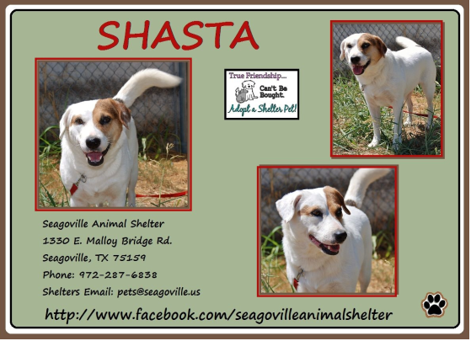

# People In North Texas Just Adopted More Than 2,200 Animals In One Day

The Huffington Post  | By Dominique Mosbergen

08/18/2014

More than 2,200 cats and dogs were reportedly adopted from animal shelters across North Texas on Saturday as part of “[Empty the Shelter Day](http://www.emptytheshelter.org/)“ — a pet adoption drive that saw more than 30 shelters in the region waiving their adoption fees for a day in an effort to find forever homes for the animals in their care. Organizers had said prior to the event that it was to be largest pet adoption effort ever to be held in North Texas, and it certainly seems to have lived up to the hype.

According to reports, the turnout Saturday was overwhelming as swarms of [adoption hopefuls descended upon participating shelters](http://www.dallasnews.com/news/metro/20140816-2200-pets-adopted-on-empty-the-shelter-day-in-dallas-area.ece) throughout the day. Dallas Morning News said, for instance, that people had “lined up around the building” of one participating shelter before it even opened its doors; a KXAS‑TV reporter tweeted …

Dallas Animal Services is packed! They already adopted out ALL 112 dogs in the Empty the Shelter program! [@NBCNews](https://twitter.com/NBCNews) [pic.twitter.com/TJHsvXB5nx](http://t.co/TJHsvXB5nx)

— Jocelyn Lockwood (@JocelynNBC5) [August 16, 2014](https://twitter.com/JocelynNBC5/statuses/500739274325512192)

“I’ve been doing this 14 years and [this is the most packed our shelter has ever been](http://www.nbcdfw.com/news/local/Empty-the-Shelter-Day-Lives-Up-To-Name-271545461.html),” Ray Rentschler, field operations director for participating shelter Arlington Animal Services, told KXAS‑TV of the incredible turnout Saturday. “We love it.”

All in all, “Empty the Shelter Day” was a huge win in many ways, said both organizers and participants. Not only did the event help to increase the visibility of animal shelters in their communities, but — given that overcrowding is an especially urgent problem in shelters during the summer — it was also critical in the saving of many, many lives.

KXAS-TV reported, for instance, that one participating shelter, Dallas Animal Services, was [euthanizing 50 to 60 animals every single day this summer](http://www.nbcdfw.com/news/local/NBC-5-Sponsors-Empty-The-Shelter-Day-268739021.html) because it simply didn't have space for them; on Saturday, however, the shelter [found homes for 149 of its 150 animals](https://twitter.com/DallasShelter/status/501020755690532864).

The day's success could perhaps be best summed up in a photograph posted by the Society for the Prevention of Cruelty to Animals of Texas, one of the event’s partners, at the end of the adoption effort. “Look at those empty kennels,” the organization wrote on Instagram. “#emptytheshelter...#savealife.”

Encouraging pet adoption by waiving fees is not a new phenomenon. In June, AZCentral.com reported that almost [2,000 pets were adopted over a weekend](http://www.azcentral.com/story/entertainment/events/2014/06/02/maricopa-county-residents-adopt-2000-cats-and-dogs/9874889/) after several shelters in one county agreed to waive their fees.

Though some critics say that “free adoption” events may attract people who aren't entirely serious about caring for their animals, a 2012 study conducted by researchers at the University of Florida found that free adoptions [do not increase the risk of abandonment or shoddy care](http://www.maddiesfund.org/Maddies_Institute/Articles/Free_Pet_Adoptions_Study_Results.html). “Free adoption promotions may [increase adoptions without compromising quality of life](http://sheltermedicine.vetmed.ufl.edu/files/2012/06/Abstract_MacArthur_Adoptathon.pdf),” the researchers said at the time.

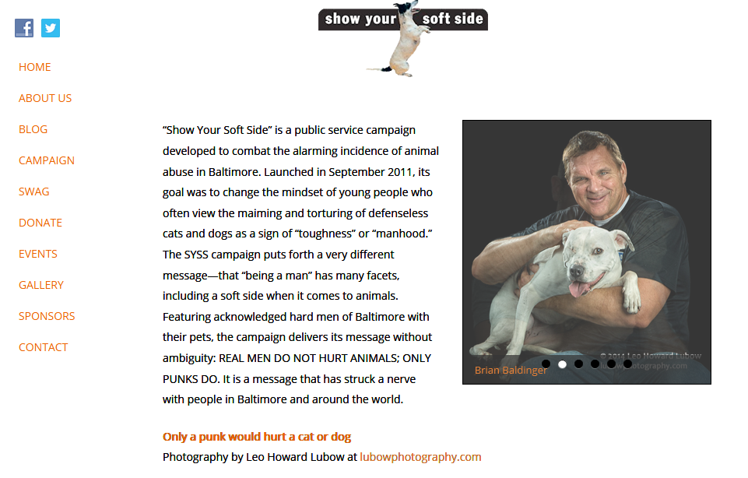**NO Kill Pima County (Arizona)**

**Pet Retention Program**

|  |
| --- |
|  |

$26.66 was all it took. Owner Retention, a component of the No Kill Equation:

Pet owners with financial difficulties sometimes turn to the shelter to euthanize their suffering or sick pet. Sometimes that decision is premature, but they were afraid of the cost to visit the vet for an actual diagnosis. Sometimes pet owners surrender their sick or suffering pet to the shelter just so they can get the medical attention they need, sacrificing their own attachment to the animal so the animal might be relieved of suffering.

The S.O.S. Help Desk, a service of No Kill Pima County, in collaboration with Pima Animal Care Center, works to help some of these pet owners, who have not seen a vet (and don’t know what the problem is and/or presumed a diagnosis/cost) consider whether a visit to the vet might change their perspective. And indeed we have discovered there are times the pet was not incurably ill or the needed treatment was not expensive and the pet could maintain a good quality of life.

For example, in September a woman was surrendering her older cat because there was something wrong with the cat’s eyes and she felt the cat was suffering and she couldn’t afford to go to the vet. With the support of a Vet who looked at the cat at no charge and a total of $26.66 for the eye drops from the S.O.S. Fund, this cat was maintained in his loving home and not surrendered to the over-crowded shelter where he would be under severe stress without a guarantee of adoption.

The S.O.S. Help Desk at PACC solicits discount services from the medical community and donations from the

public to make this possible.

[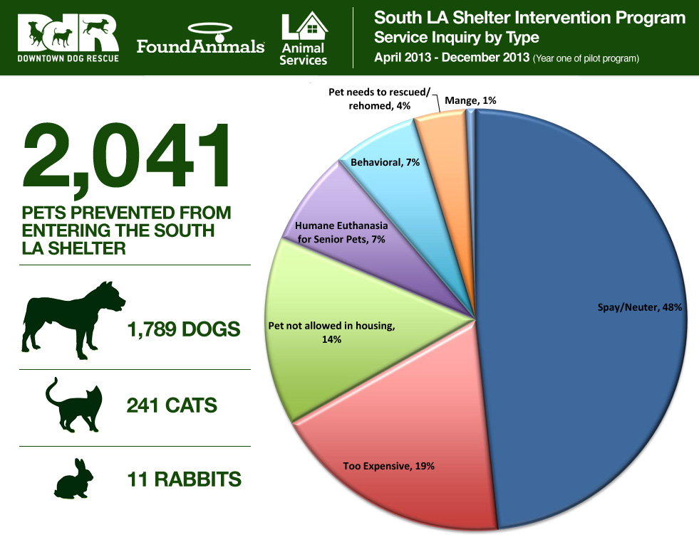](http://barkpost.com/shelter-intervention-program/graph/)**This Los Angeles Shelter Program Is Revolutionizing Animal Rescue**

There’s a groundbreaking program in Los Angeles that’s making a huge difference in the lives of people and pets – and changing the way we think about rescue. Anyone who’s been to their local shelter knows it’s easy to walk the kennels, see the faces of the “strays” and “owner surrenders” and come to the conclusion that people are horrible – but in reality the story is much more complicated. In her 16 years working in the community, [Downtown Dog Rescue](http://www.downtowndogrescue.org/) founder Lori Weise realized that the pet overpopulation problem in our country is not so much a pet problem as it is a people problem – more than that, it’s a *poverty* problem. In response to this, Downtown Dog Rescue (DDR), with the support of [Found Animals Foundation](http://foundanimals.org/) and in partnership with the South Los Angeles Shelter, launched the Shelter Intervention Program in April 2013. The goal? To intercept people surrendering their pets, address their challenges, and whenever possible, help them keep their pets out of the shelter.

**The Result? In the first 9 months of the program, 2,041 pets were kept in their homes and out of the shelter!**

That’s 2,041 pets who didn’t need to be in the shelter, leaving space open for those pets who truly do need to be rescued. The best part is that this model is already spreading! After seeing the success at the South L.A. Shelter, Kerry Lowe Armstrong, a volunteer at L.A.’s North Central Shelter, started a non-profit organization, [Home Dog LA](http://www.homedogla.com/), and began running an intervention program there. They started small two days  a week, but thanks to teamwork and sharing resources, the program grew to three days, then more, and now the North Central Shelter Intervention program is running very similar to the one in South LA. Collaborations like this save lives!

**Did you know that the average cost to keep a pup out of the shelter is $50?**

Imagine if the tax dollars spent to house, feed, and euthanize pets in shelters was instead spent on providing low-income communities with the resources they need to care for their pups! Shelters would be way less crowded and rescue groups’ resources could be spent helping pets who truly need homes.

**In South LA, almost 50% of pets land in shelters because they weren’t spayed or neutered.**

Sometimes, all it takes is a conversation (free of judgement!) to help someone who may be opposed to spay/neuter realize it’s the healthiest option for their pet. Other times, the conversation is easy – families want to spay/neuter and vaccinate their pets, but lack the funds. When this pup’s devastated owners were told they either had to neuter their pup or surrender him, and they didn’t have the money for the surgery, DDR helped them with the cost so this happy family could stay together!

**For low-income pet owners, unexpected vet bills can be a an overwhelming obstacle.**

This 7 year old pup (on the left) was adopted by his family in 2009. They love him dearly, but when an old injury (he had been hit by a car way before they adopted him) progressed to paralysis and seizures, they felt overwhelmed and considered surrendering him. With already limited resources, they were spending 50% of their monthly income on vet visits and still getting no answers. DDR is now paying for his seizure medication and rescue partner [Noah’s Bark](http://noahs-bark.org/) donated a wheelchair. This family who once felt hopeless now has the community and resources to help care for their beloved handicapped pet. High paws for teamwork!

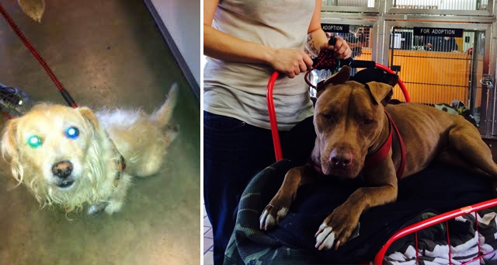Iliana the pit bull (on the right) lives with her parents Stephanie and Brian and her dachshund sister under a bridge in downtown L.A. Although homeless, the couple always puts their pups first. Stephanie said she found Iliana about a year ago being beaten by a group of men on the street. In her words, she told them: “This is not your dog any more. It’s mine.” The two have not been apart since that day. The family walked into North Central shelter as a last resort when Iliana was vomiting blood and all the vets they visited were closed. Afraid they couldn’t afford the vet bills, Home Dog L.A. sent them to a low-cost vet clinic and helped cover the cost. Iliana made a full recovery!

**Think twice when you hear about the senior dogs “dumped” at shelters.**

It might be hard to imagine, but many pup parents have never heard of humane euthanasia. For others who struggle to make ends meet each month, even the small cost to have a senior or terminally ill pet euthanized by a private vet is out of their budget. Knowing only that shelters put animals to sleep, and not wanting to see their pup suffer any longer, they bring their pet to the only place they can think of. Buddy was one of these pups. A beloved family member for 18 years, Buddy could no longer stand up on his own. His family wanted to take away his pain and thought the shelter staff would know how to do that. When DDR offered to pay for humane euthanasia at a private vet, the family was overjoyed. Instead of spending his final days alone and scared in a metal cage, Buddy was surrounded by a circle of love as his family stayed with him through the whole process. Most pup parents want to do right by their fur kids, sometimes they just don’t know how.

**Most ”strays” in shelters have a more complicated back story.**

Sometimes the unthinkable happens, pups get out. Maybe someone asked a friend or family member to watch their pet for them, only to discover their “trusted” pet sitter took their BFF to the shelter instead. Maybe the fence is broken or the gate was accidentally left open. Imagine the relief of finding your lost fur baby at the shelter…followed by the sinking disappointment when you’re told you owe $100+ for the redemption fees and you’re broke until payday. This is a reality for many pup parents. When these folks came up short for the redemption fees, donations from shelter intervention supporters saved the day.

**Sometimes communities come together to mend fences (literally).**

Reuben’s dogs Mona and Shadow kept getting out from his yard because of a gap in the fence - they were eventually picked up by animal control and brought to the shelter. Home Dog L.A. helped Reuben with the fees to get his dogs back and also offered to fix the fence so the dogs can not get out again. Ready for the pawsome part? One of the first people who received help from the North Central Intervention program, Jarvis, came out to fix the fence for Reuben. Pet parents are so grateful for the helping hand that they pay it back tenfold by helping others.

**“I’d rather be homeless than give up my dog.”**

How many of us have spoken those words? Let’s be honest, most of us will never find ourselves in such a difficult position (thankfully). No family, especially one with children, should willingly choose to live on the street. If you only saw Rocky’s kennel card, you’d think he was the result of a “heartless” owner surrender  - in reality he has a family who loves him very much. His owner, on a very low income, had paid a pet deposit for Rocky, but her landlord suddenly changed the pet policy. Unable to afford to move, she tearfully came to the shelter to surrender him. DDR shared the story on Facebook, a pro-bono lawyer stepped up to help, and this 3 year old pit bull is back with his family who loves him.

On the very first day of the North Central Intervention program, this woman arrived in tears to surrender her 10 year old Chow. After living in the same home for 37 years, her landlord suddenly said she had to pay a $200 pet deposit – which she couldn’t afford. It was the program’s first day and they had no funding yet, but Kerry Lowe Armstrong wrote a check out of her person account to cover the pet deposit and this senior pup is back in his home where he belongs.

**“There are no bad dogs.” – trainer Larry Hill**

For first time pet owners or anyone with limited resources, an unruly pup or sudden behavioral issue can be too much to deal with. Emilie adopted Scoobie (on left) from the shelter but became distressed when Scoobie started exhibiting aggression with her female pitbull. In a pawsome example of communities coming together, North Central Intervention counselors told Emilie about a low-cost class taught every Sunday by Larry Hill of [Puppy Imprinters](http://puppyimprinters.org/). Emilie and her whole family went every week and Scoobie graduated with flying colors! Shadow and Cartoon (with trainer Larry Hill on right), were also about to be surrendered for fighting at home. Like Scoobie, they are now working it out thanks to Home Dog L.A. and Puppy Imprinters. That’s three pitbulls not sitting in crowded shelters and two happy families able to stay together!

**The moral of the story…**

Yes, many times animals end up in shelters because of cruel and irresponsible pet owners – but more often than not, if you bother to talk to people surrendering their pets, you’ll find that there are so many good, caring pup parents who just lack resources and feel like they’re out of options. We can all learn a thing or two about compassion (toward both pups and their hoomans) from this program.

The Shelter Intervention Programs rely on the generous donations of their supporters. Visit their websites to learn more and donate to [Downtown Dog Rescue](http://www.downtowndogrescue.org/) and [Home Dog L.A.](http://www.homedogla.com/) Follow along with [Downtown Dog Rescue](https://www.facebook.com/pages/Downtown-Dog-Rescue/494864343909109?ref=br_tf) and the [North Central Shelter Intervention Program](https://www.facebook.com/northcentralintervention) on Facebook for more pawsome stories, and most of all, please consider trying out a program like this in your own community! (Source: <http://barkpost.com/shelter-intervention-program>, 2014)

[**Area animal shelters partner with Mobile App Company to reunite lost dogs with owners**](http://www.austintexas.gov/news/area-animal-shelters-partner-mobile-app-company-reunite-lost-dogs-owners)

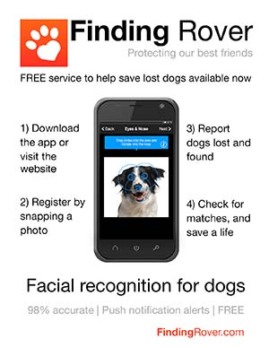The free mobile app helps pet owners find lost dogs in real-time. Austin Animal Center and area animal shelters partner with [Finding Rover](http://findingrover.com/), a free mobile app for finding lost dogs in real-time.

Nationally, more than 10 million pets go missing each year, according to The Humane Society of the United States. Finding Rover’s facial recognition technology helps reunite more dogs with their owners by enabling anyone to instantly identify a missing dog on the spot simply by taking a photo on a mobile device.

Finding Rover features a  lost and found dog notification system that sends a push notification and social feed photo alert if a dog is lost or found within a 10 mile radius. If a user spots a lost dog, he/she can take a photo either within the app, or upload a photo from a device’s photo album. Once a dog has been found and identified through Finding Rover’s facial recognition software, the finder will receive information on how to notify the owner.

“This mobile app is just one more resource in our tool box that will make it easier for lost dogs to find their owners,” said Chief Animal Services Officer  Abigail Smith.  We are thrilled that Finding Rover has chosen Austin as their launch city in Texas, and are pleased that this app will help reduce dogs entering the shelter in the first place.”

Finding Rover will soon be launched in San Antonio and Houston.

“A dog is a beloved family member and if it goes missing it can be devastating to everyone involved,” said John Polimeno, CEO and founder of Finding Rover. “We want to do everything we can to safeguard our dogs from being lost forever. Registering a dog on Finding Rover is another step all owners should take to further protect their cherished pet.”

Key benefits of the app include:

* **Simple to register:** Registration is easy through Facebook and email – all you need is a picture of your dog and a zip code.
* **Easy to use:** Anyone with a mobile phone can take a photo of a lost dog, which will be instantly posted on Finding Rover.
* **Technologically advanced:** Finding Rover spent two years with The University of Utah research and development (R&D) department creating its proprietary facial recognition technology. Finding Rover has the only technology that instantly recognizes a dog on the spot.
* **Social:** Finding Rover unites dog owners based on common interests and provides a forum for users to read up on the latest dog news, share content and interact.
* **Free!** Finding Rover is free to download.
* Finding Rover is currently online at <http://findingrover.com/>  and works on iPhone, Android, or the Web.

**Madison Co. (AR) Pet Shelter Drops Euthanasia Rate to 2%**

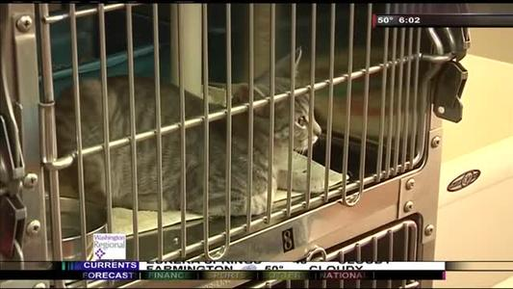

[Tevin Wooten (December 12, 2014)](https://twitter.com/TevinWooten)

http://www.nwahomepage.com

HUNTSVILLE, AR--The Madison County Pet Shelter is making a comeback after facing budget cuts in 2012. Workers at the shelter say in just a few months, they've been able to greatly reduce euthanasia rates and save pets' lives.  
  
“The euthanasia rate...I was told was at 74% and we've been able to decrease that to 2%,” says Shonna Harvey, Director of the Madison County Pet Shelter.  
  
In just 6 months, Harvey says the shelter's been able to undergo a complete turn around. “ We're updating the flooring,” says Harvey. “We're actually going to create a cat room so that the cats have an area to free roam.”  
  
Thanks to licensed rescue groups pitching in to adopt pets, and donors from all across the country, things at the shelter are looking up. “You know it, truly takes a village,” Harvey says. “It's just been such a blessing for everybody to contribute to help save lives.”  
  
In August the shelter was overcrowded with 73 animals. But because of donations and local support, they now have that number down to 37.

Donna Woods came in to finalize the adoption of her dog, shorty. Harvey says because of people like Woods, they're able to keep the shelter free of overcrowding issues that they've had in the past.  
  
“You know we've had an out-pouring of support of the community wanting to come in and help,” says Harvey. “If they find a stray animal to hold onto it for a couple of weeks and foster it until the shelter has space to take them in.”  
  
Harvey hopes the community continues to be a support mechanism for the shelter. “We have so many goals and we still have a long way to go, but the future is bright. It's really an exciting time for us,” says Harvey. “We just need continued support to keep doing what we're doing.”

1. http://www.ilovedogs.com/2012/06/woof-matches-the-formerly-homeless-with-homeless-pooches. [↑](#footnote-ref-1)