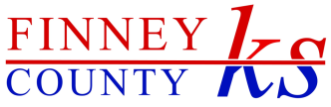

**Finney County**

**Correction Services Center**

**Sales Tax Ballot Election on Tuesday, March 4, 2014**

**WHAT IS THE PROPOSED FACILITY?**

Finney County plans to construct a new Correction Services Center on Santa Fe Street between 12th and 13th streets. The facility will combine and replace 3 separate facilities in 3 different locations.

**HOW WILL IT BE PAID FOR?**

If the ballot issue is approved, Finney County will issue bonds in an amount not to exceed $6,625,000. The bonds will be paid from a ¼ cent county wide retailers’ sales tax. **THERE WILL NOT BE A SALES TAX INCREASE.** The proposed ¼ cent sales tax will commence upon the expiration of an existing ¼ cent sales tax expected to occur in July, 2014.

**BENEFITS OF A NEW BUILDING**

* Paid for through a continuation of a ¼ cent sales tax and burden shared by all who shop in the area, not just Finney County citizens
* Central location of drug & alcohol and cognitive based programming services for both adults and juveniles
* Improved teamwork and collaboration between agencies in providing supervision to offenders on probation
* Promote greater community, law enforcement & social service agency access
* Enhanced collaborative training where possible
* 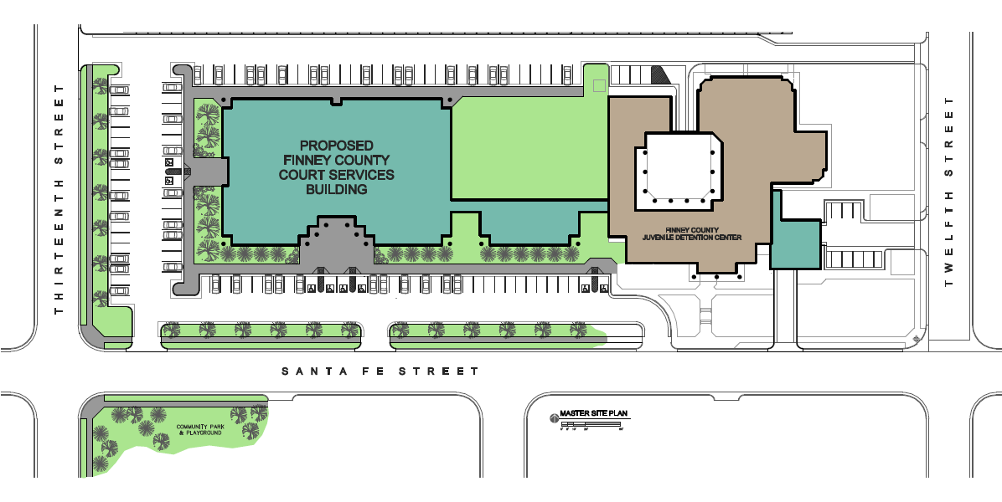Secure juvenile intake facility and unloading area

**Proposed**

**Finney County**

**Correction Services Center**

**WHAT AGENCIES WILL SHARE THE NEW CORRECTION SERVICES CENTER?**

**YOUTH SERVICES**

* Community based intensive supervision & case management of youth offenders
* Substance abuse testing, assessment/counseling, and anger management counseling
* Best practices evidence based courses for juvenile offenders

**COMMUNITY CORRECTIONS**

* Community based supervision Adult Intensive Supervision (AISP) for both male and female adult offenders
* Assistance to offenders through referrals to social service agencies or the development of in-house programs designed to provide offenders the necessary resources to maintain a crime-free lifestyle
* Chemical dependency evaluations and treatment to offenders

**COURT SERVICES**

* Supervise adult and juvenile probationer’s compliance with court-ordered probation conditions, including employment, substance abuse treatment, mental health counseling, and life skills development
* Ensure payment of victim restitution and court costs and completion of community service
* Ensure public safety through issuance of arrest warrant

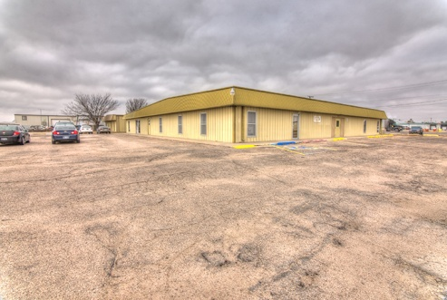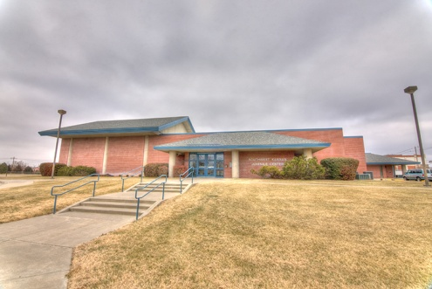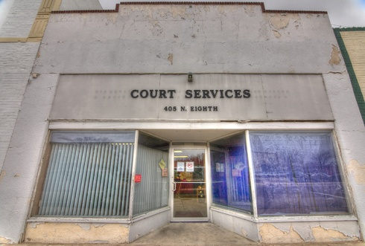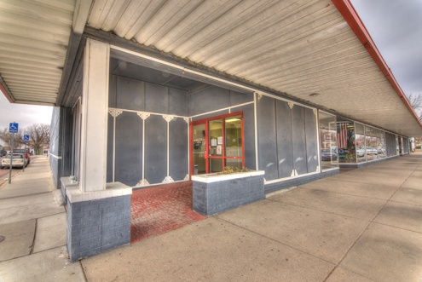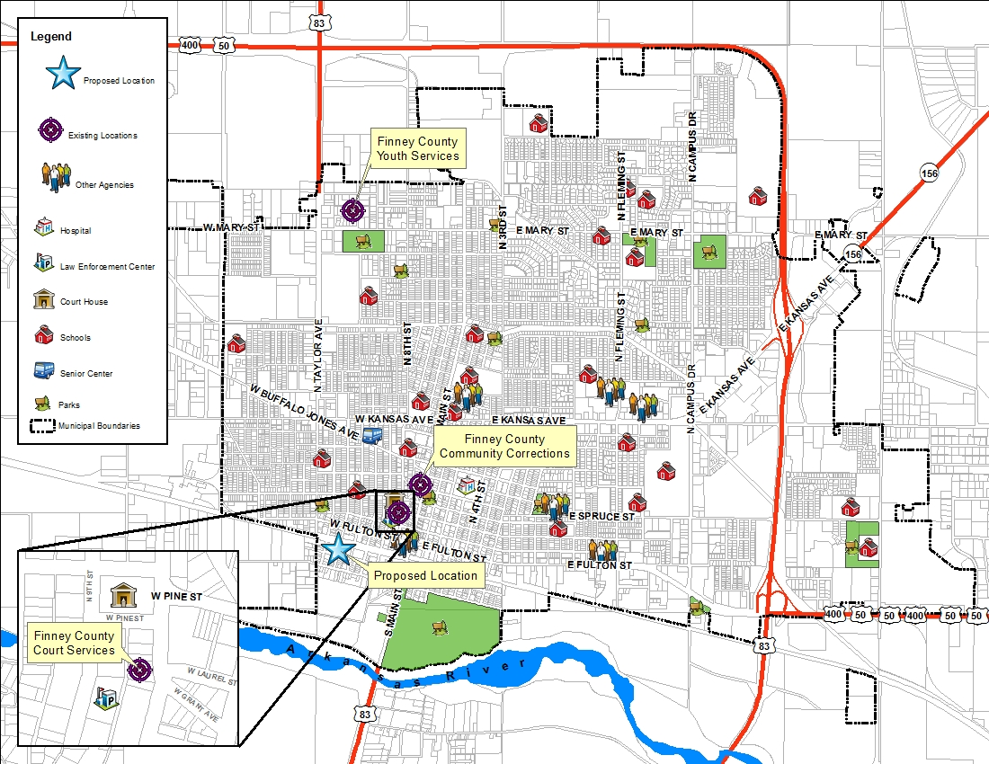

Juvenile Detention Center

**507 W. Santa Fe**

Court Services

**405 N. 8th**

Community Corrections

**601 N. Main**

