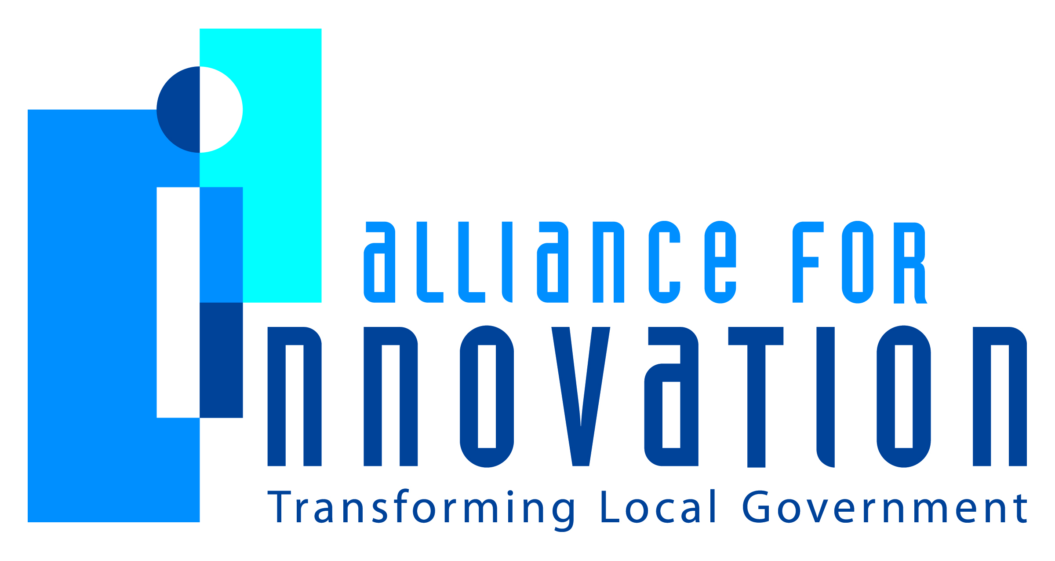

Innovation Award Application 2014

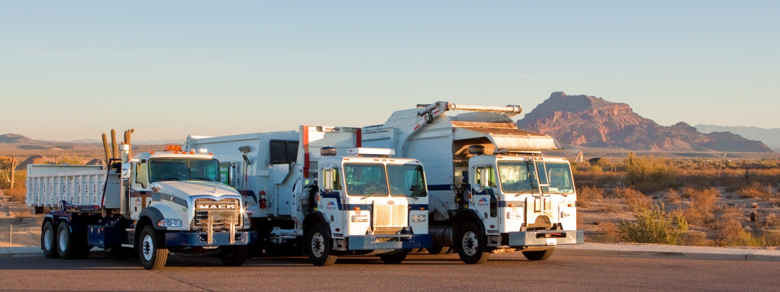

Regional Solutions for Solid Waste Disposal
Jill Kotsur
Executive Management Assistant to the City Manager
City of Mesa
P.O. Box 1466, Mesa, AZ 85211
480-644-4755
Jill.Kotsur@mesaaz.gov

Describe the Program/project/ product/ service innovation:
An Intergovernmental Agreement (IGA) between City of Mesa, Town of Gilbert and City of Tempe was implemented in November 2012. This agreement provided the ability to leverage a high volume of tonnage for reduced rates on disposal and increased recycling revenue through a multiple-agency request for proposal (RFP).

Each municipality will select the options and services most favorable to their respective communities. Thus the parties will not have to select the same respondent. Rather, each party will select a respondent based on several factors such as tipping fees, location of facility, and operational efficiency.

The intent of the project was the realization of substantial cost savings on solid waste disposal, and increased revenues on recyclable materials.

Background:

Currently, the City of Mesa has multiple disposal and commingled recyclable contracts that are nearing the end of their term. The Town of Gilbert and the City of Tempe are in similar situations with their respective contracts. This presents a critical need for Mesa, Gilbert and Tempe to acquire new disposal contracts that will not only meet our current business needs, but also provide options for future needs. With the recent growth of residential communities and businesses in south east Mesa, a new business need has arisen to provide cost-effective collection service, the most efficient solution is the addition of more disposal facilities in closer proximity to the location of the fleet.

The City of Mesa currently contracts with the Salt River Commercial Landfill Company (a division of the Salt River Pima Maricopa Indian Community), River Recycling, Waste Management and Republic Waste Services. The contract with River Recycling for 49 percent of collected commingled recyclables expires in September, 2013. Mesa’s contract with Salt River Landfill for 51 percent of commingled recyclables, and 75 percent of solid and green waste expires in December, 2015. The contracts with Waste Management and Republic Waste Services for the remaining 25 percent of solid waste/green waste both expire in September, 2013.

Short description of the importance, internal impact, and community benefits:
The City of Mesa provides solid waste collection and disposal for the incorporated areas of the City and is responsible for the collection, disposal, and recycling of the City’s municipal solid waste. Mesa currently disposes or recycles over 269,000 tons annually (FY 12-13) of commercial and residential waste. This includes approximately 216,000 tons of solid waste (trash), 34,000 tons of recycling and nearly 20,000 tons of green waste that are collected as curbside recycling, composting and source reduction.
To give a perspective of the magnitude of the service that we provide, on average, we collect 28,652 solid waste (trash) loads per year. A load is a solid waste collection truck filled to maximum capacity. These loads are currently disposed of at five different locations. With the assistance of the IGA, three new proposed facilities have become available to bring the total number of disposal sites to eight. These new sites allow the opportunity to better align the collection routes with the disposal facility locations to decrease operational costs. This positive outcome is applicable to our green waste collection as well, increasing from one disposal facility to three.

Recycling in the City of Mesa is a highly popular program and can be very profitable. Annually, we average 6,500 loads of recyclable material to material recovery facilities (MRF) which yields revenues of approximately $1.1 million. The number of MRFs available for our use will increase from two to five locations.

With the addition of new disposal locations primarily on the east end of the city, an option has become available to add a second operational center located at the East Mesa Service Center, which is an east side centralized service center shared by multiple city departments. By adding an east service center, approximately half of our staff and collection vehicles will be located closer to their routes and disposal locations, therefore minimizing driving time and wear and tear on the vehicles.

What makes this a quantum leap of creativity?
This process of procuring disposal facility agreements in a collective fashion is unique to the industry. Typically the specific service providers bid for contracts with disposal sites on an individual basis. Making this process innovative by leveraging all of the available tonnage into a more enticing opportunity for the disposal sites is an innovative concept. The ultimate goal of the IGA is to prove our theory that a RFP advertised by the municipalities will result in substantial cost savings on landfill costs, and increased revenue on recyclables.
Joint purchasing efforts between and among public agencies in the State of Arizona have been shown to improve competition, quality, and services, to lower prices, and avoid duplication of efforts. Therefore, the municipalities developed an IGA outlining a project to work together in an effort to increase respective revenues, while decreasing our expenses.
Who benefits?
The benefits from this innovative agreement start with the service provider. Mesa is able to secure more competitive disposal costs (tipping fees, transfer fees) while decreasing operating costs due to the closer proximity of the disposal sites to the collection routes. This important benefit is then shared with the customers by minimizing the potential for solid waste monthly utility rate increases and providing them additional locations for their own personal disposal needs. Another potential benefit is the opportunity for economic development with the construction of new disposal facilities and MRF’s to meet the demands of the municipalities in the IGA who have guaranteed tonnage to deliver.
How was the program/project/product/service initiated and implemented?
The project began from early discussions amongst solid waste municipal managers regarding future disposal options for trash and recycling materials. Three municipalities, City of Mesa, City of Tempe and Town of Gilbert proposed to enter into this IGA for the purpose of joint procurement of consultant services, and to cooperatively procure disposal services and recyclable marketing. The City of Mesa was designated as the lead agent for this IGA.
Once the municipalities met and concurred on the IGA, a consulting group, SAIC was hired to assist with the development of the RFPs and the review of the responses.

The consultant surveyed the market for potential providers and the relative strength of their abilities to respond to the RFP on a regional basis; analyzed the opportunities for an RFP delineating disposal and recycling opportunities for the municipalities involved; coordinated the development and issuance of an RFP; and analyzed best practices for regional landfill and recycling approaches.
Implementation then became the responsibility of each municipality to select a responder and begin the process of preparing agreements, coordinating communication with their respective legal departments, procurement departments, and city/town executives and elected officials. Once the agreements are signed, each municipality must be prepared to make adjustments to their daily operations.
The City of Mesa presented the IGA proposal to our City Council on October 15, 2013 and identified that our responsibilities included the following:
• compiling solid waste, green waste, and recyclable materials volume estimates
• preparing the initial bid or proposal documents disbursing payments to third parties
• complying with applicable laws, ordinances, and rules in the competitive procurement of disposal services and recyclable materials marketing
• procuring the professional services of a consultant(s) to assist with the preparation of the bid or proposal documents
• preparing of the final bid documents
• receiving bids or proposals
• participating with the other municipalities to evaluate the submitted bids or proposals

What risks were taken?
The risk involved with this innovation was ensuring that supply (disposal facilities and MRFs) would equal demand (combined tonnage) at a competitive rate. While IGAs are not a new concept, the IGA between municipal solid waste haulers is new and could yield expected results. Some of the defined risks if this idea failed were: lost time from each involved municipality, expense of consultant services, risk of disposal and MRF facilities not having the ability to manage the total tonnage and tipping fees and revenues increasing or decreasing significantly.
What, if any were the costs and/or savings?
The execution costs were the expense of the consultant, SAIC at approximately $80,000. This cost was shared amongst the IGA participants. Other costs were administrative and absorbed by each municipality within their operating budgets.
The savings for City of Mesa have been estimated at approximately $45,000 in annual solid waste (trash) tipping fees, and a reduction in operational costs for green waste disposal with the addition of disposal facilities.

Revenues from recyclable material sales are estimated to increase approximately $57,000 annually, as well as a reduction in operational costs with the additional MRF location that is closer to the collection routes.

What are the lessons learned that other local governments can learn from?
The most valuable lesson learned is time management. This IGA process began a couple of years ago and as it gained momentum, the time commitments grew exponentially. Ensure each involved participants allows enough time to communicate with various departments such as procurement, legal, executive management and councils or governing bodies. In addition, be flexible when coordinating with the RFP respondents whom may have different hours of availability, defined work schedules and priorities. The end result reaps benefits that far outweigh the challenges during the journey.
What department and/or individual(s) championed the innovation? If a contractor was used, please list the name and their contact information.
The City of Mesa was the lead agent for this innovative process. The initial discussions originated from the existing City of Mesa Solid Waste Director at that time, who solicited interest from other municipal managers.
The City of Mesa Mayor, Council and City Manager also supported innovation and approved the IGA with confidence in the direction that Mesa’s solid waste department was going to provide a more efficient service to our constituents.

Any additional information you would like to share?
Innovative, Informative, Inspirational:
The City of Mesa Solid Waste Management Department is proud of the successful collaboration and collective agreements with City of Tempe, Town of Gilbert and the other parties involved in this innovative initiative.

The conception and implementation of the IGA, thus bringing together several municipalities challenging the industry to compete for the best solid waste disposal and recycling material marketing options follows the selected City of Mesa’s City Council Strategic Initiatives:

REGIONAL LEADERSHIP --- The IGA addresses a challenge that requires regional cooperation. This partnership focuses on the various municipal Solid Waste Departments working together to ensure that we provide our customers with the most effective and efficient service.

FINANCIAL STABILITY --- The IGA provides proactive leadership and will consider all financial factors, such as revenues, expenditures, taxes, budgeting and efficiency.

When preparing the agreements with the responders from the RFP, this detailed process proved to be informative. Each member of the team including solid waste staff and legal staff had the opportunity to analyze the terms and conditions, resulting in opportunities to better define operating procedures within the organization. Safety procedures, billing and reporting processes and communication requirements were just some of the items that were revisited and improved upon.

Most notably, this innovative process presented a positive take-away for each individual involved. Staff members were brought together and challenged to scrutinize each detail of the agreements. The language and nature of these agreements is often not easily comprehended and pushed individuals beyond their comfort zone, therefore growing their knowledge and skill sets with this experience.

This IGA has provided value beyond dollars and cents. The City of Mesa Solid Waste department is more efficient, both operationally and fiscally, and the staff is also more knowledgeable and has a vested interest in the future success of this innovative initiative.

