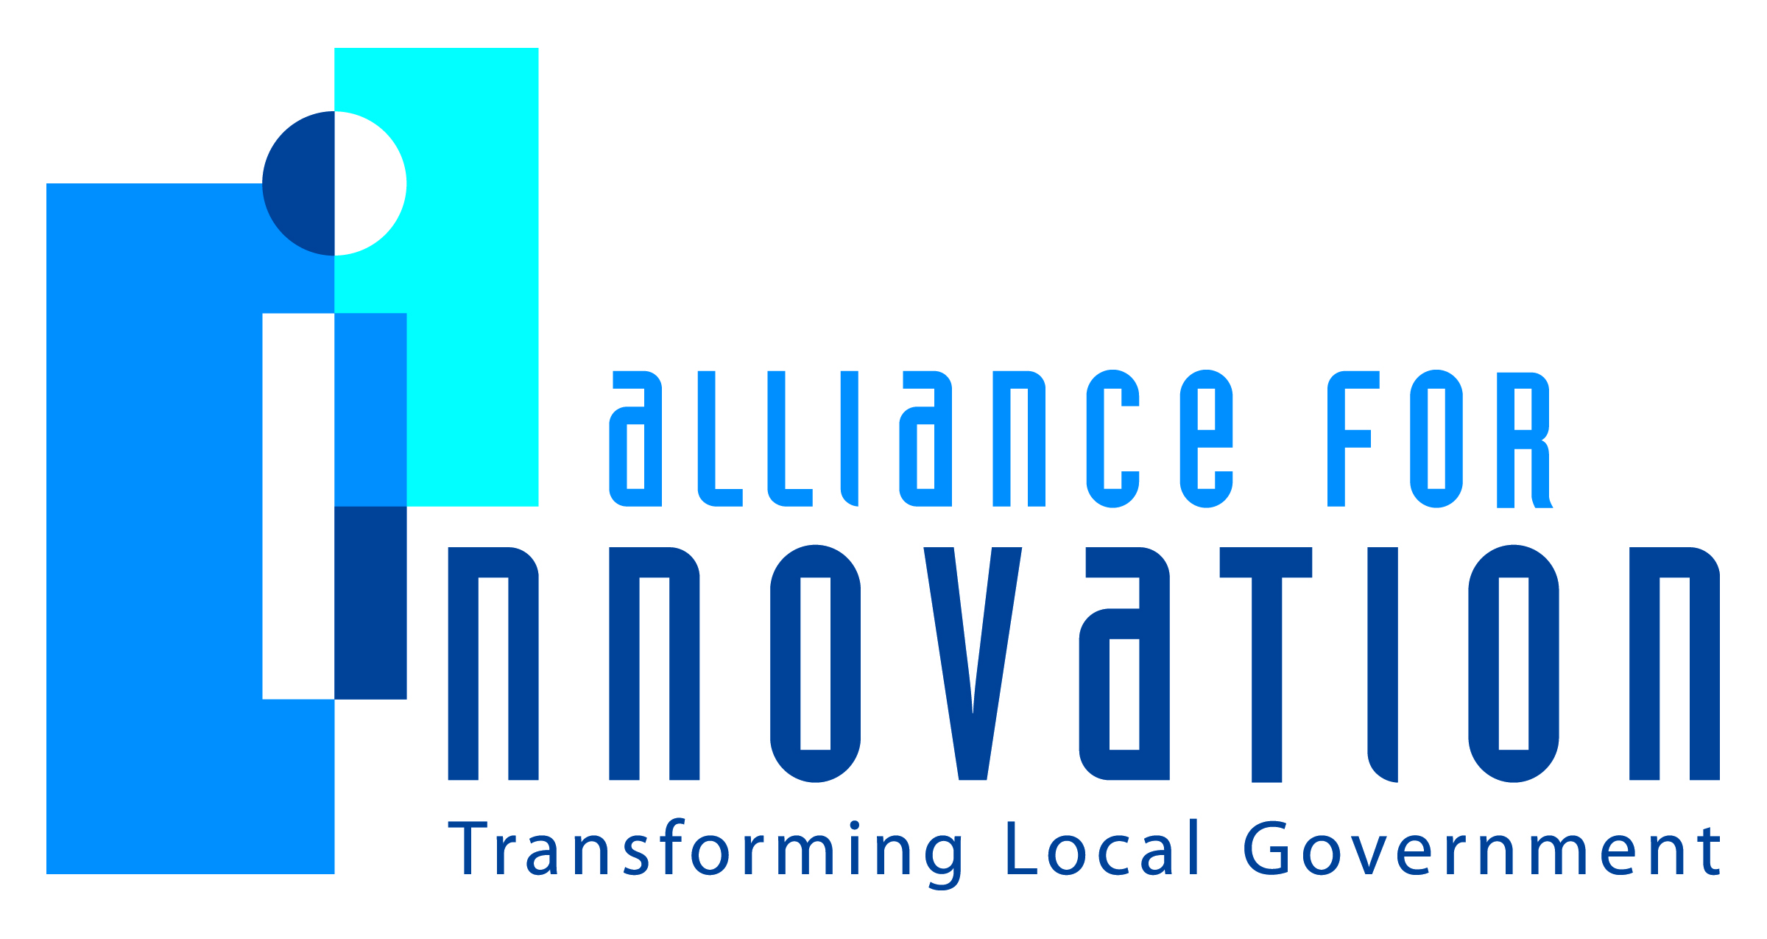

Innovation Award Application 2014

How Mesa Became a College Town
Higher Education Initiative

Jill Kotsur
Executive Management Assistant to the City Manager
City of Mesa, AZ
P.O. Box 1466, Mesa, AZ 85211
480-644-4755
Jill.Kotsur@mesaaz.gov

Describe the Program/project/ product/ service innovation:
In 2012, the City of Mesa, Arizona announced the successful recruitment of five private, non-profit, liberal arts colleges and universities – a direct result of three years of inspired vision and strategic business attraction efforts.
One year later, Albright College, Benedictine University (BenU), Upper Iowa University, Westminster College, and Wilkes University opened physical campuses in Mesa and began offering 25 full-time undergraduate programs including Environmental Science, International Business, Health Sciences, Nutrition, Information Systems and Management, Psychology, Criminal Justice, and Business Administration and six graduate degree programs including Engineering Management, Creative Writing, and Business Administration, to name a few.
Considered one of the most successful attraction strategies the City of Mesa has ever implemented, the results have garnered national media attention, earned praise from academicians, industry leaders, developers, and government officials, and has been touted as a model for innovation in higher education and public-private partnerships. The initial economic impact has started to ripple through the region, and the long-term benefits projected will be especially significant for further enhancing the region’s economy, improving Arizona’s workforce and building a better Mesa.
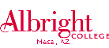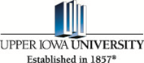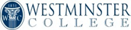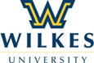
Short description of the importance, internal impact, and community benefits:
Mesa’s strategy was to attract institutions that required physical space – a “bricks and mortar” play. The City required organizations that prioritized classroom learning – not through a virtual environment. Classes began in 2013 with more than 180 students enrolled “in the classroom and on campus” in Mesa. Three of the universities landed in Downtown Mesa, BenU locating in two remodeled buildings along Main Street, while Westminster College and Wilkes University co-located in the newly-renovated Mesa Center for Higher Education, one block north of the Metro Light Rail line. Five miles away, Albright College and Upper Iowa University opened in Mesa’s Fiesta District in close proximity to Mesa Community College’s main campus which serves 26,000 students every semester.
To accommodate the three schools in Downtown Mesa, the City renovated and redeveloped three vacant, city-owned buildings. Altogether, more than 85,000 sq. ft. of unused space was
converted into state-of-the-art classrooms, conference and community rooms, nutrition and engineering labs, academic, administrative and study spaces.
In partnership with the City of Mesa, the five legacy institutions collectively:
• Created 44 net new full-time jobs (college and university faculty and staff);
• Contributed more than $6.5 million of new private investment;
• Enrolled 183 students on campuses, plus 75 students online;
• Occupied 85,000+/- square feet of previously long-term vacant space;
• Booked more than 840 room nights over an 18-month period in local hotels for traveling staff and vendors;
• Created a safe, interim housing solution for undergraduate students in the Mesa Marriott hotel within walking distance of the schools Downtown. The Marriott also created student meal plans for purchase. As demand for student housing increases, plans for more traditional student housing units will be developed;
• Created the Mesa Educates U Scholarship Program which in five years will fund more than $700,000 in tuition costs to nearly 80 Mesa residents pursuing a college degree. Mesa Educates U Scholarships are awarded by the new institutions to Mesa residents demonstrating strong academic performance and financial need. Scholarships range from $5,000-$10,000 annually per student for the length of the student’s program;
• In addition, Grand Canyon University, a private Christian university headquartered in Arizona, recently purchased 100-acres with an option on 60 additional acres in east Mesa to build a new campus that will eventually serve more than 10,000 students. Classes begin in Mesa in fall 2015.
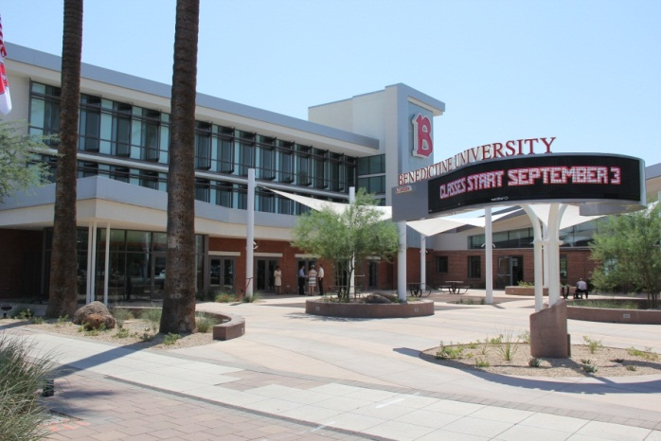
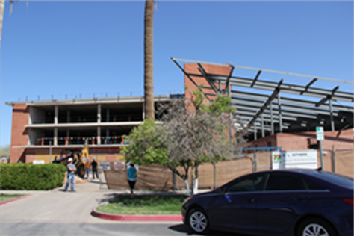Benedictine University - 225 E. Main St., Mesa, AZ
In the heart of Downtown Mesa hails a new higher education facility proudly bearing the scarlet “B” for Benedictine University. Formerly a hospital, “225 E. Main” sat vacant for eight years until its reincarnation as a transit-oriented adaptive reuse for higher education.

What makes this a quantum leap of creativity?
The City of Mesa’s Mayor and Council, city leaders, businesses, and community partners are striving to build Mesa as a vibrant 21st Century City of Innovation. To achieve this vision, City leadership recognized diverse educational opportunities are critical to Mesa’s success and sought to attract additional post-secondary schools offering programs of study which align with Mesa’s industries of opportunity including healthcare, aerospace, aviation, defense, tourism and technology.
In addition, local and national job growth trends indicated a need for workers educated in liberal arts, business/financial management, technology, and health sciences. With a goal of adding more than 1,500 students to Mesa’s higher education fabric within five years, the City began working to create a cluster of new colleges and universities offering four-year or graduate degrees in Mesa, Arizona. The City of Mesa’s long-term goal is to make Mesa a “destination for education” and attract out-of-state students, which would ultimately yield an even greater economic impact to the region.
As with most businesses expanding in today’s economy, the targeted institutions faced challenges in investment capital and finding adequate, affordable space for establishing campuses. The City of Mesa was willing to leverage city-owned assets, including land and buildings prime for reuse, to provide necessary space as part of a financially viable economic and academic development partnership for qualified selected institutions. The City provided the buildings and the capital upfront for the building improvements and the schools entered into long-term lease agreements with Mesa in the previously vacant, city-owned properties. Mesa’s progressive and innovative approach provided customized solutions to make the Council’s vision a reality.
Who benefits?
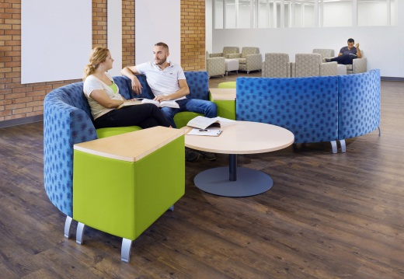
Ultimately, Arizona residents, businesses, K-12 students, new and existing post-secondary institutions benefit directly from additional diverse higher education offerings. By investing in the long term sustainability of the community, the City has committed to the future for all its citizens.
The new universities and colleges have also provided additional services to residents, businesses and employees in Greater Phoenix offering free workshops, seminars, trainings and certification classes. Workforce development is also a key benefit as universities have engaged businesses to establish internships and cooperative education programs to give students real-world work experiences while saving businesses time and money.
Additionally, Wilkes University is offering students enrolled in their Main Campus in Pennsylvania a “semester in Mesa” starting spring 2014. This inaugural group of 10 undergraduate students have partnered with local businesses and city departments for work study programs that are part of the curriculum and class credits.
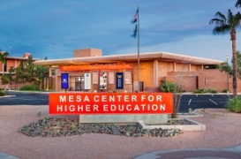 Mesa Center for Higher Education – 245 W. Second St., Mesa, AZ – Wilkes University & Westminster College
A vacant former City Court building has been redeveloped and renovated into a unique shared space for both Wilkes University and Westminster College. Now known as the Mesa Center for Higher Education (MCHE), this innovative campus-share houses two individual schools featuring complementary programs of study for undergraduate and graduate students.

How was the program/project/product/service initiated and implemented?
In 2011, the City of Mesa Office of Economic Development conducted research to ensure the pursuit of enhancing higher education would be successful. Results from the Market Analysis and Feasibility Study revealed strong support in the community from business leaders, residents and other academic institutions to recruit additional higher education resources beyond what was already in Mesa. In particular, people wanted private-sector, traditional four-year institutions, or graduate programs that provided unique and complementary programs to existing institutions. The post-secondary education providers in the region were large, public state universities and community colleges, or a few smaller private, for-profit specialty schools.
There was also a desire to recruit universities that centered on liberal arts education or niche-based programming such as engineering or technology. Community members expressed interest in colleges that offered diverse student populations, ranked nationally for quality education and expanded nationally and/or internationally for campus development. Faith-based institutions were also considered a good fit for the region as a large percentage of the region’s population is Catholic and Mormon.
The long-term goal for Mesa was to create a downtown college environment of higher learning consisting of three to five universities with four-year and/or graduate degree programs aligned with Mesa’s industries of opportunity: Healthcare; Education; Aerospace/Aviation; and Tourism/Technology (HEAT). Short-term, the City recognized we would retain students leaving the State who were seeking this type of education not prolific in Arizona. Long-term, the City desired to entice out-of-state students to come to college in Mesa.
Mayor Smith articulated a vision for Mesa to change the education landscape, and the City engaged in a deliberate effort to seek and attract “institutions that have a legacy of excellence in providing quality, unique educational opportunities.” An evaluation committee was formed, representing economic development, academia and industry, to develop a Request for Interest (RFI) and criteria for reviewing and ranking any formal proposals received. The City of Mesa, through its Office of Economic Development, sent letters and Requests for Interest (RFI) to more than 1,000 post-secondary schools around the country to generate and gauge interest in expanding their institutions to Mesa, Arizona.
Since March 2011, Mesa has hosted more than 20 prospective universities for community visits and meetings with representatives from Mesa Public Schools, Mesa Community College, other academic institutions, associations and local companies.
What risks were taken?
Research and due diligence is often underappreciated in the world of economic development. Speed to market sometimes trumps logic and deliberate thoughtful planning. The Feasibility Study and Market Analysis was the best investment the City of Mesa made for the community, as well as the individual universities and colleges. The results of the Market Analysis laid the foundation for every Community Visit we conducted. The Study justified our targeted strategy, supported our “pitch” and supplied quantitative evidence every college and university needed to make a decision. It was the business case we took to market.
Investing in city-owned real estate may have been considered a risk by some; however, with the advent of Light Rail coming through Mesa’s Downtown on Main Street, transit-oriented development was already spurring interest from the private sector. The buildings the City of Mesa improved are now able to house tenants that are re-investing in leases, spending dollars in the community and attracting a new student and faculty population to Mesa. The City mitigated the risk by only finishing the space inside that would be used for the first few years and left some “vanilla shell” inside that the schools could expand into when ready. Should the new institutions terminate the long-term lease agreements, there are penalties in place so the City may recoup some investment. If any of the schools did vacate, the City still owns the asset that is newly remodeled and can command a market lease rate.
What, if any were the costs and/or savings?
Since the announcement of the schools’ expansions to Mesa, the City has invested more $17 million to renovate and redevelop three vacant, city-owned buildings. Altogether, more than
85,000 sq. ft. of unused space has been converted into state-of-the-art classrooms, conference and community rooms, nutrition and engineering labs, academic, administrative and study spaces.
These improvements have breathed new life into Downtown Mesa. There are now tenants and activity in buildings left vacant for multiple years. Along with the new $99 million state-of-the-art Mesa Arts Center, Light Rail users will have an appealing scene as they travel through and visit Downtown. Curb appeal, supporting businesses with increased traffic, increased property values, improved space, all serve as points of pride and are benefits stemming from these investments.
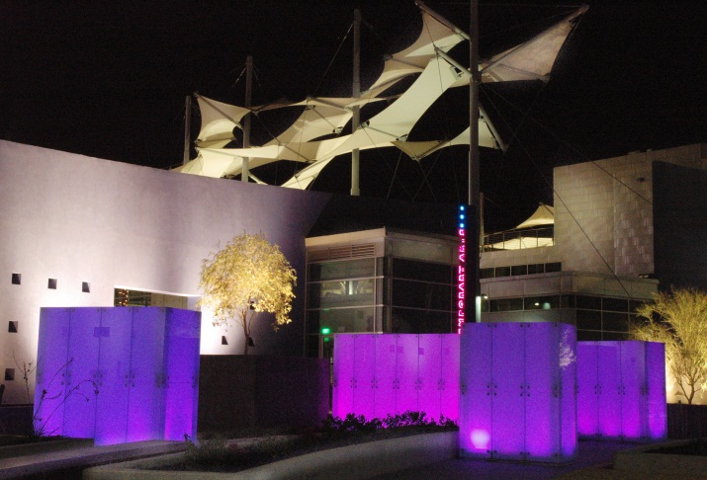
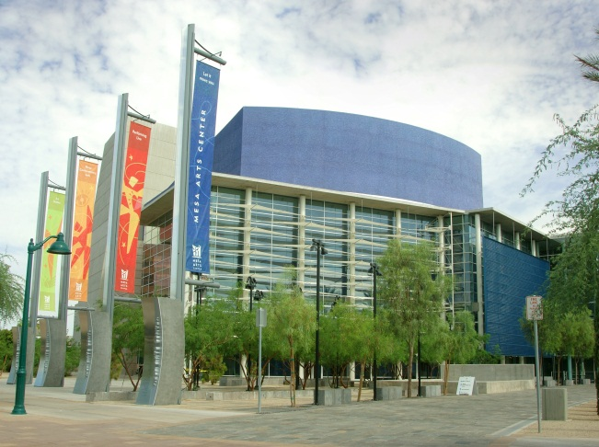
The national award-winning Mesa Arts Center is located in downtown Mesa
What are the lessons learned that other local governments can learn from?
1. Community engagement and buy-in is critical.
Engage the community early and enlist their help in defining the vision and selling the assets of the community. Our Community Tours for the colleges and universities that visited, were hosted for two full days by City of Mesa Economic Development officials, elected officials, Maricopa Community College officials, C-level executives from business and industry including healthcare, aerospace, technology, fine arts professionals, association presidents, K-12 district superintendent, State of Arizona Private Post-Secondary Commission representatives, charter schools, medical schools in Greater Phoenix, and other relevant partners to discuss workforce pipeline, hiring practices, articulation agreements, State licensure and application processes, trends in higher education and curriculum development for Arizona-specific companies, and more. Every college and university said the tour itinerary and the contacts we facilitated were incredible and would not have been easy to access on their own and in some cases never thought about even though the contact was critically important.
2. New schools (and companies) need direction, capital, and brand awareness.

Direction
Most of the new schools have formed Mesa Advisory Boards to engage the community and obtain advice and direction for curriculum and business development activities. The Advisory Board is an excellent resource for the new schools for business development leads and the individuals participating as members are extremely excited about the growth potential. For future endeavors, I would encourage an Advisory Board be created as soon as the announcement for expansion is made. Waiting a year, or even a semester, doesn’t serve the school well and the help is needed up front – at start-up. To provide ongoing support, the Economic Development Department dedicates staff time to this initiative to coordinate communications between the City and the schools, organize cooperative marketing efforts, and facilitate additional expansion opportunities and needs.

Capital
Capitalizing a new operation for any industry or satellite program is challenging in and of itself. Higher education is no different. Business plans are helpful to review the overall commitment of each school to the market and where perhaps they need some creative solutions. Leveraging marketing dollars to create brand awareness in a new market is a good strategy, but investing significantly in a marketing campaign needs to be a priority and an ongoing effort. Alumni from each of the schools proved to be resources for a variety of needs.

Brand Awareness
Treat these schools as start-ups businesses. Even though we recruited well-established institutions – the youngest was 80 years old – the schools were all new “start-ups” in Mesa and in Arizona. Brand awareness was a top priority to ensure enrollment numbers for first semester. The City of Mesa, in partnership with of eight colleges and universities in Mesa (established schools plus the five new schools) invested in an integrated cooperative marketing campaign called Mesa Educates U that includes a website to promote Mesa as a premier destination for higher education: www.mesaeducatesu.org. The campaign was valued at more than $130,000 in targeted media impressions but by leveraging funds, the City invested $20,000 for the promotion while each of the schools contributed $6,000-$10,000.
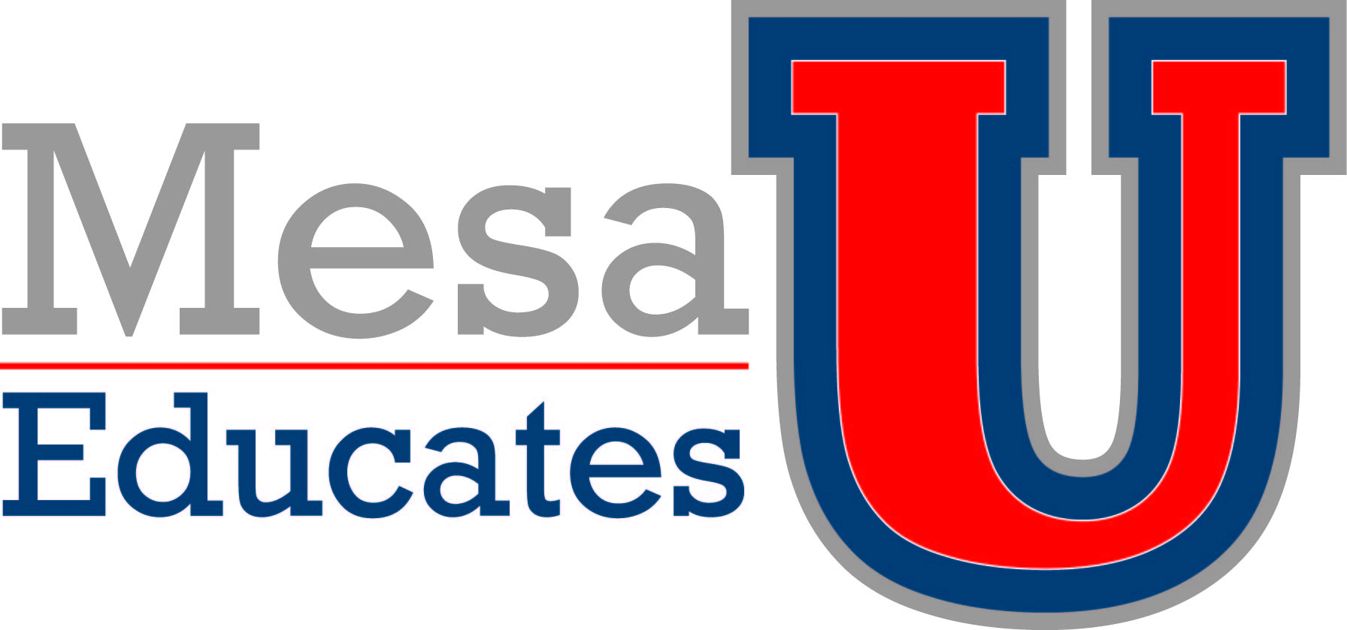
The City of Mesa continues to maintain the Mesa Educates U website and produces and executes a communications campaign promoting Mesa as a premier destination for higher education.

- Designing the space

Partnering with the schools early on in the design of the buildings was critical to the process and ensuring the decision-makers were at the table. Academic deans are different from the administrators and sometimes do not always agree. Knowing up front what programs and classes are being offered dictated appropriate use of space and layout. Budget constraints kept us focused on the “needs” and not just the “wants.” Some flexibility is good to build in, but dramatic design changes half way through construction present difficult challenges.

What department and/or individual(s) championed the innovation? If a contractor was used, please list the name and their contact information.
The higher education initiative was a vision articulated by Mesa Mayor Scott Smith, supported unanimously by Mesa City Councilmembers and championed by the City of Mesa Office of Economic Development. Staff was responsible for translating the Mayor and Council’s vision into a successful recruitment strategy. The City Manager supported the adaptive re-use of three city-owned buildings for the institutions: 51 E. Main St. (3,800 sq. ft. of office space vacant for three years) 225 E. Main St. (68,000 sq. ft., three story, vacant for eight years), 245 W. Second St. (53,000 sq. ft. former city court, vacant for 2.5 years).
Once Council approved the construction budgets, City of Mesa Engineering Department led the project management with an extremely condensed construction schedule (small remodel done in 12 weeks, two buildings in 10 months running simultaneously). The City of Mesa Legal team worked with Economic Development to negotiate the lease agreements on the three properties with three different organizations, with different space requirements and times for use.
Without the vision and support of our proactive Mayor, Council, and City management and the commitment of City staff, the universities and colleges, contractors and partners this initiative would not have come to fruition. We thank our education partners, architects, construction teams, City Engineering, Planning and Zoning, Legal, Economic Development team, and countless others for their hard work and dedication to making Mesa a better community.
Any additional information you would like to share?
Contractors

DL Withers Construction was chosen as the Construction Manager at Risk for both Mesa Center for Higher Education and the 225 E. Main St. building (BenU). DLR Group was selected through a competitive process as the architect on 225 E. Main St and Saemisch & Di Bella and Architekton were also selected through a competitive process to design the Mesa Center for Higher Education.
Attachments
Higher Education Feasibility Study and Market Analysis
Cover Letter & Request for Interest
Mesa Educates U Scholarship Brochure

