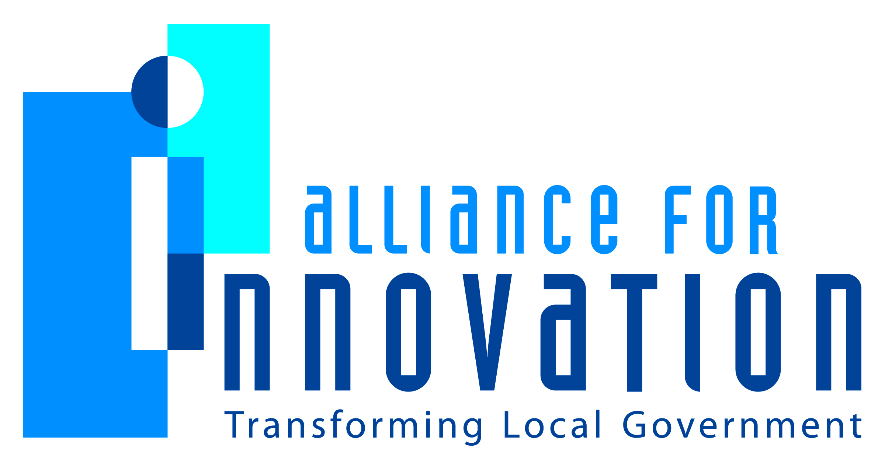

Innovation Award Application 2014

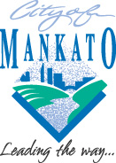

The Tapestry Project
Amy Vokal
Deputy Director of Public Safety
Mankato, Minnesota
710 South Front Street
507-387-8735
avokal@city.mankato.mn.us

The Tapestry Project
| Building a strong community, one thread at a time |


A multi-discipline partnership of public, private and non-profit organizations, along with community volunteers, collaborating to build a strong community with the refugees in Mankato… and beyond.
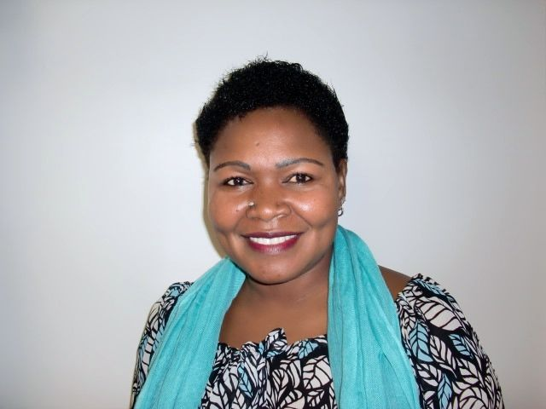
___________________________________________________________________

“This program changes lives.
It changed mine.”
- Florence Okot, former refugee, American citizen,
and proud Tapestry Project graduate
Florence is one of the approximately 5,000 refugees who fled their homelands in East Africa and now call Mankato home.

Describe the Program/project/ product/ service innovation:
Background:
Beginning in the late 1990s, Mankato, Minnesota witnessed the arrival of the first East African refugees moving in to the community. Within the next decade and a half, the refugee population surged from a handful of individuals to over an estimated 5,000 refugees who now call Mankato home. As our community demographics changed, we also noted a significant associated increase in City service needs. As we tried to meet those needs, it became evident that traditional means of service delivery were ineffective. Of greatest concern, the largest disconnect was in public safety service delivery. The East African refugees had an inherent fear of law enforcement and very little education in fire safety. Police officers and firefighters struggled to educate and protect the refugees, but the challenges remained.
After conventional outreach methods failed, we knew we had to identify new and innovative ways to reach the refugee community and improve our service delivery. Our public safety department sought assistance from the Minnesota Council of Churches (MCC) Refugee Services, a non-profit organization that supports refugees on their path to self-sufficiency. Lloyd Management, a property management firm that provides housing for much of our refugee community, joined the conversation and soon a partnership was formed.
The initial goal of this partnership was to identify concerns and problems we shared in serving the refugee community. As a public safety department, we found repeat calls for service within the refugee community and at specific apartment complexes where they were living. Reports of disturbances often involved the same issues and the same individuals. Fire personnel responded to multiple reports of kitchen fires. Of particular concern, many of these fires were grease fires in apartment complexes with multiple tenants. Property managers reported noise issues, unsupervised children, neighbor disputes and damage to property. MCC Refugee services reported feelings of isolation and depression in the refugee families. All of these issues resulted in arrests, leases not being renewed, evictions, homelessness and family instability. In a broader sense, the refugee community did not have the same quality of life, sense of belonging and community engagement as the rest of our City.
As the partnership evolved, we realized that a solution that dealt with just our particular concerns would be very narrow minded. Each of us had a vested interest in solving our common problems, but if we limited our solutions to just that, we would not resolve the underlying causes that were preventing the refugee community from fully integrating into the greater community. With support from our City leaders and our partners’ organizations, we embarked on finding solutions that went well beyond our traditional roles in the community. We reached out to additional stakeholders, such as county mental and human services, the medical community, legal aid, the school district and a local food shelf and found many of them were also struggling in reaching the new population. The refugee community eagerly participated in the dialogue and helped us define our focus and identified additional areas of concern. As collaborative group, we sought creative solutions and agreed on the broader goals of education, mentorship, communication and cross-cultural learning to help create a fully inclusive and strong community. The result is the Tapestry Project.
The innovation:
The Tapestry Project is a seven week mentorship course focused on building lasting relationships and trust with the refugee community. Meeting once a week for 2 ½ hours, this initiative focuses on the developmental needs of the refugee community while teaching problem solving skills through facilitated discussions. The curriculum covers areas of focus such as neighborhood relations, housing, City services, police and fire safety, parenting, food safety and mental and physical health. In addition to the partners, the stakeholders participated, bringing their expertise to the refugees. For example, Doctor’s from the Mayo Clinic Health Systems talked about immunizations, preventative medicine and helped define the difference between emergency and urgent care, and family practioners. The National Alliance of Mental Illness discussed mental health and depression. Lloyd Management brought cleaning supplies and demonstrated how to clean an apartment, along with teaching the refugees bed bug prevention. Public Safety had multiple stations where the refugees could sit in a police squad, watch taser demonstrations, learn to use a fire extinguisher and watch a grease fire demonstration showing proper ways to extinguish the fire.
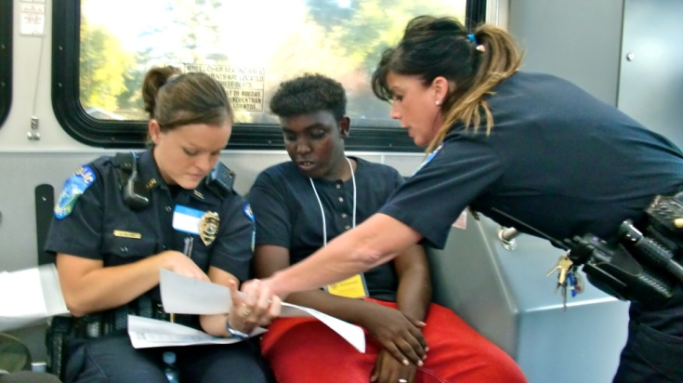
While the public safety presentations were always the favorite with the refugees, we also used this venue to feature other City services aimed at improving the quality of life and feelings of inclusion for the refugee community. Community Development presented on multiple housing options in the City, include the option of becoming a home owner. Mass Transit brought a City bus to one of the meeting nights and taught the refugees how to ride the bus. Once all the refugees were comfortable loading the bus and the pay system, they were taken on a tour of the city which was narrated by a City Council member. As the bus traveled through the city, political wards and council representation were discussed. The bus made a stop at one of our feature City parks and traveled through the City Art Walk. Numerous volunteer opportunities with the City, such as planting and watering boulevard flower gardens, were also highlighted. The final stop was a local ice cream shop. The owners of the business boarded the bus, provided ice cream to everyone, and talked about how they used City grants to start their business and build their version of the American dream.
While this made a very full and pertinent agenda, we knew that only a portion of the information would be transferred if the style of presentation was in a lecture format with traditional teacher/student roles. We knew it was critical to really engage and connect with the refugee community. With this goal in mind, we added a relational piece to the program. We called upon the faith based community and asked if they would partner with us and become “community connectors,” community members who help connect the refugees socially to the community. The response was overwhelming and soon we had volunteer community connectors on a waiting list.
Pulling all of these elements together, we created a meeting room of approximately 25 refugees with community volunteers. The classroom was set up with “community tables,” round tables consisting of three to four refugees, interpreters and one of the community volunteers. Each evening, after a group discussion on a particular area of focus, the conversation was brought back to the table. These conversations resembled the informal conversations families hold around their kitchen tables. The premise: learning not only comes from a traditional classroom setting, but from the sharing of life experiences. These conversations became the highlight of each evening. The volunteers shared very personal stories, such as having a child arrested or struggling with mental illness in their family, and the refugees shared their struggles, but also their hopes and dreams.
And then, a very interesting thing happened…the police officers and fire fighters who attended the class as presenters, continued to show up week after week. Soon, they were sitting at the community tables every week sharing their own personal life experiences and learning the refugee’s stories. Before long, each table had a police officer or fire fighter as one of the “community members.” After the pilot program, this was built in to each subsequent course.
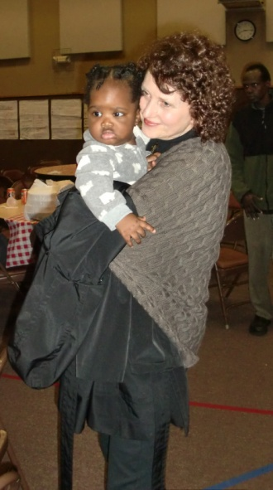
At the conclusion of each course of the Tapestry Project, a graduation ceremony is held with all of the participants bringing food from their native cultures to share. Partners, stakeholders, participants, instructors and community members that take part are encouraged to come and bring their families and friends to help bridge the gap from classroom members to real world relationships. Approximately 100 people show up for each ceremony including families of the refugees, volunteers, and police officers and fire fighters, peers of the professional instructors, representatives of other municipalities looking to replicate the program and City employees from many departments as well as City administrators and leaders. This is where the name “The Tapestry Project” comes from: the scene at this ceremony is a rich and vibrant tapestry of people all blending together as one strong community.
Short description of the importance, internal impact, and community benefits:
When they arrive in the United States, refugees are expected to be economically self-sufficient within the first year. They face many obstacles in achieving this level of stability including learning a new language, finding adequate housing and stable employment. These obstacles alone are daunting, but they also struggle with challenges such as understanding the new culture, finding reliable transportation, making social connections, navigating the educational system and finding adequate child care options, to name a few. While some are able to achieve self-sufficiency, most are far from integrated. The receiving communities also struggle to understand the newcomers and are uncertain how to contribute to and facilitate the integration process.
While there are systems in place to help the refugees achieve “economic self-sufficiency,” the Tapestry Project’s goal is more holistic. It works to give the refugees all of the tools they need to be a fully participating and appreciated member of the community. It creates a support system made up of community peers and leaders who understand they have much to offer economically, culturally and socially. The Tapestry Project leverages the assets the refugee population offers with the assets of the existing community. Diversity is no longer just accepted, it is celebrated.
Internally, participation in the Tapestry Project has improved service delivery to all of our citizens. Public Safety is no longer feared; the refugees now see the officers and fire fighters as partners and neighbors. The resulting two way communication has better equipped public safety in keeping the refugee community safe. Preventative education has reduced the number of calls for service for grease fires and neighborhood disturbances. Refugees have participated in solving crimes by providing information and calling in tips to police. Six members of the refugee community have now joined the volunteer ranks of the public safety department. Other members are on advisory committees. Not only do they want to participate, they are full contributors. Overall, our City makeup is now becoming more demographically representative of our community.
For the community, neighborhood relations have improved. Refugees report less feelings of isolation. They have greater access to services in the community and the benefits they provide. For many, their housing situations have stabilized and they better equipped to take advantage of employment opportunities. In short, this previously under-served segment of our community is now better able to reach their potential and are now fully contributing members of the city.
What makes this a quantum leap of creativity?
Innovative organizations seek creative external partners to move the community forward. In the Tapestry Project, the City not only partnered with a non-profit organization whose goal is to assist the refugee community, but also a private property management firm who shared similar issues in regards to the refugees' living situations. Further, stakeholders outside of the partners’ disciplines were identified and invited to participate. All of the partners and the stakeholders brought unique knowledge and assets that, leveraged together, allowed for a broader, more robust approach in meeting the full spectrum of developmental needs of the refugee community. Perhaps most importantly, we partnered with the faith-based community. That is the element that solidified our goal of not only connecting the refugees with services, but also connecting them socially to the community.
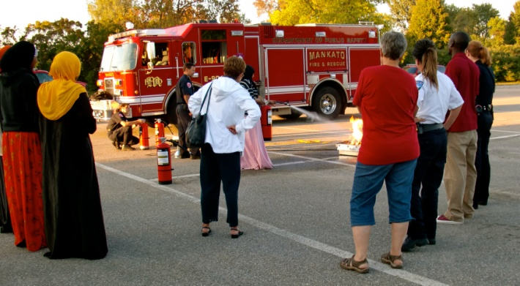
Despite the creative collaborative group, the most innovative part of the Tapestry Project is the relational component. Community members, police officers and fire fighters served as social peers and mentors. The community members volunteered out of a true desire to welcome the newcomers and also a healthy curiosity about the new culture. The police officers and fire fighters attended the sessions not only as presenters, but also as participants. Instead of presenting a topic, fielding some questions and leaving after one session, the officers and fire fighters sat alongside the refugees for seven weeks. They became mentors and helped teach problem solving skills. For example, in one session the issue of food safety was discussed. The mentors were able to offer ideas such as using zip lock bags, transporting meat long distances by using coolers and putting food away immediately after serving it. This type of teaching did not require special knowledge or expertise, just experience living in our culture. This is where the gap between classroom instruction was bridged to real world application.
Who benefits?
The success of the Tapestry Project has been overwhelming. Five sessions of the class have been held in the past three years. Over 100 refugees have participated as well as over 35 different city employees. There is currently a waiting list for the next session. As evidenced by this success, the list of beneficiaries is long and varied.
Of course the initial beneficiaries were the collaborative partners and the refugees. Each partner achieved the goals they set out to achieve: the City was able to effectively reach out to the community, MCC Refugee Services found the refugees reported less isolation and more of a sense of belonging, Lloyd Management reported less leases infractions, evictions and better neighborhood relations. The refugees reported a better understanding of the services available and critical integration skills. The stakeholders benefited from the ability to meet with the refugees and provide them with crucial information and resources.
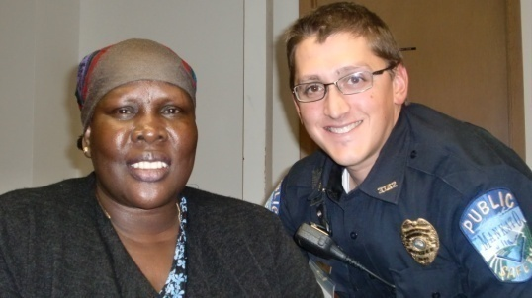
What was underestimated however, were the extent of the benefits. The partners, refugees, community members, police officers and fire fighters all came away changed. Over seven weeks, these participants developed deep and lasting relationships. After each session of the project ended, the participants all strove to find ways to continue the connections that were made. A women’s craft collective was formed. This group continues to meet once a week to work on craft projects and participate more in cross-cultural learning. The refugees have become regular as riders with the officers on patrol. The refugees have made ethnic food in the fire fighters’ kitchen and have eaten side by side with them. Community members are assisting the refugees in learning English, filling out job applications and providing transportation. Cross cultural weddings, baby showers and dinners in each other’s homes are common. In summary, true friendships were formed and a strong community is being built.
How was the program/project/product/service initiated and implemented?
The City of Mankato adopted a philosophy of community oriented governance in 2010. The guiding principles are partnerships, community engagement and problem solving. This was the environment that allowed for the Tapestry Project to be created. Instead of continuing to respond to multiple calls for service or continuing to struggle in reaching the community, we sought out partners that could help us address the causes of these issues. Further, the philosophy allowed us to commit resources to address a wide variety of issues instead of only issues that directly affected us. We recognize that any issues that negatively impact one segment of our community have a negative impact on the whole community.
Perhaps, more importantly, community oriented governance allows for individuals in the City organization to be creative, and decision making and leadership is expected of each employee. This “bottom up” approach allows those that experience the problems to have a role in finding the solutions, which creates an environment where employees become personally invested. The police officers and fire fighters took an active role because they fully bought into the intent of the project. They helped create the program and took ownership of it. They also experienced the benefits of participating.

What risks were taken?
Undertaking this initiative was an easy decision, as the risks were low. We knew we had to do something to address the disconnect with the refugee community and a failed attempt would mean we would have to find a different approach. The cost of the project was very low but the time commitment from the police officers and fire fighters was high. This was of little importance to them however, as they were voluntary participants who supported the vision and saw the potential. They truly believed in the project and would not let it fail.
The biggest risk was taken by the refugees, the community members, the police officers and fire fighters. They sat together each week sharing very personal stories and put their trust in one another. They became vulnerable to each other. However, taking that risk was rewarded by mutual respect and lasting relationships.
What, if any were the costs and/or savings?
Another very attractive feature of the Tapestry Project is the cost. MCC Refugee Services received a $5,000 community grant from the City of Mankato. This grant, along with a $2,500 donation from Lloyd Management, funded the pilot session and two subsequent sessions. The costs covered by this were interpreter services, printing and minor supplies. The City donated classroom space and the officers and fire fighters flexed their schedules to attend the classes. MCC Refugee Services’ AmeriCorps Vista coordinated the logistics and helped facilitate pre-meetings and communication. All of the presenters donated their time and expertise. The local mosque also donated funds to one session because they saw the importance of the project and the effect it would have on some of their members.
Conversely, the savings are high. Although not measureable in exact dollar amounts, the public safety department commits fewer resources because of a drop in repetitive calls for service. Fewer kitchen fires result in lower damage to property. The officers and fire fighters are more efficient and effective in responding to the refugee community as they are culturally competent and have a deeper understanding of the refugee community. Crimes have been solved, and prevented in some cases, as the refugee community has trust in the public safety department and there is now open, two way communication. The stability in housing saves the community from the costs of homelessness. The refugees who volunteer with the public safety department are invaluable for their insights and willingness to become involved. Overall, community relations are very positive and the refugee community is becoming fully integrated.
What are the lessons learned that other local governments can learn from?
The Tapestry Project has been a resounding success because it addresses issues that are specific to the Mankato community. The model of the Tapestry Project can be replicated in any community, but the content must be specific to that community’s needs. We used focus groups to identify pertinent issues and areas of development for the refugee community. The Tapestry Project model can also be used to engage any population that is underserved or where traditional outreach methods have failed, it need not be specific to refugees. As long as invested partners and stakeholders are identified and are committed to making a difference, the model can be successful. The City organization must also be willing to empower its’ employees to be creative and give them the opportunity to reach outside of their traditional roles. This bolsters the level of involvement and commitment of the champions of the initiative.
Despite the successes of the Tapestry Project, there have been obstacles along the way. In one session, we struggled with unreliable attendance. When we looked into the cause, we found that the same barriers that refugees struggle with in becoming self-sufficient were also barriers in attending the class: reliable transportation and child care. When we defined these issues, we were quickly able to employ solutions and offered transportation and on-site child care. Using the principles of continuous improvement, we met weekly while a session was underway to make minor adjustments as needed. Once each session is complete, we again use focus groups to ensure we are making the impact we intend.
What department and/or individual(s) championed the innovation? If a contractor was used, please list the name and their contact information.
Amy Vokal
Deputy Director of Public Safety – Police
Mankato Department of Public Safety
avokal@city.mankato.mn.us

Jessica O’Brien
Associate Director
Mankato Area Refugee Services
MN Council of Churches
Jessica.obrien@mnchurches.org

Julie Hawker
Community Development Manager
Lloyd Management
www.LloydManagementInc.com

Any additional information you would like to share?
The City of Mankato is very proud of the Tapestry Project. The project has been the subject of many news features (including international news outlets in Kenya, Somalia and England) and has received local and international accolades from professionals in different fields. But, perhaps the most telling sign of its success has been the requests we have received from other communities to help implement the Tapestry Model in their community. True to our commitment of building strong communities, we have presented to over seven different local government agencies, as well as presentations to state wide associations, legislative forums and international delegations who sought out progressive problem solving initiatives.

Addendums:
Addendum A – Tapestry Evaluation Fall 2013
Addendum B – Tapestry Project Sample Flyer
Addendum C – Tapestry Project Sample Curriculum
Addendum D – Tapestry Project Documentary http://www.youtube.com/watch?v=q6Z39D-sU3E

