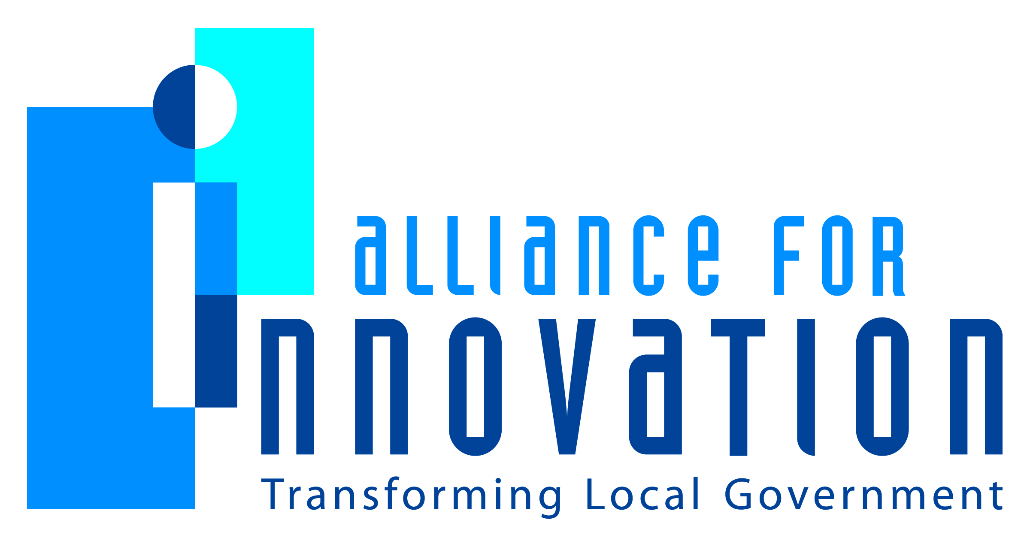

Innovation Award Application 2014

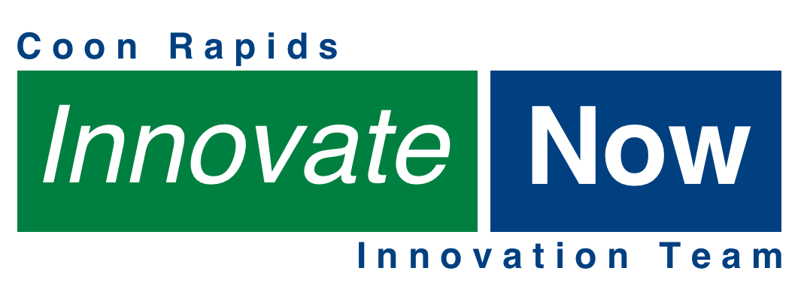
Coon Rapids Innovation Team
Matt Stemwedel
Assistant City Manager
City of Coon Rapids
11155 Robinson Drive N.W., Coon Rapids, MN 55433
763-767-6486
mstemwedel@coonrapidsmn.gov

Describe the Program/project/ product/ service innovation:
The City of Coon Rapids Innovation Team was created to advance innovation in our organization. The Team consists of members of all City departments.
Short description of the importance, internal impact, and community benefits:
The Team developed a list of goals consistent with four defined “Elements of Innovation”: (1) Shared Organizational Support; (2) A Culture Open to Change; (3) A Commitment to Work Together; and (4) a Results-Oriented Process. Championing projects in line with these elements, the Team has helped foster innovation among members of the organization, which we believe has contributed to better work efficiencies, employee morale, and improved community customer service.
What makes this a quantum leap of creativity?
We are unaware of any similar group that has taken on the breadth and depth of our challenges and projects in 2013.
Who benefits?
Organizational benefits: Employees have: (1) better abilities to learn about each others’ work, which can spark innovation; (2) increased their communication avenues with management; and (3) been given more educational opportunities. The community has: (1) seen increased work efficiencies; and (2) been provided better service and outcomes (see below).
How was the program/project/product/service initiated and implemented?
The Team was formed in November of 2012 of 16 employees in a 250+ employee organization under the City Manager’s Office. In a series of facilitated meetings the Team formed itself by answering the question: “What Elements are needed for this Team, and the City, to Innovate? The Team met monthly and in smaller sub-teams throughout the year to monitor its progress in implementing the Elements of Innovation. Late in the year the Team held a “self-examination” workshop, where it evaluated its efforts, and brainstormed ways to improve itself in 2014. We built on the evaluation in two additional meetings, and, in January of 2014, we will select new projects to complete this year.
What risks were taken?
This effort required buy-in from senior management and a willingness to devote staff time that initially yielded few tangible results. There was a risk of alienating other employees who might perceive the Team as insulated, which required us to adopt a transparent operational policy and a variety of communication avenues, including web pages, intranet presence, email, posters, and lunch-and-learns).
What, if any were the costs and/or savings?
There were no extra out-of-pocket costs to our city. Indirect costs included the devoting of staff time to the Team. Savings are reflected in reduced staff time in accomplishing tasks where innovations were introduced. In particular, the Team’s Education and Development sub-team underwrote an initiative to train nine additional meeting facilitators in ToP © (Technology of Participation) methods, and we have used the skills learned to perform numerous facilitated workshops, from analysis and building an action plan regarding a problem residence in the city, to building and hosting a retreat-planning workshop with senior staff, our Mayor, and City Council members, which generated a two day retreat plan. At the retreat itself, also using facilitation, City Council and staff will build an innovative tool we call “AIM,” which stands for “Activity Impacts Measurement,” and apply the tool to proposed activities and initiatives to build an action plan for 2014. The Tool contains an impacts metric, and specific benchmarks, so that activities can be rated on a scale of 0-100 and rated against each other. We know of no such tool currently in existence in the country for this purpose. We have already built a computer program version of the tool, and could potentially push it to the internet for citizens to “weigh in” on projects and activities using the metrics. The Innovation Team also hosted a late-2013 event where the Team interacted with senior staff in answering the question: “What are the best ideas to advance employee engagement in our organization.” That workshop not only addressed our goal of advancing shared organizational supported, but also generated dozens of engagement initiatives that will be considered by a focus group later this winter for implementation (again in a facilitated discussion!) We estimate that, for just the few months of 2013 after we rolled out our facilitation skills, we cut meeting time in half with these efforts, or approximately 100 staff hours, and produced a superior result from each of those meetings.
What are the lessons learned that other local governments can learn from?
The largest hurdle to implementing innovation in the workplace is instilling a “Culture Open to Change,” which requires education, a consistent message, action and follow-through on organizational suggestions and initiatives, multiple avenues of communication, and, above all, patience in allowing initiatives to catch hold in the organization.
What department and/or individual(s) championed the innovation? If a contractor was used, please list the name and their contact information.
The Team was formed under the guidance of the Coon Rapids City Manager’s Office and was championed by members of all departments in the City.
Any additional information you would like to share?
Our notable successes included: (1) Revitalization of our employee recognition strategies at little cost to the City; (2) The creation of an organizational Mission/Vision/Values statement; (3) Improving our cashiering and money-handling practices; (4) Creating three sub-teams (see attachment for duties) to implement the Elements of Innovation on an ongoing basis; (5) Building a physical and on-line organization-wide suggestion box, and processing dozens of suggestions in 2013; (6) Building a peer recognition program, a “Kudos Korner,” promoting a “manager’s recognition kit” for on-the-spot recognition, and sponsoring an employee recognition event at the organization employee picnic; (7) Building and rolling out a website for Innovation Team news and opportunities; (8) Sponsoring several other organization-wide events; (9) Training the organization using personality profile sessions, organizational development tools, Technology of Participation © facilitation methods; (10) Putting in place an action plan to become (we believe) the first 100% employee-trained AED/CPR city in the nation; (11) Breaking down barriers and department “silos” in the organization and providing a venue for innovation to occur at the “grass roots” level; (12) Creating an employee “Wizards” program where employees who are proficient at particular tasks, particularly with computer programs, can share their skills with others.. See attached for organizational chart and additional information.

