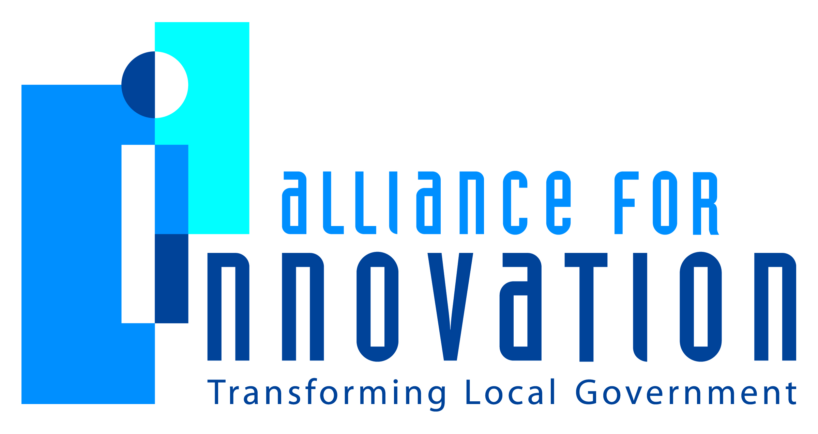

Innovation Award Application 2014

Know Your Limit
Lt. Chris Hall #620
Traffic Section Lieutenant
Scottsdale Police Department
7601 E. McKellips Rd., Scottsdale, AZ, 85257
(480) 312-7016
chhall@scottsdaleaz.gov

Describe the Program/project/ product/ service innovation:
The Know Your Limit Program is an educational detail that focuses on reducing and deterring the number of impaired drivers by means other than enforcement. Scottsdale Police Officers, with the assistance and support of surrounding agencies, patrol the City of Scottsdale’s Entertainment District on foot in an effort to contact patrons in the area. The Entertainment Districts consists of approximately 85 liquor establishments within a one square mile area. The program is designed to educate the public with regards to alcohol consumption, the effects of such alcohol on the body and decision-making abilities, as well as comparing the arrest penalties associated with a DUI conviction versus the fees incurred by taking a cab home. Patrons are provided with flyers and handouts that illustrate and describe standardized drinks, related effects, and approximate Blood Alcohol Concentrations and average metabolic rates. In an average evening of enforcement, the City may arrest around 20 impaired drivers; however, participants of the Know Your Limit Program will contact upwards of 500 patrons. The ultimate goal is to keep all of them from driving impaired, thereby reducing the number of alcohol-related traffic incidents.
Short description of the importance, internal impact, and community benefits:
The overall importance of the Program is simple: the community profits by having safer streets and roadways, as well as an increased positive opinion of law enforcement. Internally, officers have the privilege of conducting a low-stress patrol where they can interact with the public on levels that involve education over investigation.
What makes this a quantum leap of creativity?
Police departments, in general, are traditionally focused on finding criminals, investigating crimes, and making arrests. With this Program, all three of the aforementioned factors are removed. The Program creates a solution to the problem of impaired driving before any lives are placed in danger.

Who benefits?
Everyone benefits! The police officers involved in this program gain a greater understanding of DUI law and related problems in the City. A confidence and appreciation is built among officers and patrons as both sides interact together in efforts to solve a growing pandemic. The patrons that are contacted benefit by learning the ramifications of a DUI-related arrest without having to be arrested. The primary benefactor, however, is the citizen that has no immediate contact with this Program: alcohol-related collisions have decreased while DUI-related arrests have also decreased. Bottom line, the City is a safer place for motorists.
How was the program/project/product/service initiated and implemented?
The Program was initiated through a partnership with the Downtown businesses, the Governor’s Office of Highway Safety, and law enforcement. Traditional policing led business owners to believe that officers were focused more on statistics and numbers versus solving the root of the problem and preventing tragedies.
What risks were taken?
The risk with the Program was taking dedicated DUI enforcement officers off of the road during what would be enforcement time, and having them participate in a program without guaranteed results. In addition, the reaction from the liquor establishment community to the program was unknown. Officers conduct their details within close proximity to various bars which might be seen as a customer deterrent.
What, if any were the costs and/or savings?
Most of the Program is funded through grants from the Governor’s Office of Highway Safety. The costs go to materials, such as PBT straws and handouts.
What are the lessons learned that other local governments can learn from?
Enforcement and arrests are not the only tools to change people’s behavior and positively affect public safety.
What department and/or individual(s) championed the innovation? If a contractor was used, please list the name and their contact information.
Sgt. Tom Jensen, Scottsdale Police Dept.
Sgt. Rob Rucker, Scottsdale Police Dept.
Lt. Chris Hall, Scottsdale Police Dept.
Cmdr. Burl Haenel, Scottsdale Police Dept.
Any additional information you would like to share?
Below is found a web address to a video by International Association of Chiefs of Police that documents the Know Your Limit Program. http://www.youtube.com/watch?v=LQWz1fSI6E8

