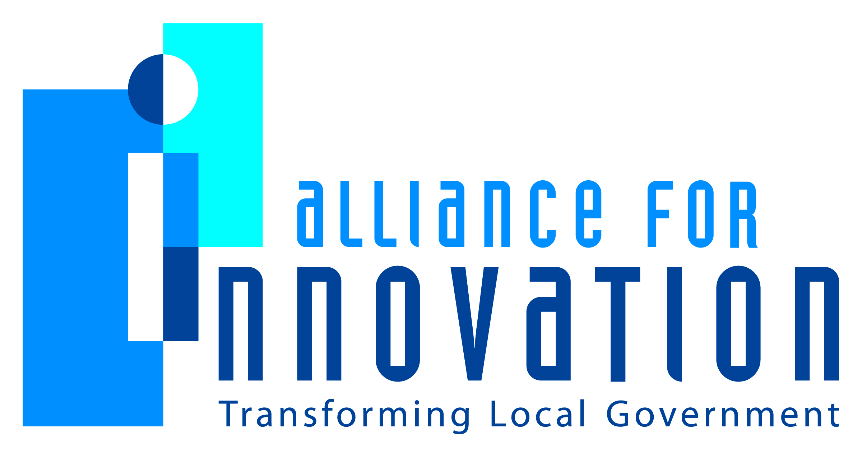

Innovation Award Application 2014

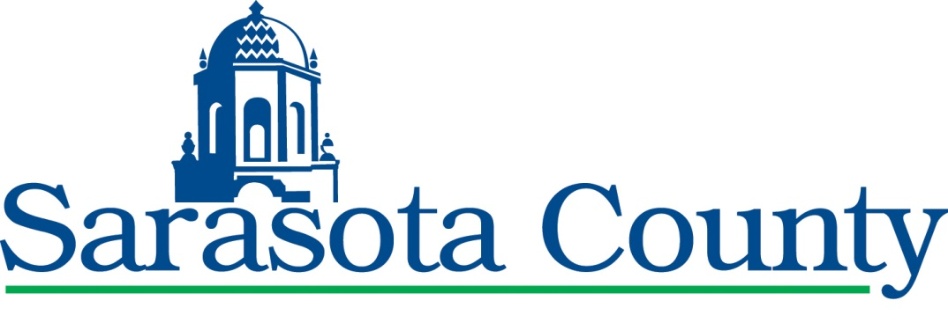

From Fishing Pond to Global Asset
The Convergence of Opportunities that Transformed a Former Borrow Pit into a World-Class Rowing Facility
Tom Harmer, Interim County Administrator
Carolyn Brown, Director Parks and Recreation
Jeff Maultsby, Director Office of Business and Economic Development
Tom Polk, Director Planning and Development Services
Sarasota County, FL
1660 Ringling Blvd., Sarasota, FL 34236
Application Contact, Tracy Miller, Strategic Management Advisor
941.861.5401 | tmiller@scgov.net
Describe the Program/project/ product/ service innovation:
It has been said that the ladder of success is best climbed by stepping on the rungs of opportunity. In Sarasota County’s case, opportunity presented itself as the convergence of creativity and vision to tie a large-scale, mixed-use development project with adjacent county-owned park lands leading to the creation of one of the premier rowing venues in the world, Nathan Benderson Park.
Opportunity 1: In the early 1990’s, Sarasota County had the foresight to purchase a 600-acre lake property for a park that was previously a site used for the excavation of shell and sand for roadfill during construction of Interstate-75 dating back to the 1960s. The former mine site had also been the focus of significant scientific research into the 2-3.5 million year old fossil shell beds exposed by the excavation until the pit was naturally filled with water from nearby Cooper Creek, creating the lake. At the time, the park had limited public access and was used primarily by local fishermen. Owning the property presented Sarasota residents with the opportunity to enjoy an inland water feature on the northern border of the county which was desirable for future development.

Opportunity 2: As Sarasota’s economy continued to grow Benderson Development Corporation, Inc. submitted a plan in 2005 for a mixed use development to include residential, commercial and office opportunities, also known as the University Town Center (UTC). This development was to be located adjacent to the park previously a former borrow pit. Leaders at the county and the developer seized the opportunity to create a unique recreation venue by tying the county-owned park land into this proposed large scale, mixed-use project. To make their vision a reality, Benderson Development worked on a Master Park Plan for the county’s adjacent park as part of the overall project.

Opportunity 3: In 2010, some improvements to the park were made after the first successful events in 2009 in which local rowing clubs utilized the park to host two regattas. The positive response to the park was undeniable. With visits from famed experts such as Harvard University rowing Coach Harry Parker, county leaders began to recognize the potential of the park to become a world‐class rowing venue that could field collegiate, national, and international competitions. Extensive diligence ensued by Benderson, at their expense, including research and visits to the best rowing venues in the world to ensure the project would exceed the highest expectations and criteria to be a premiere rowing facility. They also brought the most knowledgeable rowing venue designer Svetla Otsetova, from Switzerland to Sarasota to further refine the plans. In addition, the community and surrounding neighbors provided input to ensure that a myriad of active and passive park uses were incorporated into the design. Using the expertise of developers and ingenuity of county leaders, the pieces were tied together to package the proximity to the airport, interstate, hotels, shopping, and other tourist attractions and bring to light an opportunity like no other in the world.

Opportunity Becomes Reality: At Nathan Benderson Park, several regattas have taken place over the last few years; four in 2010, seven in 2011, seven in 2012, and eight in 2013. The sports tourism wheels began to turn and this incredible story was told to state officials resulting in Sarasota County acquiring $5 million in state funding for the park in 2012 and an additional $5 million in 2013. In the fall of 2012 with collaboration among Sarasota and Manatee Counties, Benderson Development and a host of community partners, a proposal was made to bid for the 2017 World Rowing Championships which was awarded to Sarasota County on September 1, 2013. This annual international rowing competition is the most prestigious rowing event in the world. Traditionally held on the European continent, hosting this event will place Nathan Benderson Park, the community, region, state and country on the world stage. This initiative has brought the community a sense of pride and excitement and has engaged community leaders, athletes and volunteers alike, while bringing economic value to the region where it may not have otherwise occurred. Through extensive collaboration, vision and a willingness to seize opportunities, Nathan Benderson Park is expected to seriously impact Sarasota County’s vision of becoming the best place to live, work and play!
Short description of the importance, internal impact, and community benefits:
Phase I and II of Nathan Benderson Park is under construction with $29.5 million in improvements. The 600-acre park will provide public access for non-motorized boating, fishing, bird-watching, bicycling, running, while at the same time offering a premier 2,000-meter sprint course with a wave attenuation system. As construction progresses into Phase III, jumpstarted with an additional $5 million in State funding, the famed “regatta island” will continue to be enhanced to include a multi-function boathouse, athlete training center, starting line system, finish towers, grand stands, large video screens and more. Regatta Island, as it will be known, is envisioned as an Olympic Village-styled setting that will provide competitors a place to focus, rest and recover from competition and for spectators a viewing and entertainment platform. While rowing may seem like the main focus of the park, it is expected to account for only 15% of the usage. The park has been designed to accommodate other uses such as dragon boat races, triathlons, kayaking and paddling sports, running events and a wide variety of programs for the community. While there are many quality of life benefits that Nathan Benderson Park brings to Sarasota and the region, the financial impact of developing a world-class sports tourism venue is translating into real dollars. It is estimated that the park spurred $12,970,000 of direct spending by participants and attendees and $24,615,000 of regional economic impact derived from 42,000 attendees, including 1200 athletes and 1000 coaches from 62 countries and 40,000 hotel room nights from 2009-2012.

What makes this a quantum leap of creativity?
Nathan Benderson Park represents a quantum leap of creativity through a confluence of opportunities and a willingness to take action. Having the vision to assemble the partnerships, resources, and talent to make the park a reality is a feat not easily found in local government which can typically tend to be risk adverse. This project required community leaders to think differently about elevating quality of life and place, creating conditions in the community and leveraging assets that would traditionally be planned for without regard to one another. It has taken leadership, bold action and fortitude in times of economic uncertainty to see it through.
Who benefits?
The list of beneficiaries is long and begins of course with the citizens of Sarasota County and our surrounding communities. But it does not stop there; local businesses will continue to see benefits from park visitors and the events to come. The airport, hotels, regional attractions, the state, and the nation all are beneficiaries. Perhaps most impacted are the American rowing athletes who have a training venue in one of the premier locations in our country. Additionally, the sport of rowing itself will benefit by having a world class venue in America, close to all the comforts of one of the best tourist locations on the globe. This initiative has brought rowing opportunities to youth in our community in a big way. People need to come out and experience the spirit, the energy and the excitement of parents and spectators watching their kids compete. Heartwarming sights of mothers and fathers with tears in their eyes, beaming with pride as their children receive medals. Coaches working with young people providing guidance and teaching values. People sharing, connecting and giving. It is hard to put a value on this experience because it is simply priceless.
How was the program/project/product/service initiated and implemented?
The history of Nathan Benderson Park began in the 1970’s with the construction of Interstate 75. Who knew it would lead to a world class rowing facility some 40 years later. But it is the convergence of the desire to develop and the opportunity to maximize park lands that caused the spark of creativity to do something unprecedented.
What risks were taken?
Sarasota County had to commit to fund the project in times of economic uncertainty. County leaders demonstrated the willingness to take the risk and invest in an idea. That idea paid off when the 2017 World Rowing Championships were awarded to the community.
What, if any were the costs and/or savings?
The Nathan Benderson Park remains under construction, with completion of $ 25 million in Phase I and II improvements and an additional $5 million to begin Phase III improvements. Beyond the current expenditures, more than $20 million is proposed for the facility’s future development, including a multi-function boathouse and athlete training center, finish towers, grand stands and a state of the art boat maintenance and testing facility.
What are the lessons learned that other local governments can learn from?
County leaders identified the need to coordinate the park development with the UTC project to provide a more complete and comprehensively designed project. This model of thinking, using collaborative efforts, broad scale partnerships and shared investment sources encourage economic development opportunities that could be used on community projects of any scale. The consideration given to sports tourism in design and development can provide other local governments an example for thinking through projects of this context in new ways.

What department and/or individual(s) championed the innovation? If a contractor was used, please list the name and their contact information.
This effort was spearheaded by numerous departments within Sarasota County including the County Commission, County Administration, Parks and Recreation, Planning and Development Services, Public Works, and the Office of Business and Economic Development in addition to countless community partners and Benderson Development Corporation, Inc.
Any additional information you would like to share?
Nathan Benderson Park has brought diverse groups of stakeholders together to participate in developing a community and regional asset. A wide variety of opinions were sought and integrated into the final design elements of the park. This project had phenomenal community support and has brought unbelievable PRIDE in our community. There has been volunteerism of countless hours, community input and so many people working incredibly hard to do the right thing to make this dream a reality. As community builders, Sarasota County believes in the long run, the quality of life health benefits to the community as well as the realized economic impacts far exceed the investment made to develop the park. The park is the result of opportunities realized, but there are many more highlights to come for the future of the park and its impacts on our community.

