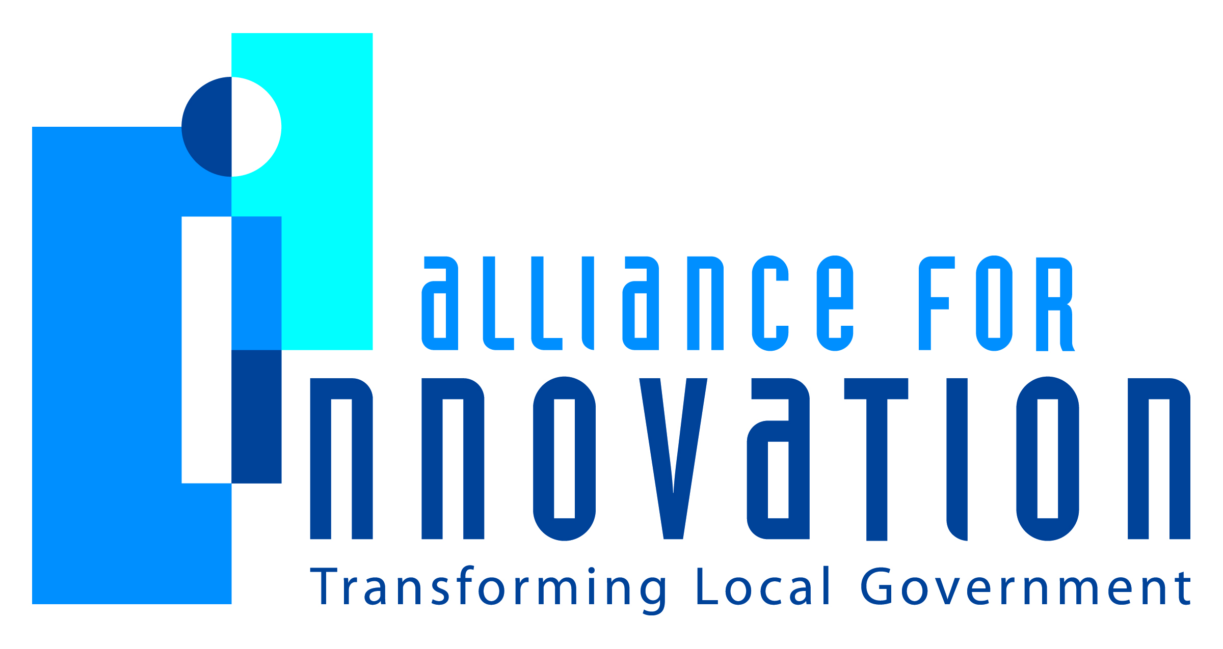

Innovation Award Application 2014

CATAWBA COUNTY, NORTH CAROLINA

CHILD WELLBEING PROJECT
Dawn Wilson
Social Work Program Manager
PO BOX 669 Newton, NC 28658
828-695-5702
DawnEWilson@catawbacountync.gov

Describe the Program/project/ product/ service innovation:
The Child Wellbeing Project is a research-based partnership between Catawba County (North Carolina) Social Services and The Duke Endowment to provide an array of post-care services to improve the quality of life for children who have exited Social Services’ custody to move to reunification, adoption, legal custody or guardianship. The long-term goal of the project is to improve well-being as evidenced by education, employment, stable housing, connection to family/community, access to health/mental health care, and wise life choices (absence of teen pregnancy, school drop-out, etc.). Post-care services include a Success Coach, Educational Advocate, Material Supports, Parent Child Interaction Therapy, and Adoption Therapy Groups, with the Success Coach serving as the foundational service that brings all other elements together.
The Success Coach is a voluntary support service for children/youth who achieve permanency from Catawba County foster care and their families. Services are offered to families who have at least one child exiting foster care before the age of 16. However, once in the service, youth can be served up to age 21. The primary goals are to support the family in providing a stable and safe environment for their children/youth, to build individual and family resiliency, and to implement supports that will have positive long-term impact on post permanency stability and child well-being. This is being done through reducing risk factors and increasing protective factors, specifically:
- Reduce risk of repeat maltreatment
- Reduce risk of reentry to foster care
- Increase social support for the family
- Increase family self-sufficiency
- Increase family’s ability to manage crises
- Increase parents’ ability to access medical and mental health services for the child
- Increase parenting skills
- Increase child’s ability to perform on or above grade level in school
- Increase parents’ ability to advocate for and access educational services
Short description of the importance, internal impact, and community benefits:
Given what research tells us about the poor educational attainment of children who have been in foster care, the impact of this position is significant. Catawba County is able to track individually and aggregately how children in foster care are actually doing academically. Since Fiscal Year 2012-13, children who are struggling have been flagged and staff has put interventions in place to improve their grades. The Educational Advocate position has also created efficiencies and reduced stress for both social workers and school staff who now can liaison with one staff person with a wealth of understanding about both the educational and child welfare systems and has the connections and credibility to better meet the needs of all stakeholders involved. Lastly, ongoing educational committee meetings with representatives from the 3 public schools serving our county has resulted in increased collaboration and planning to address issues that come up in the course of a school year. During fiscal year 2012-2013, (through May 23, 2013), a total of 115 children in foster care were placed into the Educational Advocate program. During the 2012-2013 school year, 77% of these school-aged children experienced two or fewer school moves since entry into foster care. Thirteen children were flagged as needing intervention. Interventions put into place for these children included tutoring at school during the day and after school, ensuring that all assignments and homework is completed and turned in on time, maintaining exceptional children’s services that were already in place, monitoring and “checking up” by the success coach and attending a teacher conference to discuss options for improvement. In terms of the impact of the Success Coach program, in the last evaluation report, submitted June 2012, the evaluators note that the Success Coach Service is a stabilizing force for families. Of the 66 families who have been actively engaged with their Success Coach as of June 2013, 97% (64 of 66) families have not had children re-enter foster care compared to 95% (91 of 96) families who declined the service. While these percentages are similar, with time and accrual of families in the service, we hypothesize that a greater difference will emerge.
What makes this a quantum leap of creativity?
Catawba County Social Services was the first social services agency in the State of North Carolina to utilize a full time educational advocate position. Another unique feature is that in addition to tracking achievement, the agency is flagging children who are struggling academically and coordinating with the school and social worker to arrange tutoring and other supportive services. The 2012-2013 school year is the first year in which we are tracking the outcomes of these efforts, but based on the initial results, success is expected to grow. The Success Coach component of the Child Wellbeing Project is holistic in its approach to increasing the resiliency of some of the community’s most vulnerable citizens. The steps of engagement, assessment, goal planning, service coordination, skill-building and reinforcement, crisis intervention prevention & management, and advocacy encompass the entire continuum of child well-being in order to affect positive change within the target population.
Who benefits?
The implementation of the program has resulted in a number of benefits. For the school system, having this Educational Advocate (EA) position to liaison with designated staff in each school has created efficiencies in terms of having one go-to person in social services to interact with to address concerns rather than trying to track down one of 20+ social workers who may be working with a child. The EA also works with the school designee when a child first enters care to facilitate transportation, records transfer and other information that can be essential to the school’s ability to serve the child effectively. The benefit to the child is that identified needs can be addressed much quicker. The EA reviews all report cards and “flags” students who are struggling, works with the child’s social worker and school to implement services– tutoring, requesting meetings, attending Individualized Education Plan meetings, etc. Another benefit is that, through education and annual training with school designees, the EA has increased community understanding of the impact trauma and involvement in the child welfare system has on a child’s social and emotional wellbeing and his/her ability to focus on school. The Success Coach program benefits the community by focusing on providing a family-centric approach to addressing reactive issues and increasing the family’s capacity to avoid future issues and build critical skills aimed at strengthening the overall family unit as well as improving the well-being of children participating in the program.
How was the program/project/product/service initiated and implemented?
The role of the Educational Advocate grew out of a Casey Breakthrough Series on Educational Stability and Continuity 2006-2008. As part of the initiative, Catawba County Social Services (CCDSS) began to build relationships with the three school districts in Catawba County, reworking the foster care database to identify school-aged children in foster care, their grade levels and school placements, and identifying school designees at each school. After memoranda of understanding were finalized between the three public school systems and CCDSS around information sharing, protocols were implemented around: (1) identification of children; (2) sharing of report cards; (3) reducing number of school moves; and (4) enrolling children who moved schools due to foster care placement. The Success Coach is the foundation for post-care services. Families are offered the Success Coach Service as they prepare to leave foster care and are referred for other services by their Success Coach, as appropriate, based on the assessment process. It is a voluntary, in-home service where SC works in partnership with family to assess needs, set goals, provide service coordination, skill building and reinforcement, and crisis intervention.
What risks were taken?
Initially, the main risk was acknowledgment from both social services and three public schools system staff that there were challenges and failures in serving children in foster care. From there, the main risk for both systems was a willingness to give up “territory” and “put on the table” the different mandates and requirements they are guided by and a willingness to collaborate to create communication protocols that might require more upfront effort but would best meet the needs of our most vulnerable children. Ultimately, schools saw the value in assigning designees in each school to provide timely information to the EA each nine weeks in exchange for an ease of communication and information that is helpful to them in serving their students. The main risk associated with the Success Coach program was similar to that of the Educational Advocate program: acknowledging that the existing approach was not as effective as desired. By being willing to consciously address gaps or deficiencies in the previous approach to supporting families, the outcomes related to ensuring on-going well-being of children and their families in post-care settings have been enhanced.
What, if any were the costs and/or savings?
The program budget includes the cost of five employees (the overall program manager, a supervisor and three Social Worker III positions, one of which – the Educational Advocate - is 80% or 10-month), and $3,800 allocated for program expenses to include school supplies, allocations for tutoring and materials for Reading Club program activities. Outside of funds for a staff position, the program requires very little outside resources. Because this is an internal position within Social Services, we have access to existing databases and tracking systems utilized to track academic performance. The school supply closet is partially maintained by community donors. Grants have been received that are used to supplement extra programs for our children (example- Super Kids Reading Club). To this date, we do not know the actual cost savings. What we do know is that only 50% of children who are in foster care receive a high school education (in comparison to 70% not in foster care) (US Department of Education, 2000). Those without a high school education will be more likely to need supportive services as an adult (Food Assistance, Medicaid, Emergency Assistance, etc.). CC Social Services strives to create educational stability to increase a child’s ability to graduate high school.
What are the lessons learned that other local governments can learn from?
• Developing a personal relationship with the right people is critical. Take them to lunch, get to know them. If this is a brand new effort from your agency, it will take time to build relationships. • Quarterly Education meetings help keeps the communication going. Our agency has seen a complete change of hands in our school systems administrative contacts since this program began. By conducting regular Educational Committee meetings, we have managed to keep the Educational Advocate Service on the “radar” of our school systems. • The creation, implementation, and delivery of this service rely on many people from the agency. Catawba County has needed support and expertise from: direct line staff, upper management, business/IT, etc. •The Educational Advocate should be well trained in your local child welfare system and school system. Students in foster care have unique needs and require special attention. • As with any new program- it will be necessary to have a public face. Go to your agency staff meetings, team meetings- get the word out (over and over!) and let people know of the services available to them.
What department and/or individual(s) championed the innovation? If a contractor was used, please list the name and their contact information.
Catawba County Department of Social Services: Sarah Shumate, Adoption Supervisor in Adoption (Family Builders); Heather Ball, Evaluation Coordinator; John Eller, Social Services Director, Angela Simmons (Student Services & Accountability Director, Hickory Public Schools), Mary Moren, (Student Support Coordinator, Catawba County Schools), and Bill Long (Director of CTE, Student Service, Secondary Curriculum, Newton Conover City Schools)
Any additional information you would like to share?

