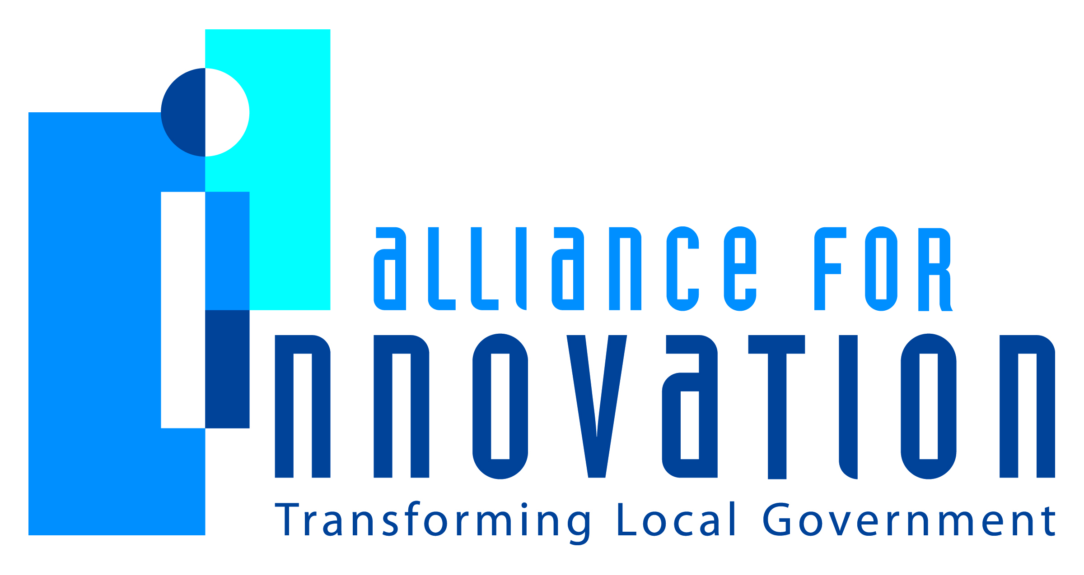

Innovation Award Application 2014

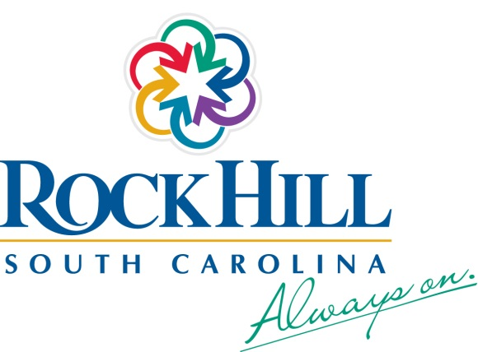

iROC: Leveraging Student Talent in Building Solutions

Holly Eskridge

Assistant to the City Manager

Rock Hill, SC

PO Box 11706, Rock Hill, SC 20731

803.326.3850

holly.eskridge@cityofrockhill.com

Describe the Program/project/ product/ service innovation:

The collaboration between the City of Rock Hill and Rock Hill School District for the iROC initiative builds an unprecedented partnership between a municipality and school system to utilize students' natural talents, gain new perspective and increase resource efficiency. Based on the philosophy of expeditionary learning, the scope of this project reaches past the boundaries of a single City department, school classroom or specific work assignment, and touches the entire Rock Hill community. It leaves a legacy of responsible, engaged citizens that have left an indelible mark on the most significant areas of the City, including infrastructure, transportation, healthy living, historic preservation, recreation, and improving quality of life for all.

Short description of the importance, internal impact, and community benefits:

iROC leverages the talents of 800+ City employees, 17,400 student citizens and 1450 teachers and administrators to create viable solutions to community challenges. In a world of decreasing budgets and demanding workloads, this collaboration provides a unique opportunity for the City to accomplish tasks that would otherwise be funded through its general fund or overlooked due to funding constraints, while giving the students real world examples to demonstrate learning. City employees at all staff levels and across all departments gain leadership and mentorship experience, encouraging cross-generational dialogue about core community values. This initiative establishes relationships between today's City leaders and the leaders of tomorrow. Harnessing the power of a young and energetic workforce gives the City the chance to answer age-old questions with new solutions. With this fresh perspective, the City of Rock Hill can better plan for the future and create an entire generation of citizens who are instilled with the expectation that they can, and should, address the needs of their community.

What makes this a quantum leap of creativity?

In a state where municipal and school funding is separate, a coalition of this magnitude is extraordinary. It provides a venue for students' worth in the community to be validated by their contributions, encouraging civic responsibility, not only in every child at the earliest age and every educator involved, but in every household in which a child or educator lives. Furthermore, public resources are conserved and City staff has the opportunity to work with younger generations on instilling civic responsibility through real life community problem-solving.

Who benefits?

This project provides a holistic approach to ensuring everyone in the community has the chance to benefit. Whether you are the educator, student or City staff working on the project, the citizen or visitor benefiting from the creation of a product such as a nature and history Catawba River trail guide, a parent whose child is benefiting from another form of learning through civic engagement or a tax payer where value is added through savings in the City’s general fund – benefits are realized by everyone.

How was the program/project/product/service initiated and implemented?

In order to make the project sustainable, the City of Rock Hill management team, the City’s Idea Generation (IG) Team, and the Rock Hill School District implemented the following plan: 1. Establish partnership between the City of Rock Hill and Rock Hill school district. 2. Explore the concepts of expeditionary learning (as demonstrated by Ron Berger, Expeditionary Learning Chief Program Officer) and challenge based learning, and educate key stakeholders. 3. Develop an initial list of potential City projects and challenges that could be tackled by Rock Hill students.4. Together, implement a pilot projects with a selection of teachers to identify and mitigate roadblocks before rolling out to students. 5. Once process is outlined successfully, begin work with students on specific projects. a. The school district will assist with matching the challenges of each City project with the appropriate school and grade level. b. A staff member from the City will personally ask each class for their help solving a particular challenge. 6. Complete an evaluation of the project and partnership results, no less than annually. The intent of the initiative is for Step 5 to be recurring throughout the school year, with projects that will last for the duration of either a semester or the entire year. In addition, multiple projects may occur at the same time, through multiple departments within the City and multiple grade levels among the schools. Since iROC’s inception, there have been six projects completed to date and five are currently underway.

What risks were taken?

The partnership identified the following risk factors for the project: 1) projects meet state and federal education standards,2) students produce quality, valuable work to solve real issues, and 3) long-term initiative sustainability. These risk factors are evaluated consistently in the work of the team to asses if any are present and if mitigation plans should be put into place. Meeting Education Standards: The ultimate goal is for students to experience learning through real-world examples. While engaged learning is more exciting than "teaching to the test," education standards are important and necessary. To ensure students are fully prepared in a curriculum, the partnership works with schools to identify standards and build projects around them, rather than trying to fit a project to standards after the fact. Quality Work with Usable Results: While the initiative's intention, expeditionary learning to solve community problems, is idealistic, the partnership understands it will be a challenge to consistently ensure students' work is valued and useful. For the partnership to be truly successful, it needs to be mutually beneficial for Rock Hill Schools and the City of Rock Hill. In order to accomplish that, it is vital the partnership establish processes for identifying projects and train employees to constructively guide students to produce excellent, effective results. Sustaining the Initiative Long Term: The creative process and exciting potential of this initiative provides the energy and enthusiasm to begin. The true measure of success, however, is in sustaining that momentum. By formally outlining expectations and responsibilities, investing in professional development and fostering prolonged support from staff at all levels, work remains stimulating and the partnership viable.

What, if any were the costs and/or savings?

The savings and value of this initiative will well out-weigh the costs. Initial start-up costs for the project were around $300,000 and were for technology, guest lecturers and training. Through the products produced by the students in their first full year, it is estimated the City and Rock Hill School District has saved around $100,000 in staff time and consulting services. This amount should stay the same or increase at the end of this school year and those following. There will be additional costs every year for technology and training. Placing a cost on the experience the students gain from this level of engagement though is priceless.

What are the lessons learned that other local governments can learn from?

The model of collaboration and using student talent in community problem-solving and civic engagement is one that can be implemented by any local government. It does take time and effort of staff to make this work and willingness of both partners to place trust in the minds and talent of younger generations. This is something that will have to happen regardless so doing it in a strategic, coordinated effort is essential. While this project invested money upfront in technology upgrades, many projects were done with existing resources located within the two partner’s capacity so costs can be minimal. There is nothing about this project that does not create a win/win approach to being creative in using resources efficiently while developing the talents and skills of future leaders. Additionally, any project completed by students must be tied to the City’s strategic goals.

What department and/or individual(s) championed the innovation? If a contractor was used, please list the name and their contact information.

No contractors were used for this project. The initial champions were the City of Rock Hill Mayor, Doug Echols, and former Rock Hill School District Superintendent, Dr. Lynn Moody. The City of Rock Hill’s Idea Generation (IG) team, guided by the City Manager and Rock Hill School District Administrative staff took on the responsibility for development and implementation of this initiative. This team has worked together since 2010 studying innovative thinking and identifying ways to apply the principles of innovation in a local government setting. The City of Rock Hill partnered with Discovery Place, exploring principles such as engagement, problem solving, communication and collaboration. The IG team represents all City departments, and Rock Hill School District, a member of the League of Innovative Schools, lends the perspective of innovation in education. The Rock Hill City Council as well adopted this project as part of its Strategic Plan. Key Contact Information: Chris Smith, Assistant Superintendent, Rock Hill School District, 660 North Anderson Road, Rock Hill, SC 29730, Phone: 803.981.1000,Email: chrisjsmith@rhmail.org/ David Vehaun, City Manager, City of Rock Hill, PO Box 11706, Rock Hill, SC 29731, Phone: 803.329.70-17, Email: david.vehaun@cityofrockhill.com

Any additional information you would like to share?

Click here to enter text.