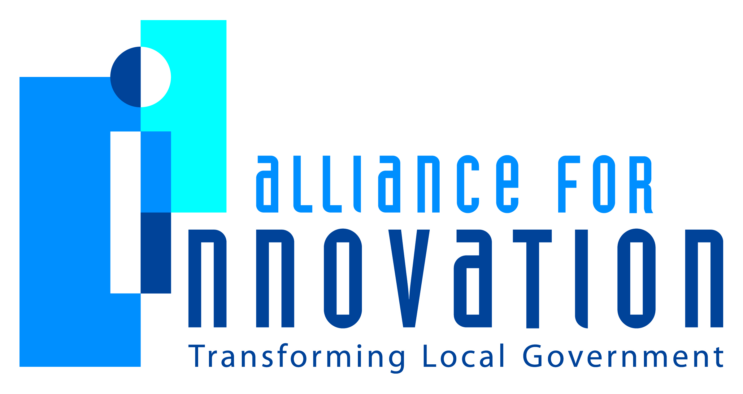

Innovation Award Application 2014

Growing Strong Neighborhoods: how collaborative government improves community quality of life
David Gassaway
Assistant to the City Manager
City of Rancho Cordova
2729 Prospect Park Drive, Rancho Cordova, CA 95670
916-851-8896
dgassaway@cityofranchocordova.org

Describe the Program/project/ product/ service innovation:
Rancho Cordova’s goal to reinvigorate neighborhoods has been realized by a pragmatic approach to improving quality of life by acting as a facilitator, broker, catalyst, and educator, not as a direct service provider. By leveraging limited resources with the passion, energy, and dedication of all community stakeholders the City has been able to do more with limited resources. This approach has created a sustainable way to realize our full potential, and the effort is called Growing Strong Neighborhoods.
Growing Strong Neighborhoods, or GSN, is a citywide effort that started in 2006. The foundation for the effort was a Blight Busters program. This initial spark involved a collective group, from Code Enforcement, Building and Safety, Police, and Fire, who proactively went neighborhood by neighborhood advising and assisting residents to bring their homes, buildings, and residences up to newly established municipal code standards. The success of Blight Busters was built extensively on collaborative partnerships aimed at collective goals, generating a positive resident response. Then in 2010, GSN reinvigorated itself by expanding the Blight Busters success to become a strategic partnership effort, aimed at creating a new and necessary paradigm in interdepartmental and stakeholder cooperation.
Short description of the importance, internal impact, and community benefits:
Commitment to communication is the essence of collaboration. Without commitment to robust and open communication between heterogeneous stakeholders and city departments, a community is unlikely to achieve desired results. As facilitator, broker, catalyst, and educator, Rancho Cordova utilizes GSN to provide stakeholders a dedicated place to communicate on issues of similar interest, within a common purview. This ensures coordinated responses to community issues of overlapping interest. This approach has resulted in award-winning programs focused on solving specific problems within the community. A reinvented Rental Housing Code Inspection Program, Citywide Graffiti Abatement, a strategic partnership with Probation and Code Enforcement, and Rental Housing Management Training, just to name a few. These programs, and more, were born from collaborative communication and have improved the quality of life for many Rancho Cordova residents.
What makes this a quantum leap of creativity?
Imagine having representatives from Economic Development, Code Enforcement, Planning, Public Works, Police, Building and Safety, Housing, Communications, Finance, City Attorney, and City Manager sitting with other community stakeholders such as the fire district, County Probation, Child Protective Services, school district, non-profit organizations, and City Council. Now imagine all of those stakeholders sitting at the same table regularly, with the sole purpose of determining ways to improve the quality of life in the community. Rancho Cordova prides itself on being a collaborative government organization. Since cityhood, the utilization of matrix-team management approaches has prevented departmental barriers that prevent communication.
The quantum leap of GSN is that it adapted the matrix-team approach to include community partners outside of the city organization. This allowed for the effective break down of community service-provider silos, and facilitated communication among stakeholders who all have similar charges within the community.
Who benefits?
From a narrow perspective, Rancho Cordova’s aged and economically disadvantaged neighborhoods have been the greatest beneficiary. These neighborhoods suffered from years of neglect and disinvestment prior to cityhood in 2003. The efforts of GSN to date have been predominately aimed at reducing crime, improving housing quality, and connecting service providers within these neighborhoods.
From a broader perspective, improvement in the “worst” neighborhoods has improved the overall quality of life in Rancho Cordova. We track a number of quality of life indicator metrics that have shown consistent improvements in the community since commencing the GSN effort. Examples include:
- Violent crime and property crime are down 11.7% and 7.7% respectively;
- Existing home sale prices maintained an average 13.5% premium over Sacramento County as a whole (near even values before the real estate crash);
- Public polling showed that resident satisfaction with City services increased by 4%; and
- The number of residents who believe their overall quality of life is improving jumped 10% in a two year period!
While we understand that there are other economic factors that may play into these types of metrics, we cannot help but believe that coordinated, collaborative efforts among community stakeholders has a demonstrable “value add” to Rancho Cordova residents.
How was the program/project/product/service initiated and implemented?
The concept of Growing Strong Neighborhoods was initiated by a council member who extensively studied strategies to improve declining suburbs. Much has been written nationally on aging, inner-ring suburbs whose development exploded after World War II. As decades have passed, many of these communities developed in the late 50’s, 60’s, and 70’s have been left behind as suburban sprawl development produced newer, nicer communities that attracted homebuyers. Utilizing the research, City staff generated performance metrics to measure community improvement by looking at the factors that people consider when determining where to live within a metropolitan region. We devised charts that identified trends in crime, school performance, housing quality, economics/growth, and overall resident satisfaction. A GSN Cabinet was then devised as a body to discuss strategies and programs to affect those performance metrics over time.
What risks were taken?
Failure to collaborate is a risk that ends in the perpetuation of status quo. That alone was enough motivation for Rancho Cordova to attempt the facilitation of these efforts. However, two identifiable risks have exposed themselves as a result of GSN to date. First, we have learned that when we attempt to publicize the good results of GSN, we further expose the public to some of the community’s major issues. Rancho Cordova has perpetually suffered from a negative image of being the “slum” of the Sacramento region. Therefore, any public relations on reducing the crime rate still demonstrate the City’s higher than average crime rate.
Secondly, GSN is not an inexpensive effort. We estimate the total cost of efforts to date to be approaching $350,000 in staff time and partner agency time. This is a substantial investment of resources in a program that produces small, incremental improvements in qualitative factors such as quality of life, a result that some “small government” activists may deem exorbitant compared to short-term results.
What, if any were the costs and/or savings?
A typical GSN meeting consists of more than $3,000 per hour of City staff time (not including other agencies’ costs). Meetings have varied in frequency, but stood bi-weekly for an hour and a half for a couple of years. At more than $9,000 per month, this is a substantial City investment. We have not yet attempted to quantify this investment against cost savings for GSN as a holistic approach to collaborative problem solving. However, two of our more prominent programs (‘Focus on 50’ highest problem properties and Volunteer Program) have had measurable savings. Focus on 50 realized a reduction of police and code enforcement calls for service by 9% over a two year period from 2011-2013. This represents a significant reduction in need for reactive city services from code enforcement and police officers. And our Volunteer program has generated more 3,290 hours of volunteer time provided to the community since its 2012 launch, at an estimated value of $50,600.
What are the lessons learned that other local governments can learn from?
Meeting with community stakeholders to talk is not collaboration. Collaboration only happens when those stakeholders are willing to remove the barrier to changing their operations in order to take advantage of partnerships to tackle common issues. We have learned that this process is not easy. The City has been unsuccessful at breaking down the barriers with our school districts, who are major community stakeholders. This fact is invaluable to other local governments in that meeting is not enough to effect change. Only action oriented (operational change) collaboration is effective. This requires full belief in a governance model that does not seek to be a direct service provider, rather it seeks to broker, catalyze, or facilitate a community’s needed services through collaboration.
What department and/or individual(s) championed the innovation? If a contractor was used, please list the name and their contact information.
Growing Strong Neighborhoods was championed by a Council member David Sander, and the City Manager and Economic Development Departments (which includes Housing and Code Enforcement Divisions).
Any additional information you would like to share?
If not selected for an innovation award, the City would still be interested in the opportunity to provide this information as a breakout session. Years ago, the Blight Busters program was featured as a TLG break out session, and Growing Strong Neighborhoods is the evolution of that collaborative process to focusing on bigger picture solutions. Rancho Cordova staff has had conversations with agencies all across the country about GSN and been met with general enthusiasm to better understand this approach. We would love the opportunity to help our peers understand how they, too, can focus community stakeholders on improving quality of life through collaborative partnership and common interest.

