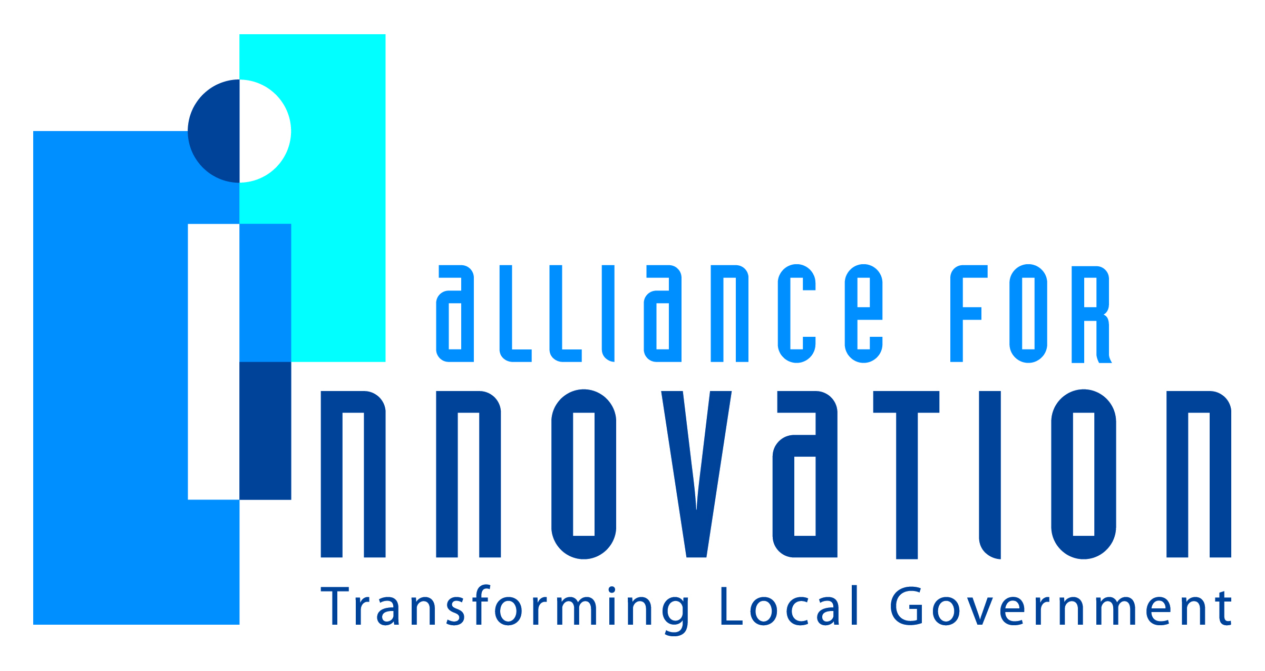

Innovation Award Application 2014

City of Austin/YMCA Public Private Partnership

Describe the Program/project/ product/ service innovation:
The City of Austin partners with community groups, non-profit organizations and businesses to build, maintain, and operate projects and facilities. The partnerships not only leverage private resources, but can also bring innovation and greater effectiveness to facilities and programs. For this project, the City of Austin entered into a public private partnership with the YMCA of Austin to design, construct, operate and manage the City of Austin/YMCA North Austin Community Recreation Center.
Short description of the importance, internal impact, and community benefits:
This innovative partnership allowed the City to leverage private resources and take advantage of the experience and expertise of the YMCA in order to provide its citizens a facility for recreation, meeting space and both traditional and progressive recreational and community service programs. The citizens of Austin received a larger facility with more robust programming than they could have received if the City built and operated the facility on its own.
What makes this a quantum leap of creativity?
It has become increasingly clear that Parks and Recreation Departments cannot continue to do business as it has done in the past and that new strategies must be implemented. There will never be enough funding and resources to maintain existing parks, facilities and programs, let alone add the new and innovative parks, facilities and programs that the Department wants to provide and that the Austin community deserves. The new strategies will focus increasingly on partnerships and private resources in order to leverage and expand on what public funding can provide. This is a creative example of this new strategy.
Who benefits?
The citizens of Austin not only have free access to at least 3,000 square feet of space for community use similar to other City recreation centers, but they also have access to an additional 27,000 square feet of space, including an indoor pool, and recreational programming at fees that are agreed upon by the City and the YMCA. In addition, the YMCA provides programs and services similar to other nearby recreation centers at competitive, low or no cost to participants.
How was the program/project/product/service initiated and implemented?
The City provided the land and approximately $8.5m in bond funds for the facility. The YMCA of Austin contributed over $1.5m to the construction of the facility and managed the construction, operates and maintains the city-owned facility and manages the community and recreational programming in a way that is responsive to community input.

What risks were taken?
The City allowed a partner to manage the construction and operate the recreation center, rather than taking the more conservative, but less creative route of constructing and operating the facility on its own.
What, if any were the costs and/or savings?
The facility cost approximately $10m with $8.5m provided by the City and $1.5m provided by the YMCA. The community received a larger facility with an indoor pool and more programming than they would have received if the City built and operated the facility on its own.
What are the lessons learned that other local governments can learn from?
Develop a detailed list of review criteria. If the partner’s mission and goals match the City’s goals and the proposed project is in alignment with the review criteria, a public private partnership may be the most efficient and effective way to complete the project, while making the most efficient use of public resources.
What department and/or individual(s) championed the innovation? If a contractor was used, please list the name and their contact information.
The Austin Parks and Recreation Department and the YMCA of Austin
Any additional information you would like to share?

