# Local Government

**in Connecticut, Third Edition**

Frank B. Connolly, with Roger L. Kemp and Philip K. Schenck

*Indispensible guide to the ins and outs of Connecticut local government, fully updated and revised*

Originally published in 1992 and revised in 2001, Frank B. Connolly’s Local Governmen*t in Connecticut* is one of the most useful and well-

established resources on the state’s local government. Written expressly for public officials and students,

the book explains Connecticut’s basic forms of local government and its many variants, as well as

examining their inner workings, including governance, management, administration, municipal services, education, and land use. This new edition has been entirely revised, expanded, and updated, with new chapters on charter revision, municipal employees and unionization, education, homeland security and local government, pensions, and economic development. It includes references to key sections of the Connecticut General Statutes. This unique and indispensable resource for the state is published in cooperation with the Connecticut Conference of Municipalities.

**Frank B. Connolly** is an active participant in local government. He has held numerous municipal positions, including as a town manager and a school business official, in several Connecticut municipalities and written articles for *Connecticut Magazine, Connecticut Government,* and several newspapers.

**Roger L. Kemp** has contributed to nearly fifty books on municipal government, most recently, *The Municipal Budget Crunch: A Handbook for Professionals*. He has served as a city manager in

cities in Connecticut, New Jersey, and California, and as the president of the Connecticut chapter of the American Society for Public Administration. **Phillip K. Schenck** has served in Connecticut and other New England municipalities as a

town manager for over forty years. He is a former president of the Connecticut Conference of Municipalities and former chairman of the

Connecticut Interlocal Risk Management Agency.

All three are on the faculty of the University of New

Haven in the Department of Public Management.

220 pp., 56 illus., 7 x 10"

Paper, $40.00, 978-0-8195-7401-5

Ebook, $31.99, 978-0-8195-7402-2

The Driftless Connecticut Series

**Publication in October 2013**

The Driftless Connecticut Series is funded by the Beatrice Fox Auerbach Foundation Fund at the Hartford Foundation for Public Giving, [www.wesleyan.edu/wespress/driftless.](http://www.wesleyan.edu/wespress/driftless)



[***www.wesleyan.edu/wespress***](http://www.wesleyan.edu/wespress)

**Save 30% on print editions when you order from our web site and use discount code W301.**

**Order from your favorite bookseller or from:**

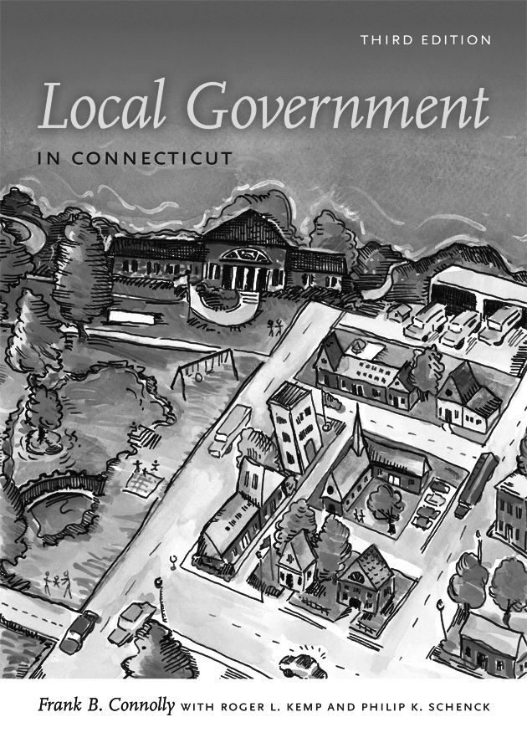

UPNE, 1 Court Street, Suite 250, Lebanon, NH 03766

USA. **Call toll-free (800) 421-1561** or FAX (603)

448-9429. Individuals must prepay and include postage:

$5.00 for first book, $1.25 for each additional book.

**Volume discounts** are available for bulk purchases. Contact Sherri Strickland, UPNE Sales Manager,

at 800-639-6102, x.238 or Sherri.L.Strickland@ Dartmouth.edu. **Purchase orders welcomed.**

## See reverse for the book’s

**table of contents**