**Navajo County, Arizona**

**TLG 2014**

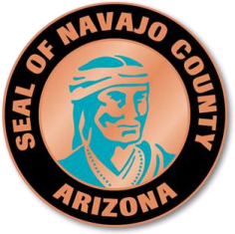

**Case Study Application**

|  |  |  |
| --- | --- | --- |
| **Case Study Title** |  | Exploring Innovation in Navajo County |
| **Case Study Category** |  | Organizational Wellness |
| **Jurisdiction Name** |  | Navajo County, AZ |
| **Jurisdiction Population** |  | 107,000 |
| **County Manager Name** |  | James Jayne  [james.jayne@navajocountyaz.gov](mailto:james.jayne@navajocountyaz.gov) |
| **Would you like the application to be considered for an Innovation Award?** |  | Yes |
| **Would you like the application to be considered for our Rapid Fire Session?** |  | Yes |
| **Project Leader (primary Contact for Case Study Notification)** |  | Melissa Buckley  100 E. Code Talkers Drive  Holbrook, Arizona 86025  928-524-4153  [melissa.buckley@navajocountyaz.gov](mailto:melissa.buckley@navajocountyaz.gov) |
| **Each Presentation Team Member** |  | Members of the Navajo County Innovation Team |

*“Enhance the quality of life in Navajo County by delivering excellence in service and leadership”*

Description: Description: Description: Description: Description: Description: cid:image001.png@01CD37EC.AEDB4E70

**What is the intent of the project/program/services?**

The Navajo County Strategic Planning Team was initially formed to develop and execute a Navajo County Strategic Plan. Navajo County assembled a group of employees, representing a cross-section of the County, and tasked the group to develop a strategic plan. The group committed to a rigorous meeting schedule and felt motivated to develop a plan that was representative of the County as a whole – a plan which would move the entire organization towards a higher level of excellence.

Further reaching outcome has become the formulation of a highly effective innovation team utilizing internal organizational talent. Ultimately the Team’s work will serve the County’s goal to further enhance organizational excellence. During this process, the group’s dynamics advanced into a highly engaged, focused and motivated team with a shared commitment. The Team recognized that by channeling this combined passion and energy towards solving problems, formulating new ideas and taking on strategic projects, the Team had an opportunity to make a meaningful impact on the organization.

The Team participated in the Alliance for Innovation’s Innovation Academy which provided tools to learn and apply innovative ideas and practices. The Team came together during the Strategic Plan process and gained skills and knowledge which enabled us to create and implement several programs beneficial to all departments in the County. This has helped create a culture of employees who are not afraid to be innovative and think outside of the box.

**What Are the Costs?**

County management has encouraged and department directors have authorized Team members to participate in the Team during work hours. While this has been a commitment of time there has been no hard dollar cost to this project.

**What Are the Savings?**

Due to the methods used there have been significant savings to the County. Minimum costs to utilize a strategic planning expert at a minimum could be expected to cost $20,000 with the top end being in the hundreds of thousands of dollars. In addition, utilizing a consultant would not have reduced the soft costs in the County due to the still considerable investment of employee time.

**What Are the Innovative Characteristics and Explain How They Improved the Organization.**

Below are some of the key components of the Team’s successful progression:

1. **Team Member Selection**. The members are across department, function and job title. Members bring different skills, education, back grounds, and levels of experience which contribute to the greater good or their individual parts. The optimum scenario is a team consisting of members that volunteer rather than being ‘voluntold’; desire and commitment are essential to the success of any team to achieve the goals.
2. **Compressed Hierarchy**. Although the Team consists of elected officials, department directors, managers, supervisors and line employees, the Team functions at the same level. The facilitator or leader is not the most important title in the room but instills passion and serves as the champion for a particular project.
3. **Autonomy**. The Team welcomes county management’s direction, but is free to follow their own path for achieving the objectives and promotes innovative solutions. Mistakes, though unintended, are used as learning tools, a pathway to continued progression.
4. **Safe and Synergistic Environment**. There is risk involved in innovation. Creative ideas can initially be perceived as foolish. If team members know they can take reasonable risks safely, those *foolish* ideas are welcome, which inspires solutions to rise to the surface. When management champions the Team’s ideas they can be creative, and drive the organization’s innovation.
5. **Resources.** Because the Team lacks financial resources, other creative ideas have been activated to achieve results. The Team has reached out to each department asking for a liaison to disseminate information but to also contribute ideas and feedback from the employees in each department. Subject matter experts have been invited to share their expertise. Skeptics have been sought out to solicit comment to improve the effort. Communication with the organization has been through word of mouth, presentations to the Personnel Commission, elected officials and department directors. Team progress is reported to all employees in the County Manager’s weekly newsletter as well as a unique program called the “Bathroom Campaign.” The team has also sought out champions to introduce new ideas and to share their successes. When new initiatives are rolled out, open meetings are scheduled for all employees to attend and ask questions. Cards, brochures and flyers with key information have been created and distributed.

**Tell us About the Obstacles you encountered when creating and/or implementing this Program.**

The team had to address the questions of how to sustain a high performance level, how to ensure consistently superior resultsand how to maintain continuity and an innovative culture.

The Team initiated a member’s rotation process. Members have the option of rotating out after a specified term of commitment, or, elect to continue. Not more than fifty percent of team members can rotate out at a time to ensure continuity and consistency. New members are accepted on a volunteer basis with the recommendation of their supervisor if applicable.

New member orientation is achieved through a one-on-one conversation with an existing senior member prior to their first meeting. The senior member explains the expectations and the story of the team. It is vital for new members to have a clear vision of where the team has been and the current direction to avoid the Team walking in circles.

The team members commit to attending full day meetings which are held off sight to eliminate distractions.

**What Were the Outcomes – Cost Savings, for Citizens, Any Performance Measures Information, etc?**

The team has successfully implemented and/or is in progress with the following projects/programs:

* Strategic Plan
* Leadership Academy
* Employee Recognition Program
* Tree of Recognition
* Bathroom Campaign
* Department Highlights
* LEAD Meetings (Leadership, Education and Direction)
* Performance Evaluations and Supervisor training on the use of Performance Evaluations
* Customer Service Training
* Employee Health Insurance Benefits
* New Employee Orientation

**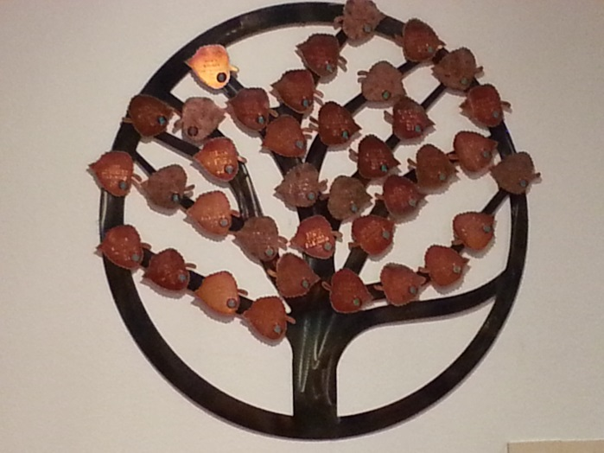  
 “Employee Recognition Tree”**

**What Are the Applicable Results and Real World Practicality?**

The formation and continuation of the Strategic Planning Team ensures lasting and positive change within the organization by creating an environment that promotes greater innovation. The County and the individual Team members have benefited from expanded skills, such as team building, collaboration and collective innovative thinking.

**Was a Private Consultant Used?**

By drawing on internal talent, collaboration with external partners and subject matter experts (pro bono) the County has saved tens of thousands of dollars in consultation fees.

**Briefly describe what your case study presentation might include. *We want to know how you will make your session creative and unique.***

A panel of Strategic Planning Team members will tell their unique and innovative story describing the culture of the Team along with information about the dynamic projects that have been produced. The presentation will include a demonstration of the “bathroom campaign” as well as a Power Point, video and handout materials.