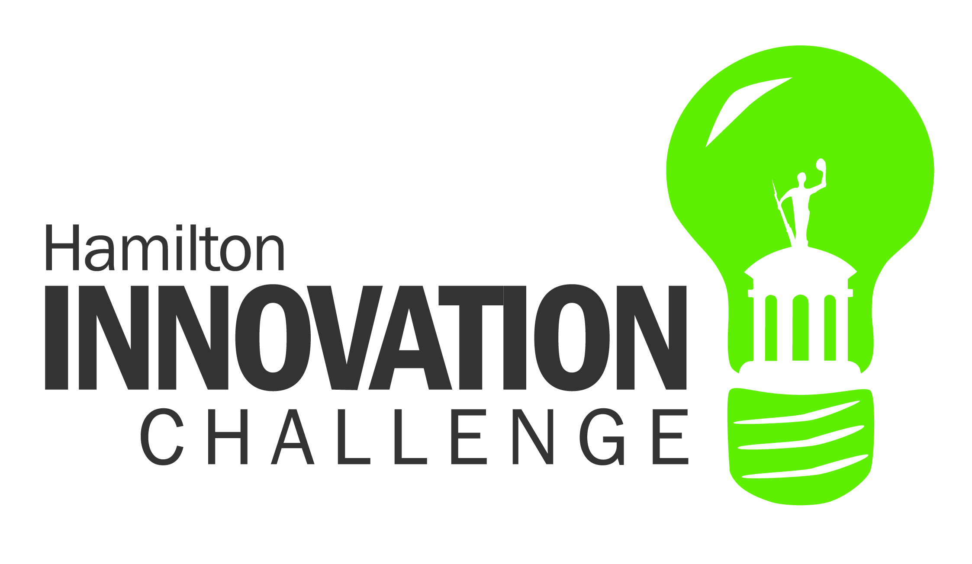
Hamilton, Ohio
Population: 62,295
City Manager: Joshua Smith

Contact information:
Mercy Montgomery
montgomem@ci.hamilton.oh.us
(513)785-7186

Introduction
The Hamilton Innovation Challenge offers a unique opportunity to draw on the valuable knowledge of employees at all levels. Clearly communicating that ideas generated within the organization are valued and have the potential to be implemented will empower employees to express new ideas and develop innovative approaches to problem solving, process improvement, and advancement of opportunities unique to the City of Hamilton. This approach capitalizes on the valuable knowledge, experience, and expertise of City employees while providing an opportunity to create interdepartmental partnerships, develop leadership opportunities, and foster an organizational culture conducive to open and innovative idea sharing.
Through the Innovation Challenge, employees will have the opportunity to submit a brief project proposal (500 words or less) as an individual or pair to outline their approach to addressing a need, improving a process, or developing an opportunity within Hamilton. These ideas will be vetted by a panel of Innovation Team members, Council Representatives, and the Executive Leadership Team who will select up to six “first round” winners.
Project leader(s) of first round winning concepts will then build a team of interested employees from various departments to assist with the development of their full program plan. This approach to project development provides an opportunity for knowledge sharing, interdepartmental collaboration, and development of new professional and personal relationships while also beginning to build a culture that is conducive to idea sharing and collaboration.
Full project teams will have around six weeks to develop concepts into a complete program plan and presentation, receiving feedback from the Large Management Team prior to exhibiting projects and presenting to the full City Council. The final decision regarding implementation of and budgeting for projects will rest with the Council, who will announce final winners within one week of receiving project presentations.

Need
The recent IBM study on organizational dynamics identified a significant gap in communication between and across organizational divides of City of Hamilton employees. This current communication structure and culture greatly diminishes our ability to effectively leverage the wealth of experience found among City employees. The Innovation Challenge provides an opportunity to collectively address this larger concern while also providing avenues for the expression of new ideas and innovative practices as well as long-standing concerns or ideas that haven’t been expressed due to lack of opportunity or an environment not conducive to creative expression.
The Innovation Challenge offers an avenue to achieve organizational impact relatively quickly through the acceptance, consideration, recognition, and anticipated implementation of employee-generated ideas. More importantly, however, the program serves as a starting point for the development of a more collaborative culture that provides an opportunity for innovative internal operations, enhanced idea sharing across divisions, and more effective operations for the City of Hamilton.
Improved communication facilitated by the Innovation Challenge and development of a more collaborative culture will likely foster feelings of organizational support, which has been shown to increase employee retention (Newman, Thanacoody, & Hui, 2012)[1] and encourage extra-role performance among employees (Marique, et. al 2012)[2]. Additionally, strengthening intra-organizational ties has also been shown to enhance employee success (Bozionelos, 2008)[3] and consequently works to diminish perceived barriers between departments. Programs similar to the Innovation Challenge have been successfully implemented in communities, companies, and local governments across the country and are often responsible for the generation of ideas and approaches that significantly advance the culture as well as operations of an organization.

Process
All of the following events are listed by tentative date. Changes to the following timeline may be necessary prior to and during the Innovation Challenge and will be announced appropriately via City communications. A full, detailed timeline of specific dates and deliverables will be released in conjunction with the Innovation Challenge Kick Off in early August.

- August 8th, Innovation Challenge Kick Off
  - Materials, including detailed description of Innovation Challenge, will be released.
  - Process and idea submission form are released and Innovation Challenge Q&A open house will be announced.
- August 8th-15th, Idea Week
  - Participants will be given one week to develop ideas and submit a basic outline through the online form.
  - Projects will be submitted through a standardized, anonymous form (500 words or less). An open house event will also be held early in the Idea Week to provide opportunity for employees to ask questions about the process and speak with the Innovation Team. Innovation Team members will also be available to meet with departments or groups of employees to answer questions about the submission and participation process.
- August 16th-21st, Review of Submissions and Selection of First Round Winners
  - Up to six “first round” winners will be selected and Innovation Team members will be matched with projects (based on expertise and background) to support teams throughout the development process.
- August 22nd, Announcement of First Round Winners and Call for Project Team Member Applications
  - First round winners will be announced and recognized. A brief description of each winning project will also be included in the announcement, as well as a call for individuals interested in collaborating on the further development of projects to submit applications.
- August 22nd-27th, 3 pm, Project Team Member Applications Accepted
  - Submissions of interest in project work will be accepted by Project Leader(s) and reviewed throughout the week.
- August 28th, Final review of all Project Team Member Applications
  - Project leader(s) will review Project Team Member applications to select final Project Team roster and submit to Innovation Team.
- August 29th, Announcement of Project Team Rosters
- Beginning of September, All Hands Meeting for Each Project Team
- Early September-September 26 (~4 weeks), Project Development
- September 27, Preliminary Presentations to Large Management Team for Feedback and Guidance
- September 27-October 11 (~2 weeks), Final Project Development
  - Project Teams work collaboratively to finalize project plans and materials in preparation for Project Open House and presentations to City Council.
- October 14, Project Open House
  - An exhibition will be held of all completed project proposals during the workday for other City employees to view.
- October 16, Presentation to Council and Project Reception to Celebrate Project Teams
- October 16-23, Consideration of Project Proposals by Council
- October 24, Announcement of Winning Project(s) Selected by Council
- November 6, Public Recognition of Innovation Challenge Winners and Participants at Council Meeting
- Implementation of Projects as Planned and Budgeted For

Requested Support from Large Management Team:
- Support of Innovation Challenge and commitment to promote and encourage the program within your department and among employees
- Willingness to allow employees time to work on projects, as appropriate
- Review of plans (in late September) to provide feedback prior to teams’ final presentation to Council

References
[1] Newman, A., Thanacoody, R., & Hui, W. (2012). The effects of perceived organizational support, perceived supervisor support and intra-organizational network resources on turnover intentions. Personnel Review, 41(1), 56-72.
[2] Marique, G., Stinglehamber, F., Desmette, D., Caesens, G., & De Zanet, F. (2012). The relationship between perceived organizational support and affective commitment: A social identity perspective. Group & Organizational Management, 38(1), 68-100.
[3] Bozionelos, N. (2008). Intra-organizational network resources: How they relate to career success and organizational commitment. Personnel Review, 37(3), 249-2

If you have any questions or would like an Innovation Team member to come talk to your department about the Innovation Challenge please contact: Mercy Montgomery at montgomem@ci.hamilton.oh.us or (513)785-7186

