**NCIS (Navajo County Information System)**

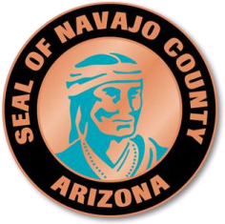

Navajo County, Arizona

Population:107,000

Category: Technology Advancement

James Jayne, County Manager

[James.Jayne@navajocountyaz.gov](mailto:James.Jayne@navajocountyaz.gov)

**Project Leader:**

Melissa Buckley

100 E. Code Talkers Drive

Holbrook, Arizona 86025

928-524-4153

[melissa.buckley@navajocountyaz.gov](mailto:melissa.buckley@navajocountyaz.gov)

*Would you like the application to be considered for an innovation award? Yes*

*Would you like the application to be considered for our rapid fire session? Yes*

**Presentation Team Member:**

Trent Larson

*“Enhance the quality of life in Navajo County by delivering excellence in service and leadership”*

Description: Description: Description: Description: Description: Description: cid:image001.png@01CD37EC.AEDB4E70

**Intent of the project/program/services**

The intent of the Navajo County Information System (NCIS) is to support intelligent business decision making processes through cooperative data management, reporting and analysis. NCIS serves as a means to blend any number of separate work processes, applications and units into a single interactive database.

**Costs**

The initial cost to develop the program was $140,000. However, once the program was developed and implemented, the maintenance was turned over to our GIS team which then there is no cost other than staff time. Future upgrades to the system are handled internally or contracted on a line item work order.

**Savings**

NCIS helps eliminate duplication of effort which equates to saving time for staff not having to look for the information we used to spend hours or sometimes days researching. NCIS provides administrative, time and office space savings by enabling the majority of our daily functions to be conducted electronically. NCIS supports the elimination of data redundancy and inconsistency through the side-by-side listing of all data in a common database. For example Navajo County has implemented the Smartphone Inspection System using NCIS for the quick and easy inspection of signs, bridges, code enforcement, building inspections, highways, and we plan to add to this list. The initial program of NCIS Mobile, the signs application, can upload the entire database of signs to allow for easier more efficient sign inspection. The end result is a simplified inspection process, where the smartphone directs the inspector to the first sign and subsequently the entire route.

Not only was the post inspection time consuming with lots of opportunities for errors and mishaps, but the sign inspection would take an average of 5 minutes to complete. NCIS combines the smartphone technology with the sign inspection policy and now the previous 5 minute inspection takes 90 seconds or less to complete. Other data management programs, that would have to be purchased separately for each department, can range in price from $10,000 - $90,000. Given that this one program works for so many different departments and drastically reduces man hours required per task, a conservative estimate of savings in the past 6 years is $200,000.

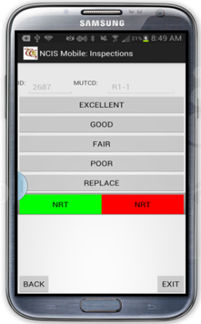

**Innovative Characteristics**

The most innovative characteristic of NCIS is the ability to combine information from all the different departments of Navajo County in one place and develop an interactive platform for managing, reporting and analyzing this information. This has helped bring the different departments of Navajo County together as one organization with a forum for sharing information, opposed to isolating data in different managing software programs that don't communicate with each other. The innovative characteristic that has made this such a success is its adaptability. NCIS is custom tailored to fit the needs of each individual user’s data instead of having to manipulate the data to fit the management software. NCIS has also formed a data management environment that does not have to be rebuilt or reinvented every 5-10 years, because its adaptive nature thrives on technology change and evolution. This continuous improvement allows the organization to focus costs on the development of improved work processes rather than purchasing new software for dealing with data as technology evolves.

**Obstacles**

There was an initial reaction to the risk involved and skepticism from the perspective that if the project fails it will have been a huge waste of money. This is not a program that can be bought off the shelf and installed on a desktop so training has also been an obstacle. Developing the program was an obstacle because there was no model of this system for the County or the contractor to work from. The program was initially started within the Public Works department. The time it has taken for other County departments to see the value and security of the system and have enough trust to begin using it has been an obstacle.

**Outcomes**

NCIS has data management, reporting and analysis functions for measuring Navajo County's employee performance which has enhanced organizational accountability. Much of the work we do at the County level is connected in some way to work that another department performs. NCIS has helped improve our level of service by streamlining business processes for internal efficiency. NCIS has also helped lower the communication barriers that existed between different departments within the same organization. Given that this one program works for so many different departments and drastically reduces man hours required per task, a conservative estimate of savings in the past 6 years is $200,000. NCIS benefits also extend to the public; one example of this is the Navajo County website that has been updated with an interactive property information search map. Using NCIS the new map allows the website user to click on a property and immediately access owner information, tax records, addressing, zoning, flood hazards, political and jurisdictional boundaries, etc.

To experience the capabilities of this program you can visit our website by clicking on the following link: <http://www.navajocountyaz.gov/pubworks/genii/parcels2/ParcelBase/BingMap.aspx> We are still discovering the endless opportunities that NCIS has to offer.

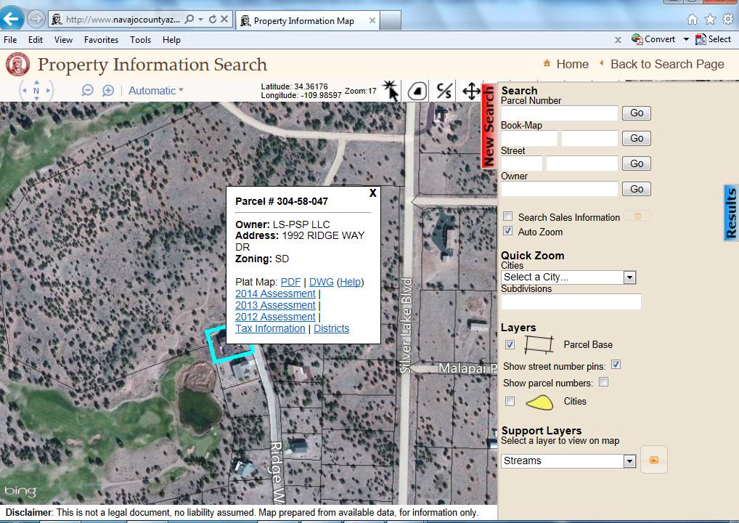

**Applicable results**

Departments in Navajo County currently using NCIS include: Animal Control, Assessor, Building and Grounds, Building Permit Department, Emergency Operations, Fleet Management, Flood Control District, Highways, Health District, Planning & Zoning, Public Works, Rural Addressing, Signs Department, Sheriff’s Office and the Treasurer. Within Public Works almost everything is linked either to a road or a property parcel. For example, the cooperative data management provided by NCIS allows you to point to a road on a map and access the table of maintained roads to obtain design features and traffic counts. You can access all work performed for each road, for each work event, and view the labor, material and equipment charges. You can obtain fuel purchases and mileage/hours of each piece of road maintenance equipment and narrow that information down to the maintenance history. You can easily view any sign on any road and see inspection and maintenance history for each sign.

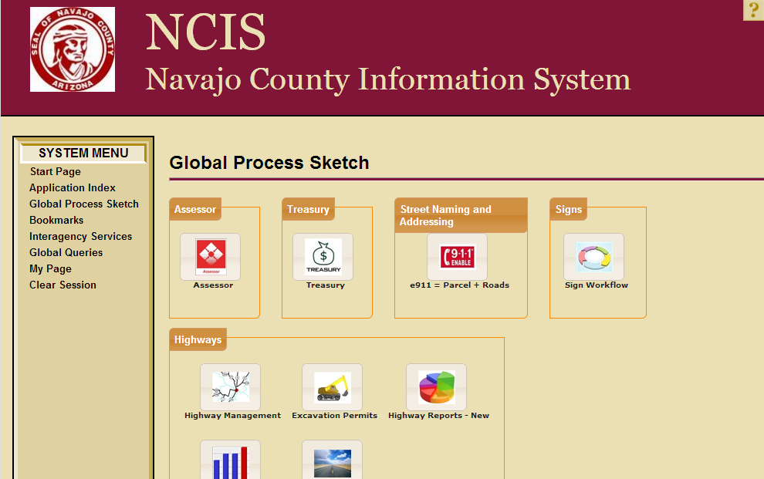

**Was a private consultant used?**

The Navajo County GIS team had a vision of what they wanted to accomplish with the capabilities of our current technology so they contracted with Terra Genesis Inc. to assist in the development of NCIS. The contractor personally met with each individual department and developed the system to function and meet the specific needs of each department.

Terra Genesis: 480-775-4000; [mwyman@tgi-systems.com](mailto:mwyman@tgi-systems.com)

**Presentation style**

The case study presentation will include a power point presentation as well as a real-time demonstration of how NCIS works through the Navajo County public website parcel information search and the new Smartphone app being used in the field by our inspectors.