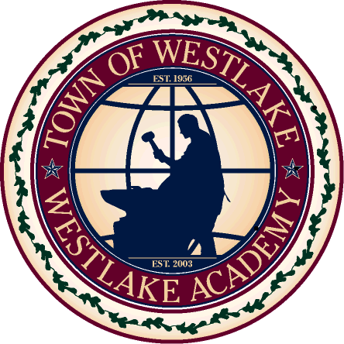

Strategic Issues-focused Governance System (SIGS)

2013 International City/County Management Association
Strategic Leadership and Governance Awards

Town of Westlake – Population 992

Project Description
Strategic Issues-focused Governance System (SIGS)

This program has taken a new approach to our strategic planning efforts as we converted our ‘traditional’ 22-page planning document into a user and staff friendly workable program. As a Leadership Team, Staff performed a document analysis, SWOT review, attended professional development training, and completed an in-house book study to combine the Balanced Scorecard format with an ‘issues-focused’ theory for our new plan. The result is a strategic document that is integrated into our agenda planning process and provides staff with a relevant and active system to use in their daily tasks.

TOWN OF WESTLAKE, TEXAS
Contents

- Project History and Early Work 2
- Leadership and Organizational Development 2
- Governance Direction 4
- Plan Implementation 5
- Benefits, Lessons Learned & Next Steps 6

- Project History and Early Work
By most standards, Westlake, Texas qualifies as a small community. However, the Town has experienced a 380% percent increase in residential growth over the last ten (10) years ~ from 207 to 992, today! Also, many Fortune 500 and international companies have made Westlake their home, such as Deloitte, First American Real Estates Services, Inc., Wells Fargo, McKesson Corporation, Sonitrol, Walco International, Pfizer, Inc., and many more.
The Town hired its first Town Manager in 1999 who, through staff hiring and budget direction, began to steadily lay the groundwork needed to create a culture able to develop our first strategic plan. During this time, our staff consisted of a Town Manager, an Assistant to the Town Manager, and a Town Secretary. Strategy and direction was communicated in face-to-face meetings and long-term planning was handled solely through the budget document. As positions were added, the Town continued to function through the use of line-item budget allocations, five-year financial forecasting, and proposed Capital Improvement Plans (CIP) as the methodology of choice to convey direction to residents and stakeholders.
Our current Town Manager identified the need to move the process to the next level in order to provide a framework for the strategic planning processes. In June of 2008, staff attended off-site retreats with elected officials to develop mission, vision, and values statements for our community. The statements were matched with relevant goals and objectives and compiled into a rough working document. The work was rewarding and we were successful in creating a ‘traditional,’ 22-page, strategic planning document. After creation, the document was mostly forgotten and staff went about their daily duties – leaving a work product behind that was beautiful and thorough, but non-usable in our public services.
- Leadership / Organizational Development
After passage of the ‘traditional’ strategic plan, the staff team began to invest in the organization through professional development. Our Manager allocated funding to send department heads through specialized courses covering topics such as becoming a high performance organization, team building and breaking down silos, structured strategic planning, and conducted a book study as a group. The team began to understand that our first pass at a strategy was good, but it could be made better.
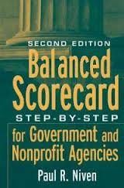
Balanced Scorecard Framework: The Leadership Team, which consists of the various department heads, identified an alternative strategic planning framework called the Balanced Scorecard and merged the concept with an issues-focused list of staff action items. The Scorecard process builds on the private sector theory that expands an organization’s focus from a strictly financial (profit/loss) viewpoint which measures success, to one that also incorporates customer service, operational processes, and organizational capacity. This system can also create linkage between the value themes of municipalities and outcome objectives which drive the organization forward.
The issues-focused concept narrows down standard ‘long-term wish list’ types of goals and objectives, which may be difficult for a smaller municipality to fund or obtain, to one that utilizes a ‘non-traditional’ model that performs a constant scan of our internal and external environment. This approach is better suited to the ever changing situations that exist in today’s local government and helps us, as a team, to focus and readily identify potential positive or negative events which can impact our service provision levels for our residents. These events can range from financial to organizational capacity related topics.
The book, Balanced Scorecard – Step-by-Step – for Government and Nonprofit Agencies by Paul R. Niven, was selected by the Team to use to work through the process of updating the existing ‘traditional’ strategic planning. We read the book individually and then met once or twice a month to review each chapter as a group. The Balanced Scorecard is segregated into the four perspectives mentioned above - financial, customer, operational, and capacity development - and strategic objectives (outcomes) are identified for each of the perspectives (associated book costs - $ 500.00 + staff planning time).
- Governance Direction
During the second off-site retreat in May of 2011, the Council and staff met with the facilitator to discuss strategic issues for our community. A new member had been recently elected to the Council and it was necessary to review the Town’s existing vision, mission, and values statements to determine our overall direction. Throughout the morning session these were discussed and new statements were drafted for the strategic plan. Our Town Manager also provided readings about governance to the Council and the group reviewed, Cuff’s Rules of Good Governance (George Cuff and Associates, Ltd.).
The afternoon meeting transitioned into a staff presentation of the Balanced Scorecard concept and issues-focused theory was identified as the option recommended by the team. We walked the Council through the four-perspectives and explained how the format would widen our organizational performance and view of service delivery, to include staff development and satisfaction, internal reviews of operational processes, and customer service delivery methods. A rudimentary strategy map was constructed to indicate how the plan would work and show the proposed changes to our ‘traditional’ strategic planning document. We demonstrated how integration of the results from our biennial resident survey could also be utilized within the customer value and service perspective. The feedback we received from the Council was very positive, and direction was given for the staff team to construct a draft of the strategic plan.
Over the next six (6) months, the team met to review the chapters in the book and formulate strategic objectives for each of the four perspectives in the map. As sections were completed, staff presented the information to the Council during workshop sessions. Objectives were listed under the corresponding perspective, such as Customer Service, and the strategy map was developed. We also formulated desired outcomes for the strategic objectives and identified possible performance measures. Under the issues-focused theory, which streamlines and allocates resources in the most effective manner, we condensed our ‘wish list’ of goals from the previous strategic plan, into a workable list of staff action items. These items covered a two year period and were placed into a Gantt chart to identify deadlines.
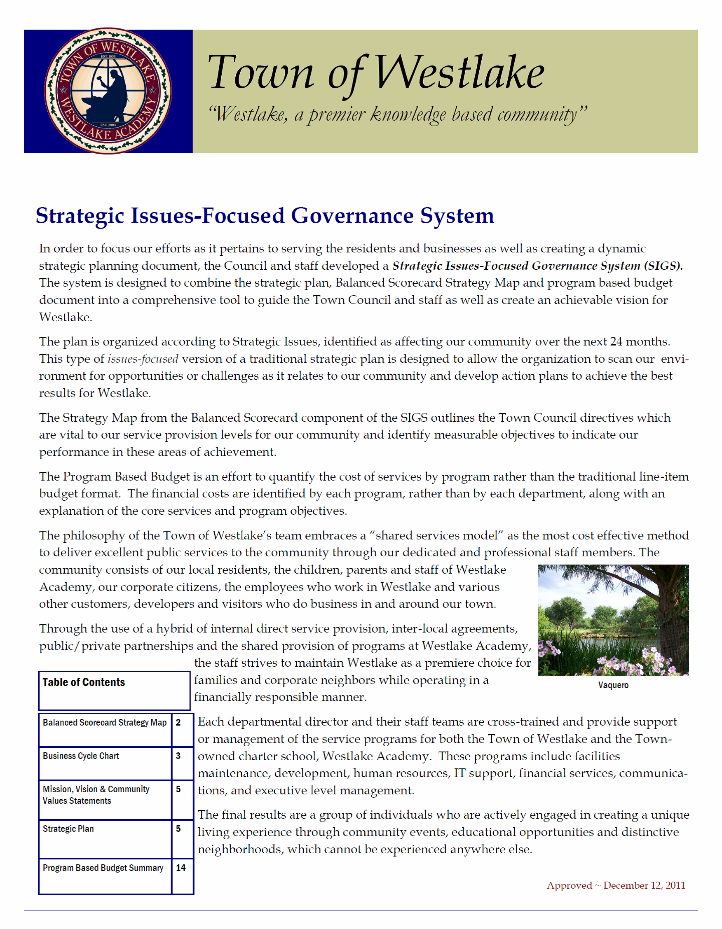
Upon completion of the strategic plan draft, it was presented to Council at a workshop in November of 2011. The objectives were identified and an in-depth review of the desired outcomes was provided. Staff action items were also discussed, with attention given to the anticipated deadlines for each project. The final draft of the Strategic Issues-focused Governance System, (SIGS), was approved in December of 2011.
- Plan Implementation
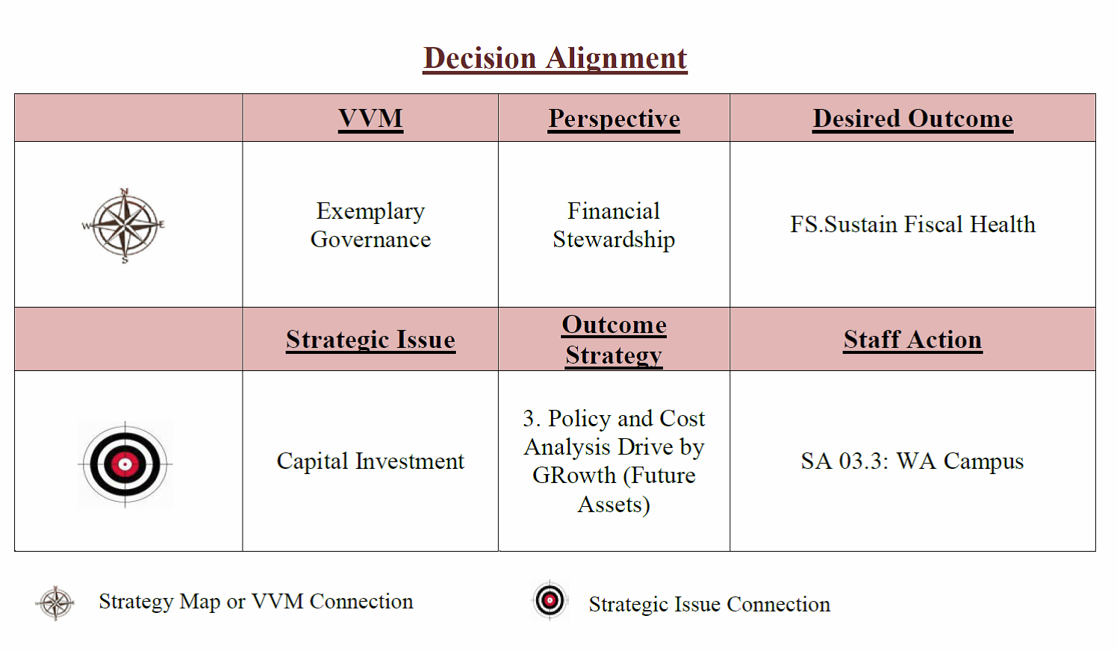
Councilmembers were clear in their directive to have the strategic plan drive monthly meeting agendas and asked staff to identify ways to incorporate the strategy map and issues-focused action items into this process. The Leadership Team reworked the Council Agenda Memo to identify linkages to our vision statements, the scorecard perspectives, and action items. We also created a Strategic Governance Calendar, which shows a four-month glance of pending staff action items, to help increase staff accountability and transparency. Council feedback to this action plan has been favorable. According to our Mayor, “The use of this form helps keep us on track and tied to our Strategic Plan.”
Staff created binders for the SIGS system and distributed the plan to the Leadership Team. The plan is used during management meetings and the Governance Calendar is updated on a monthly basis. Timelines are adjusted when an emergency situation arises or a major project requires staff attention in other areas, which prohibits achieving a completion date. We also use the deadlines to help track future agenda items and ensure they are placed on the agenda in a timely manner. SIGS binders were made for each employee and updates to the calendar are handed out at the beginning of the month.
- Benefits, Lessons Learned, and Next Steps
The goal of the Council, the Town Manager, and the Leadership Team has been to develop a working document which can be flexible enough to adapt to the current realities of a rapidly changing work environment and our small staffing configuration. The Council has enjoyed this focused approach to planning, the increased transparency about project expectations, and timely updates. The Governance Calendar is reviewed at every meeting and comments are regularly given about the benefits of this system.
The Leadership Team has found this strategy to be effective in planning future work flow and determining what is truly important to our residents, through review of our survey results in alignment with staff action items. We have realized that without the leadership provided by the Council and Town Manager, it would have been easy to set this project aside and classify it as being not an immediate need. It is tempting to look only at completing the urgent issues of the day, rather than allocating time toward becoming a high performance group. The Balanced Scorecard has also been a great tool to provide us structure to recreate an outdated planning document into one that is more focused on service delivery for all stakeholders. Coupled with the issues-focused theory for program delivery and identification of opportunities and/or weaknesses in your organization, this is a powerful tool for any local government.
The next steps involve updating the current strategy map and developing firm links between each outcome objective. Staff has attended further training on the implementation of the Scorecard concept and will be bringing a facilitator in to discuss the creation of strategic themes with the Council. We will also be facilitating feedback and discussion groups throughout all levels of the organization. While the entire staff received SIGS binders, they were not directly involved in creating the strategic objectives and performance measures. The next draft will allow for input across the entire group of staff members. Our ultimate goal is to provide excellent service delivery for our residents – which can be achieved through a plan such as ours, which is well communicated, supported by leadership, and implemented by all employees!

