Local governments scramble for budget solutions
For decades, the mantra of local government has been to do more with less, which has led many counties and municipalities to limit or reduce spending in their operating budgets.
However, in a number of states the election results of 2010 have translated the public debate over the appropriate level of government spending into specific proposals to reduce the amount of state financial support for local governments.
In some states, such as Wisconsin, revenue reductions are paired with state requirements that limit or reduce the ability of local governments to independently raise revenues via property taxes. In a recent survey of local governments in the upper Midwest, Baker Tilly provides insight into the budget options that counties and municipalities are considering in response to a challenging economic situation and to proposed revenue cuts.
Public employee fringe benefit cuts and wage freezes appear most likely
Many municipalities and counties responding to the survey reported they are more likely to pursue budget options that reduce the cost of public sector labor without cutting staff, either via fringe benefit cost reductions (3.61) or a wage freeze (3.44), as shown in the chart below.
- 57.7% of survey respondents indicated staff benefit cost reductions, and 60.3% indicated a wage freeze, were “almost a certainty" or “likely" (that is, had a better than 50/50 chance).
- 43.6% indicated staffing reductions were almost a certainty or likely.
- 34.7% of survey respondents rated budget initiatives that involve shared service with neighboring jurisdictions as having a better than 50/50 chance.
- 33.3% of respondents indicated that the likelihood of consolidation of service delivery had a better than 50/50 chance.
- 29.4% rated “increased revenue" as either “likely" or “almost a certainty."
- 20.5% rated privatization/outsourcing as having a better than 50/50 chance.
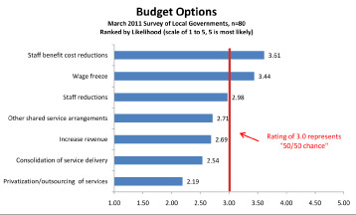
On a scale of 1 to 5, with 1 indicating essentially no chance and 5 indicating almost a certainty, staff reductions (2.98), were ranked as having just under a 50/50 chance of being acted on by local governments in the survey. As a group, survey participants assessed the likelihood of both “Increase Revenues" (2.69) and “Other Shared Service Arrangements" (2.71) (ie. joint purchasing, mutual aid) as less than 50/50. It should be noted that a majority of the respondents were from local governments in Wisconsin, where the budget debate has been particularly intense, and where public employee fringe benefits have been a focus of legislative activity.
Staff reductions are anticipated
In some states, the recent recession created strong pressures for staff reductions in local government. This is particularly true in Illinois, where a significant portion of local government revenues depends on transactional taxes and fees such as sales taxes, hotel/motel taxes, and real estate transfer fees which are highly sensitive to swings in the economy. In states like Wisconsin, where more stable property tax revenues are a larger source of local government revenues, widespread layoffs have not occurred to date, although many local governments have avoided filling position vacancies to achieve budget savings. As noted, survey respondents rated “staff reductions" as having a just under 50/50 chance of being implemented in their community when compared to a range of other budget options. However, when asked directly, more than 61 percent reported that they are anticipating at least some staff reductions in response to current budget pressures.
Staff reductions can take a number of forms, including:
- Not rehiring to fill vacant positions: This approach to staff level reductions is widespread
- Layoffs: A Reduction in Force can be targeted to a specific Department or function, or can be an across-the-board cut
- Furloughs: Labor cost reductions achieved through reducing the number of hours worked (and compensated)
Of the survey respondents anticipating reductions, the scale of anticipated position reductions is likely to involve a "few positions" across a range of pre-defined functions, with Public Works, Streets & Highways, Parks & Recreation, Administrative functions, and Public Safety all receiving roughly equal ratings.
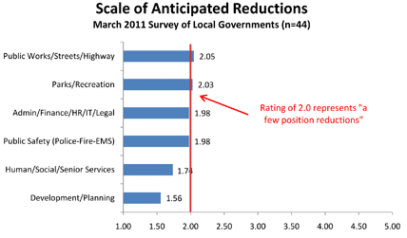
Additional survey comments included:
- Hoping to reduce staffing through attrition
- Depends on attrition in departments as well as targeted cuts
- Two retirements anticipated in public works this year, one position will like be replaced in the utilities
Increasing revenue is also anticipated
Overall, survey respondents rated the likelihood of implementation of new revenue enhancements as less than 50/50 when compared to other budget savings options. However, when asked directly, more than half of respondents (56.6%) reported they anticipate increasing revenue in response to current budget pressure.
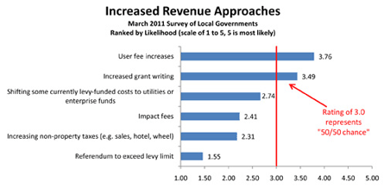
Local governments have a variety of authorized revenue tools (taxes, fees, and rates), and survey respondents reported significant differences in the likelihood of specific revenue approaches. Survey respondents reported that increased user fees (3.76) and increased grant writing (3.49) were the most likely approaches to be implemented.
Additional comments included:
- Expect increased use of special charges
- Likely to implement a recycling user fee if budget is passed
- Implemented (a new) Jail fee (room and board charges for inmates)
- Possibility of implementing an indirect cost allocation plan
The two revenue approaches that offer the greatest opportunity for increased revenues for local governments (increased sales, hotel & wheel taxes (2.31) and exceeding levy limits via referenda (1.55) were rated least likely to be implemented.
A majority of local governments do not anticipate new outsourcing efforts
Local government organizations have engaged in both contracting and outsourcing throughout history. Almost every public sector organization with which Baker Tilly has worked either contracts for or outsources at least some services or functions. For the purposes of this research, “outsourcing" means the procurement of services under contract with an external for-profit or not-for-profit organization, whereas “contracting" represents paying for services provided by another local government. More than two thirds (69.8%) of respondents answering this question indicated they are not seriously considering outsourcing additional local government services in the short term. Because of the nature of the survey, it is unknown whether the number of local governments seriously considering increased privatization/outsourcing is higher or lower than in previous years.
Survey respondents who indicated they are considering new outsourcing efforts were asked to identify specific functions that are under consideration, or to comment on the question. Respondents indicated:
- Solid Waste Collection (***)
- Currently analyzing - to be determined (***)
- Animal Control
- Considering utility meter installation & repair
- General administration
- Grass cutting
- Imaging of documents printing
- Landscaping, communication
- Nearly everything outsourceable is already out-sourced after 5+years of levy caps in Wisconsin
- Records management
- Recycling
- Snow Plowing
- Some highway maintenance, housekeeping, campground management
- Staffing by temporary services
Note: Asterisks indicate multiple responses for the same category
Local governments already outsource a broad range of functions
All of the counties participating in the survey, and 86.4% of the municipalities, volunteered information about the single most successful outsourcing arrangement currently in place. Of the 27 municipal functions reported in the survey, the most commonly identified beneficial outsourcing arrangements were legal services, residential solid waste collection and disposal, and recycling. The small number of counties responding to the survey did not appear to strongly favor a particular function.
The two most commonly cited benefits for these arrangements included operating savings (3.79) and improved focus on core functions (3.47).
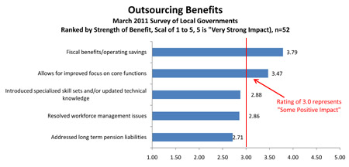
There are risks inherent to outsourcing government service delivery, and any potential initiative should be evaluated rigorously both in terms of fiscal impact and impact on service delivery. 11.5% of survey respondents indicated that they have brought some functions back in-house that were previously externally sourced. When asked why outsourcing was abandoned in these cases, survey respondents indicated:
- Difficulty contacting them on weekends to help with City events. And to cut expenses
- The contracted management team was ineffective and ignoring the utility infrastructure
- Cost savings and qualified (internal) staff
- Needed additional work for current employees
- More cost effective (to do in-house)
- Too expensive and not enough result
- we are better able to allocate these resources and manage our preventive maintenance program at a lower cost
The bottom line?
Local governments face serious fiscal challenges that will require hard choices, and not all budget options are appropriate for all communities. For example, your community may be self-insured, which can limit potential fringe benefit savings opportunities. Alternatively, your organization may have already enacted significant staffing reductions in recent years, and you may wish to explore shared services or consolidation opportunities. If your organization is looking for alternatives on how to meet these challenges while preserving core services, it is important to draw on the lessons learned from similar communities.
http://www.bakertilly.com/Local-Government-Scramble-for-Budget-Solutions

