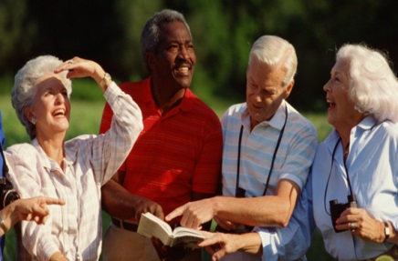

Making Your Community

A Good Place to Grow Up and to Grow Old

Many communities are facing the aging of their populations and may not be prepared to deal with the challenges that their residents might face. The Livable Communities for All Ages Learning Collaborative will focus on how communities can work to ensure that all residents, regardless of age, ethnicity, income or physical ability are able to benefit from livability improvements. Despite the current budgets crises that many cities and counties are facing, there is much that communities can do to become good places to grow up and grow old by strengthening or making shifts in what they are already doing in areas such as housing, transportation, land use planning, social service delivery, and civic engagement.

DETAILS

To help America’s cities and counties create more livable communities for all ages - places that meet the needs of citizens across their lifespan - with generous assistance of a grant from MetLife Foundation, the National Association of Area Agencies on Aging (n4a) is interested in working with six communities across the United States to serve as a Livable Communities for All Ages Learning Collaborative.

Communities are invited to apply to participate in the Livable Community for All Ages Learning Collaborative. Six communities will be selected for participation. A team composed of at least three partners, including the local government, local Area Agency on Aging, and a local public/private or non-profit stakeholder group, is required to represent each community. This local team will work together to determine key issues and priorities and develop an action plan around a specific opportunity to develop a more livable community for all ages. Training and technical assistance will be provided by n4a. Travel and per diem expenses to meetings will be covered.

GOALS

The project will facilitate local focus groups in each of the six sites to determine what the community sees as important to support a livable communities initiative including; priority potentials for change, challenges to be addressed, existing resources that could be utilized, and needs for technical assistance. Each Livable Community for All Ages Collaborative will develop and share an action plan to move community efforts forward.

Livable Community for All Ages Collaborative teams will participate in a national two-day symposium in the Washington DC area with joint training in livable communities principles and applications to further refine individual project goals, objectives, and action plans.

The Livable Community for All Ages Collaborative teams will participate as a learning community with the goals of advancing local livable community development plans and developing a compendium of experiences of each community’s on-the-ground experiences and achievements.

ACTIVITIES

n4a will work to support the following activities:

- Work with local Livable Community for All Ages Collaborative teams to develop and conduct focus groups to gain input to their action plan.
- Provide technical assistance to develop an action plan to prepare for identified community development action.
- Provide training in livable community principles and applications to help refine individual project goals, objectives, and action plans.
- Provide technical assistance to support local community teams.
- Develop a compendium of learning, experiences, and successes to be released at a national press event.

REQUIREMENTS

Lead or applicant organizations must represent a team composed of at least three required partners including a local government entity, the local Area Agency on Aging (AAA), and a local stakeholder group. Partners are identified and are ready and committed to participate in a collaborative effort to advance a livable communities for all ages project.

Please include the following in the application:
- Lead agency or organization name and contact information.
- Name and contact information of each participating representative of the identified partners.
- Describe proposed livable communities for all ages project.
- Describe any activities to date, if any.

To apply, complete the short online application at Livable Communities Application (https://www.grantinterface.com/Common/LogOn.aspx?eqs=wG-r-jJPukZQW0R8MhHMvw2)

The application deadline is August 16, 2013. Selections will be announced on September 9, 2013. Please direct any questions to Mark Fetterhoff at n4a, mfetterhoff@n4a.org.

