Transforming Local Government 2013 Case Study Proposal

Co-Sourcing Concepts: Maximizing Partnerships

Category: Organizational Design

City Manager J. Michael Wilkes

Please consider for an Innovation Award

Project Leader: Mary Miller
Assistant Director of Human Resources
City of Olathe
100 E. Santa Fe, Olathe, KS 66051
913-971-8723
mmiller@olatheks.org

Additional Presenters: James Charlesworth
Risk Management Consultant
Charlesworth Consultants
(913) 851-4730
james@charlesworth.net

Angela Reed
Loss Control Coordinator
Human Resources
(913) 971-8816
areed@olatheks.org
B. SYNOPSIS

Intent
To discuss the Human Resources innovative concept of co-sourcing and determine the impact on organizational design and necessary transformation, expected cultural changes and the technological advantages that result in better overall governmental services.

Cost
Co-Sourcing is often cost neutral and is a result of resource shifting. The initial decision to consider co-sourcing can be a need or desire to reduce cost, and/or expand services.

Savings
Co-sourcing can lead to cost savings by reduced full-time equivalents and the ancillary costs. The initial savings are augmented by the expanded scope of services and expertise that a professional organization provides.

Innovative Characteristics
The organizational structure of a governmental entity must fit that entity’s organizational strategies. Co-sourcing is an innovative design that transforms the organization to better align with the strategy. A key result is improved lateral communication related to the co-sourced function, versus a soloed role in a specific department. To be successful, co-sourcing requires cultural changes to transition the function from an individual department duty/ job title to a shared organizational responsibility. Technological advantages of co-sourcing include the “extended reach” provided by the co-sourced partners including both electronic technical components and highly experienced and targeted technical abilities. These three elements combined optimize the Human Resources innovation of co-sourcing.

Obstacles
When to co-source / when not to co-source? Outsourcing versus co-sourcing versus privatizing is a complex decision. Not all functions are good candidates for co-sourcing and selecting the best candidates is largely dependent on a myriad of variables unique to each organization. The concept of co-sourcing may be the right approach, but your co-sourced partner may not meet the requirements. Be sure that your partner understands the concept and has a proven track record of successful co-sourced relationships. Focus the co-sourcing lens on functions that are critical and service-oriented, but are not reflective of the entity’s brand.

Outcomes Cost Savings
The City of Olathe has been highly successful in the utilization of multiple co-sourced partners. Risk Management had historically been an FTE/ job and two-person responsibility, but when the risk manager departed, the City took the innovative risk to utilize a private firm that specialized in governmental entity risk management. But in lieu of outsourcing the responsibility, the City created a co-sourced relationship. The risk management consultant became an extension of the City. This new design integrated the resources of city staff for certain aspects (e.g., safety, contract negotiations) and the provider for others (e.g., tort claims, risk identification and transfer). The co-sourced partner also provides the City with a wide net of resources based on their deep experience and strategic involvement with other governmental entities.

Applicable Results and Real World Practicality
Problems facing government extend beyond Monday through Friday, 8am to 5pm. The citizens expect a certain level of service, and government is expected to provide that level with reduced resources. This has forced co-sourced relationships, but has also highlighted the unique advantages of co-sourcing as compared to outsourcing or privatizing.

Consultants used/Involvement
Charlesworth & Associates is an independent risk management and insurance consulting firm that does not sell insurance nor have any affiliation with an insurance company, agency or broker. They are the co-sourced Risk Management partner with the City of Olathe, as well as other municipalities in the central United States. James Charlesworth is the lead consultant on the City’s account, but the firm has four qualified consultants that can represent the City on a variety of situations and circumstances.

Risk management is just a single example of a successful co-sourced relationship with the City. The City of Olathe also partners with the Lockton Companies for insurance and risk management resources, Thomas McGee for workers’ compensation claims administration, and WINS for the onsite clinic. These relationships complement the variety of outsourcing the City does for specific training, drug screening, claim audits, etc. (See Olathe Works Safe graphic in Appendix)

Additional Information

The concept of co-sourcing is relatively new. In this organizational design, the governmental entities have a long-term engagement of services with vendors that act as consultants being viewed as a part of the management team. It differs from outsourcing or privatizing where an organization relinquishes control and brand identity.

Staff Augmentation, Out-Tasking and Project-based Outsourcing are design strategies that are highly effective in some situations and environments. Overall, the HR innovation of co-sourced partnerships expands the service capabilities of the governmental entity- a true optimization of resources.

C. PRESENTATION STYLE

In keeping with the theme of "Cool Communities,” participants will be given pinwheel fans as they enter. When people are laughing they are listening, so we will launch our presentation with an entertaining "Man on the Street" segment shot on location in Olathe, Kansas. The topic will be co-sourcing and how it applies to city workers. We will then use a blended, interactive approach with the attendees to explore the "What?, So What?, and Now What?" of innovative organizational design. We will hit the "What?, and So What?" for the key points (organizational transformation, culture change, technology and HR innovation) using PowerPoint. Group activities and facilitated discussions will focus on the "Now What?", or real city application (i.e., co-sourcing the risk management function). Our wrap-up will return to the theme of "Cool Communities" and reinforce these new ideas, by challenging participants to decorate each point of their pin wheel with the key learning concepts from the session. Pretty cool, huh?

APPENDIX

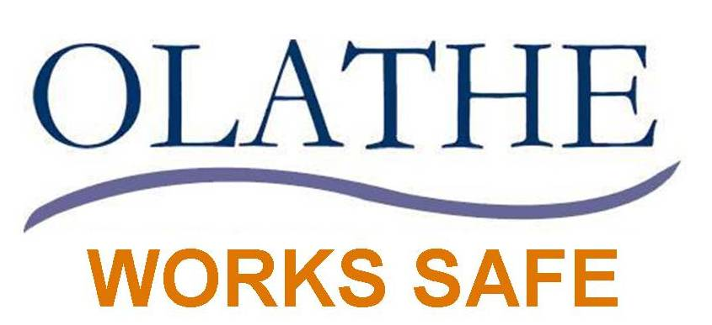
Risk Identification
Claims
Risk Financing
Risk
Control
Safety Manual MVR checks
Risk Management Manual
CDL Testing
Safety training/videos
Safety Committee
&
Teams
Ergonomic Checks
Incentives
Safety Equipment
Post offer testing
Testing, physicals, drug screens
PRIMA
ARC*
Health
&
Safety Fair
Worker’s Comp 101

TPA- Thomas McGee*
Tort Process
Charlesworth Reports*
Claim Audits*
WINS Onsite Clinic*
Safety
Audits
Risk Management Audits
Loss Control Coordination field & site inspections

Contract Reviews*
Lockton Insurance*
Subrogation*
RM Fund
WC Rate* Calculations***
Concentra*
Risk Management 101
Self
Insurance
Risk Transfer*
MVP*
Premier*
* Co-Source

