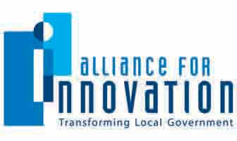
Brandi Allen
Conferences & Education Director
Alliance for Innovation
ballen@transformgov.org
602- 496-1097
Cover Page

Innovation Study Title City of Tyler Industry Growth Initiative

Category Community Building

Jurisdiction Name City of Tyler

City Manager Mark McDaniel

Submit Application for an Alliance Innovation Award Yes [ X ] No [ ]

Submit Application for the Rapid Fire Session Yes [ X ] No [ ]

Project Leader/Primary Contact

Name Kristi Boyett

Title Manager for Organizational Development

Phone Number 903-595-7172

Email kboyett#@tylertexas.com

Mailing Address 212 N. Border Ave. Tyler, TX 75702

Presentation Team Member

Name Kristi Boyett

Title Manager for Organizational Development

Phone Number 903-595-7172

Email kboyett@tylertexas.com

Mailing Address 212A N. Border Ave. Tyler, TX 75702
B. Synopsis

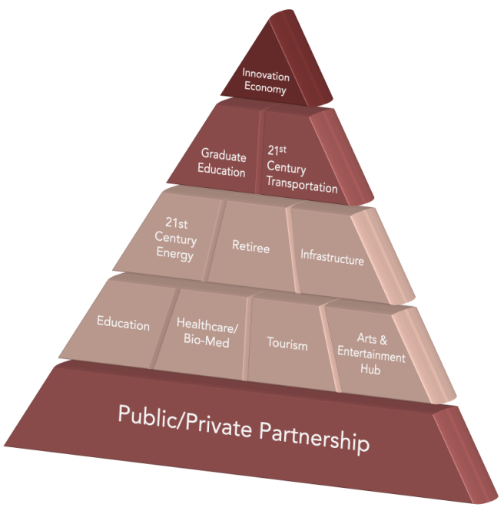
Intent
The Industry Growth Initiative (IGI) is a focused strategy stemming from the City of Tyler’s “Tyler 21” plan, which outlines a strategic framework for growing with the changing needs of Tyler and action plans for execution.
The intent of the IGI plan was to recommend 10 primary building blocks that Tyler should develop to foster an Innovation Economy because Tyler’s public and private leaders began to see that the City’s economic development could no longer hinge solely upon the manufacturing sector.
Implementation of an Innovation Economy would bring higher paying jobs, economic growth, job creation and a higher standard of living to the Tyler community.
To determine the best strategy for achieving this, a Leadership Roundtable was formed of public/private entities and an all-encompassing community study was initiated. After the collection and analysis of data, review and analysis of existing studies and interviews with key stakeholders and community members, an implementation plan was created. This planning document presents Tyler with 45 strategic tactics to attain long‐term economic opportunities ‐‐ some near term and others long term and aspirational. A Champion was named for each of the 10 building blocks and Catalyst 100 Teams were formed by volunteers to actively pursue implementation of the strategies outlined in the plan.

Costs
The total cost of the work done by the consultants was $45,851.

Innovative Characteristics
A unified approach was taken as all participating public/private entities adopted the plan. The city council, county commissioners, chamber of commerce, school district, four colleges, two hospitals, Tyler Economic Development, Convention and Visitors Bureau, Tyler Metro Chamber, Hispanic Business Alliance and Faith Community Leadership have adopted it. What is unique about Tyler is that these organizations were willing to go through a paradigm shift where they now see economic development differently. Numerous plans and results have been realized through this unified vision since its inception in May 2010.

Obstacles
With every new initiative the initial issue of buy in and acceptance can be an obstacle. This was quickly diverted by seeking and implementing the input from all public/private entities from the beginning.

Outcomes
Some of the major outcomes include:
- Branding Tyler as a college town. TJC passed a bond in May 2012 for additional on-campus housing and new facilities for Allied Health Program. The Center for Earth and Space Science Education opened at TJC in November 2011. A chemical engineering program and a doctorate program in human resources development was added at the University of Texas at Tyler.
- The University of Texas Health Science Center in Tyler opened new academic center and Cancer Center, is expanding their residency programs and construction is in progress for new Heart Hospital.
- An area development plan for the healthcare district is underway.
- An additional two cent hotel tax was established and dedicated to a Hotel/Conference Center and Arena project.
- The Texas Rose Festival impact grew more than $200,000 in 2011.
- In downtown Tyler, Liberty Hall, a performing arts venue, was completely renovated with private money and opened in October 2011 while a the Main Street Department developed a downtown façade grant program through HUD.
- Engaged local oil and gas industry leaders with creation of the CAT 100/Chamber Committee for oil and gas.
- The City and Chamber held an Energy Summit to raise awareness in 2011 and 2012 and then the City started a pilot Compressed Natural Gas filling station and converted 16 vehicles in March 2012.
- The Lake Tyler, Lake Bellwood and Parks master plans were completed by the City and a Master Street Plan update is in progress.
- The City is also ensuring balanced growth through completion of water/sewer lines in north Tyler and major road projects in west Tyler. TxDOT continues constructing Toll Road Loop 49 and the Traffic department is expanding the Adaptive Control System to alleviate traffic congestion.
- Tyler Pounds Regional Airport received its largest grant to date from the FAA to increase safety on our longest runway.

Applicable Results and Real World Practicality
All objectives in the IGI were selected through substantial research by the consultants and community surveys. Those objectives were then put in action with a goal of achieving the long-term IGI plan. To achieve project success, the Catalyst 100 Teams began to grasp and get behind their assigned objective; many choosing to become “chapter committees” ensuring future interest, sustainability and progress. The IGI has gone from a “plan,” to a grass-roots effort driven by community members taking ownership in the process; this lends itself to transferability with other planning principles.

Consultants
Tripp Umbach
2359 Railroad Street #3502
Pittsburgh, PA 15222
1-800-250-6724

Boyette Levy
225 East Markham, Suite 400
Little Rock, AR 72201
501.604.6130

C. Presentation Style
For the presentation of this case study, we will use an extraordinary and colorful PowerPoint along with a movie showing the process of creating the IGI and the variety of outcomes. We will be entertaining and educational through the group activity by getting attendees to go through some of the exercises that our own citizens did that ultimately led to this successful paradigm shift.

